

EXERCISE 4: SQL BUILT IN FUNCTIONS

**FacultyName:Dr.L.JaniAnbarasi Slot: L21+L22 / L51+L52**

**ClassNumber:**CH2022232501096/CH2022232501094

**Name**:Priyanshu Soni

**Reg.No.**:21BRS1629

**Date:18/05/2023**

# Create an EMPLOYEE Table with the following attributes EMPID, EMPNAME, JOB, DOB, SALARY, DEPTNO, GENDER

**Query:-**

CREATE TABLE EMPLOYEE_21BRS1629(EMPID INT,EMPNAME VARCHAR(10),JOB VARCHAR(10),DOB DATE,SALARY INT,DEPTNO VARCHAR(5),GENDER VARCHAR(6));

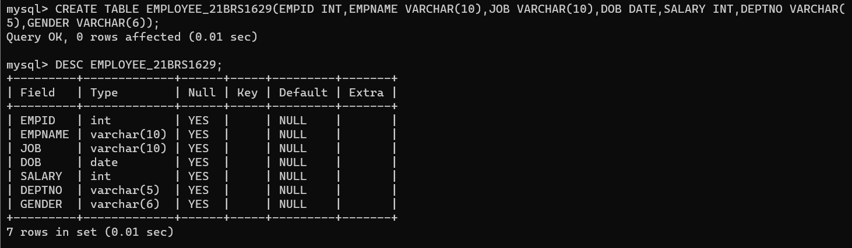

# Write queries for solving the following:

## Calculate the square root of the salary of all employees. Query:

SELECT sqrt(SALARY) FROM EMPLOYEE_21BRS1629;

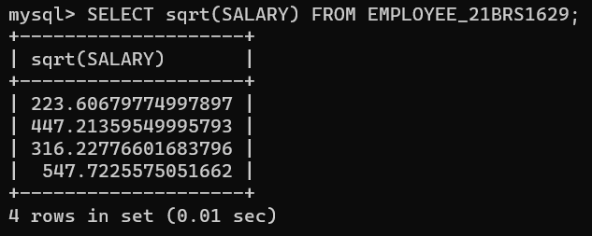

## Apply any other five numeric built in function to ‘salary’ attribute of employee table Query:

SELECT POWER(SALARY,2) FROM EMPLOYEE_21BRS1629;  
  
  
SELECT MOD(SALARY,3) FROM EMPLOYEE_21BRS1629;

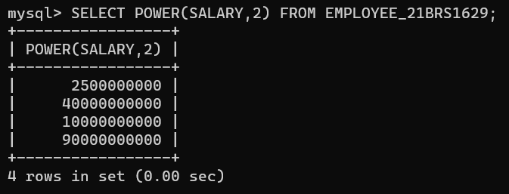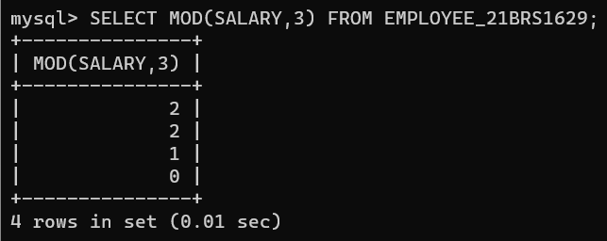

SELECT SALARY,ROUND(SQRT(SALARY),1) FROM EMPLOYEE_21BRS1629;

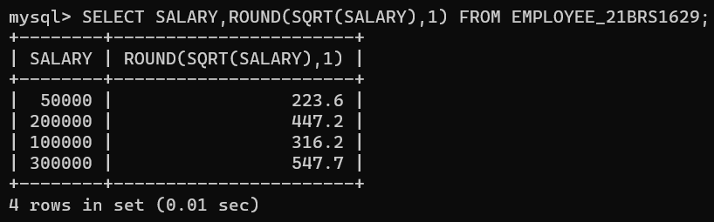

SELECT SALARY, TRUNC(SQRT(SALARY),2) FROM EMPLOYEE_21BRS1629;

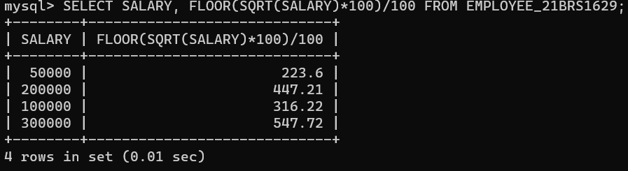

SELECT SIGN(SALARY) FROM EMPLOYEE_21BRS1629;

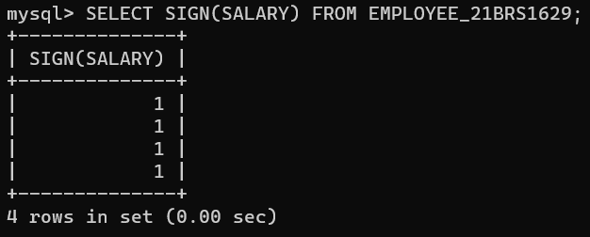

## Extract only the first 5 characters of the employee names. Query:

SELECT SUBSTR(EMPNAME,1,5) FROM EMPLOYEE_21BRS1629;

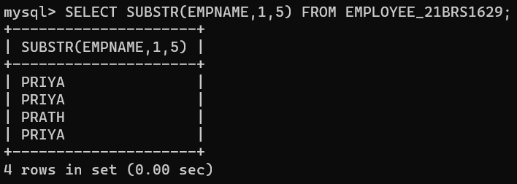

## Apply any other five string built in function to ‘name’ attribute of employee table Query:

SELECT UPPER(EMPNAME) FROM EMPLOYEE_21BRS1629;

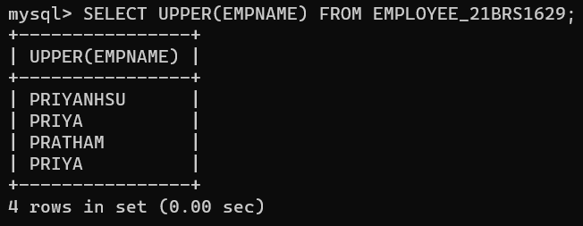

SELECT LOWER(EMPNAME) FROM EMPLOYEE_21BRS1629;

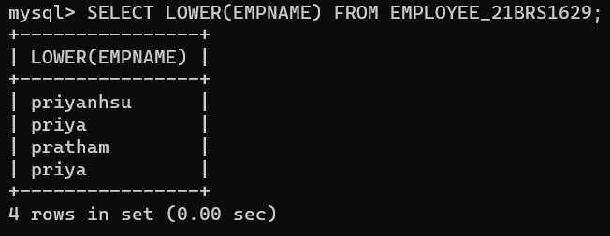

SELECT EMPNAME,LENGTH(EMPNAME) AS NAME_LENGTH FROM EMPLOYEE_21BRS1629 WHERE LENGTH(EMPNAME)>3;

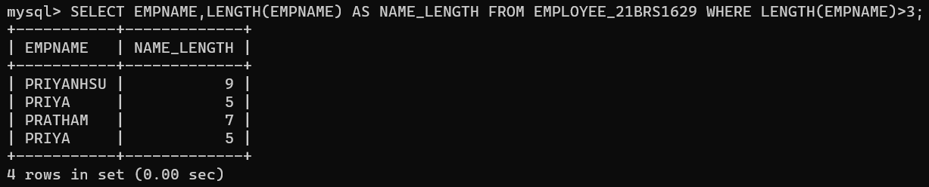

SELECT EMPNAME, INSTR(EMPNAME,'A',1) FROM EMPLOYEE_21BRS1629;

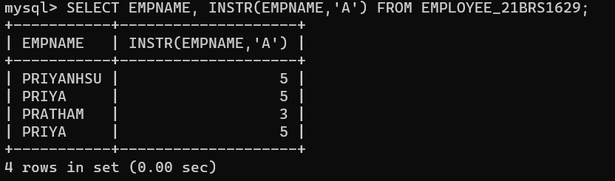

SELECT LPAD("EMPNAME",10,'-') FROM EMPLOYEE_21BRS1629;

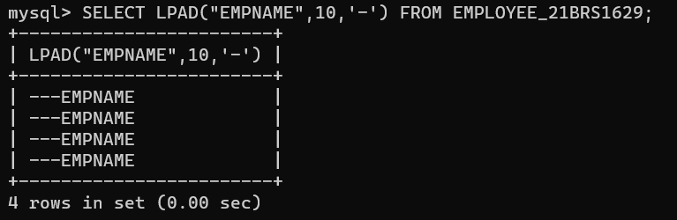

## Determine the max and min salary and rename the column as max_salary and min_salary.

Query:

SELECT MAX(SALARY) FROM EMPLOYEE_21BRS1629;

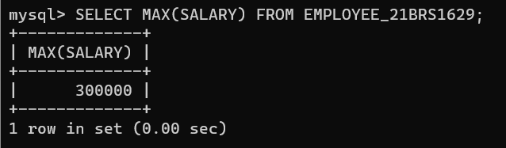

SELECT MIN(SALARY) FROM EMPLOYEE_21BRS1629;

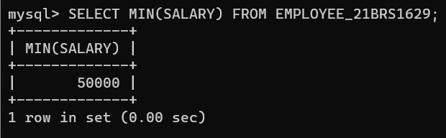

## Display the month name of date “14-jul-15” in full. Query:

SELECT TO_CHAR(TO_DATE('14-Jul-15', 'DD-Mon-RR'), 'Month') AS month_name FROM dual;

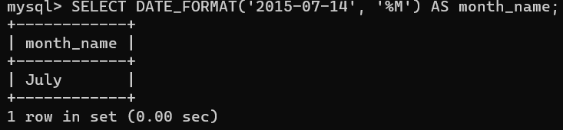

## 7. Display the Dob of all employees in the format “dd-mm-yy”. Query:

SELECT TO_CHAR(DOB,'DD-MM-YY') AS DOB FROM EMPLOYEE_21BRS1629;

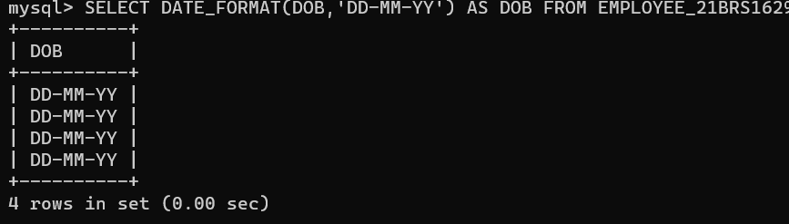

## 8.Display the date two months after the Dob of employees. Query:

SELECT Add_months(DOB,2) AS NEW_DOB FROM EMPLOYEE_21BRS1629;

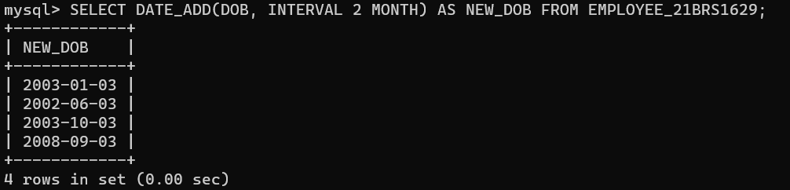

## 9.Display the last date of that month in “05-Oct-15”. Query:

SELECT LAST_DAY('05-OCT-15') AS LAST_DATE FROM DUAL;

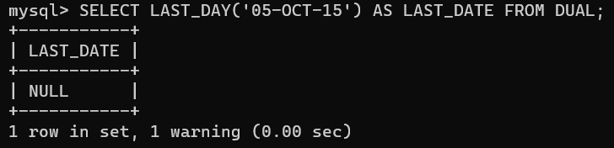

## 10.Display the rounded date in the year format, month format, day format

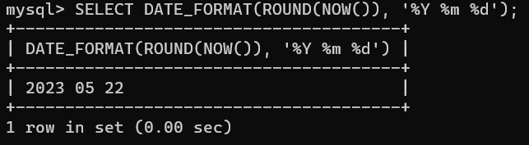

11. Display the date 60 days before current date. Query:

SELECT CURRENT_DATE - INTERVAL '60' DAY AS NEW_DATE FROM DUAL;

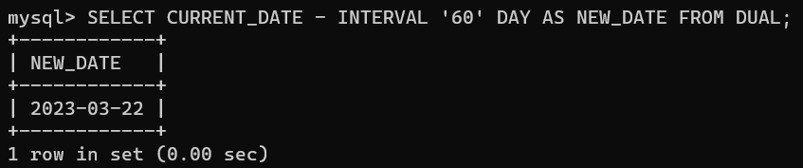

## 12. Display the names and dob of all employees who were born in August. Query:

SELECT * FROM EMPLOYEE_21BRS1629 WHERE EXTRACT(MONTH FROM DOB)=8;

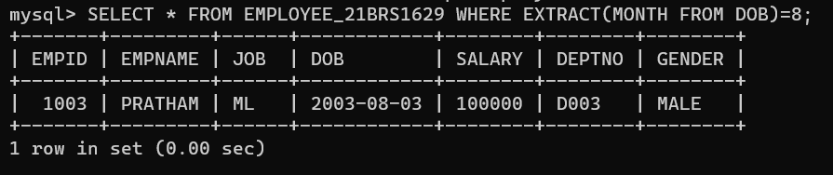

## 13. List out the employee names who will celebrate their birthdays during current month. Query:

SELECT * FROM EMPLOYEE_21BRS1629 WHERE EXTRACT(MONTH FROM DOB)=EXTRACT(MONTH FROM CURRENT_DATE);



## 

## 14. List all female employees who were born April ? Query:

SELECT * FROM EMPLOYEE_21BRS1629 WHERE GENDER='FEMALE' AND EXTRACT(MONTH FROM DOB)=4;

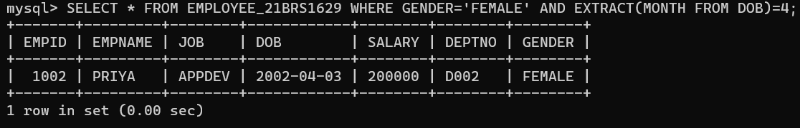

## 15.What is the difference between maximum and minimum salaries of employees in the organization?

Query:

SELECT MAX(SALARY)-MIN(SALARY) FROM EMPLOYEE_21BRS1629;

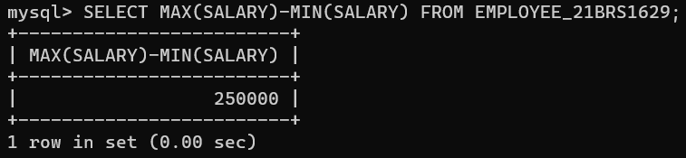

## 16. Display number of employees working in each department and their department name. Query:

SELECT JOB,COUNT(*) AS EMPLOYEE_COUNT FROM EMPLOYEE_21BRS1629 GROUP BY JOB;

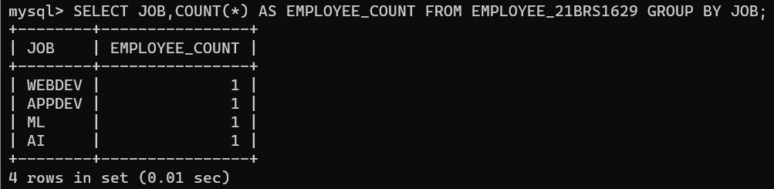

## 17. Display total salary spent for employees. Query:

SELECT SUM(SALARY) FROM EMPLOYEE_21BRS1629;

## 18. Display total salary spent for each job category. Query:

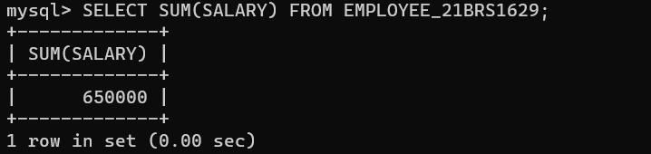

SELECT JOB,SUM(SALARY) AS TOTAL_SALARY FROM EMPLOYEE_21BRS1629 GROUP BY JOB;

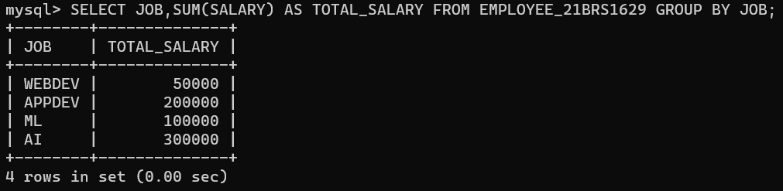

## 19.Display lowest paid employee details under each manager. Query:

SELECT E.EMPID,E.EMPNAME,E.JOB,E.DOB,E.SALARY,E.DEPTNO,E.GENDER FROM EMPLOYEE_21BRS1629 E WHERE E.SALARY=(SELECT MIN(SALARY) FROM EMPLOYEE_21BRS1629);

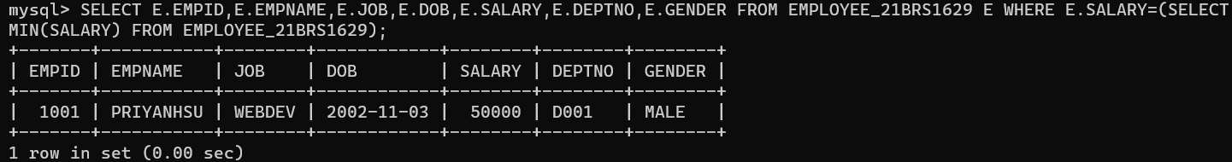

## 20. Find how many job titles are available in employee table. Query:

SELECT COUNT(DISTINCT JOB) FROM EMPLOYEE_21BRS1629;

