LAB SESSION-6

COURSE:- Computer Networks Lab Course Code:- BCSE308P

Faculty:- Anita X Name:- Priyanshu Soni

Reg. No.:- 21BRS1629

# TCP Client server chat application using socket programming.

## Client:

## import java.io.*;

## import java.net.*;

## public class client1 {

## public static void main(String[] args) throws Exception {

## String hostName = "localhost";

## int portNumber = 8000;

## Socket clientSocket = new Socket(hostName, portNumber);

## System.out.println("Connected to server: " +

## clientSocket.getInetAddress().getHostAddress() + " on port " +

## clientSocket.getPort());

## BufferedReader inFromUser = new BufferedReader(new InputStreamReader(System.in));

## BufferedReader inFromServer = new BufferedReader(

## new InputStreamReader(clientSocket.getInputStream()));

## DataOutputStream outToServer = new DataOutputStream(clientSocket.getOutputStream());

## String clientMessage, serverMessage;

## while (true) {

## System.out.print("Enter message to send: ");

## clientMessage = inFromUser.readLine();

## outToServer.writeBytes(clientMessage + "\n");

## if (clientMessage.equals("bye")) {

## System.out.println("Disconnecting from server...");

## break;

## }

## serverMessage = inFromServer.readLine();

## System.out.println("Received response from server: " +

## serverMessage);

## }

## clientSocket.close();

## }

## }

Server:

import java.io.*;

import java.net.*;

public class server2 {

public static void main(String[] args) throws Exception {

ServerSocket serverSocket = new ServerSocket(8000);

System.out.println("Server started. Listening for connections on port 8000...");

Socket clientSocket = serverSocket.accept();

System.out.println("Client connected: " +

clientSocket.getInetAddress().getHostAddress() + " on port " +

clientSocket.getPort());

BufferedReader inFromClient = new BufferedReader(new

InputStreamReader(clientSocket.getInputStream()));

DataOutputStream outToClient = new

DataOutputStream(clientSocket.getOutputStream());

String clientMessage, serverMessage;

while(true) {

clientMessage = inFromClient.readLine();

if(clientMessage.equals("bye")) {

System.out.println("Client has disconnected.");

break;

}

System.out.println("Received message from client: " +

clientMessage);

serverMessage = "You said: " + clientMessage + "\n";

outToClient.writeBytes(serverMessage);

}

serverSocket.close();

}

}

Output:

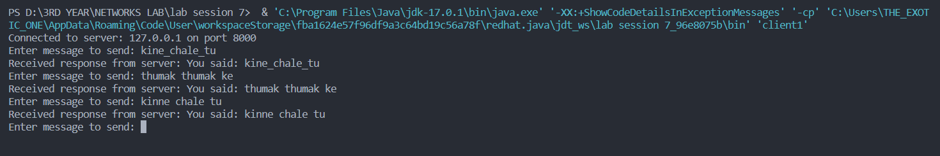

# UDP Client server chat application using socket programming.

## Client:

import java.net.*;

public class client1 {

public static void main(String[] args) throws Exception {

DatagramSocket socket = new DatagramSocket();

InetAddress address = InetAddress.getByName("localhost");

byte[] buffer;

while (true) {

String message = System.console().readLine("> ");

buffer = message.getBytes();

DatagramPacket packet = new DatagramPacket(buffer, buffer.length,

address, 4445);

socket.send(packet);

buffer = new byte[1024];

packet = new DatagramPacket(buffer, buffer.length);

socket.receive(packet);

String response = new String(packet.getData(), 0,

packet.getLength());

System.out.println("Server: " + response);

}

}

}

Server:

import java.net.*;

public class server2 {

public static void main(String[] args) throws Exception {

DatagramSocket socket = new DatagramSocket(4445);

byte[] buffer;

while (true) {

buffer = new byte[1024];

DatagramPacket packet = new DatagramPacket(buffer, buffer.length);

socket.receive(packet);

String message = new String(packet.getData(), 0,

packet.getLength());

System.out.println("Client: " + message);

String response = "Hello from server!";

buffer = response.getBytes();

packet = new DatagramPacket(buffer, buffer.length,

packet.getAddress(), packet.getPort());

socket.send(packet);

}

}

}

Output:

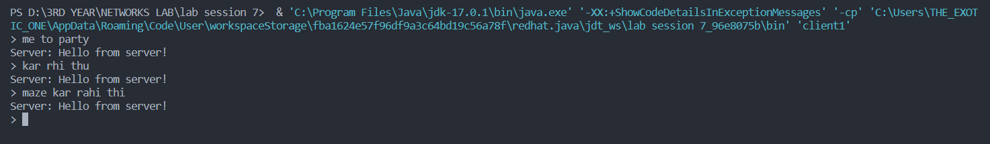

* **Getting the date from the server using socket programming.**

Client:

import java.io.*;

import java.net.*;

import java.time.LocalDateTime;

import java.time.format.DateTimeFormatter;

public class Client {

private Socket socket = null;

private DataInputStream input = null;

private DataOutputStream out = null;

public Client(String address, int port,String formattedDateTime)

{

try

{

socket = new Socket(address, port);

System.out.println("Connected");

System.out.println("helloo");

System.out.println("Formatted Date and Time: " +

formattedDateTime);

input = new DataInputStream(System.in);

out = new DataOutputStream(

socket.getOutputStream());

}

catch (UnknownHostException u)

{

System.out.println(u);

return;

}

catch (IOException i)

{

System.out.println(i);

return;

}

String line = "";

while (!line.equals("Over"))

{

try {

line = input.readLine();

out.writeUTF(line);

}

catch (IOException i)

{

System.out.println(i);

}

}

try {

input.close();

out.close();

socket.close();

}

catch (IOException i) {

System.out.println(i);

}

}

public static void main(String args[])

{

LocalDateTime now = LocalDateTime.now();

System.out.println("Current Date and Time: " + now);

DateTimeFormatter formatter =

DateTimeFormatter.ofPattern("yyyy-MM-dd HH:mm:ss");

String formattedDateTime = now.format(formatter);

Client client = new Client("127.0.0.1", 5000,formattedDateTime);

}

}

Server:

import java.net.*;

import java.io.*;

public class Server

{

private Socket socket = null;

private ServerSocket server = null;

private DataInputStream in = null;

public Server(int port)

{

try

{

server = new ServerSocket(port);

System.out.println("Server started");

System.out.println("Waiting for a client ...");

socket = server.accept();

System.out.println("Client accepted");

in = new DataInputStream(

new BufferedInputStream(socket.getInputStream()));

String line = "";

while (!line.equals("Over"))

{

try

{

line = in.readUTF();

System.out.println(line);

}

catch(IOException i)

{

System.out.println(i);

}

}

System.out.println("Closing connection");

socket.close();

in.close();

}

catch(IOException i)

{

System.out.println(i);

}

}

public static void main(String args[])

{

Server server = new Server(5000);

}

}

Output:

