

**COURSE TITLE: DATABASE SYSTEMS LAB COURSE CODE: BCSE302P**

**EXPERIMENT NO: 6**

SQL JOINS

**NAME:** PRIYANSHU SONI **REGISTER NO:** 21BRS1629 **SLOT:** L21+L22

**CLASS NUMBER:** CH2022232501096 **DATE:** 15-APRIL, 2023 **FACULTY NAME:** L. JANI ANBARASI

Create three tables: salesman, customer and orders.

* SALESMAN( )

## CODE:

CREATE TABLE SALESMAN_21BRS1629(SALESMAN_ID INT PRIMARY KEY, NAME VARCHAR(15), CITY VARCHAR(15), COMMISSION INT);

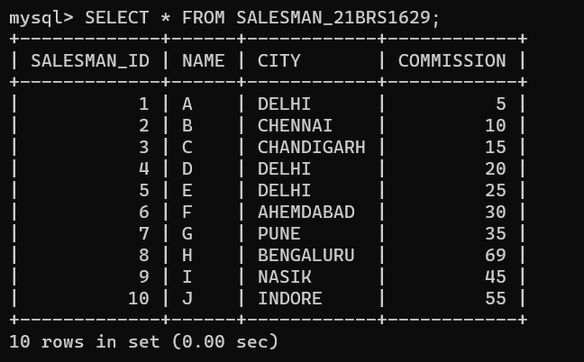

* CUSTOMER(CUSTOMER_ID, CUST_NAME, CITY, GRADE, SALESMAN_ID)

## CODE:

CREATE TABLE CUSTOMER_21BRS1629(CUSTOMER_ID INT PRIMARY KEY, CUST_NAME VARCHAR(15), CITY VARCHAR(15), GRADE INT, SALESMAN_ID INT,FOREIGN KEY (SALESMAN_ID) REFERENCES SALESMAN_21BRS1629(SALESMAN_ID));

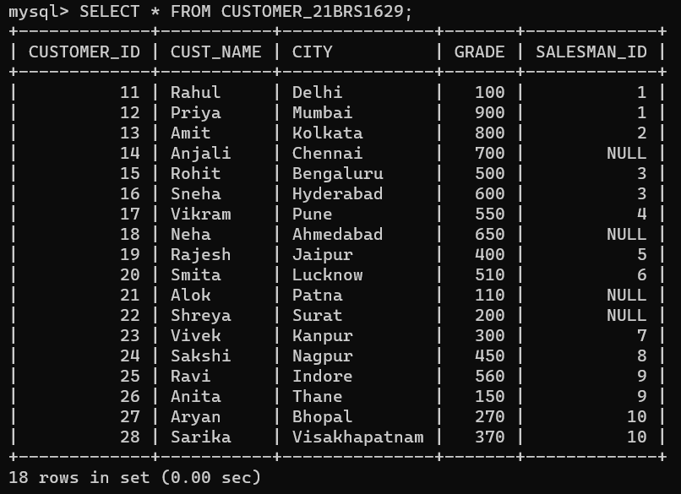

* ORDERS(ORDER_NO, ORDER_AMT, ORDER_DATE, CUST_ID, SALESMAN_ID)

## CODE:

CREATE TABLE ORDER_21BRS1629(ORDER_NO INT PRIMARY KEY, ORDER_AMT DECIMAL(10,2), ORDER_DATE DATE, CUST_ID INT, SALESMAN_ID INT, FOREIGN KEY (SALESMAN_ID) REFERENCES SALESMAN_21BRS1629 (SALESMAN_ID) ,FOREIGN KEY(CUST_ID) REFERENCES CUSTOMER_21BRS1629(CUSTOMER_ID) );

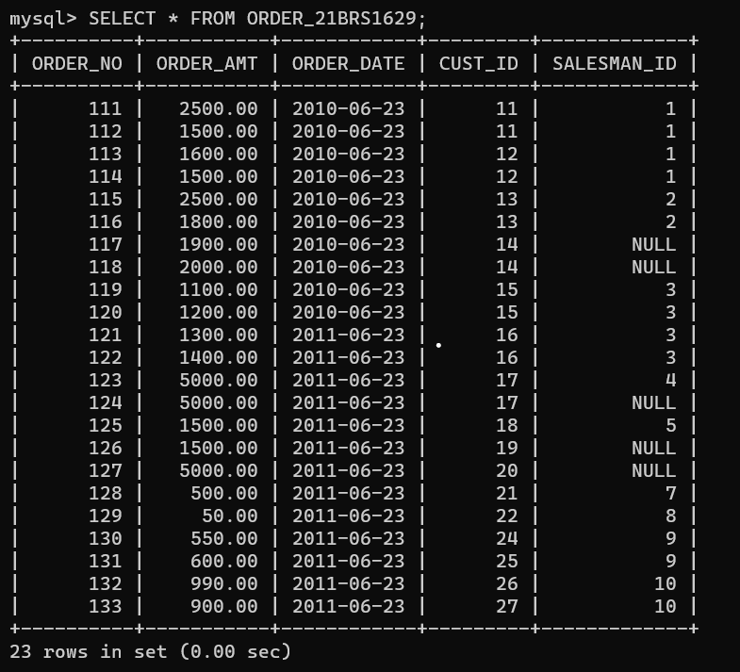

# Prepare a list with salesman name, customer name and their cities for the salesmen and customer who belongs to the same city.

**CODE:**

SELECT S.NAME AS SALESMAN_NAME, C.CUST_NAME AS CUSTOMER_NAME, S.CITY FROM SALESMAN_21BRS1629 S JOIN CUSTOMER_21BRS1629 C ON S.CITY = C.CITY;

**OUTPUT**:

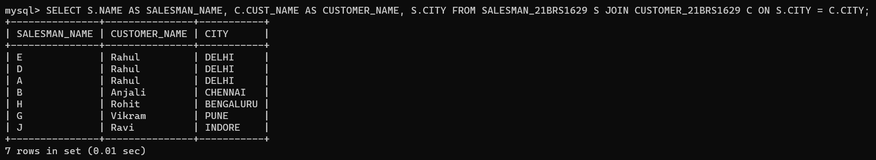

1. **Make a list with order no, purchase amount, customer name and their cities for those orders which order amount between 500 and 2000.**

# CODE:

SELECT O.ORDER_NO, O.ORDER_AMT, C.CUST_NAME, C.CITY FROM ORDER_21BRS1629 O JOIN CUSTOMER_21BRS1629 C ON O.CUST_ID = C.CUSTOMER_ID WHERE O.ORDER_AMT BETWEEN 500 AND 2000;

**OUTPUT**:

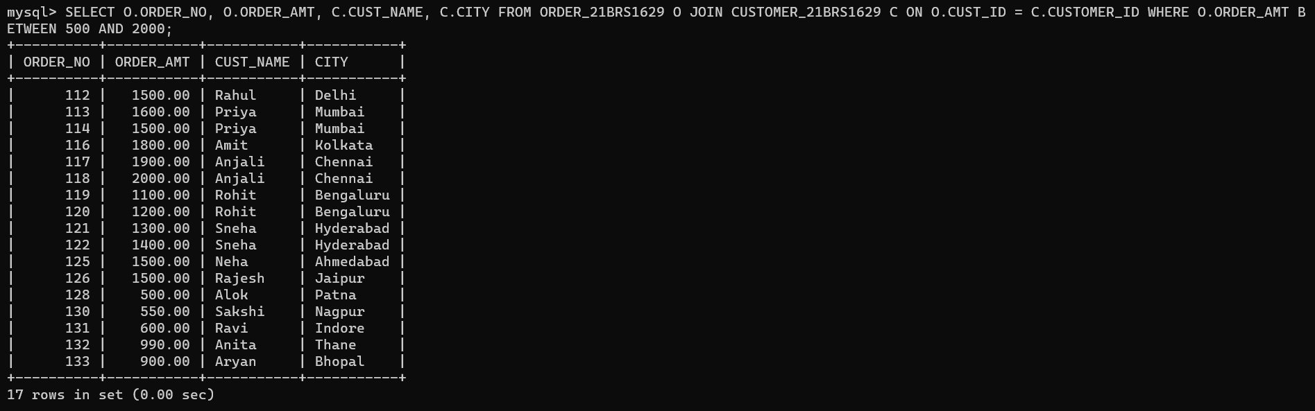

1. **Know which salesman is working for which customer.**

# CODE:

SELECT S.NAME, C.CUST_NAME FROM SALESMAN_21BRS1629 S JOIN CUSTOMER_21BRS1629 C ON S.SALESMAN_ID = C.SALESMAN_ID;

**OUTPUT**:

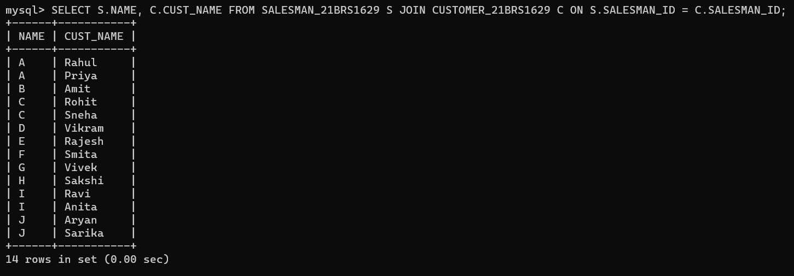

1. **Find the list of customers who appointed a salesman for their jobs who gets a commission from the company is more than 12%.**

# CODE:

SELECT C.CUST_NAME FROM CUSTOMER_21BRS1629 C JOIN SALESMAN

_21BRS1629 S ON C.SALESMAN_ID = S.SALESMAN_ID WHERE S.COMMISSION > 12;

**OUTPUT**:

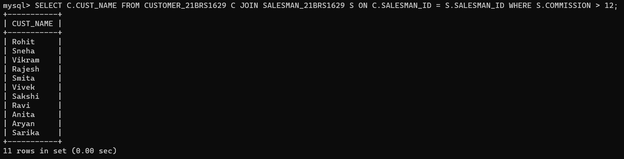

1. **Find the list of customers who appointed a salesman for their jobs who does not live in the same city where their customer lives, and gets a commission is above 12%.**

# CODE:

SELECT C.CUST_NAME FROM CUSTOMER_21BRS1629 C JOIN SALESMAN_21BRS1629 S ON C.SALESMAN_ID = S.SALESMAN_ID WHERE S.CITY != C.CITY AND S.COMMISSION > 12;

**OUTPUT**:

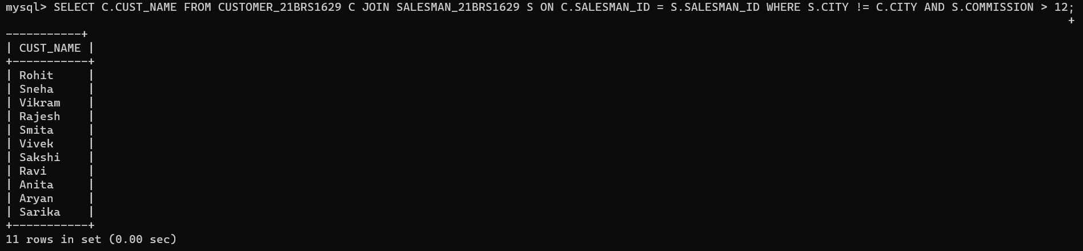

1. **Find the details of an order i.e. order number, order date, amount of order, which customer gives the order and which salesman works for that customer and how much commission he gets for an order.**

# CODE:

SELECT O.ORDER_NO, O.ORDER_DATE, O.ORDER_AMT, C.CUST_NAME AS CUSTOMER_NAME, S.NAME AS SALESMAN_NAME, S.COMMISSION FROM ORDER_21BRS1629 O JOIN CUSTOMER_21BRS1629 C ON O.CUST_ID = C.CUSTOMER_ID JOIN SALESMAN_21BRS1629 S ON O.SALESMAN_ID = S.SALESMAN_ID;

**OUTPUT**:

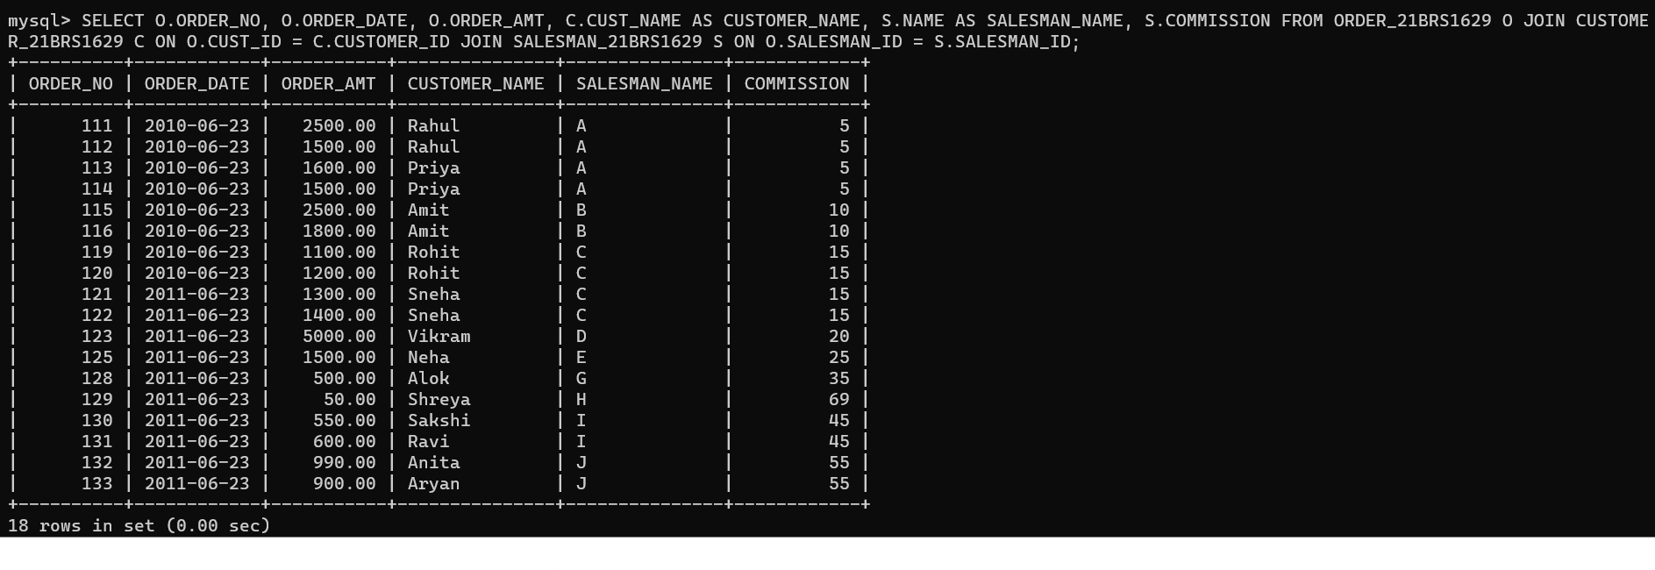

1. **Make a join on the tables: salesman, customer and orders in such a form that the same column of each table will appear once and only the relational rows will come.**

# CODE:

SELECT S.SALESMAN_ID, S.NAME AS SALESMAN_NAME, S.CITY AS SALESMAN_CITY, S.COMMISSION,C.CUSTOMER_ID, C.CUST_NAME, C.CITY AS CUSTOMER_CITY, C.GRADE, O.ORDER_NO, O.ORDER_AMT, O.ORDER_DATE FROM SALESMAN_21BRS1629 S JOIN CUSTOMER_21BRS1629 C ON S.SALESMAN_ID = C.SALESMAN_ID JOIN ORDER_21BRS1629 O ON C.CUSTOMER_ID = O.CUST_ID;

**OUTPUT**:

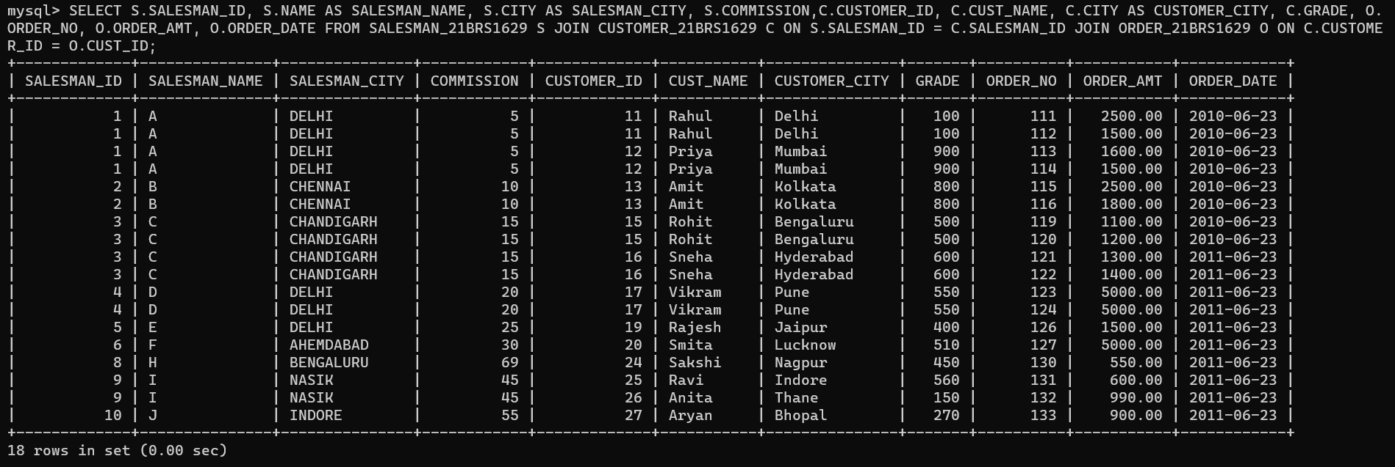

1. **Make a list in ascending order for the customer who works either through a salesman or by own.**

# CODE:

SELECT C.CUST_NAME FROM CUSTOMER_21BRS1629 C LEFT JOIN SALESMAN_21BRS1629 S ON C.SALESMAN_ID = S.SALESMAN_ID WHERE C.SALESMAN_ID IS NOT NULL OR C.SALESMAN_ID IS NULL ORDER BY C.CUST_NAME ASC;

**OUTPUT**:

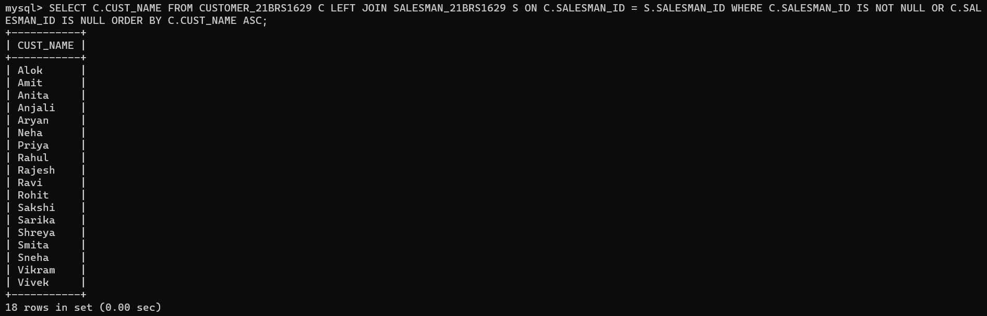

1. **Make a list in ascending order for the customer who holds a grade less than 300 and works either through a salesman or by own.**

# CODE:

SELECT C.CUST_NAME FROM CUSTOMER_21BRS1629 C LEFT JOIN SALESMAN_21BRS1629 S ON C.SALESMAN_ID = S.SALESMAN_ID WHERE C.GRADE<300 AND (C.SALESMAN_ID IS NOT NULL OR C.SALESMAN_ID IS NULL) ORDER BY C.CUST_NAME ASC;

**OUTPUT**:

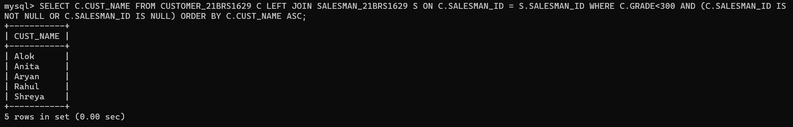

1. **Make a list in ascending order for the salesmen who work either for one or more customer or not yet join under any of the customers.**

# CODE:

SELECT S.NAME AS SALESMAN_NAME FROM SALESMAN_21BRS1629 S LEFT JOIN CUSTOMER_21BRS1629 C ON S.SALESMAN_ID = C.SALESMAN_ID WHERE C.CUSTOMER_ID IS NOT NULL OR C.CUSTOMER_ID IS NULL ORDER BY S.NAME ASC

**OUTPUT**:

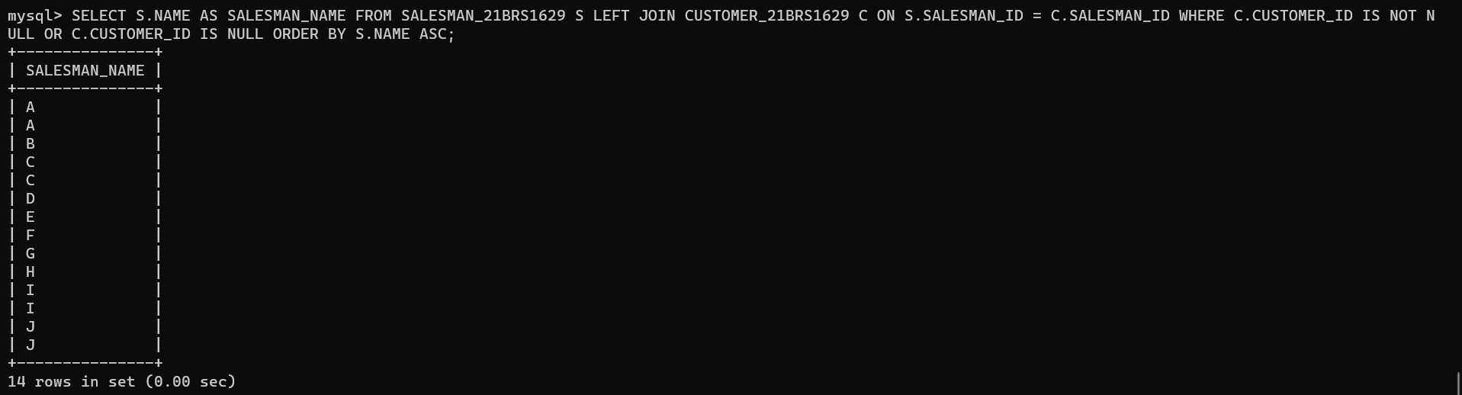

1. **Make a list for the salesmen who work either for one or more customer or not yet join under any of the customers who placed either one or more orders or no order to their supplier.**

# CODE:

SELECT S.NAME AS SALESMAN_NAME FROM SALESMAN_21BRS1629 S LEFT JOIN CUSTOMER_21BRS1629 C ON S.SALESMAN_ID = C.SALESMAN_ID LEFT JOIN ORDER_21BRS1629 O ON C.CUSTOMER_ID = O.CUST_ID WHERE (C.CUSTOMER_ID IS NOT NULL OR C.CUSTOMER_ID IS NULL) AND (O.ORDER_NO IS NOT NULL OR O.ORDER_NO IS NULL) ORDER BY S.NAME ASC;

**OUTPUT**:

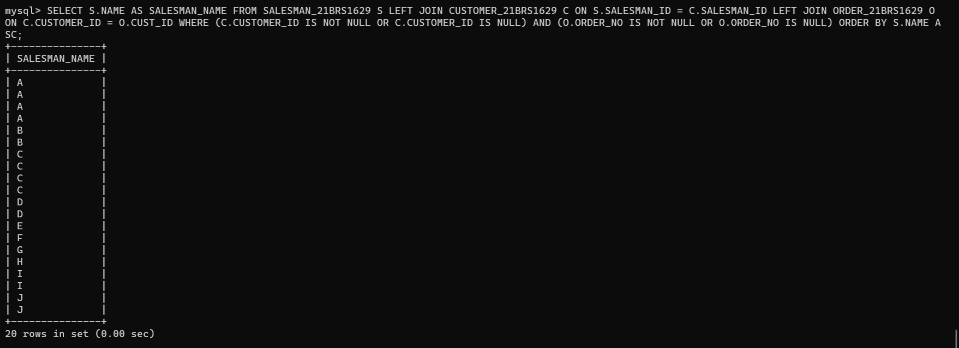

1. **Make a Cartesian product between salesman and customer i.e. each salesman will appear for all customers and vice versa.**

# CODE:

SELECT S.NAME AS SALESMAN_NAME, C.CUST_NAME FROM SALESMAN_21BRS1629 S, CUSTOMER_21BRS1629 C;

**OUTPUT**:

