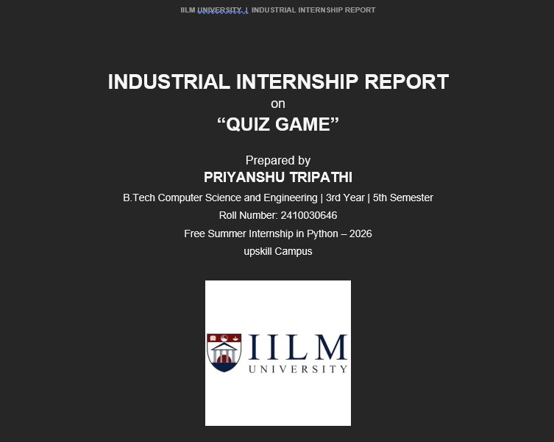

Executive Summary
This report provides details of the Industrial Internship provided by upSkill Campus and The IoT Academy, in collaboration with industrial partner UniConverge Technologies Pvt Ltd (UCT), under the Free Summer Internship in Python – 2026 programme.
This report presents the work completed during my four-week Free Summer Internship in Python – 2026. The internship focused on strengthening Python programming skills through structured learning activities, practical project work, and assessments. The project I developed was a console-based Quiz Game containing five multiple-choice questions. The program displays questions and options, accepts the user's answer, checks the response using conditional logic, tracks the score, calculates the percentage, and displays performance feedback.
The internship also covered Python conditional statements, NumPy, Pandas, and Python assessments. The experience improved my programming logic, problem-solving ability, and confidence in applying Python concepts to a practical application. Overall, it was a valuable opportunity to gain exposure to industry-style, project-based learning.

TABLE OF CONTENTS

1 Preface
The Free Summer Internship in Python – 2026, offered by upSkill Campus and The IoT Academy in association with UniConverge Technologies Pvt Ltd (UCT), was a valuable learning experience that helped me strengthen my programming foundation and understand how Python concepts can be applied to a practical project.
Internships play an important role in career development because they bridge the gap between classroom learning and real, hands-on application. This opportunity allowed me to move beyond theory and build a working piece of software from the ground up.
The internship began with Python learning activities and the selection of the Quiz Game project. This project was chosen because it provides a simple and meaningful way to apply variables, lists, dictionaries, loops, user input, comparisons, and conditional statements.
During the internship, I studied Python fundamentals and conditional statements, including if, if-else, and if-elif-else. I then explored NumPy and Pandas and completed activities related to numerical operations and data manipulation. The fourth week included a Python assessment that helped evaluate my understanding of the topics covered.
The completed Quiz Game contains five multiple-choice questions. It accepts answers in A/B/C/D format, checks each response, updates the score, calculates the percentage, and provides performance feedback based on the final percentage. The programme was successfully completed between 08 August 2026 and 07 September 2026, as confirmed by the certificate of completion below.
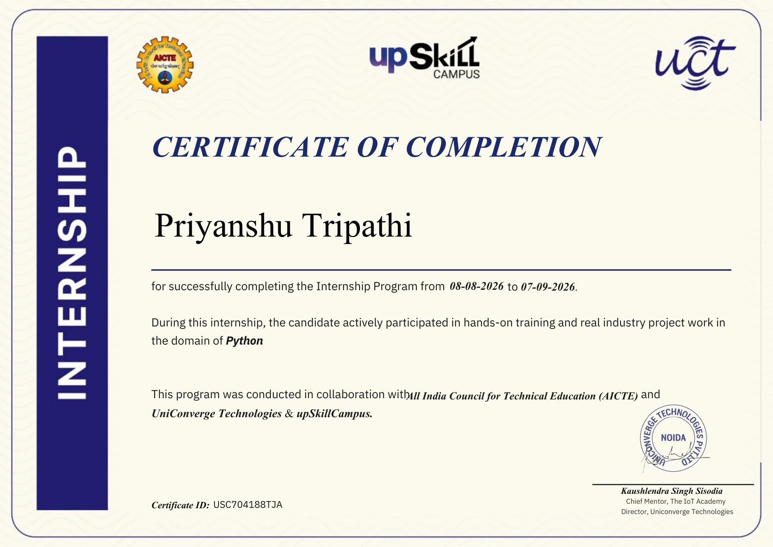
Figure 1: Certificate of Internship Completion – Priyanshu Tripathi (Certificate ID: USC704188TJA)
I am thankful to the internship organizers — upSkill Campus, The IoT Academy, and UniConverge Technologies Pvt Ltd — and to my mentors for providing this opportunity and structured learning resources.
I would recommend juniors and peers to use internships as an opportunity to practice concepts through small projects, because project-based learning makes programming concepts easier to understand and remember.

2 Introduction

2.1 About UniConverge Technologies Pvt Ltd (UCT)
UniConverge Technologies Pvt Ltd (UCT) is a company established in 2013, working in the Digital Transformation domain and providing industrial solutions with a strong focus on sustainability and return on investment (RoI). To develop its products and solutions, UCT leverages a range of cutting-edge technologies, including the Internet of Things (IoT), Cyber Security, Cloud Computing (AWS, Azure), Machine Learning, communication technologies (4G/5G/LoRaWAN), Java full-stack development, Python, and front-end engineering.
UCT's key offerings include the UCT IoT Platform for rapid deployment of IoT applications and business analytics; the Smart Factory Platform for production and asset monitoring, OEE, and predictive maintenance; LoRaWAN-based solutions for Agritech, smart cities, and industrial monitoring; and predictive maintenance solutions that combine embedded systems, industrial IoT, and machine learning.

2.2 About upSkill Campus (USC)
upSkill Campus, along with The IoT Academy and in association with UniConverge Technologies, facilitated the smooth execution of the complete internship process. USC is a career development platform that delivers personalized, industry-aligned learning in an affordable, scalable, and measurable way.
The learning process for this internship included a Python introductory video, the Learning Python e-book, conditional-statement activities, NumPy and Pandas activities, and Python assessments — all of which supported a structured, step-by-step learning journey.

2.3 The IoT Academy
The IoT Academy is the EdTech division of UCT, running long-term executive certification programmes in collaboration with EICT Academies at IIT Kanpur, IIT Roorkee, and IIT Guwahati across multiple technology domains.

2.4 About the Internship
The Free Summer Internship in Python – 2026 was undertaken to develop practical knowledge of Python programming and to apply the concepts learned through a small project. The internship followed a structured, weekly learning process:
- Week 1: Understanding the internship, strengthening Python basics, reviewing project choices, and selecting the Quiz Game.
- Week 2: Conditional statements (if, if-else, if-elif-else).
- Week 3: Introduction to NumPy and Pandas.
- Week 4: Python assessment and revision.
This progression provided a strong foundation for implementing a small console application and helped connect theoretical learning with a practical programming task.
Item | Details
Program | Free Summer Internship in Python – 2026
Organization | upSkill Campus, The IoT Academy & UniConverge Technologies Pvt Ltd
Duration | 08 August 2026 – 07 September 2026 (4 Weeks)
Domain | Python
Project | Quiz Game
Certificate ID | USC704188TJA

2.5 Project Overview
The Quiz Game is a console-based Python application designed to conduct a short multiple-choice quiz. The completed implementation contains five questions, each with four options labelled A, B, C, and D, along with a predefined correct answer.
The program displays each question and its options, receives the user's answer through keyboard input, converts the input to uppercase for consistent comparison, and checks it against the stored answer. A correct response increases the score by one. After all five questions have been attempted, the program displays the total score, calculates the percentage, and provides performance feedback using four categories: Excellent performance, Good performance, Keep practicing, and You need more practice.
Main Features:
- Five multiple-choice questions
- Four answer choices for each question
- Console-based user input
- Automatic answer verification
- Score tracking
- Percentage calculation
- Performance categories based on percentage

2.6 Objectives
- Develop and strengthen Python programming fundamentals.
- Understand decision-making using conditional statements.
- Use loops to process multiple questions.
- Organize question data using Python lists and dictionaries.
- Gain introductory knowledge of NumPy and Pandas.
- Apply Python concepts to a practical Quiz Game project.
- Improve logical thinking and problem-solving ability.
- Evaluate learning through Python assessments.
- Develop a simple and understandable console application.

2.7 Reference
- Python For Data Science – Course for Beginners (internship learning resource).
- Learning Python e-book provided as part of the internship.
- Python conditional statement learning activity.
- Introduction to NumPy and NumPy Operations learning activities.
- Introduction to Pandas and Operations learning activity.
- Python assessment activities completed during the internship.
- Weekly internship progress reports, Weeks 1–4.

2.8 Glossary
Term | Meaning
Python | A high-level programming language used for general-purpose programming.
Quiz Game | An interactive application that asks questions and evaluates user answers.
Conditional Statement | A programming construct used to make decisions based on conditions.
Loop | A programming structure used to repeat a block of code.
List | A Python collection used to store multiple values in an ordered sequence.
Dictionary | A Python data structure that stores data as key-value pairs.
NumPy | A Python library for numerical computing.
Pandas | A Python library commonly used for data manipulation and analysis.
Score | The number of correct answers obtained in the quiz.
Percentage | The score expressed as a percentage of the total number of questions.

3 Problem Statement
The problem addressed by the project is the creation of a simple, interactive quiz application that can present questions, accept user answers, verify the responses, and maintain the user's score.
A conventional manual quiz requires a person to ask questions, receive responses, check answers, and calculate the score. A small software application can automate these repetitive activities and provide immediate feedback.
Functional Requirements:
- Display the quiz title and questions through the console.
- Store multiple questions with options and correct answers.
- Present each question sequentially.
- Accept the user's selected option.
- Compare the user's response with the correct answer.
- Increase the score for every correct response.
- Display the final score after all questions.
- Calculate the final percentage.
- Provide performance feedback according to the percentage.

4 Existing and Proposed Solution

4.1 Existing Approach
A conventional manual quiz requires a person to ask questions, receive responses, check answers, and calculate the result. This process can become repetitive and error-prone when several questions are involved.

4.2 Proposed Solution
The proposed and implemented solution is a Python console-based Quiz Game. Questions, options, and correct answers are stored in a structured list of dictionaries. A loop processes each question, while conditional logic checks the user's answer and updates the score.
Value Addition:
- Automated answer checking.
- Automatic score maintenance.
- Automatic percentage calculation.
- Immediate feedback after each response.
- Simple, easy-to-understand performance categories.
- Clear and readable Python code structure.

4.3 Code Submission (GitHub)
GitHub Repository:
https://github.com/priyanshutripathi-tech/2024-28_Priyanshu_Tripathi_2410030646_5th_semeseter_3CSE4

4.4 Report Submission (GitHub)
The final internship report has been uploaded to the same GitHub repository, as required by the internship submission process.

5 Proposed Design / Model
The Quiz Game follows a simple sequential design. The program initializes the score, loads the question data, processes each question, accepts an answer, checks the answer, updates the score when appropriate, and finally calculates and displays the result.

5.1 High-Level Diagram
START → Initialize score = 0 → Load quiz questions → Display question & options →
Accept user answer → Compare with correct answer → Correct? Yes → increase score →
More questions? Yes → next question / No → Calculate percentage →
Display score & performance category → END
Figure 2: High-Level Flow of the Quiz Game

5.2 Low-Level Design
The question data is organized using a Python list. Each question is represented by a dictionary containing the question text, options, and answer. The options are stored as a list. A for loop iterates through the questions, and another loop displays the options.
The user's response is read using input(). The upper() method standardizes the response to uppercase. An if-else statement compares the response with the stored correct answer, and if they match, the score is increased by one.
After all questions are processed, len(questions) provides the total number of questions. The percentage is calculated from the score and total question count, and a final if-elif-else structure determines the performance message.

5.3 Interfaces
- Input Interface: keyboard input through the console using A/B/C/D.
- Question Interface: text display of the question and four options.
- Feedback Interface: “Correct!” or “Wrong!” message after each response.
- Result Interface: final score, percentage, and performance category.
Example Console Interface:
WELCOME TO QUIZ GAME

What is the capital of India?
A. Mumbai
B. Delhi
C. Kolkata
D. Chennai

Enter your answer (A/B/C/D): B
Correct!

6 Performance Test
The purpose of testing is to verify that the completed Quiz Game performs its main functions correctly. For this small console application, the important constraints are functional correctness, correct score calculation, correct percentage calculation, and consistent user interaction.

6.1 Test Plan / Test Cases
TC | Test Case | Expected Result | Status
TC01 | Start program | Welcome message and quiz appear | Pass
TC02 | Select correct option | “Correct!” displayed and score increases | Pass
TC03 | Select incorrect option | “Wrong!” displayed and score unchanged | Pass
TC04 | Complete all 5 questions | Quiz ends after all questions | Pass
TC05 | Check final score | Score displayed out of 5 | Pass
TC06 | Check percentage | Percentage calculated correctly from score | Pass
TC07 | Score ≥ 80% | “Excellent performance” displayed | Pass
TC08 | Score 60–79% | “Good performance” displayed | Pass
TC09 | Score 40–59% | “Keep practicing” displayed | Pass
TC10 | Score < 40% | “You need more practice” displayed | Pass

6.2 Test Procedure
- Run the Python program in VS Code.
- Confirm that the welcome message is displayed.
- Verify that each question appears with four options.
- Enter a correct option and verify that the score increases.
- Enter an incorrect option and verify that the score does not increase for that question.
- Continue until all five questions are answered.
- Verify the final score and total number of questions.
- Verify that the percentage is calculated correctly from the score.
- Verify that the appropriate performance category is displayed.

6.3 Performance Outcome
The completed program satisfies all core functional requirements: it displays five multiple-choice questions, accepts answers, checks them, tracks the score, calculates the percentage, and displays performance feedback.
The application is lightweight and does not require an external database, network service, or large data-processing component. The main performance considerations are therefore functional correctness, simplicity, and responsive console interaction.
The internship also included a Python assessment during Week 4, which provided an additional opportunity to evaluate my understanding of the Python concepts used in the project.

7 My Learnings
The internship improved my understanding of Python and helped me connect individual programming concepts with a complete, small application.
Learning Area | Outcome
Python Fundamentals | Improved understanding of Python syntax, variables, input/output, data structures, and program flow.
Conditional Statements | Learned to use if, if-else, and if-elif-else for decision-making and answer verification.
Loops | Understood how loops can process multiple questions without repeating code manually.
Lists and Dictionaries | Learned how structured question data can be stored and accessed.
NumPy | Gained introductory knowledge of numerical computing and basic array operations.
Pandas | Gained introductory knowledge of data manipulation and basic operations.
Problem Solving | Improved logical thinking by converting requirements into program steps.
Testing | Learned the importance of checking inputs and validating results.
Project Development | Gained experience in turning a project idea into a working console application.

These skills will support my future academic projects and help me approach programming tasks in a more structured manner.

8 Future Work Scope
The current Quiz Game provides the basic functionality required for a console-based quiz. Several improvements can be added in the future to make the application more interactive, flexible, and user-friendly:
- Increase the number of questions and maintain them in an external file.
- Add more quiz categories such as Science, Technology, General Knowledge, and Programming.
- Add difficulty levels such as Easy, Medium, and Hard.
- Randomize the order of questions and options.
- Add input validation for invalid entries.
- Add a timer for each question.
- Store user scores and quiz history.
- Develop a graphical user interface using a suitable Python GUI framework.
- Add user profiles and a leaderboard in a future version.
- Perform broader testing with more users and larger question sets.

Conclusion
The four-week internship provided practical exposure to Python programming and helped me apply learned concepts to the development of a Quiz Game. The completed project demonstrates the use of structured data, loops, conditional statements, user input, score tracking, percentage calculation, and performance feedback. The internship also introduced NumPy and Pandas and included assessment-based learning.
Overall, the experience strengthened my technical foundation and provided a useful starting point for more advanced Python projects.
GitHub Repository:
https://github.com/priyanshutripathi-tech/2024-28_Priyanshu_Tripathi_2410030646_5th_semeseter_3CSE4

Annexure: Certificate of Internship Completion
Certificate ID: USC704188TJA | Issued by UniConverge Technologies Pvt Ltd, in collaboration with AICTE, upSkill Campus & The IoT Academy

