Wireless Communication
Project Report

Handoff Simulation for Static and UAV-Based Mobile Base Stations
User Mobility across two cells
(RSS based decision)

By

Priyanshu Srivastava
S20230020339
Yogeshwar B.
S20230020284
Aim

- To simulate handoff for a user travelling between two different cells (base-stations) and visually depict the handoff process and the Received Signal Strength (RSS).

- To design and simulate a UAV-assisted 5G mobile communication environment in which mobile aerial base stations dynamically support user connectivity, and to analyse the handoff performance using an RSS-based decision mechanism under realistic mobility, path loss, and shadowing conditions.

Objectives

Stationary Base Stations
- Read papers on Handoff
- Choose appropriate method for simulation (Log Distance Path-Loss)
- Write Python code for handoff simulation
- Visually depict the results using graphs

UAV Mobile Base Stations
- Represent two UAVs acting as mobile aerial base stations with controlled movement inside circular patrol zones.
- Use a log-distance path loss model that includes reference path loss, distance-dependent attenuation, and shadow fading.
- Implement a hard handoff algorithm using RSS comparison with hysteresis to reduce ping-pong effects.
- Plot UAV paths, user trajectory, and handoff locations on a spatial map.
- Introduce log-normal shadowing to observe its influence on RSS fluctuations and handoff stability.
Introduction

This project presents a simulation of a handoff process based on Received Signal Strength (RSS) for a mobile user moving between two cell towers. The primary goal is to model and analyse how a mobile device maintains seamless connectivity by transferring its session from one base station to another without interruption. The simulation utilizes a log-distance path loss model to realistically calculate the diminishing signal strength as the user moves away from a base station. Initial results demonstrate an idealized handoff scenario, where the decision to switch cells is based solely on the user's position and the corresponding path loss.

Unmanned Aerial Vehicles (UAVs) are emerging as an essential part of next-generation (5G/6G) wireless communication networks. Because UAVs can dynamically position themselves in the air, they act as aerial base stations capable of extending coverage, improving line-of-sight connectivity, and supporting users in remote or emergency environments.
However, UAV-based communication introduces new challenges:
- UAVs themselves are mobile and follow unpredictable flight paths.
- Users on the ground move across coverage regions.
- Wireless channels experience path loss, shadowing, and fading, causing continuous fluctuations in signal strength.
- As the user travels, the network must decide when to switch (handoff) from one UAV to another without disrupting service.

This project simulates a complete UAV handoff scenario using Python. Two UAV base stations patrol within predefined circular zones, while a user moves along a path. At each time step, the simulation computes the received signal strength (RSS) using a log-distance path loss model combined with random shadowing effects. A hysteresis-based decision algorithm determines whether a handoff should occur to avoid ping-pong switching. Finally, the project visualizes the RSS, signal difference, serving cell, and the entire spatial movement of UAVs and the user.
This simulation demonstrates how mobility patterns, channel variations, and handoff algorithms jointly affect the quality and continuity of communication in UAV-assisted wireless networks.

Equipment/software needed
1. Python 3.x
Used for implementing UAV mobility, radio propagation modelling, RSS calculation, handoff logic, and visualization of system performance.
2. Python Libraries Used
a. NumPy – for numerical computations, distance calculations, random direction generation, and vector-based mobility modelling.
b. Matplotlib – for generating RSS plots, handoff detection graphs, and spatial trajectory maps of UAVs and the user.
3. Development Environment
Any Python IDE (e.g., Visual Studio Code)– used to write, execute, debug, and visualize the simulation outputs.

Background

In modern wireless communication, handoff is the critical process of transferring an ongoing call or data session from one cell tower to another without interrupting the service. Ensuring this seamless connectivity is vital for user satisfaction, especially for real-time applications like video calls and online gaming, where disruptions can be significant.

The handoff decision is guided by the Received Signal Strength (RSS), a key metric that measures the quality of the connection between a mobile device and a base station. As a user moves, the system monitors the RSS from nearby base stations to determine the optimal connection point, as illustrated in the figure below.

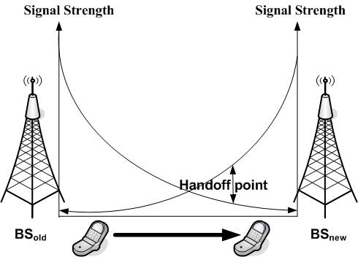

However, several challenges can complicate this process:
- Path Loss: Signal strength naturally weakens as the distance between the user and the base station increases, which can degrade connection quality.
- Multipath Propagation and Rayleigh Fading: Signals often travel along multiple paths to reach a receiver due to reflections off buildings and other objects. This causes interference and rapid fluctuations in signal amplitude, a phenomenon known as Rayleigh fading.
- Ping-Pong Effect: If the handoff criteria are too sensitive, a device on the boundary of two cells might switch back and forth frequently between them. This is mitigated by using a hysteresis margin, which introduces a threshold to prevent unnecessary handoffs.

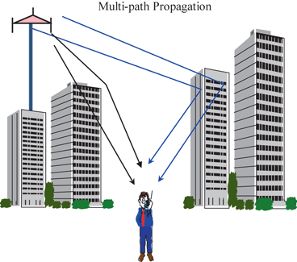

System Model

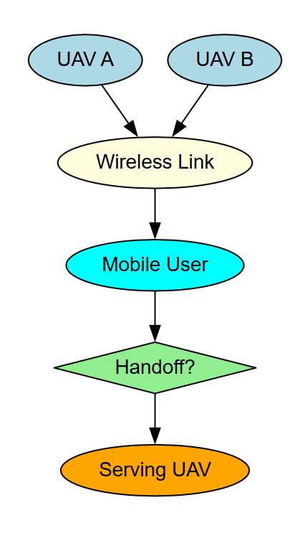

1. UAV A and UAV B (Aerial 5G Base Stations)
These are flying base stations that provide wireless coverage from the sky. Each UAV moves within a defined patrol zone. Their positions change over time, causing their coverage areas to shift dynamically.

2. Wireless Link (UAV ↔ User Communication)
The mobile user continuously receives wireless signals from both UAV A and UAV B.
The user's device measures radio parameters such as received signal strength, path loss, fading, and distance to each UAV.
This block represents the ongoing signal communication between the user and both UAVs.

3. Mobile User
The user moves along a path on the ground. As they move, the quality of the signals received from the two UAVs changes. Sometimes UAV A provides better coverage, and sometimes UAV B does, depending on distance and movement.

4. Handoff Decision (Handoff?)
At each moment, the user (or network) compares the signal strengths from both UAVs.
A handoff is triggered only if:
- The other UAV provides stronger signal quality, and
- The improvement exceeds a defined hysteresis margin to avoid unnecessary switching.
This block represents the intelligence of the system that decides when a change of serving UAV is necessary.

5. Serving UAV
Based on the decision:
- If the current UAV still provides better service, the user remains connected.
- If the other UAV offers significantly better signal quality, the user hands off to that UAV.
This block represents which UAV (A or B) is currently serving the user after the decision is made.

Mathematical framework

1. 3D Distance Calculation
The 3D Euclidean distance between the user and a UAV is calculated as:
$$d=\sqrt{(x_{u}-x_{UAV})^{2}+(y_{u}-y_{UAV})^{2}+(z_{u}-z_{UAV})^{2}}$$
Where:
- $(x_{u},y_{u},z_{u})$= user position
- $(x_{UAV},y_{UAV},z_{UAV})$= UAV position

2. Log-Distance Path Loss Model
The received signal strength (RSS) from a UAV is computed using the log-distance path loss model with shadowing:

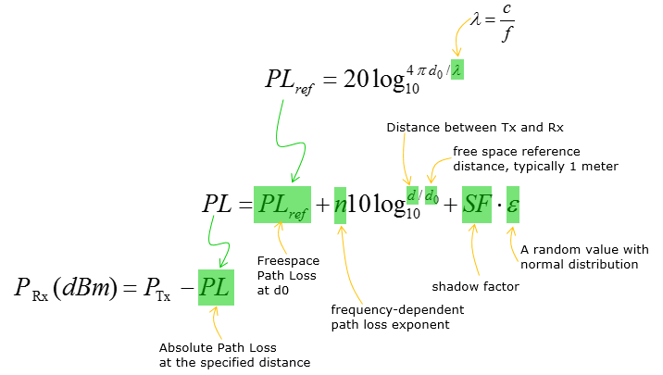

3. Handoff Decision Criterion
A hysteresis-based handoff ensures stable cell association:
$$\text{If serving UAV = A:}RSS_{B}>RSS_{A}+H ⟹\text{ handoff to B} \\ \text{If serving UAV = B:}RSS_{A}>RSS_{B}+H ⟹\text{ handoff to A}$$
Where:
- $H$= hysteresis margin (dB)
- Prevents unnecessary ping-pong switching due to small RSS fluctuations

4. UAV Mobility Constraint
UAVs move within a circular patrol zone of radius $R$centered at anchor $(x_{c},y_{c})$:
$$\text{If }\sqrt{(x_{UAV}-x_{c})^{2}+(y_{UAV}-y_{c})^{2}}>R,\text{ then redirect UAV toward center}$$
- Ensures UAVs remain within the defined coverage area.
- Direction can change randomly to simulate realistic patrolling.

Simulation Framework

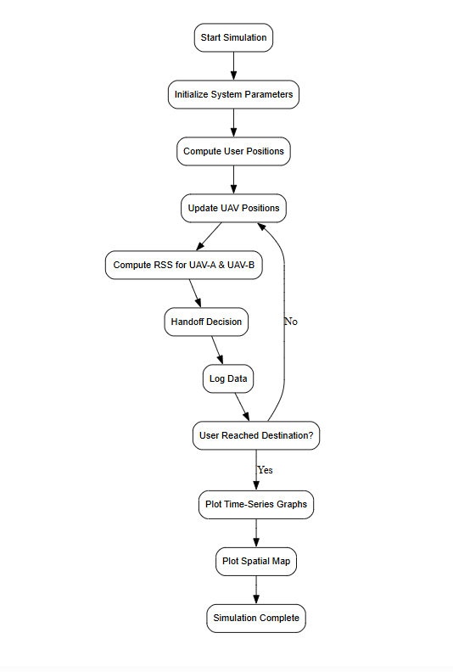

Graphs/Results

Stationary Base Stations
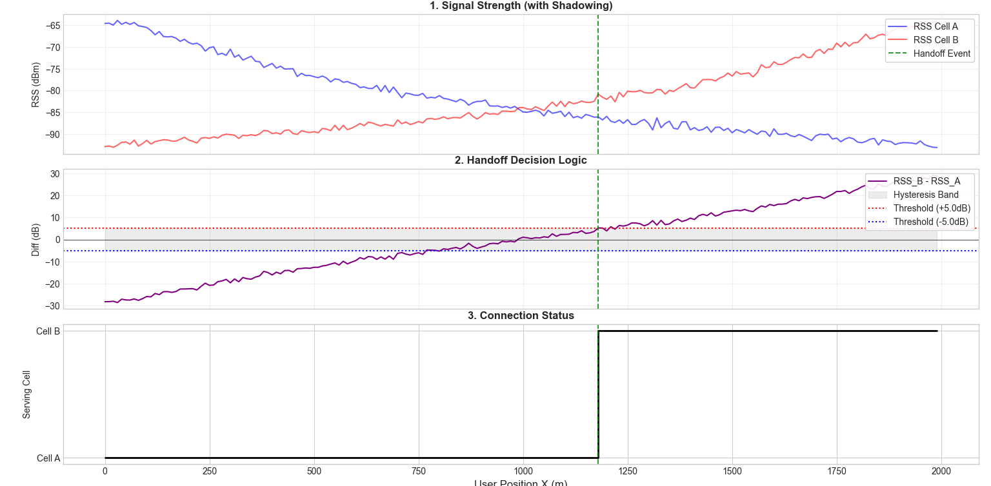

Signal Strength (1): Shows the signal strength. The Blue line (Cell A) drops and the Red line (Cell B) rises as the user moves. The lines are "noisy" to simulate real-world interference.

Handoff Logic (2): This is the decision maker. It waits for Cell B to be 5 dB stronger than Cell A (crossing the red dotted line) before switching. This delay (the grey band) prevents rapid disconnecting/reconnecting.

Connection Status (3): Shows the actual connection. The user stays connected to Cell A until the signal is clearly better, resulting in a single, clean switch to Cell B.

UAV Mobile Base Stations

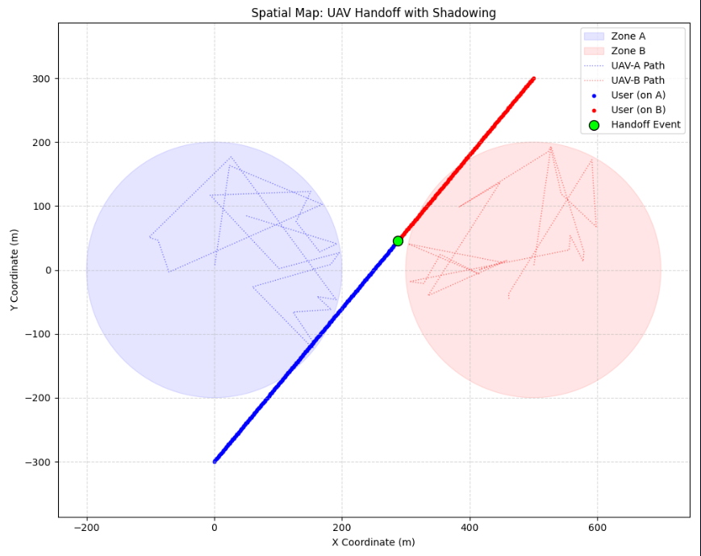

This plot shows the positions and movement paths of UAV-A and UAV-B along with their circular coverage zones.
The user moves along a diagonal path, initially connected to UAV-A (blue) until the signal from UAV-B becomes stronger.
The green marker indicates the exact position where the handoff occur

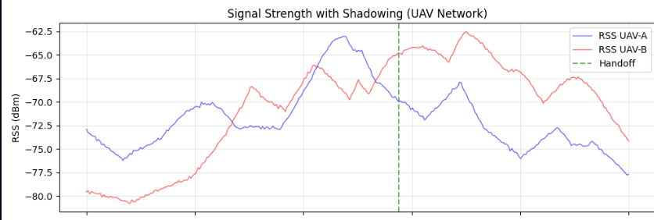

This graph compares the received signal strength from UAV-A and UAV-B as the user moves.
Fluctuations occur due to distance changes and shadow fading.
The vertical dashed line marks the point where UAV-B’s signal surpasses UAV-A sufficiently to trigger a handoff.

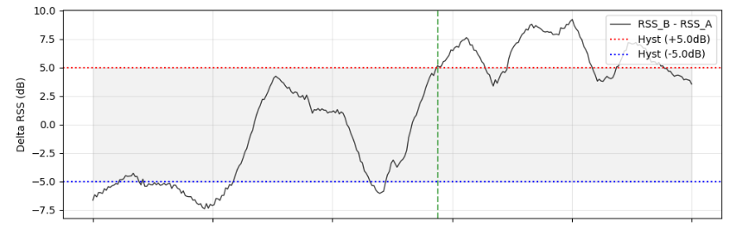

This graph compares the received signal strength from UAV-A and UAV-B as the user moves.
Fluctuations occur due to distance changes and shadow fading.
The vertical dashed line marks the point where UAV-B’s signal surpasses UAV-A sufficiently to trigger a handoff.

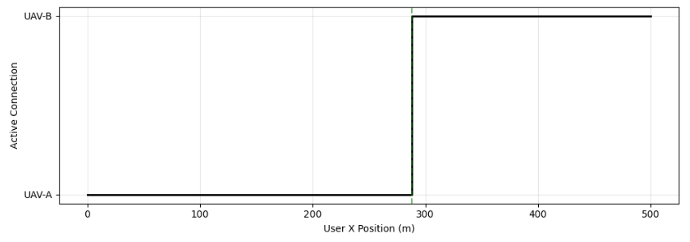

This step graph shows which UAV is serving the user at every point on the path.
The connection stays with UAV-A until the handoff event, after which the user switches to UAV-B.
The sharp transition represents the exact moment, the handoff is executed.

Conclusion
- Our project successfully models stationary base-stations and UAV-assisted wireless coverage with RSS-based handoff.
- We plot graphs for stationary base station network for the RSS, Handoff Decision and the Connection Status.
- We also plot a spatial map for better visualisation of the UAV movement.
- It demonstrates seamless connectivity and UAV mobility within patrol zones.

References
Handoff Paper1
Handoff Paper2
UAV Handoff Paper1

