Grafana itself doesn’t store data. Each panel explicitly defines a data source.
In this dashboard, some of usage tables are backed by a postgresql database and some of are from direct backend server's APIs, while activity graphs are driven by time-series data from Postgressql.

- It sends queries to the configured db
- Receives structured results
- and display them as a table or graghs
- Does not store or modify the underlying data

- Analytics city data :

in which,

This dashboard panel retrives analytical data from a clickhouse db using graphana. that executes SQL queries against website_views table to visualize the website and location based data.

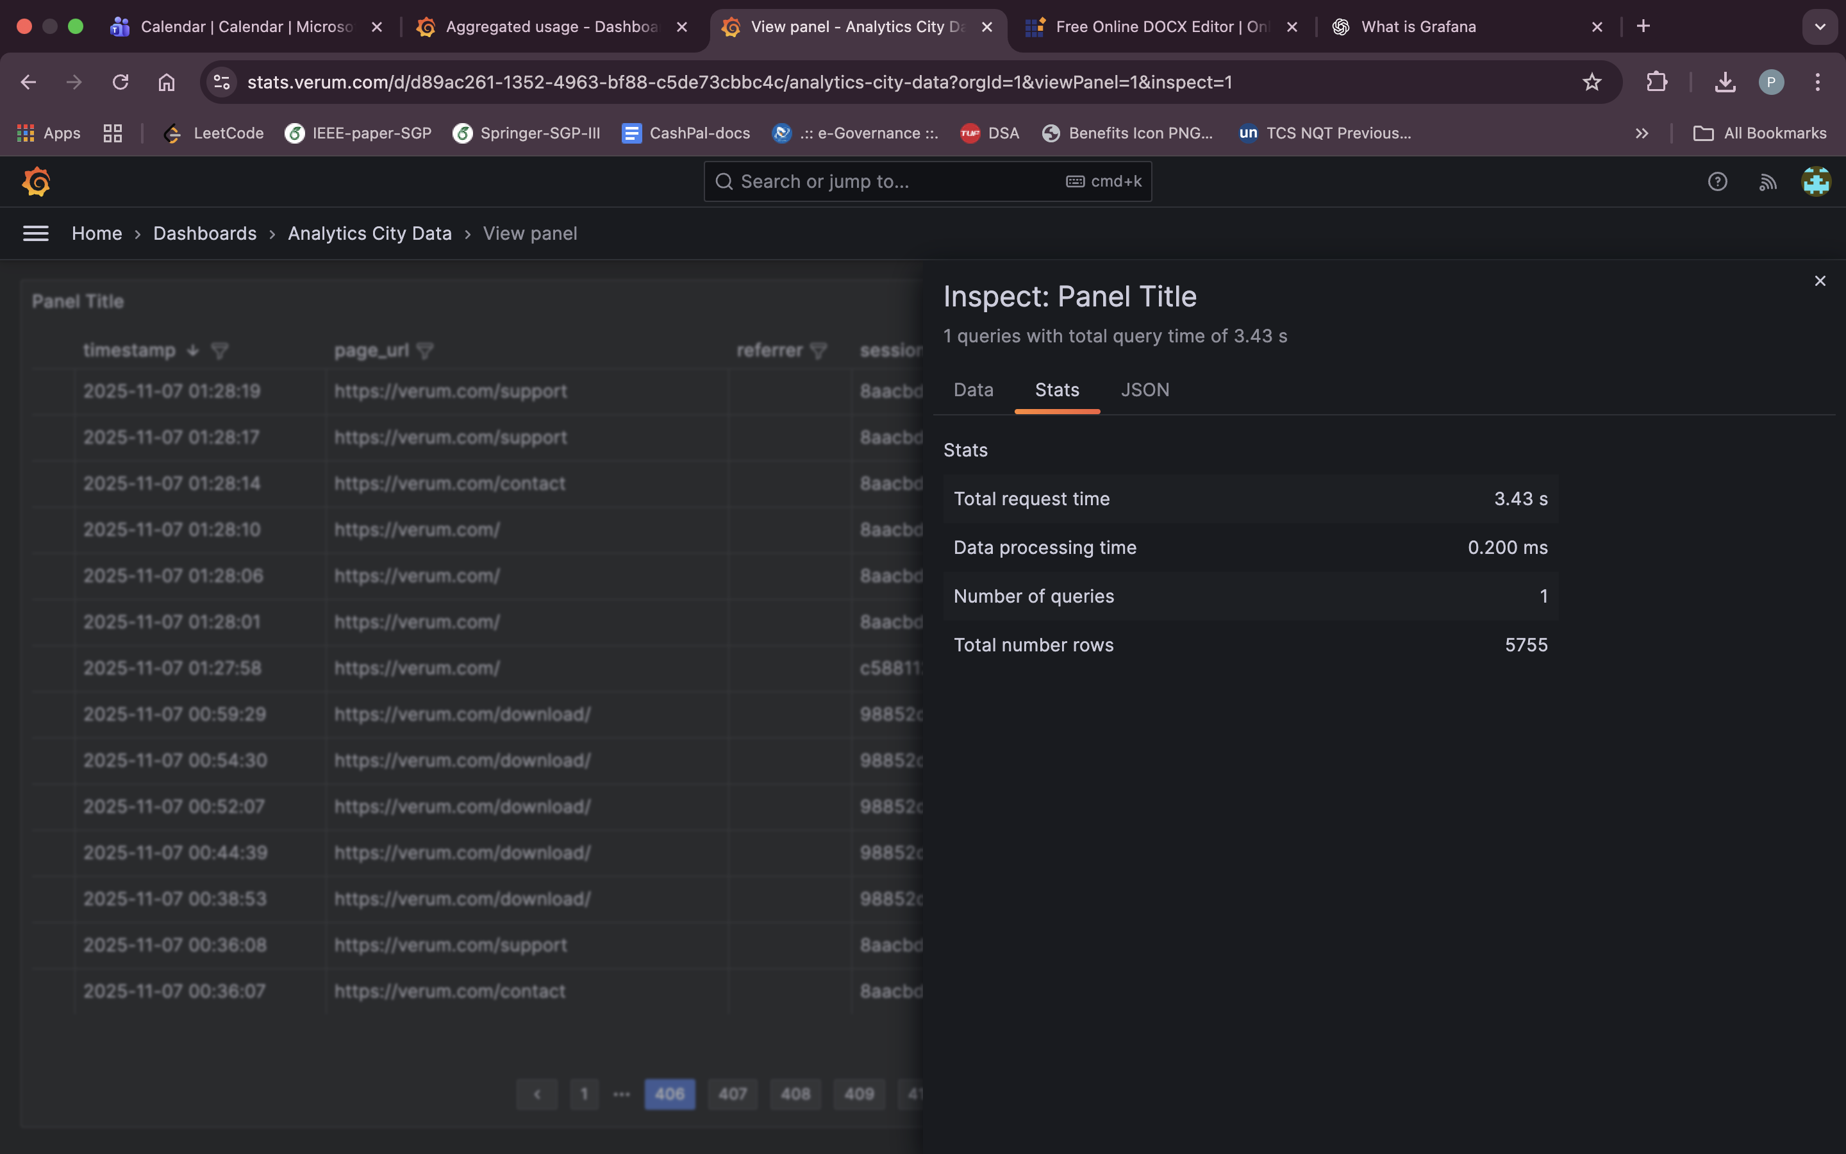

- API Monitor
that includes Contact API and API monitoring, so for that data source is: verum.com server from which they are using direct json data from REST APIs like: api/monitoring/metrics
in contact api data source is: https://verum.com/api/monitoring/metrics

- Capgemini: User data monitoring

it is a dashboard designed to monitor and analyze product usage for a specific customer organization. It provides visibility into user activity, unique users and overall adoption trends over a selected time range.

- Email Dashboard
This dashboard retrieves data using Grafana’s JSON API data source (from REST API)

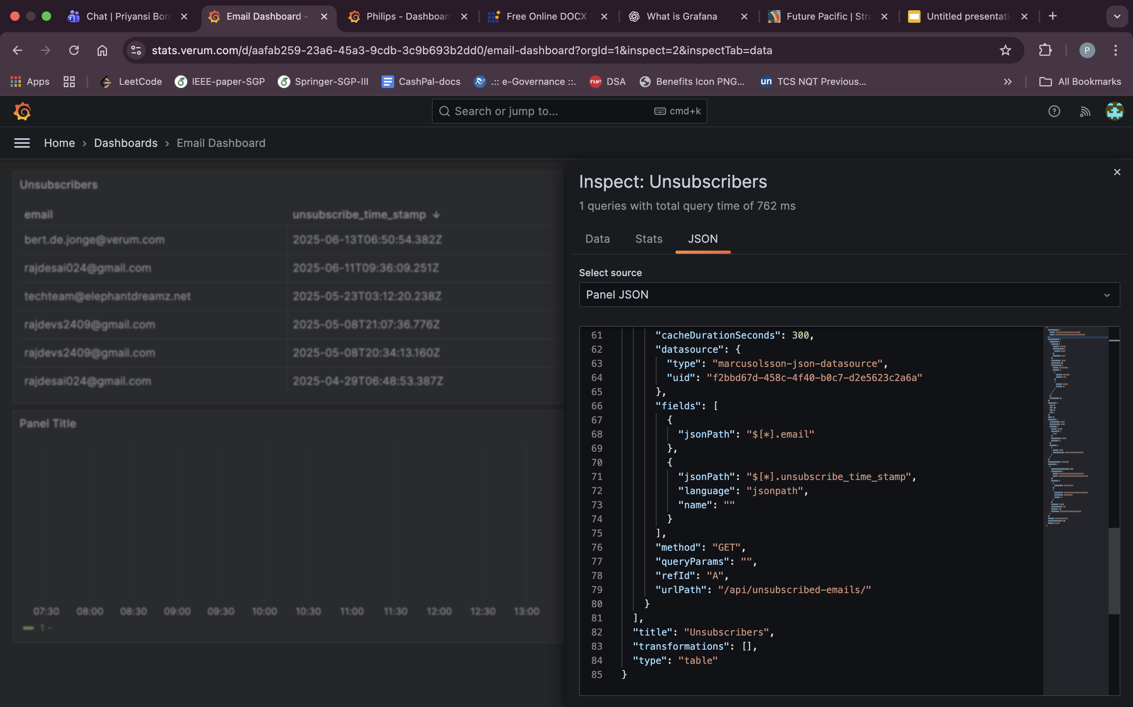

- Future (Pacific Enterprise)

it also use data from postgresql db using roe SQL queries.

- Kulicke & soffa

Kulicke & Soffa is known for pioneering products in electronic assembly equipment and packaging
solutions. and they are connected to us (our commercial users) and using 2.18 version.

so from this dashboard, we can track their user activity on dezyne and active user counts.

- MOBA

The MOBA Usage Dashboard is a Grafana dashboard that provides visibility into how users from MOBA interact with the product over time. The dashboard tracks user activity, product version usage, and engagement trends for this commercial customer.
- Nearfield instruments
they are curently using 2.14.0 version of Dezyne and using perticular data from postgresql server using query and showing on the table form and graph form also.

- Philips
same using postgresql db and using row sql queries it is showing perticular data of users and version.

- Thermofisher
they are the current commercial users, that using Dezyne 2.18.3 nowadays

- Aggregated useage
In which, they displays commercial and trial users data from postgresql db and representing in graph and tabular form.

