Competitor Research – Flooring Store UI/UX
Patterns Observed
- Clear product categories
- Powerful filtering options
- Large product images
- Product comparison features
- Easy quote/request process
- Store locator and contact information visible
- Customer reviews on product pages
Inspiration: 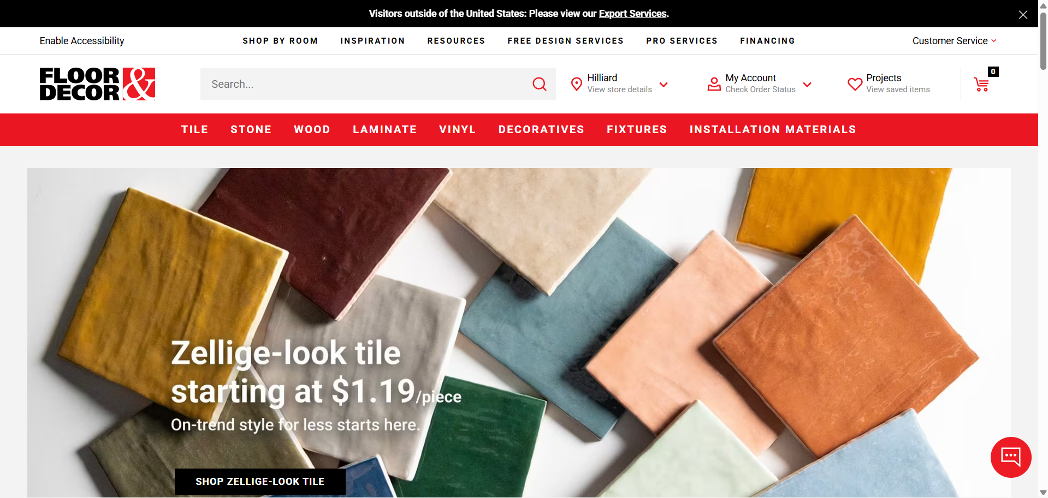
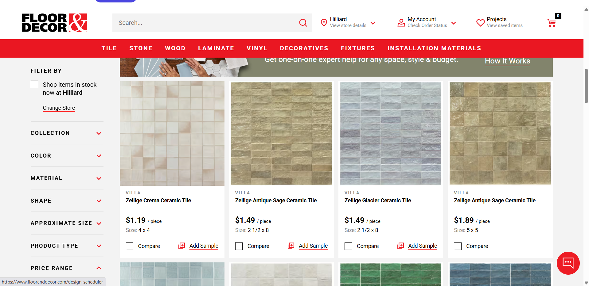
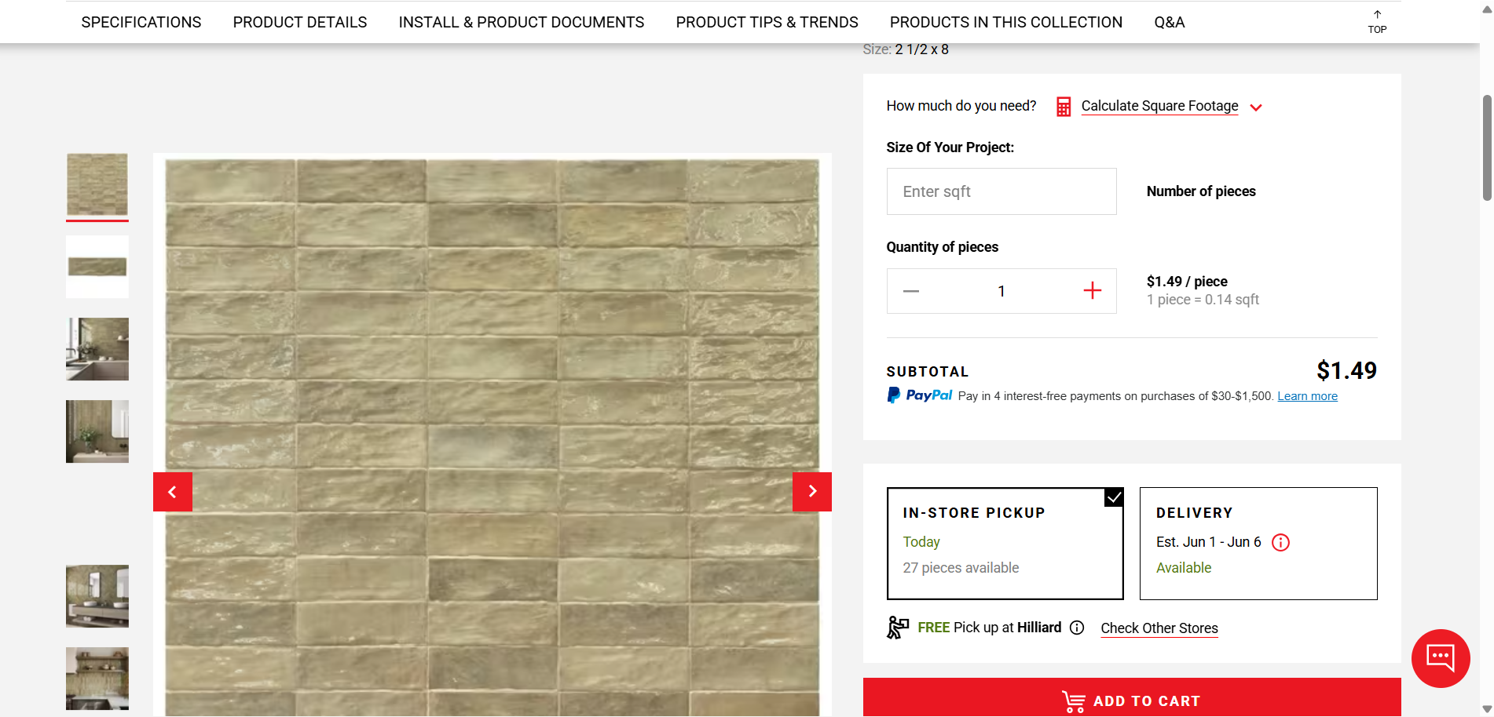
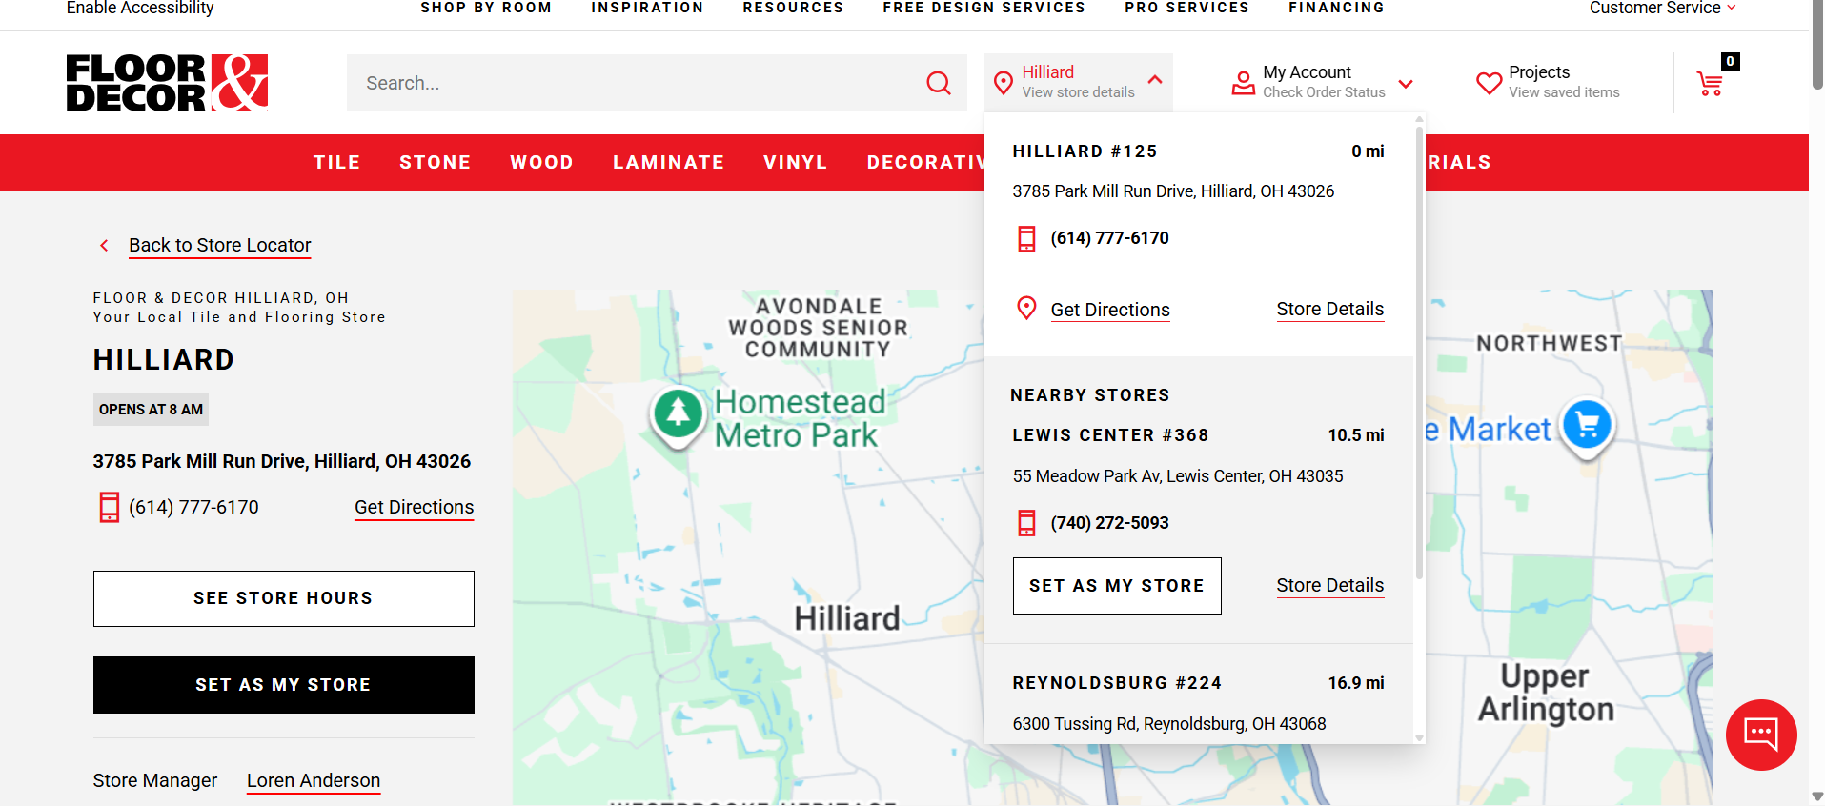
- Do List:
Use clear product categories
Provide advanced filters
Use high-quality flooring images
Make quote requests easy
Display contact information clearly
Ensure mobile-friendly design
- Don't List:
Avoid cluttered layouts
Avoid complicated forms
Avoid hidden navigation
Avoid excessive popups
Avoid inconsistent colors and typography
Avoid slow-loading pages

