1. Create ‘Gradle’ type project in eclipse.

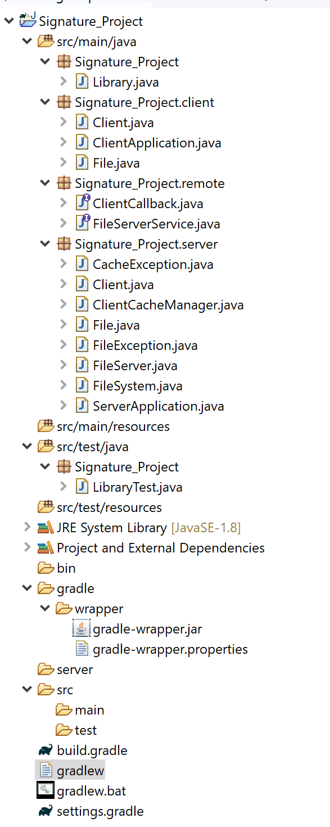

1. Set JAVA_HOME variable in control panel -> system and security -> system -> Advanced system settings -> Advanced -> Environment variables.

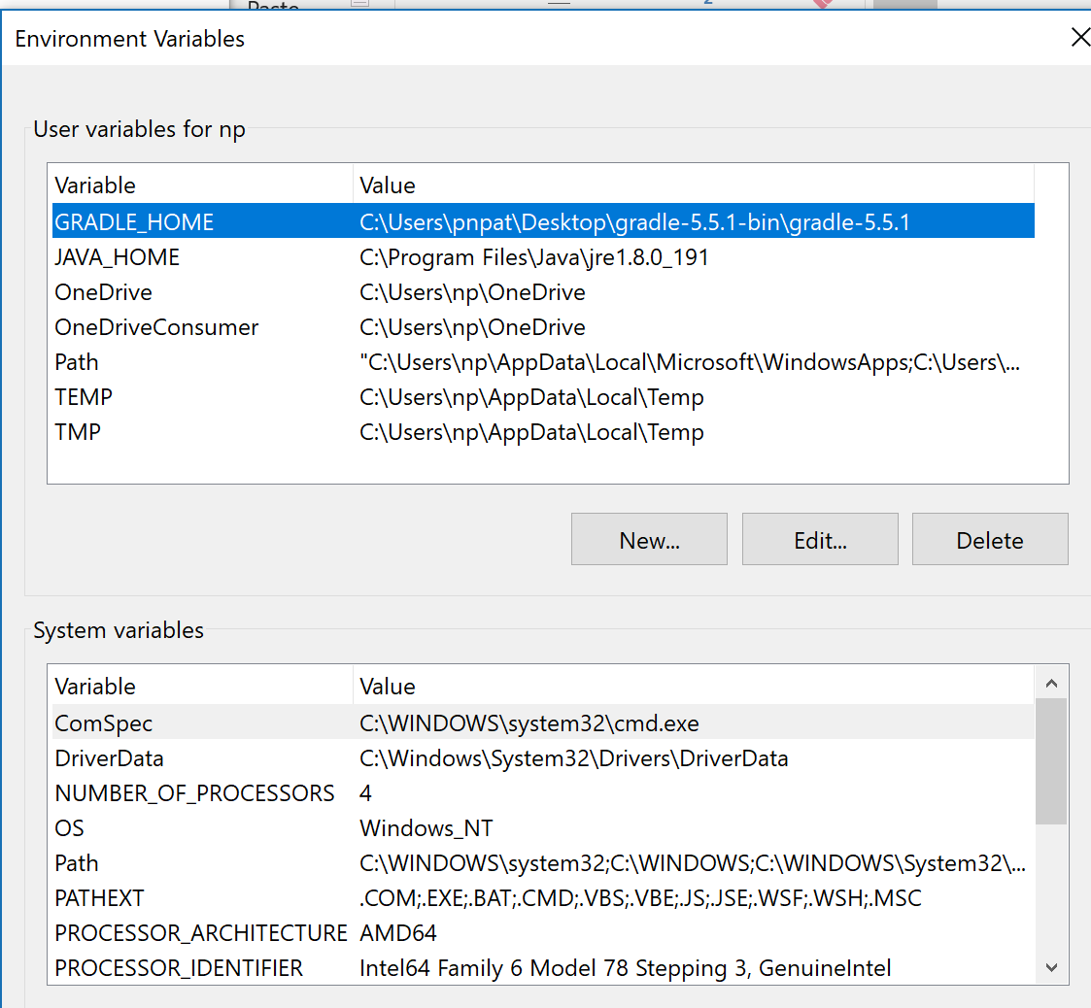

Check the path variable make sure it is correct according to your java jdk and jre path.

java -jar client.jar

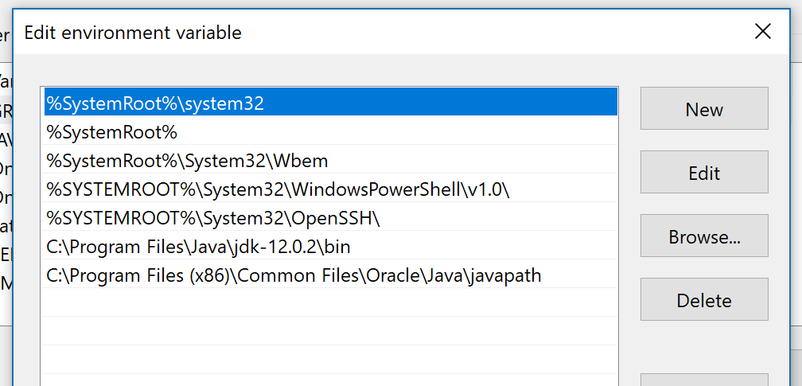

1. In CMD run following commands:

C:\Users\Priya\eclipse-workspace\gradle_project\Signature_Project \gradlew clean

C:\Users\Priya\eclipse-workspace\gradle_project\Signature_Project \gradlew jarServer

C:\Users\Priya\eclipse-workspace\gradle_project\Signature_Project \gradlew jarClient

Jar are ready to use.

C:\Users\Priya\eclipse-workspace\gradle_project\Signature_Project\build\libs >java -jar server.jar

Open another cmd and run

C:\Users\Priya\eclipse-workspace\gradle_project\Signature_Project\build\libs >java -jar client.jar

Server and client are ready to use.

After server and client are running perfectly, we need to perform create, delete, update on a file or something (as per project document).

So, in the client window just type 'help' it will show the list of all operations that are allowed. We need to run all these operations.

(e.g, create a text file, modify it, delete it, etc.)

Below is the sample of just one command, we need to perform all the operations and need to understand it very well (how it is working - client-server communication).

