Vehicle Rental System

CREATE DATABASE VehicleRentalSystem;
USE VehicleRentalSystem;

Creating tables

Customer Table
CREATE TABLE Customer (
customer_id INT PRIMARY KEY
CustomerName VARCHAR(50),
phone VARCHAR(15),
LicenseNoVARCHAR(200)
);
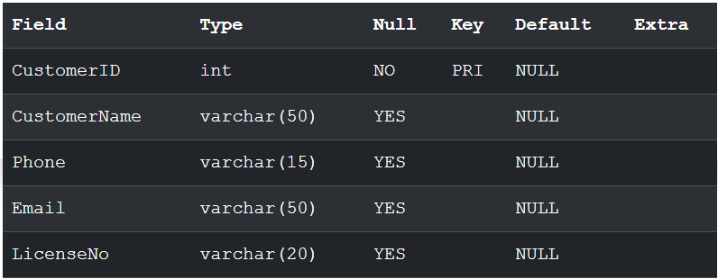

Vehicle Table
CREATE TABLE Vehicle (
VehicleID INT PRIMARY KEY,
VehicleModel VARCHAR(50),
VehicleType VARCHAR(20),
RentalRate DECIMAL(10,2),
Status VARCHAR(20)
);
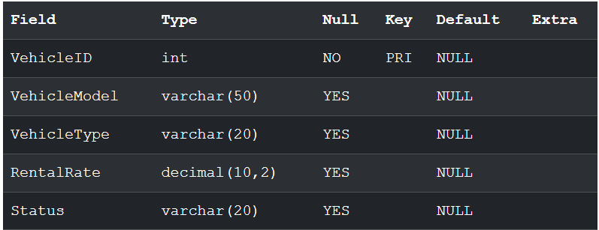

Booking Table
CREATE TABLE Booking (
BookingID INT PRIMARY KEY,
CustomerID INT,
VehicleID INT,
BookingDate DATE,
FOREIGN KEY (CustomerID) REFERENCES Customer(CustomerID),
FOREIGN KEY (VehicleID) REFERENCES Vehicle(VehicleID)
);
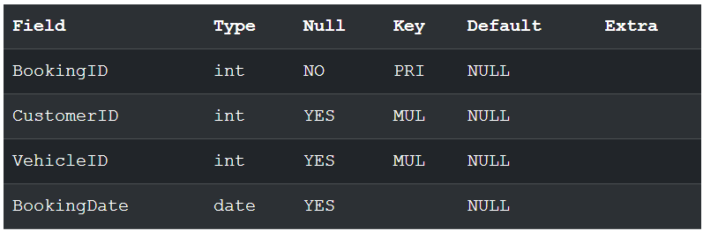

Rental Table
CREATE TABLE Rental (
RentalID INT PRIMARY KEY,
BookingID INT,
StartDate DATE,
EndDate DATE,
TotalAmount DECIMAL(10,2),
FOREIGN KEY (BookingID) REFERENCES Booking(BookingID)
);
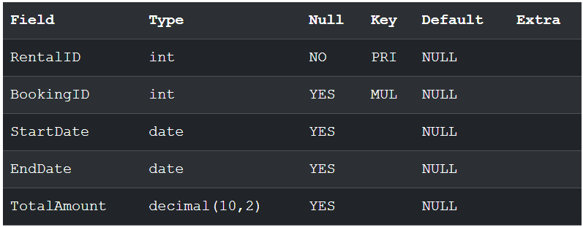

Payment Table
CREATE TABLE Payment (
PaymentID INT PRIMARY KEY,
RentalID INT,
Amount DECIMAL(10,2),
PaymentDate DATE,
PaymentMethod VARCHAR(20),
FOREIGN KEY (RentalID) REFERENCES Rental(RentalID)
);
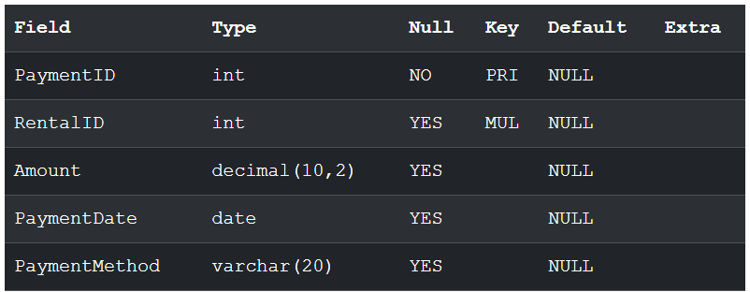

Maintenance Table
CREATE TABLE Maintenance (
MaintenanceID INT PRIMARY KEY,
VehicleID INT,
MaintenanceDate DATE,
Description VARCHAR(100),
Cost DECIMAL(10,2),
FOREIGN KEY (VehicleID) REFERENCES Vehicle(VehicleID)
);
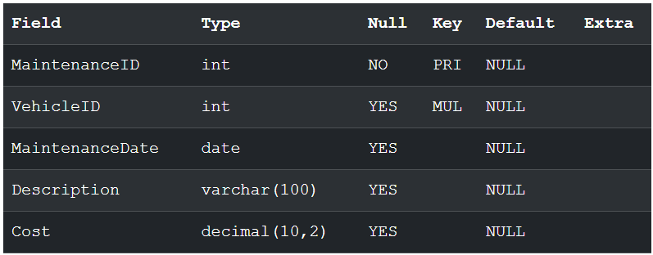

Insert Data into Tables

Customer Table
INSERT INTO Customer VALUES
(1,'Rahul Sharma','9876543210','rahul@gmail.com','DL1001'),
(2,'Priya Patel','9876543211','priya@gmail.com','DL1002'),
(3,'Amit Verma','9876543212','amit@gmail.com','DL1003'),
(4,'Sneha Rao','9876543213','sneha@gmail.com','DL1004'),
(5,'Karan Singh','9876543214','karan@gmail.com','DL1005');
select * from customer;
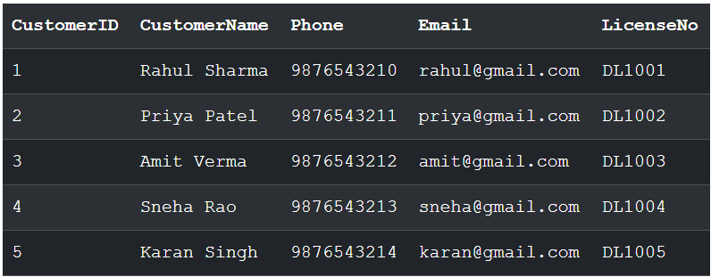

Vehicle Table
INSERT INTO Vehicle VALUES
(101,'Hyundai Creta','SUV',2500,'Available'),
(102,'Honda City','Sedan',2200,'Available'),
(103,'Toyota Innova','MPV',3500,'Available'),
(104,'Royal Enfield 350','Bike',1000,'Available'),
(105,'Mahindra Thar','SUV',4000,'Available');
SELECT * from vehicle;
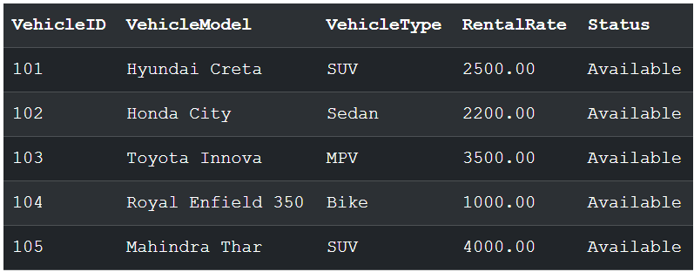

Booking Table
INSERT INTO Booking VALUES
(201,1,101,'2025-06-01'),(202,2,101,'2025-06-02'),(203,3,101,'2025-06-03'),(204,4,101,'2025-06-04'),(205,5,101,'2025-06-05'),(206,1,101,'2025-06-06'),(207,2,101,'2025-06-07'),(208,3,101,'2025-06-08'),(209,4,105,'2025-06-09'),(210,5,105,'2025-06-10'),(211,1,105,'2025-06-11'),(212,2,105,'2025-06-12'),(213,3,105,'2025-06-13'),(214,4,105,'2025-06-14'),(215,5,105,'2025-06-15'),(216,1,105,'2025-06-16'),(217,2,102,'2025-06-17'),(218,3,102,'2025-06-18'),(219,4,102,'2025-06-19'),(220,5,103,'2025-06-20'),(221,1,103,'2025-06-21'),(222,2,104,'2025-06-22'),(223,3,104,'2025-06-23');
SELECT * from Booking;
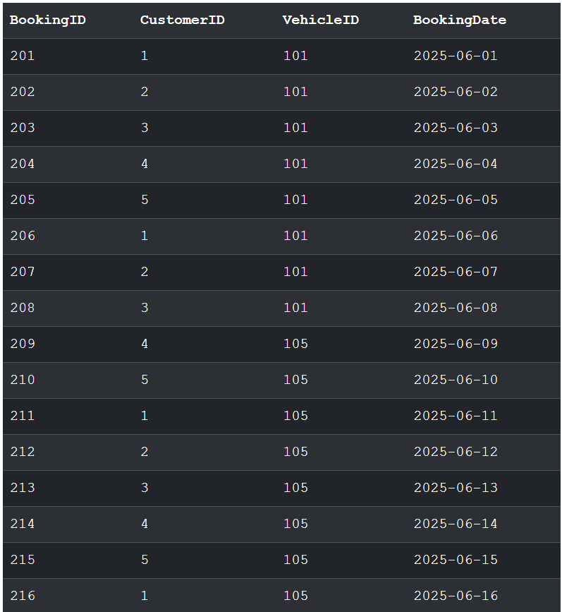
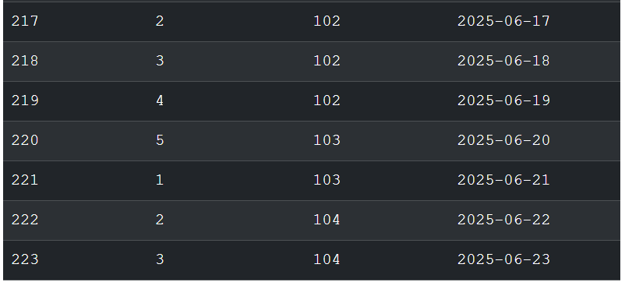

Rental Table
INSERT INTO Rental VALUES
(301,201,'2025-06-01','2025-06-05',10000),
(302,202,'2025-06-02','2025-06-04',4400),
(303,203,'2025-06-03','2025-06-08',17500),
(304,204,'2025-06-04','2025-06-06',2000),
(305,205,'2025-06-05','2025-06-10',20000);
SELECT * from Rental;
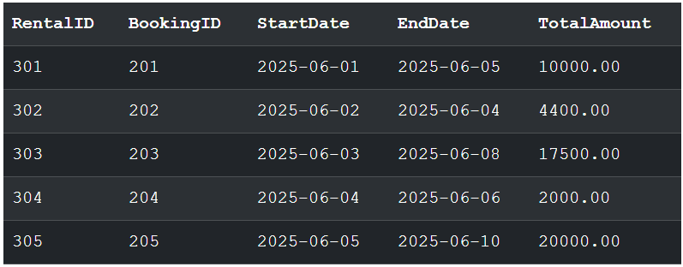

Payment Table
INSERT INTO Payment VALUES
(401,301,10000,'2025-06-05','UPI'),
(402,302,4400,'2025-06-04','Card'),
(403,303,17500,'2025-06-08','Cash'),
(404,304,2000,'2025-06-06','UPI'),
(405,305,20000,'2025-06-10','Card');
SELECT * from payment;
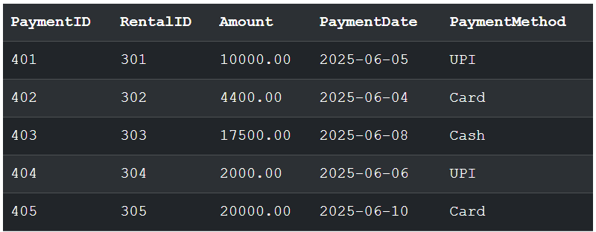

Maintenance Table
INSERT INTO Maintenance VALUES
(501,101,'2025-05-01','Engine Service',5000),
(502,102,'2025-05-02','Oil Change',1500),
(503,103,'2025-05-03','Brake Repair',3000),
(504,104,'2025-05-04','Tyre Change',2500),
(505,105,'2025-05-05','Battery Replacement',4000);
SELECT * from Maintenance;
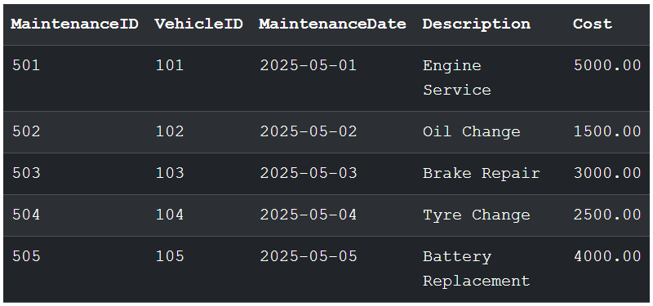

Queries

- Retrieve all vehicles.
SELECT * FROM Vehicle;


- Display vehicles available for rent.
SELECT *
FROM Vehicle
WHERE Status = 'Available';
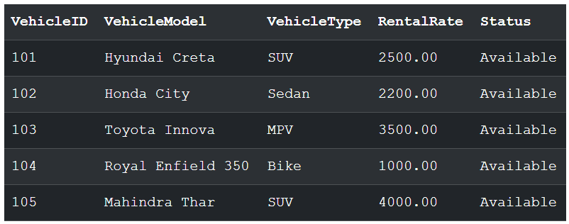

- Display rental and customer details (2-table INNER JOIN).
SELECT
C.CustomerID,
C.CustomerName,
R.RentalID,
R.StartDate,
R.EndDate,
R.TotalAmount
FROM Customer C
INNER JOIN Booking B
ON C.CustomerID = B.CustomerID
INNER JOIN Rental R
ON B.BookingID = R.BookingID;
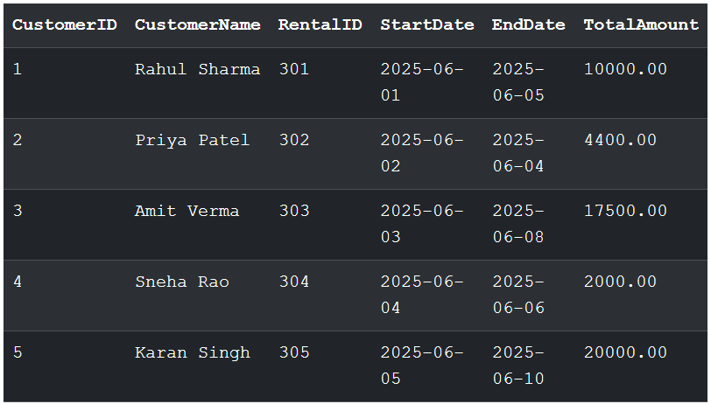
- Display rental, customer, and vehicle details (3-table JOIN).
SELECT
C.CustomerName,
V.VehicleModel,
V.VehicleType,
R.StartDate,
R.EndDate,
R.TotalAmount
FROM Customer C
JOIN Booking B
ON C.CustomerID = B.CustomerID
JOIN Vehicle V
ON B.VehicleID = V.VehicleID
JOIN Rental R
ON B.BookingID = R.BookingID;
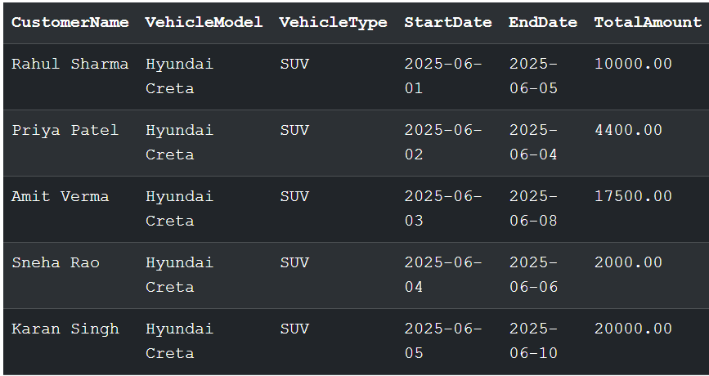
- Count number of rentals per vehicle type (GROUP BY).
SELECT
V.VehicleType,
COUNT(*) AS TotalRentals
FROM Vehicle V
JOIN Booking B
ON V.VehicleID = B.VehicleID
GROUP BY V.VehicleType;
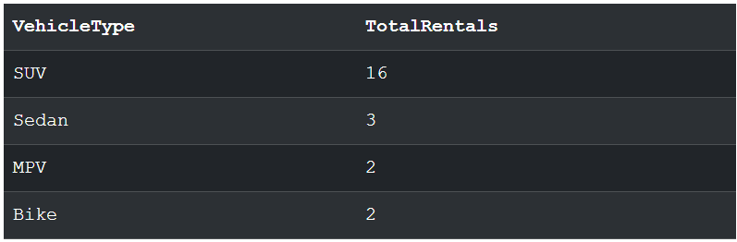

- Display vehicle types having more than 15 rentals (HAVING).
SELECT
V.VehicleType,
COUNT(*) AS TotalRentals
FROM Vehicle V
JOIN Booking B
ON V.VehicleID = B.VehicleID
GROUP BY V.VehicleType
HAVING COUNT(*) > 15;
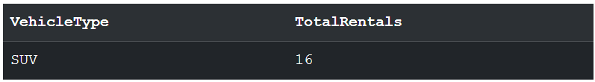

7. Retrieve vehicles whose rental charge is greater than the average rental charge(Subquery).
SELECT *
FROM Vehicle
WHERE RentalRate >
(
SELECT AVG(RentalRate)
FROM Vehicle
);

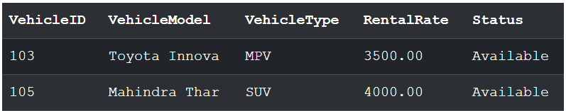

8. Retrieve customers who rented more vehicles than a specific customer (CorrelatedSubquery).
SELECT C.CustomerID, C.CustomerName
FROM Customer C
WHERE (
SELECT COUNT(*)
FROM Booking B
WHERE B.CustomerID = C.CustomerID
)
>
(
SELECT COUNT(*)
FROM Booking
WHERE CustomerID = 4
);
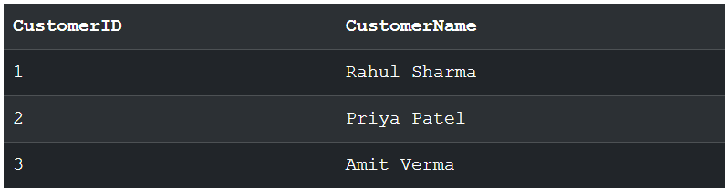

9. Display all vehicles including those not rented (LEFT JOIN).
SELECT
V.VehicleID,
V.VehicleModel,
R.RentalID
FROM Vehicle V
LEFT JOIN Booking B
ON V.VehicleID = B.VehicleID
LEFT JOIN Rental R
ON B.BookingID = R.BookingID;
INSERT INTO Vehicle
VALUES
(106,'Kia Seltos','SUV',2700,'Available');
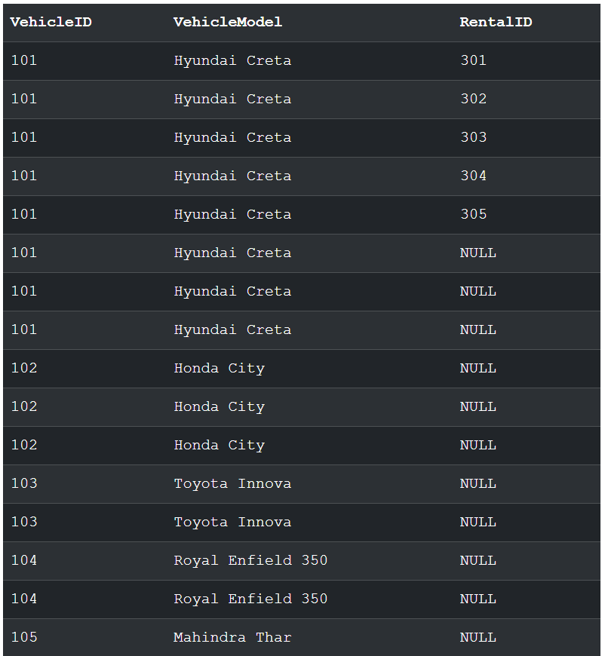
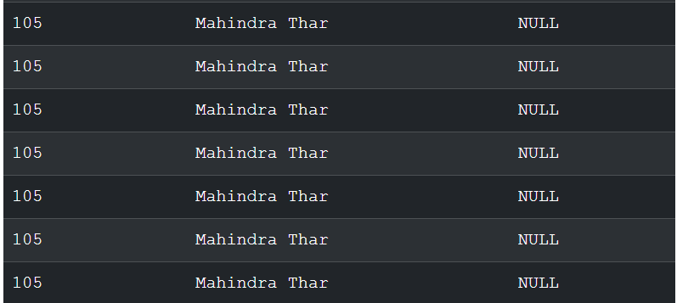

10. Retrieve vehicles that were never rented (NOT EXISTS).
SELECT *
FROM Vehicle V
WHERE NOT EXISTS
(
SELECT *
FROM Booking B
WHERE B.VehicleID = V.VehicleID
);
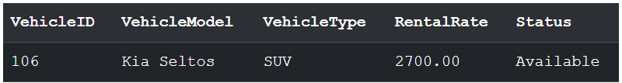

Stored Procedures

1. Procedure to calculate rental charge based on number of days.
DELIMITER //

CREATE PROCEDURE CalculateRentalCharge(
IN p_VehicleID INT,
IN p_Days INT
)
BEGIN
DECLARE v_RentalRate DECIMAL(10,2);
SELECT RentalRate
INTO v_RentalRate
FROM Vehicle
WHERE VehicleID = p_VehicleID;
SELECT
VehicleID,
VehicleModel,
RentalRate,
p_Days AS NumberOfDays,
(RentalRate * p_Days) AS TotalRentalCharge
FROM Vehicle
WHERE VehicleID = p_VehicleID;
END //
DELIMITER ;
Execute Procedure
CALL CalculateRentalCharge(103, 5);
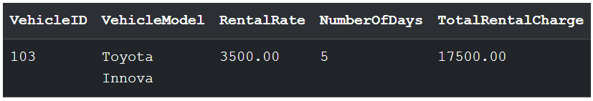

2. Procedure to retrieve vehicle availability report.
DELIMITER //
CREATE PROCEDURE VehicleAvailabilityReport()
BEGIN
SELECT
VehicleID,
VehicleModel,
VehicleType,
RentalRate,
Status
FROM Vehicle
ORDER BY VehicleID;
END //
DELIMITER ;

Execute Procedure
CALL VehicleAvailabilityReport();
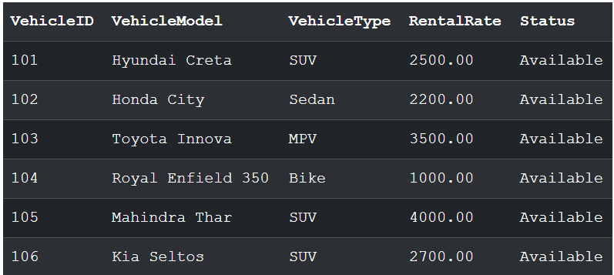

Trigger Questions

1. Trigger to update vehicle status after booking.
DELIMITER //
CREATE TRIGGER trg_update_vehicle_status
AFTER INSERT ON Booking
FOR EACH ROW
BEGIN
UPDATE Vehicle
SET Status = 'Rented'
WHERE VehicleID = NEW.VehicleID;
END //
DELIMITER ;
INSERT INTO Booking
VALUES (224,2,101,'2025-06-24');
SELECT *
FROM Vehicle
WHERE VehicleID = 101;
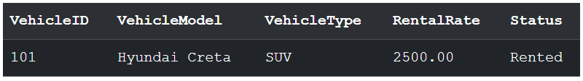

2. Trigger to prevent booking if vehicle is under maintenance.
DELIMITER //
CREATE TRIGGER trg_prevent_booking
BEFORE INSERT ON Booking
FOR EACH ROW
BEGIN
DECLARE v_status VARCHAR(20);
SELECT MaintenanceStatus
INTO v_status
FROM Vehicle
WHERE VehicleID = NEW.VehicleID;
IF v_status = 'Yes' THEN
SIGNAL SQLSTATE '45000'
SET MESSAGE_TEXT = 'Booking not allowed. Vehicle is under maintenance.';
END IF;
END //
DELIMITER ;
SELECT VehicleID, VehicleModel, MaintenanceStatus
FROM Vehicle
WHERE VehicleID = 103;
INSERT INTO Booking
VALUES (225,1,103,'2025-06-25');
