**Team Peter and Priya**

**Docker image location -** <https://hub.docker.com/r/wnameless/oracle-xe-11g/>

**Command to pull -** $ docker pull wnameless/oracle-xe-11g

**--Display a list of student assignments for a subject.Sample subject id = 1**

SELECT S.SUBJECT_NAME, g.ASSIGNMENT_ID, g.ASSIGNMENT_NAME, g.URL

FROM ASSIGNMENT G, SUBJECT S

WHERE S.SUBJECT_ID = G.FK_SUBJECT_ID

and g.fk_subject_id=1;

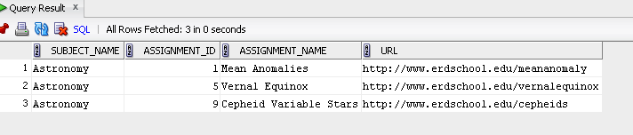

**-- Display a list of all students taught by a given teacher. Sample teacher - Teacher id 2, Carolyn Porco**

SELECT T.First_name||' '||t.last_Name as teacher_Name, S.FNAME||' '||s.LName as student_name

FROM STUDENT S, HOMEROOM H, teacher t

WHERE S.FK_HOMEROOM_ID = H.HOMEROOM_ID

AND H.FK_TEACHER_ID = T.TEACHER_ID

and t.teacher_id = 2;

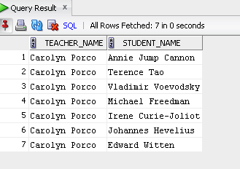

**-- DISPLAY A LIST OF ALL THE STUDENT WORK BY A STUDENT. Sample student_id = 22**

SELECT S.FNAME||' '||S.LNAME as student_Name, H.URL as homework_URL

FROM HOMEWORK H, STUDENT S

WHERE S.STUDENT_ID = H.FK_STUDENT_ID

and S.STUDENT_ID = 22;

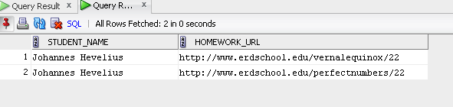

**-- Display a list of student work for a classroom. Sample homeroom_id = 2**

SELECT h.FK_STUDENT_ID AS HOMEROOM_2_STUDENTS, s.fname||' '||s.lname as Student_Name, h.URL AS STUDENT_WORK

FROM HOMEWORK h, STUDENT S

WHERE FK_STUDENT_ID IN ( SELECT STUDENT_ID FROM STUDENT WHERE FK_HOMEROOM_ID = 2)

and s.student_id = h.fk_student_id;

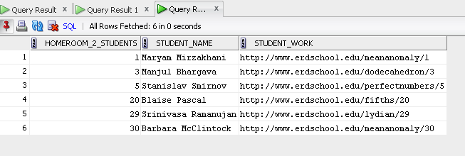

**Primary key validation – inserting duplicate student_id displays appropriate error messages**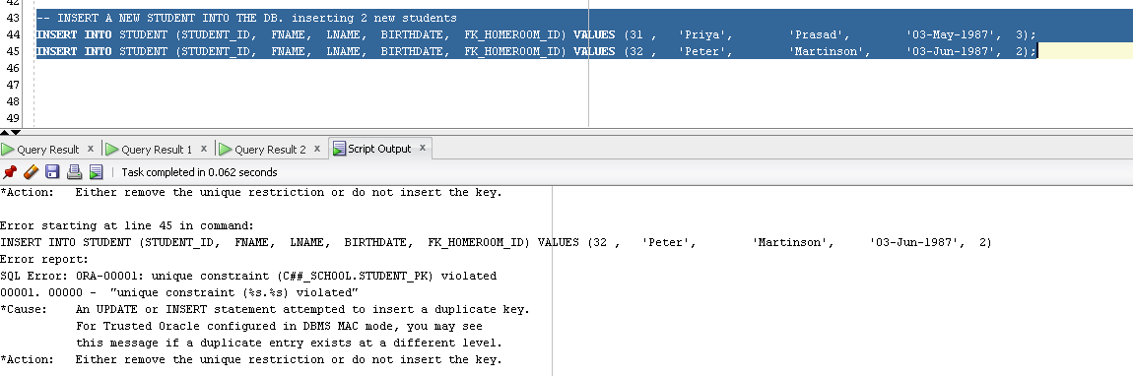

**Update operations –**

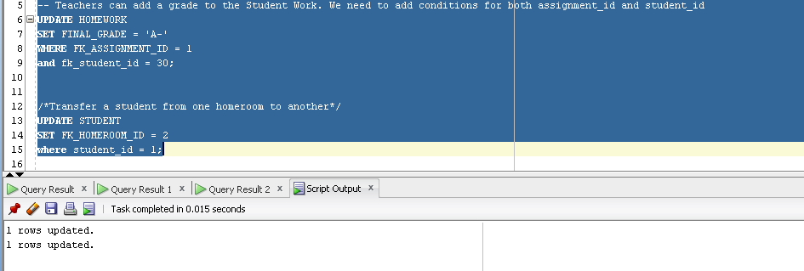

**-- Display a list of all teachers not teaching a subject**

**-- ** This is to show a useful application of LEFT OUTER JOINs \*\***

SELECT DISTINCT

teacher.first_name || ' ' || teacher.last_name AS teacher_name

, teacher.teacher_id

FROM

teacher

LEFT OUTER JOIN subject

ON SUBJECT.FK_TEACHER_ID = TEACHER.TEACHER_ID

WHERE subject.subject_id IS NULL;

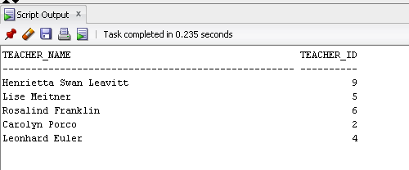

**-- Replace a subject's teacher with a substitute. Sample subject_id = 3**

**-- First, find a possible substitute:**

SELECT DISTINCT

subject.subject_name

, teacher.first_name || ' ' || teacher.last_name AS current_teacher

, teacher.preferred_subject

, possible_sub.first_name || ' ' || possible_sub.last_name AS possible_sub

, possible_sub.teacher_id

FROM

subject

INNER JOIN teacher

ON teacher.teacher_id = subject.fk_teacher_id

LEFT OUTER JOIN teacher possible_sub

ON possible_sub.preferred_subject = teacher.preferred_subject

AND possible_sub.teacher_id <> teacher.teacher_id

AND POSSIBLE_SUB.TEACHER_ID NOT IN ( SELECT FK_TEACHER_ID FROM SUBJECT)

WHERE subject.subject_id = 3;

**-- Second, update the subject table**

UPDATE subject

SET FK_TEACHER_ID = 9

WHERE subject_id = 3;

