Overloading: Method name must match and , return type , access specifier, exception and parameter doses’t matter
In method overloading one type is automatically promoted to another type.
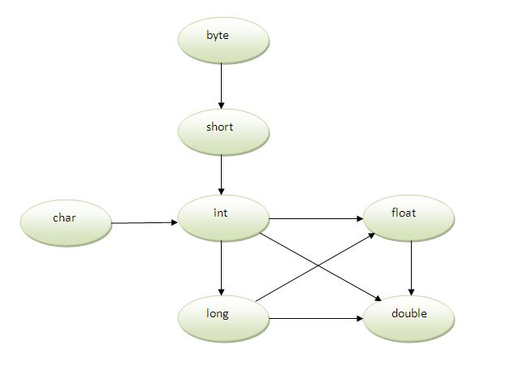

Example of Method Overloading with Type Promotion in case of ambiguity
If there are no matching type arguments in the method, and each method promotes similar number of arguments, there will be ambiguity.
- class OverloadingCalculation3{
- void sum(int a,long b){System.out.println("a method invoked");}
- void sum(long a,int b){System.out.println("b method invoked");}

- public static void main(String args[]){
- OverloadingCalculation3 obj=new OverloadingCalculation3();
- obj.sum(20,20);//now ambiguity
- }
- }

Example of Method Overloading with TypePromotion
- class OverloadingCalculation1{
- void sum(int a,long b){System.out.println(a+b);}
- void sum(int a,int b,int c){System.out.println(a+b+c);}

- public static void main(String args[]){
- OverloadingCalculation1 obj=new OverloadingCalculation1();
- obj.sum(20,20);//now second int literal will be promoted to long
- obj.sum(20,20,20);

- }
- }

