WebDriver:

package org.openqa.selenium;

import java.net.URL;
import java.util.List;
import java.util.Set;
import java.util.concurrent.TimeUnit;
import org.openqa.selenium.logging.Logs;

public abstract interface WebDriver
extends SearchContext
{
public abstract void get(String paramString);

public abstract String getCurrentUrl();

public abstract String getTitle();

public abstract List<WebElement> findElements(By paramBy);

public abstract WebElement findElement(By paramBy);

public abstract String getPageSource();

public abstract void close();

public abstract void quit();

public abstract Set<String> getWindowHandles();

public abstract String getWindowHandle();

public abstract TargetLocator switchTo();

public abstract Navigation navigate();

public abstract Options manage();

public static abstract interface ImeHandler
{
public abstract List<String> getAvailableEngines();

public abstract String getActiveEngine();

public abstract boolean isActivated();

public abstract void deactivate();

public abstract void activateEngine(String paramString);
}

public static abstract interface Navigation
{
public abstract void back();

public abstract void forward();

public abstract void to(String paramString);

public abstract void to(URL paramURL);

public abstract void refresh();
}

public static abstract interface Options
{
public abstract void addCookie(Cookie paramCookie);

public abstract void deleteCookieNamed(String paramString);

public abstract void deleteCookie(Cookie paramCookie);

public abstract void deleteAllCookies();

public abstract Set<Cookie> getCookies();

public abstract Cookie getCookieNamed(String paramString);

public abstract WebDriver.Timeouts timeouts();

public abstract WebDriver.ImeHandler ime();

public abstract WebDriver.Window window();

@Beta
public abstract Logs logs();
}

public static abstract interface TargetLocator
{
public abstract WebDriver frame(int paramInt);

public abstract WebDriver frame(String paramString);

public abstract WebDriver frame(WebElement paramWebElement);

public abstract WebDriver parentFrame();

public abstract WebDriver window(String paramString);

public abstract WebDriver defaultContent();

public abstract WebElement activeElement();

public abstract Alert alert();
}

public static abstract interface Timeouts
{
public abstract Timeouts implicitlyWait(long paramLong, TimeUnit paramTimeUnit);

public abstract Timeouts setScriptTimeout(long paramLong, TimeUnit paramTimeUnit);

public abstract Timeouts pageLoadTimeout(long paramLong, TimeUnit paramTimeUnit);
}

@Beta
public static abstract interface Window
{
public abstract void setSize(Dimension paramDimension);

public abstract void setPosition(Point paramPoint);

public abstract Dimension getSize();

public abstract Point getPosition();

public abstract void maximize();

public abstract void fullscreen();
}
}

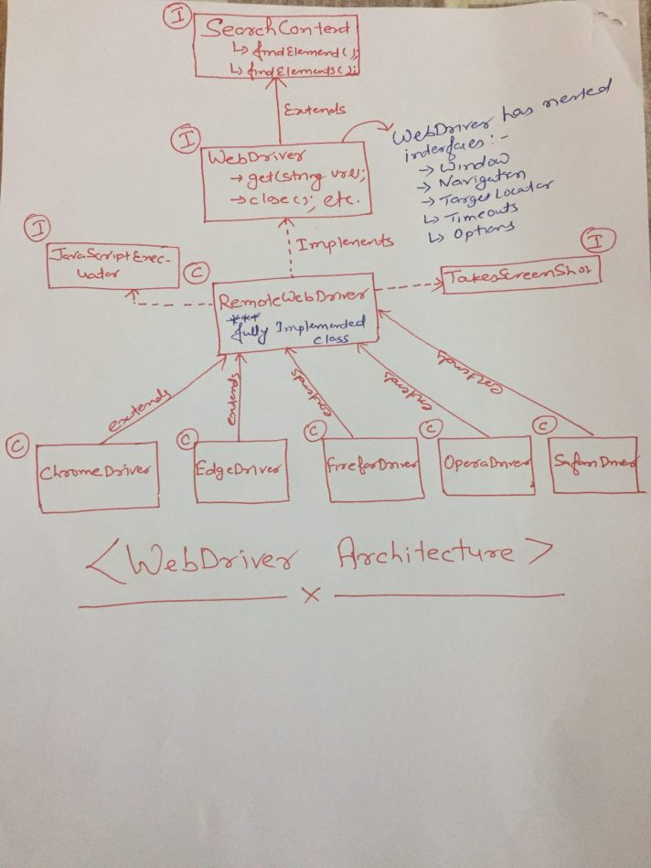
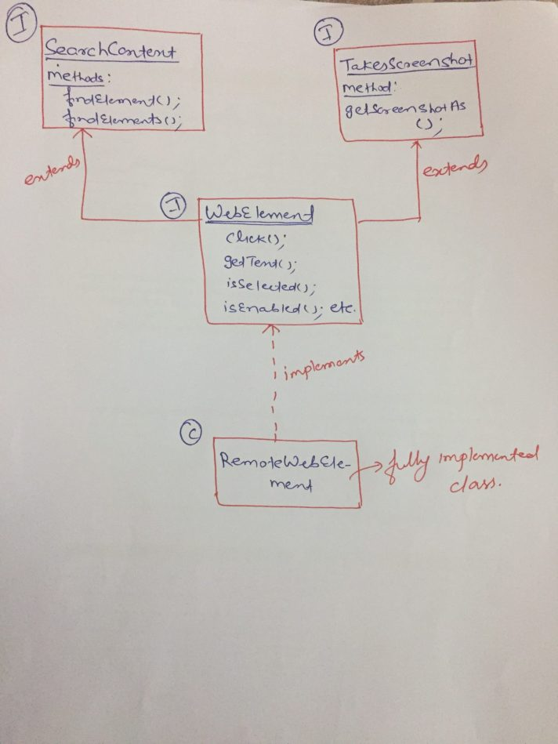

Syntax of firefox driver:
public class FirefoxDriver
extends RemoteWebDriver
implements Killable

syntax of remotewebdriver
public class RemoteWebDriver
implements WebDriver, JavascriptExecutor, FindsById, FindsByClassName, FindsByLinkText, FindsByName, FindsByCssSelector, FindsByTagName, FindsByXPath, HasInputDevices, HasCapabilities, TakesScreenshot

syntax of alert:
public abstract interface Alert
{
public abstract void dismiss();

public abstract void accept();

public abstract String getText();

public abstract void sendKeys(String paramString);

@Beta
public abstract void setCredentials(Credentials paramCredentials);

@Beta
public abstract void authenticateUsing(Credentials paramCredentials);
}
Sysntax webelemnt:

public abstract interface WebElement
extends SearchContext, TakesScreenshot
{
public abstract void click();

public abstract void submit();

public abstract void sendKeys(CharSequence... paramVarArgs);

public abstract void clear();

public abstract String getTagName();

public abstract String getAttribute(String paramString);

public abstract boolean isSelected();

public abstract boolean isEnabled();

public abstract String getText();

public abstract List<WebElement> findElements(By paramBy);

public abstract WebElement findElement(By paramBy);

public abstract boolean isDisplayed();

public abstract Point getLocation();

public abstract Dimension getSize();

public abstract Rectangle getRect();

public abstract String getCssValue(String paramString);
}

