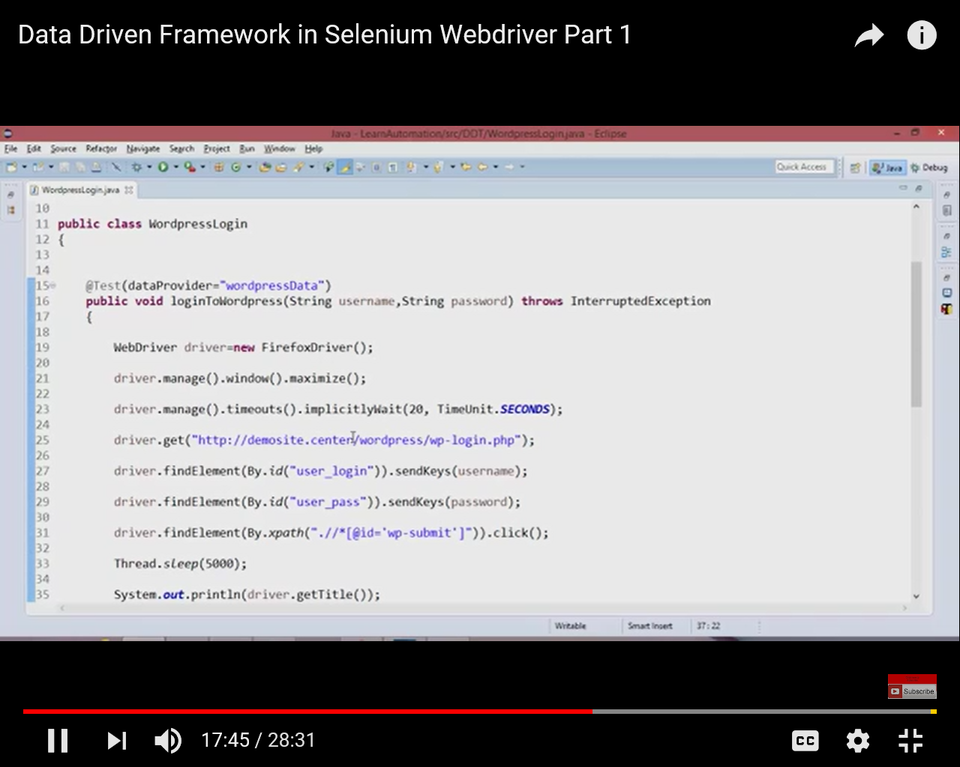
http://demosite.center/wordpress/wp-login.php

the current wardpress site is as below:

http://demosite.center/bbpress/wp-login.php
