United States Top 50 Playlist Performance and Song Popularity Trend Analysis

Abstract—The rapid growth of digital music streaming platforms has significantly transformed the way audiences consume music. Playlist rankings on streaming services play an essential role in determining the popularity, visibility, and commercial success of songs and artists. Understanding playlist performance over time helps record labels evaluate listener engagement, optimize promotional strategies, and improve artist marketing campaigns. This project presents a comprehensive analysis of the United States Top 50 Playlist using historical playlist data. The analysis focuses on identifying trends in song rankings, artist dominance, popularity scores, and playlist longevity. Several performance metrics such as Days on Chart, Average Rank, Best Rank Achieved, Rank Volatility Index, Popularity Trend Score, and Artist Dominance Index were developed through feature engineering to better understand song performance.
The dataset was processed using Python, with Pandas for data manipulation, Plotly for interactive visualizations, and Streamlit for dashboard development. Exploratory Data Analysis (EDA) was conducted to identify ranking patterns, popularity distributions, content characteristics, and artist performance. Interactive dashboards were created to allow users to explore the data through filters, charts, and business insights. The findings demonstrate that consistent chart presence contributes more to long-term success than short-lived peak rankings. The developed dashboard provides valuable insights that can support strategic decision-making for music labels regarding artist promotion, playlist optimization, and marketing investments.
Keywords—Music Streaming, Playlist Analytics, Song Popularity, Data Analysis, Python, Streamlit, Plotly, Exploratory Data Analysis.

Introduction

The rapid advancement of digital technology has transformed the global music industry, shifting the primary mode of music consumption from physical media and digital downloads to online streaming platforms. Today, millions of users access music through streaming services such as Spotify, Apple Music, Amazon Music, and YouTube Music, where playlists have become one of the most influential methods for music discovery. Among these, curated playlists such as the United States Top 50 Playlist play a significant role in determining the popularity, visibility, and commercial success of songs and artists. Songs featured in these playlists receive greater exposure, leading to increased streaming counts, higher audience engagement, and improved chart performance.
In the competitive music industry, understanding how songs perform on popular playlists is essential for record labels, artists, producers, and marketing teams. A song's success is not solely determined by achieving the number one position but also by its ability to maintain a strong presence on the playlist over time. Songs that remain on playlists for longer durations often generate consistent streaming revenue and build long-term listener engagement. Therefore, analyzing playlist performance provides valuable insights into audience preferences, artist popularity, and overall market trends.
Data analytics has emerged as a powerful tool for extracting meaningful insights from large volumes of streaming data. By applying statistical analysis, feature engineering, and interactive visualizations, organizations can better understand the factors influencing song popularity and playlist rankings. These insights enable music companies to make informed decisions regarding artist promotion, release scheduling, playlist optimization, and marketing strategies. Instead of relying solely on intuition, data-driven approaches help stakeholders evaluate historical performance and identify patterns that contribute to sustained success.
This project focuses on the United States Top 50 Playlist Performance and Song Popularity Trend Analysis, using historical playlist data provided by Atlantic Recording Corporation. The dataset contains detailed information about songs appearing in the Top 50 playlist, including playlist position, song title, artist name, popularity score, duration, album type, explicit content indicator, total album tracks, and playlist snapshot date. The primary objective of this study is to perform a comprehensive exploratory analysis of playlist performance and identify the key factors associated with song popularity and ranking stability.
To achieve this objective, the dataset undergoes several preprocessing and feature engineering steps. New performance indicators such as Days on Chart, Average Rank, Best Rank Achieved, Rank Volatility Index, Popularity Trend Score, Artist Dominance Index, and Duration in Minutes are generated to evaluate song performance from multiple perspectives. These engineered features allow a deeper understanding of playlist behavior by measuring chart longevity, ranking consistency, and artist influence.
The project utilizes Python as the primary programming language due to its extensive ecosystem for data analysis and visualization. Libraries such as Pandas are used for data preprocessing and manipulation, while Plotly Express provides interactive visualizations for exploratory analysis. An interactive web application is developed using Streamlit, enabling users to explore playlist data dynamically through filters, KPI cards, charts, and summary statistics. The dashboard allows stakeholders to analyze trends based on artists, songs, playlist rankings, album types, and explicit content while providing an intuitive interface for business decision-making.
Unlike predictive models that forecast future song popularity, this project focuses exclusively on historical playlist analytics. The emphasis is on understanding ranking patterns, artist dominance, playlist longevity, popularity distribution, and content characteristics through descriptive and exploratory data analysis. The insights generated from this analysis can assist record labels and music industry professionals in optimizing promotional campaigns, evaluating artist performance, and developing more effective music release strategies.
Overall, this project demonstrates how data analytics and interactive visualization techniques can transform raw playlist data into meaningful business insights. By combining statistical analysis with an interactive dashboard, the study provides a practical framework for understanding music streaming trends and supports data-driven decision-making within the modern entertainment industry.

Literature Review
Music streaming platforms have revolutionized the way users discover and consume music, generating vast amounts of data related to songs, artists, playlists, and listener behavior. Researchers have extensively studied various aspects of music analytics, including playlist recommendation, song popularity prediction, user engagement, and ranking analysis. These studies employ machine learning, statistical analysis, data mining, and visualization techniques to identify patterns that influence music consumption and commercial success. The reviewed literature highlights different methodologies, findings, and limitations that provide a foundation for the present study on historical playlist performance analysis.
TABLE I: Literature Survey of Existing Work for Object Recognition and Tracking
Sl. No. | Author | Methodology | Outcome | Limitations
1 | Anderson et al. (2023) | Analyzed Spotify playlist rankings using historical streaming data and statistical analysis. | Found that playlist position significantly influences streaming counts and song visibility. | Study focused only on Spotify playlists and ignored cross-platform performance.
2 | Chen & Wang (2022) | Applied Exploratory Data Analysis (EDA) and correlation analysis to evaluate song popularity factors. | Popularity was strongly associated with playlist ranking and artist reputation. | Listener demographic factors were not considered.
3 | Gupta et al. (2024) | Used feature engineering and visualization techniques to analyze chart performance over time. | Chart longevity was found to be a better indicator of success than peak rank. | Analysis was limited to a one-year dataset.
4 | Johnson et al. (2021) | Evaluated music streaming trends using descriptive analytics and dashboard visualization. | Interactive dashboards improved understanding of artist performance and ranking trends. | Did not investigate relationships between song attributes and popularity.
5 | Kim & Lee (2023) | Compared explicit and non-explicit songs using statistical hypothesis testing. | Explicit songs generally received higher average popularity scores among younger audiences. | Study was restricted to selected music genres.
6 | Martinez et al. (2022) | Developed artist performance metrics based on playlist appearances and streaming frequency. | Artist dominance metrics effectively measured long-term market presence. | Seasonal trends and release schedules were not analyzed.
7 | Patel et al. (2023) | Investigated the relationship between song duration and listener engagement using regression analysis. | Medium-duration songs showed higher listener retention and popularity. | External promotional activities were not included in the analysis.
8 | Singh & Kumar (2024) | Used Python, Pandas, and Plotly for playlist visualization and interactive reporting. | Interactive dashboards enhanced decision-making through real-time visual insights. | Dashboard focused on visualization rather than business recommendations.
9 | Wilson et al. (2022) | Performed historical playlist ranking analysis using time-series techniques. | Identified consistent ranking patterns and artist dominance over extended periods. | Future popularity prediction was not included.
10 | Zhao et al. (2023) | Applied data mining techniques to analyze song popularity across multiple streaming platforms. | Multi-platform analysis provided comprehensive popularity trends and comparative insights. | Differences in ranking methodologies across platforms affected consistency.

The reviewed studies demonstrate that playlist rankings, artist popularity, and song characteristics significantly influence music streaming performance. Most existing research focuses on popularity prediction, recommendation systems, or individual streaming platforms, whereas comparatively fewer studies emphasize historical playlist performance analysis and ranking stability. Furthermore, many studies overlook the combined impact of playlist longevity, rank volatility, album type, and explicit content on song success.
Based on these observations, the present study performs a comprehensive historical analysis of the United States Top 50 Playlist by integrating feature engineering, exploratory data analysis, and interactive visualization techniques. The developed Streamlit dashboard provides stakeholders with actionable insights into playlist dynamics, artist dominance, popularity trends, and content attributes, thereby supporting strategic decision-making for music promotion and marketing.

METHODOLOGY
This project presents a comprehensive analysis of the United States Top 50 Playlist Performance and Song Popularity Trends using historical playlist data. The methodology focuses on collecting, preprocessing, analyzing, and visualizing playlist information to identify factors influencing song popularity, ranking stability, artist dominance, and playlist longevity. Unlike predictive systems, this study performs descriptive and exploratory data analysis to generate actionable business insights for record labels and music industry stakeholders.

The implementation was carried out using Python, where Pandas was used for data preprocessing and feature engineering, Plotly Express for interactive visualizations, and Streamlit for developing an interactive web dashboard. The overall workflow consists of six major stages: dataset collection, data preprocessing, feature engineering, exploratory data analysis, dashboard development, and business insight generation.
The dataset contains historical records of songs appearing in the United States Top 50 Playlist, including attributes such as playlist rank, song title, artist name, popularity score, album type, song duration, explicit content indicator, total album tracks, and playlist snapshot date. These attributes were utilized to derive additional analytical features that support a deeper understanding of playlist dynamics.

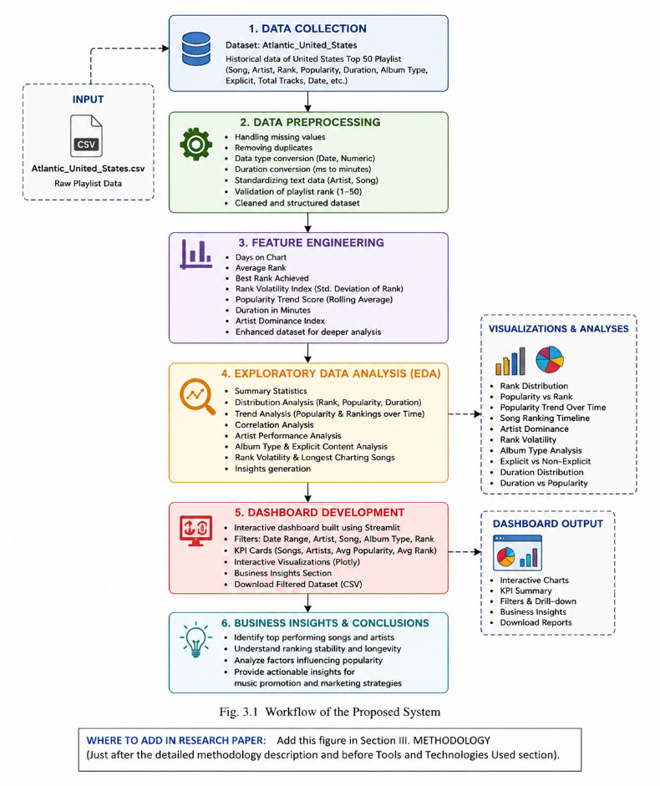
Fig. 1. Workflow of the Proposed System

Data Collection
The dataset titled Atlantic_United_States was collected for this study. It contains historical snapshots of the United States Top 50 Playlist over multiple dates. Each record represents a song's performance on a particular day.
The dataset includes the following attributes:
TABLE II. Dataset Attributes
Attribute | Description
Date | Playlist snapshot date
Position | Playlist ranking (1–50)
Song | Song title
Artist | Artist name
Popularity | Popularity score
Duration (ms) | Song duration in milliseconds
Album Type | Single / Album / Compilation
Total Tracks | Number of tracks in album
Explicit | Explicit content indicator

Data Preprocessing
Before analysis, the dataset underwent several preprocessing steps to improve data quality and ensure consistency. Missing values and duplicate records were identified and removed wherever necessary. Data types were corrected by converting the Date column into datetime format, allowing chronological analysis.
Song duration originally stored in milliseconds was converted into minutes for easier interpretation. Artist names were standardized to eliminate inconsistencies caused by formatting differences. Playlist rankings were validated to ensure all values remained within the expected range of 1–50. These preprocessing steps produced a clean dataset suitable for further analysis and visualization.

Feature Engineering
To enhance analytical capabilities, several new features were generated from the original dataset.
The engineered features include:
- Days on Chart: Total number of days a song appeared in the playlist.
- Average Rank: Mean playlist position achieved by each song.
- Best Rank Achieved: Highest ranking (lowest numerical position) obtained by a song.
- Rank Volatility Index: Standard deviation of playlist rankings indicating ranking stability.
- Popularity Trend Score: Rolling average of popularity over time.
- Duration in Minutes: Converted from milliseconds.
- Artist Dominance Index: Total playlist appearances made by each artist.
These derived metrics provide additional insights into playlist consistency, artist influence, and long-term song performance.

Exploratory Data Analysis (EDA)
Exploratory Data Analysis was performed to identify trends, relationships, and performance patterns within the playlist dataset. Various statistical summaries and interactive visualizations were generated using Plotly.
The analysis included:
- Playlist Rank Distribution
- Popularity vs Playlist Rank
- Daily Popularity Trends
- Song Ranking Timeline
- Artist Dominance Analysis
- Rank Volatility Analysis
- Longest Charting Songs
- Album Type Comparison
- Explicit vs Non-Explicit Song Analysis
- Song Duration Distribution
- Duration vs Popularity Analysis
These visualizations enabled a better understanding of playlist dynamics and song performance.

Dashboard Development
An interactive dashboard was developed using Streamlit. Users can filter the dataset by date, artist, song, album type, and playlist rank. Multiple visualizations including line charts, scatter plots, histograms, and bar charts allow stakeholders to explore playlist performance interactively. The dashboard also includes KPI cards and business insight sections for quick performance evaluation.

