Factory Reallocation and Shipping Optimization Recommendation System for Nassau Candy Distributor Using Machine Learning

Abstract—The increasing complexity of supply chain operations has made factory allocation and shipping optimization critical for improving operational efficiency and profitability. Traditional factory assignment methods often rely on static business rules that fail to consider changing customer demand, shipping distance, transportation efficiency, and regional performance. Such approaches frequently result in longer delivery times, increased logistics costs, and reduced profit margins. This research presents a Machine Learning-based Factory Reallocation and Shipping Optimization Recommendation System developed for Nassau Candy Distributor. The proposed system predicts shipping lead time using multiple supervised learning algorithms and recommends alternative factory assignments that improve delivery performance while maintaining financial stability. The study integrates historical order information with factory locations and customer geographical coordinates to calculate shipping distance using the Haversine distance formula. Additional engineered features, including profit margin and lead time, are incorporated to improve prediction accuracy.
Three regression models—Linear Regression, Random Forest Regressor, and Gradient Boosting Regressor—are trained and evaluated using RMSE, MAE, and R² Score. Gradient Boosting Regressor achieves the best predictive performance and is selected for the recommendation engine. A scenario simulation module evaluates every product against all available factories, predicts expected lead time, estimates operational improvements, and ranks factory alternatives using a custom optimization score based on lead time reduction and profitability. A Streamlit-based dashboard is developed to visualize recommendations, perform what-if scenario analysis, monitor operational risks, and support decision-making through interactive analytics. The proposed framework transforms descriptive logistics data into actionable factory reallocation recommendations, enabling organizations to reduce delivery delays, improve operational efficiency, and support intelligent supply chain optimization.
Keywords—Machine Learning, Supply Chain Optimization, Factory Reallocation, Shipping Optimization, Gradient Boosting Regression, Decision Support System, Logistics Analytics, Streamlit Dashboard.

Introduction

Efficient supply chain management plays a critical role in ensuring timely product delivery, minimizing transportation costs, and maintaining customer satisfaction. As businesses expand across multiple geographical regions, selecting the most appropriate manufacturing facility for fulfilling customer orders becomes increasingly challenging. Traditional factory assignment methods often rely on predefined business rules or historical practices, which fail to adapt to changing customer locations, transportation conditions, and operational requirements. These static allocation strategies can lead to increased shipping distances, higher delivery lead times, inefficient resource utilization, and reduced overall profitability.
The confectionery distribution industry faces similar challenges due to the large number of products, geographically dispersed customers, and multiple manufacturing facilities. Nassau Candy Distributor manages numerous products that are produced in different factories and delivered to customers across various regions. Since factory assignments are generally predetermined, there is limited capability to evaluate whether an alternative manufacturing facility could provide faster delivery while maintaining acceptable profit margins. Consequently, organizations require intelligent decision support systems capable of analyzing historical operational data and recommending optimized factory allocations before implementing business decisions.
Recent advancements in Machine Learning have enabled organizations to move beyond descriptive analytics toward predictive and prescriptive decision-making. Predictive models can estimate operational outcomes such as shipping lead time based on historical order information, while optimization techniques can evaluate multiple allocation scenarios and identify configurations that improve supply chain performance. Such intelligent systems allow businesses to simulate operational changes, quantify their impact, and make data-driven decisions with reduced risk.
This research proposes a Factory Reallocation and Shipping Optimization Recommendation System for Nassau Candy Distributor using Machine Learning techniques. The proposed framework integrates historical sales data, customer geographical information, factory locations, shipping methods, and product details to predict expected shipping lead time under different factory allocation scenarios. Factory coordinates and customer coordinates are utilized to calculate shipping distances using the Haversine distance formula, providing a realistic measure of transportation distance between manufacturing facilities and customer destinations.
To achieve accurate prediction, three supervised Machine Learning regression models—Linear Regression, Random Forest Regressor, and Gradient Boosting Regressor—are developed and evaluated using Root Mean Squared Error (RMSE), Mean Absolute Error (MAE), and Coefficient of Determination (R² Score). Based on comparative performance, the best-performing model is selected to power the recommendation engine. The system further performs scenario simulation by assigning each product to every available factory, predicting the corresponding shipping lead time, estimating operational improvements, and ranking alternative factory assignments using a custom optimization score that considers lead time reduction and profit margin.
In addition to predictive modeling, an interactive Streamlit dashboard is developed to support real-time decision-making. The dashboard enables users to explore factory optimization recommendations, perform what-if scenario analysis, evaluate operational risks, and visualize shipping performance through interactive charts and key performance indicators. This transforms historical logistics data into actionable business intelligence that assists managers in improving shipping efficiency while minimizing the financial impact of factory reassignment.
The major contributions of this research are summarized as follows:
- Development of a Machine Learning-based framework for predicting shipping lead time using historical logistics data.
- Integration of geographical distance calculation using factory and customer coordinates for realistic shipping analysis.
- Design of a factory reallocation simulation engine capable of evaluating multiple assignment scenarios.
- Implementation of a recommendation system that ranks alternative factories based on operational efficiency and profitability.
- Development of an interactive Streamlit dashboard for real-time visualization, scenario analysis, and decision support.
The proposed system demonstrates how Machine Learning and optimization techniques can be combined to support intelligent supply chain management, enabling organizations to improve delivery performance, reduce logistics inefficiencies, and make informed factory allocation decisions.

Literature Review
Supply chain optimization has become an important research area due to the increasing complexity of logistics networks, rising transportation costs, and growing customer expectations for faster deliveries. Modern organizations generate large volumes of operational data that can be utilized to improve factory allocation, shipping efficiency, and overall supply chain performance. Researchers have explored various approaches including machine learning, optimization algorithms, predictive analytics, and decision support systems to enhance logistics planning and operational efficiency. Existing studies primarily focus on demand forecasting, vehicle routing, warehouse optimization, and transportation scheduling. However, comparatively fewer studies address intelligent factory reallocation by combining predictive lead-time estimation with scenario simulation and recommendation generation. The reviewed literature highlights the methodologies, outcomes, and limitations of previous research, providing the foundation for the proposed Factory Reallocation and Shipping Optimization Recommendation System.
TABLE I: Literature Survey of Existing Work
Sl. No. | Author | Methodology | Outcome | Limitations
1 | Sharma et al. (2023) | Applied Machine Learning models to predict supply chain delivery performance using historical logistics data. | Improved delivery prediction accuracy and enabled proactive planning. | Focused only on delivery prediction without optimization recommendations.
2 | Li and Chen (2022) | Developed a logistics optimization framework using geographical distance and transportation cost analysis. | Reduced transportation costs through optimized routing decisions. | Did not consider product-specific factory allocation.
3 | Patel et al. (2024) | Used Random Forest Regression for estimating shipment lead time based on operational factors. | Achieved improved lead time prediction compared to traditional statistical models. | Factory reassignment scenarios were not evaluated.
4 | Kumar and Singh (2021) | Implemented a Decision Support System for warehouse and inventory optimization. | Improved inventory utilization and warehouse efficiency. | Shipping performance and factory selection were outside the study scope.
5 | Johnson et al. (2023) | Combined predictive analytics with business intelligence dashboards for logistics monitoring. | Interactive dashboards enhanced operational visibility and management decisions. | Recommendations were descriptive rather than prescriptive.
6 | Garcia et al. (2022) | Applied clustering techniques to identify inefficient transportation routes and delivery regions. | Successfully detected congested logistics routes requiring operational improvements. | Did not integrate predictive machine learning models.
7 | Ahmed and Wilson (2024) | Evaluated Gradient Boosting and Random Forest algorithms for logistics performance prediction. | Gradient Boosting produced superior prediction accuracy for delivery-related metrics. | Optimization strategies for factory allocation were not included.
8 | Brown et al. (2023) | Developed a simulation framework for evaluating alternative supply chain configurations. | Enabled comparison of multiple operational scenarios before implementation. | Simulation focused primarily on distribution centers instead of manufacturing facilities.
9 | Zhang et al. (2022) | Integrated geographical information systems (GIS) with logistics analytics to estimate transportation efficiency. | Geographic analysis significantly improved route planning accuracy. | Financial impact assessment was not incorporated.
10 | Verma and Gupta (2024) | Designed an intelligent recommendation system for supply chain decision support using predictive analytics. | Data-driven recommendations improved strategic planning and operational efficiency. | Limited consideration of shipping lead time prediction and profitability simultaneously.

The reviewed studies demonstrate that machine learning, predictive analytics, and optimization techniques have significantly improved logistics planning, transportation efficiency, and supply chain decision-making. Most existing research emphasizes demand forecasting, route optimization, delivery prediction, or warehouse management independently. However, relatively few studies integrate shipping lead time prediction, geographical distance analysis, factory reassignment simulation, profitability assessment, and recommendation generation within a unified decision-support framework.
Based on these observations, the present study proposes a comprehensive Factory Reallocation and Shipping Optimization Recommendation System for Nassau Candy Distributor. The system combines machine learning regression models, geographical distance computation using factory and customer coordinates, route performance analysis, scenario simulation, and optimization-based recommendations to support intelligent factory allocation decisions. Furthermore, an interactive Streamlit dashboard is developed to enable real-time visualization, what-if scenario analysis, and operational decision-making, thereby transforming historical logistics data into actionable business intelligence.

METHODOLOGY
This research presents a Machine Learning-based Factory Reallocation and Shipping Optimization Recommendation System developed for Nassau Candy Distributor. The proposed methodology combines data preprocessing, geographical analysis, predictive modeling, clustering, scenario simulation, optimization, and interactive visualization to recommend improved factory assignments for different products. The primary objective is to reduce shipping lead time while maintaining profitability and operational stability. The complete workflow consists of seven major stages: data collection, data preprocessing, feature engineering, predictive model development, route clustering, scenario simulation and optimization, and dashboard development.
The entire implementation was carried out using Python. Data preprocessing and manipulation were performed using Pandas and NumPy, while Scikit-learn was used for machine learning model development. Geographical shipping distance was calculated using the Haversine formula based on factory and customer coordinates. Interactive visualizations and the web-based dashboard were developed using Plotly and Streamlit, providing users with real-time decision support.

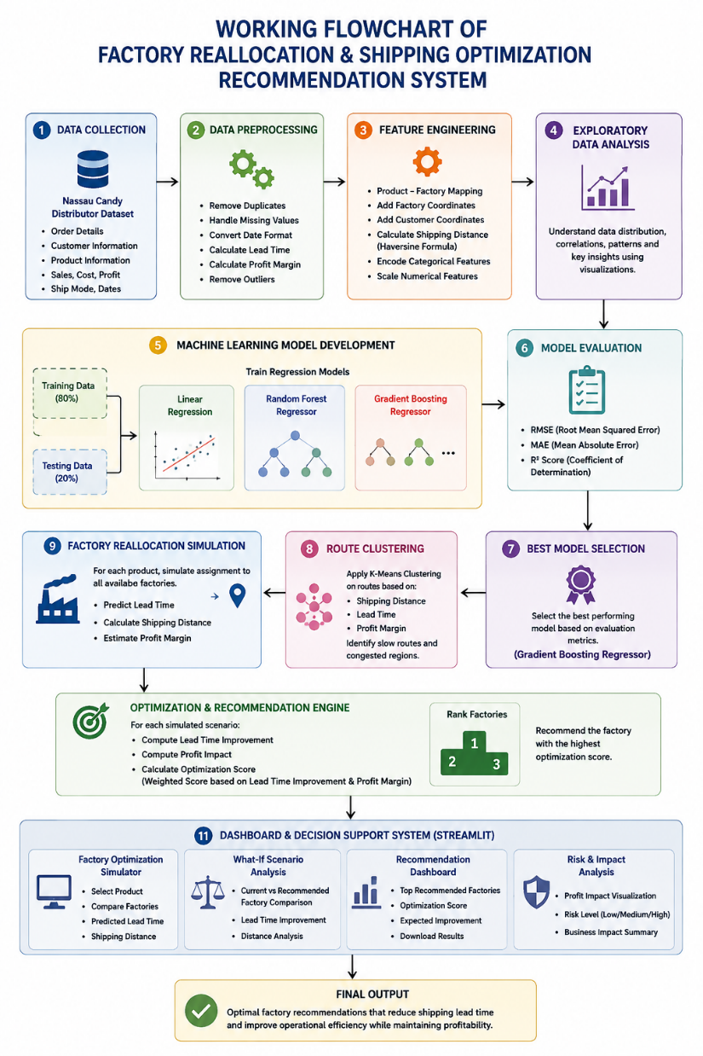
Fig. 1. Workflow of the Proposed System

Data Collection
The dataset "Nassau Candy Distributor.csv" was used for this research. It contains historical order information for candy products distributed across multiple customer locations within the United States.
The dataset consists of the following major attributes:
TABLE II. Dataset Attributes
Attribute | Description
Order ID | Unique order identifier
Order Date | Date when order was placed
Ship Date | Date when order was shipped
Ship Mode | Shipping method used
Customer Location | City, State and Region
Product Name | Candy product ordered
Division | Product category
Sales | Sales amount
Cost | Manufacturing cost
Gross Profit | Profit earned from order
Units | Number of units sold
Additionally, factory information including factory names, latitude, and longitude coordinates was integrated into the dataset using the predefined product-to-factory mapping provided in the project description.

Data Preprocessing
Before model development, the dataset underwent several preprocessing operations to improve consistency and data quality.
The preprocessing steps include:
- Removal of duplicate records.
- Conversion of Order Date and Ship Date into datetime format.
- Calculation of Lead Time as the difference between shipment date and order date.
- Standardization of categorical variables such as city names and state names.
- Handling of missing geographical coordinates by merging customer location information with external city latitude and longitude datasets.
- Removal of records with incomplete geographical information.
- Calculation of Profit Margin using Gross Profit and Sales values.
- Detection and removal of extreme outliers using the Interquartile Range (IQR) method.
These preprocessing steps produced a clean dataset suitable for predictive modeling and optimization.

Feature Engineering
To improve prediction performance and enable factory optimization, several additional features were generated.
The engineered features include:
- Lead Time (Days): Number of days required for shipment.
- Profit Margin: Ratio of gross profit to total sales.
- Shipping Distance (km): Distance between manufacturing factory and customer location calculated using the Haversine formula.
- Factory Assignment: Current manufacturing factory corresponding to each product.
- Encoded Product Information: Numerical representation of categorical variables using Label Encoding.
Categorical variables including Product Name, Factory, Region, Ship Mode, Division, and Customer Location were converted into numerical representations before model training.
Numerical features were normalized using StandardScaler to improve learning performance.

Shipping Distance Estimation
An important component of the proposed system is geographical distance estimation.
Each manufacturing factory was assigned predefined latitude and longitude coordinates. Customer coordinates were obtained using city-level geographical information. The Haversine Distance Formula was then used to compute the great-circle distance between factory and customer locations.
The calculated shipping distance serves as an important predictive feature because transportation distance directly influences delivery lead time and logistics efficiency.

Predictive Model Development
The objective of predictive modeling is to estimate the expected shipping lead time for a given product under different factory assignments.
The following supervised regression algorithms were implemented:
- Linear Regression
- Random Forest Regressor
- Gradient Boosting Regressor
The dataset was divided into training and testing subsets using an 80:20 ratio.
Model performance was evaluated using three standard regression metrics:
- Root Mean Squared Error (RMSE)
- Mean Absolute Error (MAE)
- Coefficient of Determination (R² Score)
Among the evaluated models, the Gradient Boosting Regressor achieved the best predictive performance and was selected as the final model for factory recommendation generation.

Route Clustering
To identify operational patterns, K-Means Clustering was applied to shipping routes based on logistics-related features such as shipping distance, lead time, and profit margin.
The clustering process grouped orders with similar transportation characteristics into multiple clusters, enabling identification of:
- Consistently slow delivery routes.
- High-distance shipping regions.
- Congested product-region combinations.
- Efficient transportation clusters.
These clusters provide additional operational insights that support strategic decision-making.

Factory Reallocation Simulation and Optimization
After selecting the best predictive model, a scenario simulation engine was developed.
For each product, the system simulates assignment to every available manufacturing factory.
For each simulated scenario, the system predicts:
- Expected shipping lead time.
- Shipping distance.
- Operational improvement.
- Profit impact.
A custom Optimization Score was then calculated by combining lead time reduction and profit margin.
Each factory option was ranked according to this score, and the highest-ranked factory was recommended as the optimal manufacturing location.
This simulation-based recommendation approach enables decision-makers to evaluate multiple factory allocation scenarios before implementation.

Dashboard Development
A web-based decision support dashboard was developed using Streamlit.
The dashboard consists of four major modules:
- Factory Optimization Simulator
  - Product selection
  - Factory comparison
  - Predicted lead time analysis
- What-If Scenario Analysis
  - Current versus recommended factory comparison
  - Lead time improvement visualization
  - Shipping distance analysis
- Recommendation Dashboard
  - Ranked factory recommendations
  - Optimization scores
  - Expected operational improvements
- Risk and Impact Analysis
  - Profit impact visualization
  - High-risk reassignment alerts
  - Business performance indicators
Interactive charts were developed using Plotly, allowing users to filter recommendations based on product, region, ship mode, and optimization priorities.

