Software Requirements Specification

for

Cafeteria Ordering System, Release 1.0

Version 1.00

Prepared by:

Priyanka Raskar

April 14th, 2018

Table of Contents

Version 1.00 i

Table of Contents 2

Revision History 5

1. Introduction 6

1.1 Purpose 6

1.2 Scope 6

1.3 Definitions, acronyms, and abbreviations 6

1.4 References 7

1.5 Overview 7

2. Overall Description 10

2.1 Product Perspective 10

2.2 Product Features 11

2.3 User Classes and Characteristics 12

2.4 Operating Environment 13

2.5 Design and Implementation Constraints 13

2.6 User Documentation 13

2.7 Assumptions and Dependencies 14

3. Use Case Diagram with Use-case descriptions 14

4. External Interface Requirements 34

4.1 User Interfaces 34

4.2 Hardware Interfaces 34

4.3 Software Interfaces 34

4.4 Communications Interfaces 34

5. Other Nonfunctional Requirements 35

5.1 Performance Requirements 35

5.2 Safety Requirements 35

5.3 Security Requirements 35

5.4 Software Quality Attributes 35

6. Other Requirements 36

PART II 36

7. Data Flow Diagram 36

8. Functional Requirements (FRs) 38

8.1 Functional Requirement #1 – Create Account 38

*8.1.1* Introduction 38

8.1.2 Inputs 38

8.1.3 Processing 39

8.1.4 Outputs 39

8.1.5 Error Handling 39

8.2 Functional Requirement#2- Login 40

8.2.1 Introduction 40

8.2.2 Processing 40

8.2.3 Outputs 40

8.2.4 Error Handling 40

8.3 Functional Requirement#3- Create & Place Order 41

8.3.1 Introduction 41

8.3.2 Inputs 41

8.3.3 Processing 41

8.3.4 Outputs 42

8.3.5 Error Handling 42

8.4 Functional Requirement#4- Subscribe Menu 42

8.4.1 Introduction 42

8.4.2 Inputs 42

8.4.3 Processing 43

8.4.4 Outputs 43

8.4.5 Error Handling 43

8.5 Functional Requirement#5- Ask for Assistance 44

8.5.1 Introduction 44

8.5.2 Inputs 44

8.5.3 Processing 44

8.5.4 Outputs 44

8.5.5 Error Handling 44

8.6 Functional Requirement#6- Track Order 44

8.6.1 Introduction 44

8.6.2 Inputs 44

8.6.3 Processing 45

8.6.4 Outputs 45

8.6.5 Error Handling 45

8.7 Functional Requirement#7- Manage Menu 45

8.7.1 Introduction 45

8.7.2 Inputs 45

8.7.3 Processing 45

8.7.4 Outputs 46

8.7.5 Error Handling 46

8.8 Functional Requirement#8- Monthly Reporting 46

8.8.1 Introduction 46

8.8.2 Inputs 46

8.8.3 Processing 46

8.8.4 Outputs 46

8.8.5 Error Handling 46

8.9 Functional Requirement#9- Browse Restaurants 47

8.9.1 Introduction 47

8.9.2 Inputs: Employee Login details 47

8.9.3 Processing: 47

8.9.4 Outputs 47

8.9.5 Error Handling 47

8.10 Functional Requirement#10- Check Food Nutritional Benefits, Macros & Recipes 47

8.10.1 Introduction 47

Employee shall be able to check nutritional benefits of the selected food item. 47

Employee shall be able to view the Macros and set the macros according to his diet plan 47

8.10.2 Inputs: Employee Login details 47

8.10.3 Processing: 47

8.10.4 Outputs 48

8.10.5 Error Handling 48

8.11 Functional Requirement#11- Meal payment 48

8.11.1 Introduction 48

8.11.2 Inputs: Employee Login details, Debit/Credit card details 48

8.11.3 Processing: 48

8.11.4 Outputs 48

8.11.5 Error Handling 48

8.12 Functional Requirement#13- View, Update and Cancel Order 49

8.12.1 Introduction 49

8.12.2 Inputs: Employee Login details, Order Confirmation No. 49

8.12.3 Processing: 49

8.12.4 Outputs 49

8.12.5 Error Handling 49

8.13 Functional Requirement#14- Repayment 49

8.13.1 Introduction 49

8.13.2 Inputs: Employee account details 49

8.13.3 Processing: 49

8.13.4 Outputs 50

8.13.5 Error Handling 50

8.14 Functional Requirement#15- View Previous Orders 50

8.14.1 Introduction 50

8.14.2 Inputs: Employee Login details 50

8.14.3 Processing: 50

8.14.4 Outputs 50

8.14.5 Error Handling 50

8.15 Functional Requirement#16- Reorder previous meal orders 50

8.15.1 Introduction 50

8.15.2 Inputs: Employee Login details 50

8.15.3 Processing: 50

8.15.4 Outputs 51

8.15.5 Error Handling 51

8.16 Functional Requirement#16- Employee Feedback 51

8.16.1 Introduction 51

8.16.2 Inputs: Employee Login details 51

8.16.3 Processing: 51

8.16.4 Outputs 51

8.16.5 Error Handling 51

9. Sequence Diagram 52

10. Class Diagrams 55

10.1 Initial Class Diagram 55

10.2 Modified Class Diagram 55

10.3 Detailed Class Diagram 56

Revision History

|  |  |  |  |
| --- | --- | --- | --- |
|  |  |  |  |
|  |  |  |  |
|  |  |  |  |
|  |  |  |  |
|  |  |  |  |
|  |  |  |  |
|  |  |  |  |
|  |  |  |  |
|  |  |  |  |
|  |  |  |  |
|  |  |  |  |
|  |  |  |  |
|  |  |  |  |
|  |  |  |  |
|  |  |  |  |
|  |  |  |  |
|  |  |  |  |
|  |  |  |  |

# Introduction

## Purpose

The System Requirement Specification (SRS) document will define the functional requirements and quality attributes for the initial release (release 1.0) for Cafeteria Ordering System(COS). The SRS document being prepared will be used by project team members (developers/testers) to successfully implement and validate if the product developed is functioning as expected. This document includes all the requirements which are considered critical for release 1.0

## Scope

The Cafeteria Ordering System is a system devised to replace traditional approach with modern approach which will benefit the employees by saving their time spent ordering manually. The COS will authorize cafeteria users (employees) to place meal orders online, which will be delivered to their respective company locations at requested time and date. By using COS, employees will be able to use their time in a more productive way. Furthermore, this will reduce the food wastage and improve cafeteria staff efficiency. The users can get variety of options to choose from the dishes being updated in real time. This will overcome traditional approach problems of long queues, food shortage and poor management.

## Definitions, acronyms, and abbreviations

|  |  |  |
| --- | --- | --- |
| **Abbreviation** | **Full Forms** | **Definition** |
| SRS | System Requirement Specification | A software requirements specification (SRS) is a description of a software system to be developed. It defines functional and non-functional requirements. |
| COS | Cafeteria Ordering System |  |
| e-currency | Electronic currency | Electronic currency is a type of currency available only in digital form, not in physical form such as Cash (banknotes and coins) |
| ETC | Expected Time of Calling |  |

## References

1. ***Vision and Scope Document*** for *Cafeteria Ordering System -* Last accessed on Mar,17’2018
2. Wiegers, Karl. *Process Impact Intranet Development Standard, Version 1.3 -* Last accessed on Mar,17’2018
3. [*IEEE SRS Template - rick4470/IEEE-SRS-Template*](https://github.com/rick4470/IEEE-SRS-Tempate), Wikipedia *-* Last accessed on Mar,17’2018
4. Wikipedia, <https://en.wikipedia.org/wiki/Software_requirements_specification> *-* Last accessed on Mar,17’2018
5. Wikipedia, [1] <https://en.wikipedia.org/wiki/Data_flow_diagram> - Last accessed on Apr. 14’2018

## Overview

This SRS document provides detailed overview of our software product, its parameters and goals.

**Section 2: Overall Description**

Product Perspective: This section describes the context and origin of the product being specified in this SRS. It informs the respective audience about the main intention behind developing the product, whether the product is new or an enhancement to an already developed product. This section also discusses about the future aspects of the product. It includes a context diagram that shows the major components of the overall system, subsystem interconnections, and external interfaces which helps in getting the high level understanding of the system.

Product Features: This section covers the essential features of the product or the significant functions that it performs or lets the user perform which will be developed in the initial product release. Details will be provided in Section 3, so only a high level summary has been covered in this section.

User Classes and Characteristics: This section describes various user classes and characteristics that each user class shall be using. The user classes identified are: Employee, Cafeteria Staff, Menu Manager and Meal Deliverer. Employee is considered as the favored user class as this user class satisfaction is most closely aligned with achieving the projects business objectives.

Operating Environment: This section describes the operating environment in which COS will work. It includes information regarding the browser compatibility, operating systems for which the system will work, different devices and connection like internet/intranet on which system will execute.

Design and Implementation constraints: This section describes various design and implementation constraints which developers need to consider while developing the system and testers needs to consider while testing the system.

User Documentation: This section lists the user documentation components such as online help and user help which will be available in the COS.

Assumptions and Dependencies: This section provides the list of assumptions which affects the requirements stated. The project could be affected if these assumptions are incorrect, are not shared or change. Hence the assumptions and dependencies have been carefully projected for this system.

**Section 3: Use Case Diagrams with Use case descriptions:** This section describes the sequence of interactions between the system and the external agents identified for the COS system. Use cases helps in constructing functional requirements and test cases.

**Section 4: External Interface Requirements**

User Interface: This section describes the characteristics of each interface between the software product and the users. This describes the standard button, ‘Help’ which will appear on every screen.

Hardware Interface: This section describes the logical and physical characteristics of each interface between the software product and the hardware components of the system. However, for the COS system developed currently no hardware interface have been identified.

Software Interface: This section describes the connections between COS product and other specific software components. It describes the nature of communication carried between systems.

Communication Interface: This section describes the requirements associated with any communications functions required by this product.

**Section 5: Other Nonfunctional Requirements**

Performance Requirements: This section comprises of all the performance related requirements to be defined and their respective rationale which helps developers to understand the intent and make suitable design choices for the system.

Safety Requirements: This section describes the requirements which are considered with possible loss, damage or harm which could result by using the product. Currently no safety requirements have been identified for the COS system being developed.

Security Requirements: This section describes the requirements regarding security or privacy issues surrounding use of the product or protection of the data used or created by the product.

Software Quality Attributes: This section describes the quality characteristics for the product that will be important to either the customers or the developers.

**Section 6: Other Requirements**

This section defines any other requirements that are not covered elsewhere in the SRS. Currently no other requirements have been identified for the system in context.

**Section 7: Data Flow Diagram**

This section shows the depiction of level 0 and level 1 data flow diagram. Data flow diagram is a graphical representation of the flow of data through an information system, modeling its process aspects. [1]

**Section 8: Functional Requirements**

This section describes the specific features of the software product in context.  The requirements specify functionality that define what a system is supposed to accomplish.

**Section 9: Sequence Diagram**

This section depicts the interactions among the classes.

**Section 10: Class Diagram**

This section describes the classes of the system and their attributes, methods and relationship among objects. This section comprises of Initial, Modified and Detailed class diagrams.

# Overall Description

## Product Perspective

The Cafeteria Ordering System is a new system which will overcome the issues related to traditional approach of ordering meal. The context diagram depicted in ***Figure 1***demonstrates the interface between external entities and COS system for Release 1.0

Future releases will advance the system, to implement diverse payment options including virtual currency (crypto currency) payments, placing orders from office communicators and delivery of home cooked food which will add up as an additional menu content.

***Figure 1****: System context diagram*

## Product Features

FE-1: Order meals from the cafeteria menu to be picked up or delivered

FE-2: Create, view, modify, and delete meal service subscriptions

FE-3: Register for varied meal payment options

FE-4: Request meal delivery

FE-5: Create, view, modify, and delete cafeteria menus

FE-6: Order custom meals that aren’t on the cafeteria menu

FE-7: Produce recipes and ingredient lists for custom meals from cafeteria

FE-8: Provide system access through office Intranet or through outside Internet access for authorized employees

FE-9: Browse restaurants for ordering meals

FE-10: Check food nutritional benefits and macros

FE-11: Track order status and deliverer location through application map

FE-12: Ask for assistance.

FE-13: Monthly reporting.

FE-14: Track order

## User Classes and Characteristics

|  |  |
| --- | --- |
| Employee (favored) | An Employee is a Process Impact user at the corporate office Clackamas, Oregon who aspires to order meals to be delivered online through company cafeteria. The office contains approximately 1000 employees out of which approximately 750 employees uses cafeteria for daily meals including breakfast, lunch and dinner (source: cafeteria usage weekly reports). Due to various clients visits and office events, employees often order bulk meals. As per the source report it is expected approximately 780 employees will be using Cafeteria Ordering System out of which 95% of orders will be placed during office hours using corporate Intranet and 5% of orders will be placed using Internet access by the employees working from home. Employees will have an option to subscribe for meals to save everyday ordering time consumption. An employee can cancel the meal subscription for the specific day prior to 4 hours of delivery time. |
| Cafeteria Staff | Total of about 15 Cafeteria Staff will be working in the Process Impact cafeteria who will cook meals, receive orders from the Ordering System, package delivery items, print receipts, confirm order and provide status updates. In order to use the Cafeteria Ordering system effectively most of the Cafeteria Staff will be provided basic training to use computer, using internet and Web browser sites. |
| Menu Manager | The Menu Manager is a cafeteria staff manager, who will be in charge for creating and maintaining daily meal menus of the food items available by referring to raw materials information and the times of day where each item is available. Menu Manager will update the list of items which cannot be delivered. Menu Manager will also define the chef’s special, Occasion specific meals. Menu Manager will be maintaining and updating the menu items based on the availability. Menu Manager will monitor the reports of the most liked items to include more similar items to the menu. |
| Meal Deliverer | Once the meal is packaged and the receipt is printed by the Cafeteria Staff meal delivery request is issued to the Meal Deliverer (cafeteria staff or contractor). The Meal Deliverer will ensure the packing to avoid spill ups, the delivery location, delivery instructions and deliver the food to the employee. The Meal Deliverers’ primary task will be to ensure meal delivery on time. |

## Operating Environment

OE-1: The Cafeteria Ordering System shall operate with latest versions of the following Web browsers: Microsoft Internet Explorer, Mozilla Firefox, Chrome, Safari.

OE-2: The Cafeteria Ordering System shall be compatible with Windows, Mac and Ubuntu Operating System.

OE-3: The Cafeteria Ordering System shall be accessible using computers and mobile devices.

OE-4: The Cafeteria Ordering System shall allow employees to access from the office Intranet and from home internet.

## Design and Implementation Constraints

CO-1: The Cafeteria Ordering System shall be accessible using web browser (Microsoft Internet Explorer, Mozilla Firefox, Chrome, Safari) and internet access.

CO-2: The Cafeteria Ordering System shall use latest versions of web browsers (Microsoft Internet Explorer, Mozilla Firefox, Chrome, Safari).

CO-3: The Cafeteria Ordering System shall maintain standard corporate database to maintain

employee records.

CO-4: All scripts shall be written in JQuery.

CO-5: The Cafeteria Ordering System shall maintain secured payment gateways.

## User Documentation

UD-1: The Cafeteria Ordering System will provide online audio/video tutorials which will describe steps for ordering meals for first time users.

UD-2: The Cafeteria Ordering System will provide FAQ’s module for customer queries relating to first time order, payments, subscription, discounts and offers.

UD-3: The Cafeteria Ordering System will provide on call assistance for users facing issues in placing orders or other related queries.

## Assumptions and Dependencies

AS-1: The Cafeteria Ordering System is available for breakfast, lunch and dinner on

business days and snacks for employees who are working in night shifts.

DE-1: Employees must have internet connection to place orders online.

DE-2: The menu displayed in the Cafeteria Ordering System will be based on the availability of raw materials.

# Use Case Diagram with Use-case descriptions

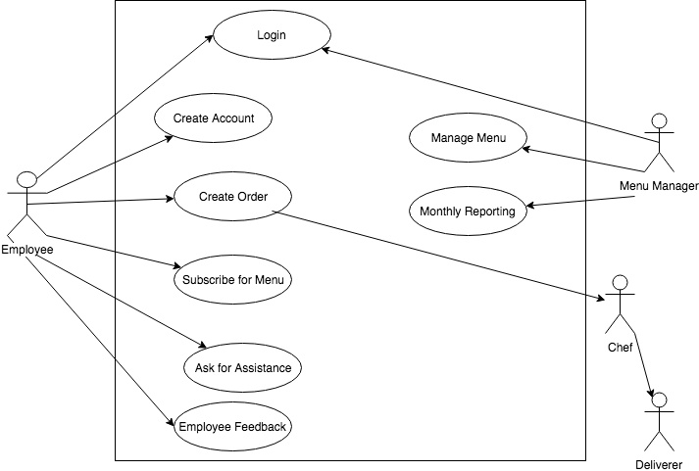

**Figure. 2** Use Case Diagram

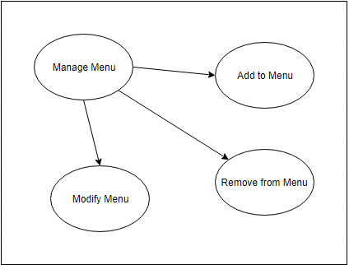

**Figure. 3** Sub-use case diagram for Manage Menu

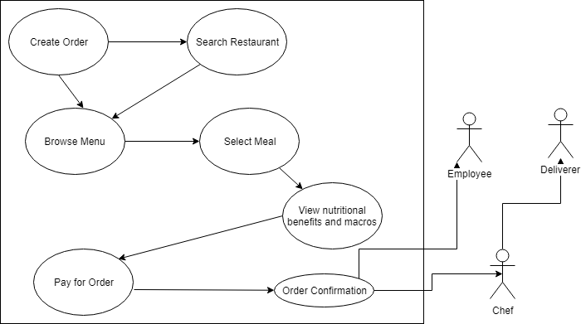

**Figure. 4** Sub-use case diagram for Create Order

|  |  |
| --- | --- |
| **Name** | Login |
| **ID** | UC-1 |
| **Primary Actor** | Menu Manager, Employee |
| **Goal** | Enable system access through web application |
| **Trigger** | Menu Manager, Employee requested access to perform his actions |
| **Preconditions** | 1. Menu manager has a valid username and password and is not logged in to the system  2. Employee has a valid username and password and is not logged in to the system |
| **Post conditions** | 1. Menu manager will be able to access menu profile  2. Employee will be able to access menu profile |
| **Normal Flow** | 1) The user selects ‘Log In’ from the web application  2) Web application prompts login window for his username and password  3) The user enters his username and password  4) The web application provides access to the system according to access control |
| **Exceptions** | 3.0.E1 User enters invalid username and password  1. Application prompts error message as Wrong Username or Password.  2a. User selects Forgot Password  2a.1 Application prompts Forgot password window  2a.2 User provide Login name and emailID to get password and go to Normal Flow 3.  2b. User selects reset password  2b.1 Application prompts Reset password window  2b.2 User provide emailID to get new password  2b.3 User gets new system generated password through email and go to step 3 |

|  |  |
| --- | --- |
| **Use Case** | Manage Menu |
| **ID** | UC-2 |
| **Primary Actor** | Menu Manager |
| **Goal** | Enable Menu Manager to manage menu |
| **Trigger** | Menu Manager requested to perform action |
| **Preconditions** | Menu Manager should be logged in to the system |
| **Post conditions** | Menu manager will be able to perform actions on menu |
| **Normal Flow** | 1 Manage Menu selection  1.1 Manager select Manage Menu button  1.2 Manager make changes to selected menu  1.3 Manager saves the changes |
| **Exceptions** | 1.3.E1 Exception on save button  1. Application will show error message of ‘Error in saving data: [Object]’. [Object] will be error information from service  2. Application retain information changed by user on page and remain on same page to Save data again by user. |

|  |  |
| --- | --- |
| **Use Case** | Add to Menu |
| **ID** | UC-3 |
| **Primary Actor** | Menu Manager |
| **Goal** | Enable Menu Manager to add menu item to menu |
| **Trigger** | Menu Manager requested to perform action |
| **Preconditions** | 1. Menu Manager should be logged in to the system  2. Menu Manager should be on Manage Menu page |
| **Post conditions** | Menu manager will be able to perform add menu action |
| **Normal Flow** | 1. Add item selection  1.1 Manager selects Add new item button  1.2 Manager provide new item information  1.3 Manager saves new item by clicking Save button |
| **Exceptions** | 1.2.E1 Exception if item already exist  1. If typed item is already exists, system should show error message and show the matching item information.  1.3.E1 Exception on save button  1. Application will show error message of ‘Error in saving data: [Object]’. [Object] will be error information from service  2. Application retain information changed by user on page and remain on same page to Save data again by user. |

|  |  |
| --- | --- |
| **Use Case** | Remove from Menu |
| **ID** | UC-4 |
| **Primary Actor** | Menu Manager |
| **Goal** | Enable Menu Manager to remove menu item from menu |
| **Trigger** | Menu Manager requested to perform action |
| **Preconditions** | 1. Menu Manager should be logged in to the system  2. Menu Manager should be on Manage Menu page |
| **Post conditions** | Menu manager will be able to perform remove menu item action |
| **Normal Flow** | 1 Delete from Menu selection  1.1 Manager selects menu item to be deleted  1.2 Manager deletes menu item by selecting delete button in front of selected item  1.3 Manager saves changes by clicking save button |
| **Exceptions** | 1.3.E1 Exception on save button  1. Application will show error message of ‘Error in saving data: [Object]’. [Object] will be error information from service  2. Application retain information changed by user on page and remain on same page to Save data again by user. |

|  |  |
| --- | --- |
| **Use Case** | Modify Menu |
| **ID** | UC-5 |
| **Primary Actor** | Menu Manager |
| **Goal** | Enable Menu Manager to modify menu item from menu |
| **Trigger** | Menu Manager requested to perform action |
| **Preconditions** | 1. Menu Manager should be logged in to the system  2. Menu Manager should be on Manage Menu page |
| **Post conditions** | Menu manager will be able to perform modify menu item action |
| **Normal Flow** | 1 Modify Menu selection  1.1 Manager select menu item to modify  1.2 Manager make changes to selected menu  1.3 Manager saves changes by clicking save button |
| **Exceptions** | 1.3.E1 Exception on save button  1. Application will show error message of ‘Error in saving data: [Object]’. [Object] will be error information from service  2. Application retain information changed by user on page and remain on same page to Save data again by user. |

|  |  |
| --- | --- |
| **Name** | Create Order |
| **ID** | UC-6 |
| **Primary Actor** | Customer, employee |
| **Goal** | Enable employee to create order |
| **Trigger** | Employee requests to create order |
| **Preconditions** | Employee should be logged in to the system |
| **Post conditions** | Employee will be able to see create order page |
| **Normal Flow** | 1. Create order selection  1.1 Employee selects Create Order page from Home page  1.2 Employee shall be able to see Create Order page  1.2. Create order page shall contain Menu and Restaurant selection options |
| **Alternate Flow** | * 1. Create Order from previous orders      1. Employee shall be able to see previous ordered meals      2. Employee shall be able to select item from previous ordered meal and go to normal flow of UC 11. |
| **Exceptions** | 1.1.E1 Exception in showing Create Order Page if user is not logged in  1. If employee is not logged in to the system, system should show Login window for user login |

|  |  |
| --- | --- |
| **Name** | Browse Menu |
| **ID** | UC-7 |
| **Primary Actor** | Customer, employee |
| **Goal** | Enable employee to Browse Menu |
| **Trigger** | Employee requests to create order |
| **Preconditions** | 1. Employee should be logged in to the system  2. Employee should be on Create Order page |
| **Post conditions** | Employee will be able to see browse menu |
| **Normal Flow** | 1 Browse menu option  1.1 Employee selects Browse Menu option  1.2 Employee shall be able to view menu from restaurant’s menu  1.3 Employee shall be able to see nutritional values of item in front of every item |

|  |  |
| --- | --- |
| **Name** | Select Meal |
| **ID** | UC-8 |
| **Primary Actor** | Customer, employee |
| **Goal** | Enable employee to Select meal from menu |
| **Trigger** | Employee requests to create order |
| **Preconditions** | 1. Employee should be logged in to the system  2. Employee should be on Create Order page |
| **Post conditions** | Employee will be able to select meal from menu |
| **Normal Flow** | 1 Select Meal option  1.1 Employee shall be able to select meal from searched menu  1.2 Employee shall be able to add selected meal to Order List  1.3 Employee shall be able to select continue to checkout button  1.4 Employee shall be able to navigate to order summary page |
| **Alternate Flow** | 1.2.1 Employee shall be able to select another meal from menu  1. Employee shall be able to add new selection to Order List and go to Normal Flow 1.3 |

|  |  |
| --- | --- |
| **Name** | Select Restaurant |
| **ID** | UC-9 |
| **Primary Actor** | Customer, employee |
| **Goal** | Enable employee to Select Restaurant |
| **Trigger** | Employee requests to create order |
| **Preconditions** | 1. Employee should be logged in to the system  2. Employee should be on Create Order page |
| **Post conditions** | Employee will be able to select restaurant |
| **Normal Flow** | 1 Select Restaurant option  1.1 Employee shall be able to search Restaurant  1.2 Employee shall be able to select searched Restaurant  1.3 System should navigate employee to Browse menu page of selected Restaurant |

|  |  |
| --- | --- |
| **Name** | View nutritional benefits and macros |
| **ID** | UC-10 |
| **Primary Actor** | Customer, employee |
| **Goal** | Enable employee to view food nutritional benefits and macros of selected item |
| **Trigger** | Employee requests to view nutritional values |
| **Preconditions** | 1. Employee should be logged in to the system  2. Employee should be on Create Order page  3. Should have selected menu item to view nutritional values |
| **Post conditions** | Employee will be able to view food nutritional benefits and macros |
| **Normal Flow** | 1 Select Menu item  1.1 Employee shall be able to view food nutritional benefits and macros of selected food item |

|  |  |
| --- | --- |
| **Name** | Select Address |
| **ID** | UC-11 |
| **Primary Actor** | Customer, employee |
| **Goal** | Enable employee to Select meal delivery address |
| **Trigger** | Employee requests to create order |
| **Preconditions** | 1. Employee should be logged in to the system  2. Employee should be on Checkout page |
| **Post conditions** | Employee will be able to select meal delivery address |
| **Normal Flow** | 1 Select Meal delivery address  1.1 Employee shall be able to select meal delivery address from user profile  1.2 Employee shall be able to select continue to checkout button  1.4 Employee should be navigated to order summary page |
| **Alternate Flow** | 1.1.1 Employee shall be able to select delivery address  1. Employee shall be able to add new address and go to Normal Flow 1.2 |

|  |  |
| --- | --- |
| **Name** | Pay for Order |
| **ID** | UC-12 |
| **Primary Actor** | Customer, employee |
| **Goal** | Enable employee to pay for order |
| **Trigger** | Employee requests to pay for order |
| **Preconditions** | 1. Employee should be logged in to the system  2. Employee should be on Checkout page |
| **Post conditions** | Employee will be able to pay for order |
| **Normal Flow** | 1 Pay for Order  1.1 System should show Application page with order details with price  1.2 Employee shall be able to click on Pay for Order button  1.3 Application should show Payment window for order payment  1.4 Employee should be able to pay for order  1.5 Application should show message prompt ‘Order has been placed.’ After successful payment |

|  |  |
| --- | --- |
| **Name** | Order confirmation |
| **ID** | UC-13 |
| **Primary Actor** | Customer, employee |
| **Goal** | Enable employee to confirm order |
| **Trigger** | Employee requests to create order |
| **Preconditions** | 1. Employee should be logged in to the system  2. Employee should have completed payment process |
| **Post conditions** | Employee will be able to place order |
| **Normal Flow** | 1 Order confirmation to chef  1.1 Employee pays for order  1.2 Cafeteria Ordering system informs chef to prepare order  1.3 Cafeteria Ordering system will send an email to Employee for order confirmation  1.4 Once order is prepared, Deliverer will get notification for delivery |
| **Alternate Flow** | * 1. Cancel order      1. Employee shall be able to cancel the order      2. Employee shall be able to see Cancel Order button on confirm order page      3. Employee shall be able to select cancel order button      4. After cancel order, order should be canceled and navigate to Browse Restaurant Page. |

|  |  |
| --- | --- |
| **Name** | Create Account |
| **ID** | UC-14 |
| **Primary Actor** | Employee, Customer |
| **Goal** | Enable employee to register to Cafeteria Ordering System |
| **Trigger** | Employee request for registration |
| **Preconditions** | 1. User should be part of organization  2. User should have valid EmailID |
| **Post conditions** | Employee will be able to register for account |
| **Normal Flow** | 1) Employee selects Create Account option  2) Employee selects Register for Payment option  3) Employee adds delivery address |
| **Exceptions** | 1.0.E1 Employee is already registered  1. Application should show message prompt ‘Already registered user’ and go to Use Case Log In. |

|  |  |
| --- | --- |
| **Name** | Subscribe Menu |
| **ID** | UC-15 |
| **Primary Actor** | Employee, Customer |
| **Goal** | Enable employee to subscribe menu |
| **Trigger** | Employee request for subscription |
| **Preconditions** | 1. User should be logged in to application |
| **Post conditions** | Employee will be able to subscribe menu |
| **Normal Flow** | 1 Employee selects Subscribe menu  1.1 Employee shall be able to select and subscribe menu plan  2 Employee selects Modify subscription  2.1 Employee shall be able to update subscriptions for menu  3 Employee selects Delete subscription option  3.1 Employee shall be able to select subscribed menu item  3.2 Employee shall be able to delete the subscription for selected menu item  4 Employee selects Create subscription option  4.1 Employee shall be able to create subscription for menu  4.2 Employee shall be able to save the subscription  5 Employee selects View subscription option  5.1 Employee shall be able to view his subscriptions |
| **Exceptions** | 1.0.E1 Employee have already subscribed for same menu  1. Application should show message prompt ‘Already subscribed for menu’ and go to Normal flow 1. |

|  |  |
| --- | --- |
| **Name** | Ask for Assistance |
| **ID** | UC-16 |
| **Primary Actor** | Employee, Customer |
| **Goal** | Enable employee to get help for queries |
| **Trigger** | Employee request for help |
| **Preconditions** | 1. User should have opened the Home page |
| **Post conditions** | Employee will be able to get help from assistance |
| **Normal Flow** | 1) Employee selects Help option from Home page  2) Employee selects Talk to Assistance option |
| **Exceptions** | 1.0.E1 No assistant available to attain the session  1. Application should show message prompt ‘Assistant will be available in [provide time], please wait. |

|  |  |
| --- | --- |
| **Name** | Monthly Reporting |
| **ID** | UC-17 |
| **Primary Actor** | Menu Manager |
| **Goal** | Enable Manager to download monthly report |
| **Trigger** | Manager request for monthly report |
| **Preconditions** | 1. Manager should be logged in to the system |
| **Post conditions** | Manager will be able to download monthly report |
| **Normal Flow** | 1) Manager selects Monthly report button  2) Manager selects date range for report  3) Manager clicks on download report button |
| **Exceptions** | 2.0.E1 Manager selects wrong date range  1. Application should show message prompt ‘Please check the date range’. |

|  |  |
| --- | --- |
| **Name** | Track Order |
| **ID** | UC-18 |
| **Primary Actor** | Employee |
| **Goal** | Enable employee to track order |
| **Trigger** | Employee request for location tracking |
| **Preconditions** | 1. Employee should be logged in to the system  2. Employee should have ordered a meal |
| **Post conditions** | 1. Employee will be able to track the order status  2. Employee will be able to track the deliverer location |
| **Normal Flow** | 1) Employee selects track delivery button |

|  |  |
| --- | --- |
| **Name** | Employee Feedback |
| **ID** | UC-19 |
| **Primary Actor** | Employee |
| **Goal** | Enable employee to give feedback for order |
| **Trigger** | Employee request for feedback |
| **Preconditions** | 1. Employee should be logged in to the system  2. Employee should have ordered a meal |
| **Post conditions** | 1. Employee will be able to provide feedback |
| **Normal Flow** | 1. After ordering meal, Employee shall be able to see Feedback button on Order Page 2. Employee shall be able to select Feedback button for selected meal 3. Employee shall be able to write feedback for meal 4. Employee shall be able to submit feedback for selected meal |

# External Interface Requirements

## User Interfaces

*UI-1: Employee shall have the ability to access the COS from different browsers (*Microsoft Internet Explorer, Mozilla Firefox, Chrome, Safari*).*

UI-2: The COS system shall provide help button on Home web page, Order Menu page, Profile page, Manage Menu page, Subscription page, to explain how to use that page.

## Hardware Interfaces

Hardware interface has not been identified for the COS.

## Software Interfaces

SI-1: Payroll System

SI-1.1: The COS system shall communicate with payroll system to register the user payroll information.

SI-1.2: The COS system shall communicate with payroll system to un-register the user payroll information.

SI-1.3: The COS system shall communicate with payroll system to submit the payment request.

SI-1.4: The COS system shall communicate with payroll system to request for refund.

## Communications Interfaces

CI-1: The COS shall send an e-mail and notification message to the employee to confirm acceptance of an order, price, and delivery instructions.

CI-2: The COS shall provide notification message to the user for status of the delivery from pick-up, on the way, and delivered.

CI-3: The COS shall send an e-mail and notification message to the employee to report any problems with the payment, order problem, order not delivered.

# Other Nonfunctional Requirements

## Performance Requirements

PE-1: The system shall accommodate 1000 users during the peak usage time window of 8:00am to 10:00am, 12:00pm to 2:00pm, and 6:00pm to 8:00pm local time, with an estimated average session duration of 10 minutes.

PE-2: All html pages should be loaded no more than 1 seconds over a 4MBps modem connection.

PE-3: The system shall complete the payment within 4 seconds once payment submitted and display the confirmation message.

## Safety Requirements

Safety requirements have not been identified.

## Security Requirements

SE-1: All financial transactions involved on COS should be encrypted.

SE-2: Users should be logged in order to place the order.

SE-3: COS system shall only allow the menu manger to create, edit or modify the menu.

SE-4: COS system shall only view the order placed by the user itself not others.

## Software Quality Attributes

Availability-1: The COS shall be available to users on the Internet and website should be up 99.99% on weekdays.

Robustness-1: If the connection interrupted while placing order by the user it should recover the system from the last state of the user.

Performance-1: Order processing should be fast, for timely delivery.

Usability-1: COS System provides help tutorials in the form of audio/video, which will make

system easy to learn.

# Other Requirements

No other requirements have been identified.

# PART II

# Data Flow Diagram

**Cafeteria Ordering System**

**Menu Manager**

**Meal Deliverer**

**Cafeteria Staff**

**Payroll System**

**Employee**

Meal order

Menu

Register for payment

Meal Subscription

Order Assistance

Manage Menu

Raw Materials Information

Monthly Reporting

Order delivery and receipt

Delivery Status

Process Refunds

Process Payments

Status Update

Confirm order

**Figure 5** : Level 0 data flow diagram of the Cafeteria Ordering System.

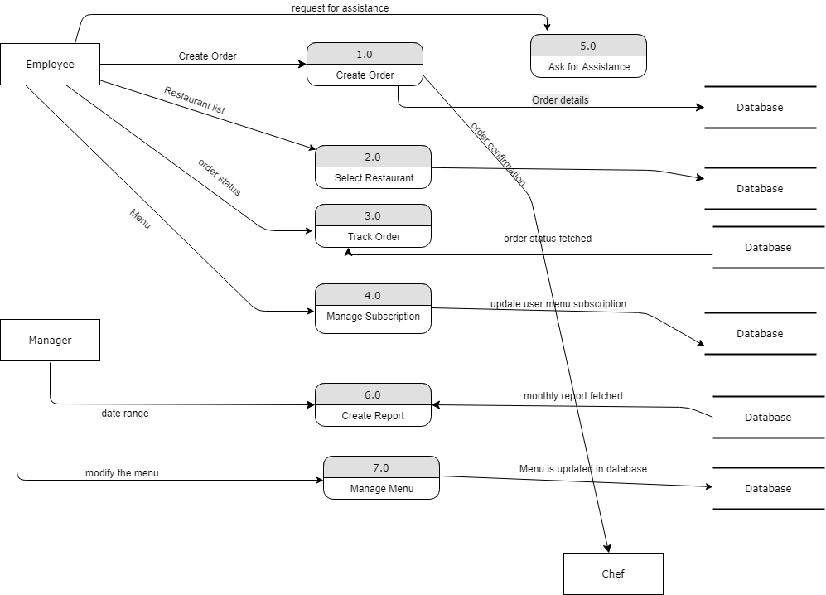

**Figure 6** : Level 1 data flow diagram of the Cafeteria Ordering System.

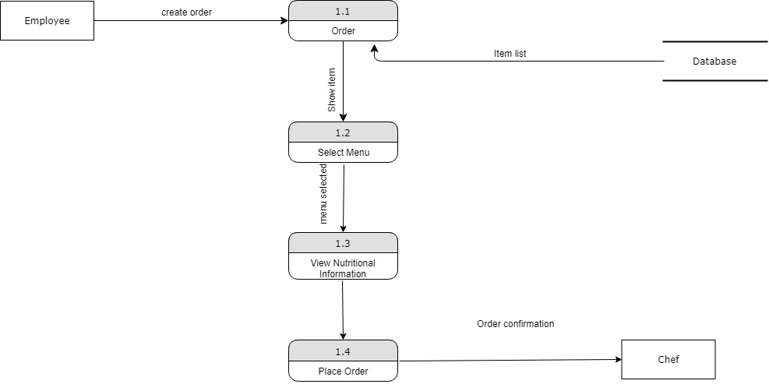

**Figure 7** : Level 2 data flow diagram for placing an order.

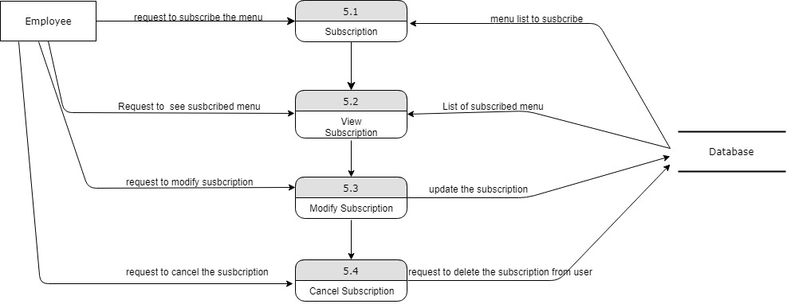

**Figure 8** : Level 2 data flow diagram for Menu subscription.

# Functional Requirements (FRs)

## Functional Requirement #1 – Create Account

### Introduction

An employee should be able to create an account in order to place meal orders from

Cafeteria Ordering System.

### Inputs

Employee should provide below information to create an account:

* First Name
* Last Name
* DOB
* Employee ID
* Email ID
* Gender
* Phone No.
* Delivery Address (Desk no./ meeting room/ home)
* Payment Mode

### Processing

Step 1: Employee shall be able to open Cafeteria Ordering System URL.

Step 2: Employee shall be able to view COS webpage with Create Account link.

Step 3: Employee shall be able to click on Create Account Link.

Step 4: Employee shall be able to view Create Account webpage after clicking on

Create Account link.

Step 5: Employee shall be able to input First Name, Last Name, DOB, Employee ID,

Email ID Gender, Phone No. and Delivery Address.

Step 6: Employee should receive verification code on mobile after entering phone no. in

the field.

Step 7: Employee shall enter the request code to verify the phone no.

Step 8: Employee shall be able to select payment mode and fill card details if the delivery

is not COD.

Step 9: Employee shall be able to view and select meal subscription option.

Step 10: Employee shall be able to select Terms & Conditions checkbox and click on

Submit button.

### Outputs

Employee shall receive account creation confirmation message on webpage and on

Email ID with user name and temporary password.

### Error Handling

**Error 1:** Employee unable to access COS URL.

**Solution 1:** Employee should change proxy settings by adding the URL to trusted sites.

**Error 2:** COS webpage is not getting displayed correctly.

**Solution 2:** Employee should check the recommended browser versions to access the URL.

**Error 3:** Employee did not receive confirmation mail for account creation.

**Solution 3:** Employee shall call for assistance.

## Functional Requirement#2- Login

### Introduction

An employee and menu manager should be able to login in Cafeteria Ordering System

using his/her username and password.

**8.2.2 Inputs**

In order to login in system employee or menu manager must have:

* User Name
* Password

### Processing

Step 1: Employee/Menu Manager shall be able to open Cafeteria Ordering System URL.

Step 2: Employee/Menu Manager shall be able to view COS webpage with Login link.

Step 3: Employee/Menu Manager shall be able to click on Login link.

Step 4: Employee/Menu Manager shall be able to view login window to enter username

and password.

Step 5: Employee/Menu Manager shall be able to enter username and password and

and click on login button.

### Outputs

Employee/Menu Manager shall be logged in the COS and shall be able to view their

name below people icon button.

### Error Handling

**Error 1:** Employee unable to access COS URL.

**Solution 1:** Employee should change proxy settings by adding the URL to trusted sites.

**Error 2:** COS webpage is not getting displayed correctly.

**Solution 2:** Employee shall refresh the webpage.

**Error 3:** Login window does not get displayed after clicking on login link on COS webpage.

**Solution 3:** Employee should check the recommended browser versions as few features wouldn’t work appropriately if the recommended version is not being used.

**Error 4:** COS webpage is taking more time to load.

**Solution 4:** Employee should delete temp files and try loading the webpage again.

## Functional Requirement#3- Create & Place Order

### Introduction

#### An employee should be able to create and place an order to be picked up.

#### An employee should be able to create and place an order to be delivered to

desired delivery location.

### Inputs

Below are the inputs which system will require in order to create and place order:

* User Name
* Password
* Meal items
* Payment details
* Delivery address (in case of delivery on desired location)
* Contact Details

### Processing

Step 1: Employee shall be able to open Cafeteria Ordering System webpage and

login.

Step 2: Employee shall be able to browse menu from Cafeteria or ‘Search

Restaurant’ to order meal.

Step 2.a: Employee shall be able to select restaurant from which he would like to

place order.

Step 3: Employee shall be able to browse menu.

Step 4: Employee shall be able to select meal by adding and removing items in

cart.

Step 5: Employee shall be able to update the quantity of item in the cart.

Step 6: Employee shall provide delivery preference as pick-up or delivery to

desired location.

Step 7: Employee shall be able to select new address for delivery or can use the

address provided at the time of account creation.

Step 8: Employee shall be able to select payment option.

Step 9: Employee shall be able to place order by clicking on Place Order button.

### Outputs

Employee shall receive order confirmation on email and phone.

Employee shall receive link to track the order.

### Error Handling

**Error 1:** Employee is not able to search desired restaurant to order meal.

**Solution 1:** Employee should check if he/she is searching with correct restaurant name.

**Error 2:** Employee is not able to select the restaurant to order.

**Solution 2:** Employee shall check if the restaurant is available for delivery.

**Error 3:** Card payment is not successful.

**Solution 3:** Employee shall verify if the card has been expired or card does not contain

enough cash to be deducted.

## Functional Requirement#4- Subscribe Menu

### Introduction

An employee should be able to Subscribe for menu items to save daily ordering time

consumption.

### Inputs

Below inputs are required to Subscribe Menu:

* User login details
* Meal Items to be chosen for meal subscription

### Processing

Step 1: Employee shall be able to open Cafeteria Ordering System webpage and

login.

Step 2: Employee shall be able to create subscription.

2.1 **Create Subscription:**

2.1.a. Employee shall be able to select subscription checkbox option while creating account.

2.1.b. Employee shall be able to subscribe for menu by navigating to Account details tab.

2.2 Employee shall be able to select different meals options to subscribe.

Step 3: Employee shall be able to modify subscription existing subscription menu.

3.1 **Modify Subscription:**

3.1.a. Employee shall be able to add new items to subscription menu.

3.1.b. Employee shall be able to remove items from subscription menu.

3.1.c. Employee shall be able to update quantity of items in subscription menu.

Step 4: Employee shall be able to add multiple subscriptions in his/her account

according to weekly food choices.

Step 5: Employee shall be able to view and delete subscription menu from account

details page.

### Outputs

Employee shall be able to create/view/delete/modify/manage multiple subscriptions.

### Error Handling

**Error 1:** Employee is unable to subscribe for menu.

**Solution 1:** Employee should check if the subscription for same menu already exists.

## Functional Requirement#5- Ask for Assistance

### Introduction

Employee shall be able to Ask for Assistance in case of any queries or issues related to

Order placement or COS system as a whole.

### Inputs

* User Login details.

### Processing

Step 1: Employee shall be able to open Cafeteria Ordering System webpage and

login.

Step 2: Employee shall be able to view and select Help icon from COS home page.

Step 3: Employee shall be able to click on ‘Ask for Assistance’ icon.

Step 4: Employee shall be able to view chat window with the message prompt

‘Assistant will be available in [provide time], please wait.’

### Outputs

Employee shall be able to communicate with the technical assistant in order to

resolve queries or any other issues faced.

### Error Handling

**Error 1:** Assistant is not available to chat.

**Solution1:** Employee shall be provided with an option to call back with ETC provided.

## Functional Requirement#6- Track Order

### Introduction

Employee shall be able to track order once the order is confirmed.

### Inputs

* User Login Details

### Processing

Step 1: Employee shall be able to open Cafeteria Ordering System webpage and

login.

Step 2: Employee shall be able to click on track delivery icon on home page.

Step 3: Employee shall be able to view order status in following phases:

1. Order Confirmed
2. Preparing
3. Dispatched

Step 4: Employee shall be able to track deliverer location on map along with the name and contact details of deliverer.

### Outputs

Employee shall be able to track the order status and delivery status successfully.

### Error Handling

**Error 1:** Employee unable to track deliverer status on map while using mobile device.

**Solution:** Employee GPS and location settings should be on while using mobile device.

## Functional Requirement#7- Manage Menu

### Introduction

Menu manager shall be able to modify, delete and add menu based on the food

items available for delivery.

### Inputs

* Specific Access Control login.

### Processing

Step 1: Menu manager shall be able to open Cafeteria Ordering System webpage

and login.

Step 2: Menu manager shall be able to add item in the menu.

Step 3: Menu manager shall be able to modify menu based on the availability of

the food items available.

Step 4: Menu manager shall be able to delete the items from the menu

which are not available.

Step 5: Menu manager shall be able to save the menu.

### Outputs

Menu manager shall be able to access the menu and make necessary changes

required.

### Error Handling

**Error 1:** Menu manager is unable to add item to the menu.

**Solution 1:** Menu manager should check if the item has already been added to the menu.

## Functional Requirement#8- Monthly Reporting

### Introduction

Manager shall be able to download and view monthly report of food items sold and

raw materials usage.

### Inputs

* Specific Access Control login.

### Processing

Step 1: Manager shall be able to access reports from the COS homepage.

Step 2: Manager shall be able to download reports for specific date range.

### Outputs

Manager shall be able to access and download report for require date range.

### Error Handling

**Error 1:** Manager unable to extract report for specific date range.

**Solution1:** Manager shall verify if the correct date range is provided.

## Functional Requirement#9- Browse Restaurants

### Introduction

Employee shall be able to browse restaurants.

### Inputs: Employee Login details

### Processing:

Step 1: Employee shall be able to login in COS.

Step 2: Employee should be on Create Order page.

Step 3: Employee shall be able to view list of restaurants available for food delivery.

Step 4: Employee shall be able to search the restaurant of choice.

Step 5: Employee shall be able to select the restaurant of choice and order food.

### Outputs

Employee shall be able to browse restaurants and order food from selected restaurant.

### Error Handling

**Error 1:** Employee unable to select a specific restaurant from list of restaurants.

**Solution1:** Employee shall check if the specific restaurant is ready for taking food orders and is enabled in the list of restaurants.

## Functional Requirement#10- Check Food Nutritional Benefits, Macros & Recipes

### Introduction

### Employee shall be able to check nutritional benefits of the selected food item.

### Employee shall be able to view the Macros and set the macros according to his diet plan

Employee shall be able to view the recipe for the selected food item.

### Inputs: Employee Login details

### Processing:

Step 1: Employee shall be able to login in COS.

Step 2: Employee shall be able to select the food item.

Step 3: Employee shall be able to check the nutritional facts of the selected food item.

Step 4: Employee shall be able to view and set the macros according to his diet plan requirements.

Step 5: Employee shall be able to view the recipe for the selected food item.

### Outputs

Employee shall be able to successfully view Nutritional benefits, macros and recipes for the selected food items.

### Error Handling

**Error 1:** Employee is unable to select the food items to view nutritional benefits, macros and recipe.

**Solution1:** Employee shall verify if the food item is still available. Employee will not be able to view the above mentioned features of the food item if it is not available.

## Functional Requirement#11- Meal payment

### Introduction

Employee shall be able to pay for meal either from his debit/credit card or cash on delivery.

### Inputs: Employee Login details, Debit/Credit card details

### Processing:

Step 1: Employee shall be able to login in COS.

Step 2: Employee shall be able to view order details page with the total price.

Step 3: Employee shall be able to click on pay for order button and select the payment option.

Step 4: Employee shall be able to view ‘Order has been placed’ confirmation text after successful payment.

### Outputs

Employee shall be able to select meal payment option and shall be able to successfully place the order.

### Error Handling

**Error 1:** Employee card details are not being accepted by the COS system.

**Solution1:** Employee need to verify if the card is valid and he/she is entering correct card details.

## Functional Requirement#13- View, Update and Cancel Order

### Introduction

Employee shall be able to view, update and cancel the order within 10mins, once the order is placed.

### Inputs: Employee Login details, Order Confirmation No.

### Processing:

Step 1: Employee shall be able to login in COS.

Step 2: Employee shall be able to view the order using order confirmation number.

Step 2.a: Employee shall be able to view the order by navigating to recent orders webpage.

Step 3: Employee shall be able to update the order either by calling customer service or by clicking on update order link available (enabled) on the order detail page.

Step 4: Employee shall be able to cancel the order by calling the customer service or by clicking on cancel order link available (enabled) on the order detail page.

### Outputs

Employee shall be able to successfully view, update and cancel the order placed.

### Error Handling

**Error 1:** Employee is unable to update and cancel the order.

**Solution1:** Employee shall verify if the update and cancel order links are enabled on order detail page.

## Functional Requirement#14- Repayment

### Introduction

COS shall initiate repayment request if the order has been canceled or failed.

### Inputs: Employee account details

### Processing:

Step 1: COS system shall notify the employee if the order has cancelled or failed.

Step 2: COS system shall initiate repayment request and send an email confirmation regarding same.

Step 3: COS system shall inform the employee regarding the amount being repaid and in the number of days it will be reflecting in his/her bank account.

### Outputs

COS system shall be able to complete the repayment request successfully.

### Error Handling

**Error 1:** Amount not debited successfully.

**Solution1:** COS system shall validate if the employee account details are correct to make repayment.

## Functional Requirement#15- View Previous Orders

### Introduction

COS system shall allow employee to view past 3months meal orders.

### Inputs: Employee Login details

### Processing:

Step 1: Employee shall be able to login in COS.

Step 2: Employee shall be able to navigate to Past Orders page.

Step 3: Employee shall be able to view meals ordered within the previous 3months.

### Outputs

Employee shall be able to successfully view the previous 3months meal orders.

### Error Handling

Not identified.

## Functional Requirement#16- Reorder previous meal orders

### Introduction

COS system shall allow employee to reorder previous 3months meal orders.

### Inputs: Employee Login details

### Processing:

Step 1: Employee shall be able to login in COS.

Step 2: Employee shall be able to navigate to Past Orders page.

Step 3: Employee shall be able to view meals ordered within the previous 3months.

Step 4: Employee shall be able to view reorder button enabled beside every meal ordered within past 3months.

### Outputs

Employee shall be able to successfully reorder meals placed within last 3months.

### Error Handling

Not identified.

## Functional Requirement#16- Employee Feedback

### Introduction

COS system shall allow employees to provide feedback on the current order placed.

### Inputs: Employee Login details

### Processing:

Step 1: Employee shall be able to login in COS.

Step 2: Employee shall be able to navigate to Orders page.

Step 3: Employee shall be able to view and select current order.

Step 4: Employee shall be able to click on feedback button and provide feedback.

### Outputs

Employee shall be able to successfully provide feedback for the current order.

### Error Handling

**Error:** Employee is unable to provide feedback.

**Solution:** Employee shall verify if he is trying to provide feedback for past orders.

# Sequence Diagram

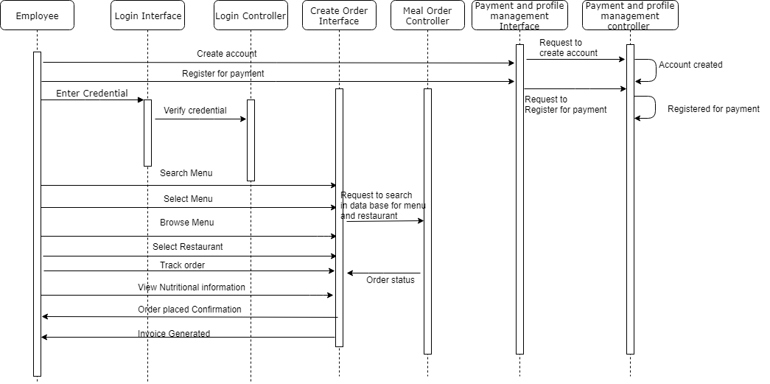

***Figure 9.*** *Sequence diagram is derived from UC- 6 to UC-14*

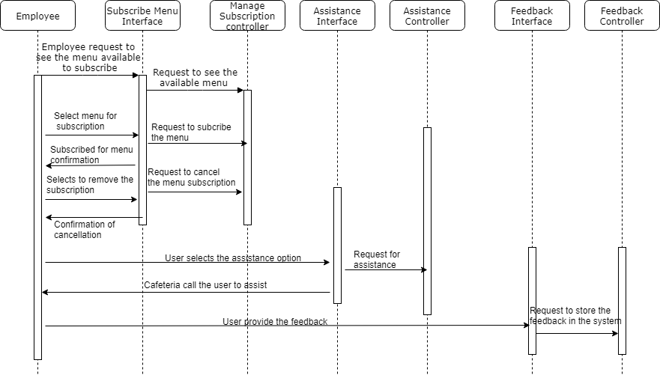

**Figure 10.**Sequence diagram is derived from UC-15 and UC-17

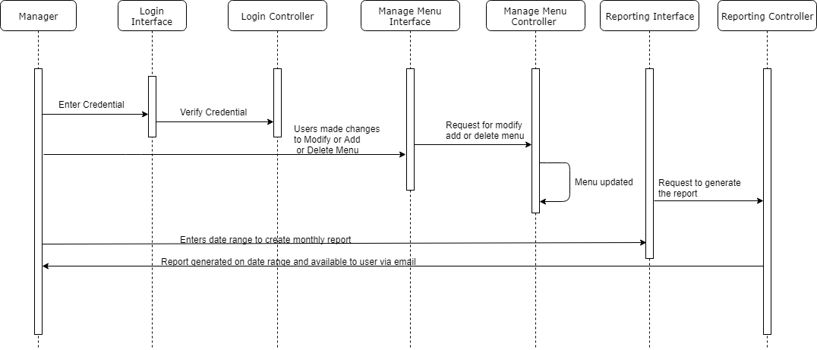

**Figure 11.**Sequence diagram is derived from UC-1 to UC-5 and UC-17

# Class Diagrams

## Initial Class Diagram

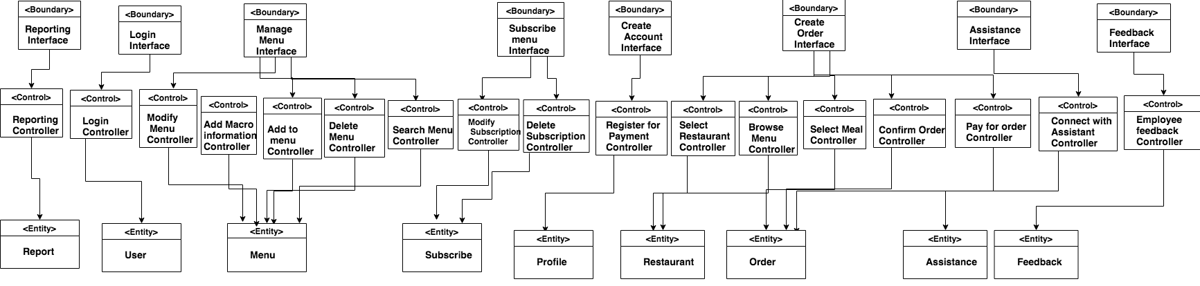

***Figure 12.****Initial Class Diagram*

## Modified Class Diagram

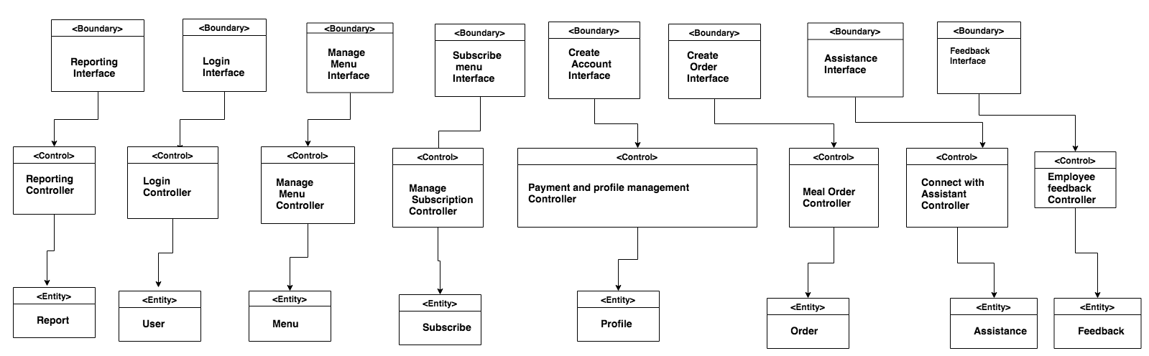

***Figure 13.****Modified Class Diagram*

## Detailed Class Diagram

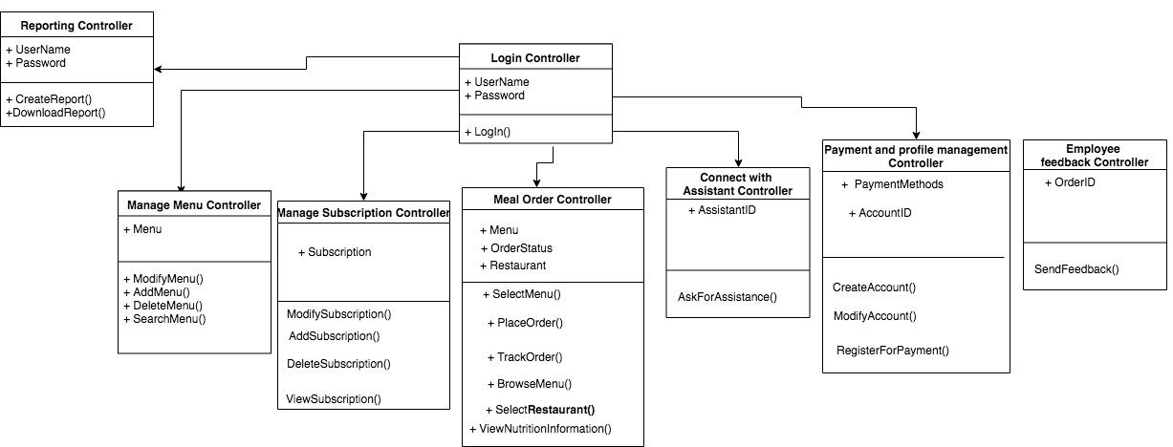

***Figure 14*** *Detailed Class Diagram*