Output 1:

Drawing a circle and box.

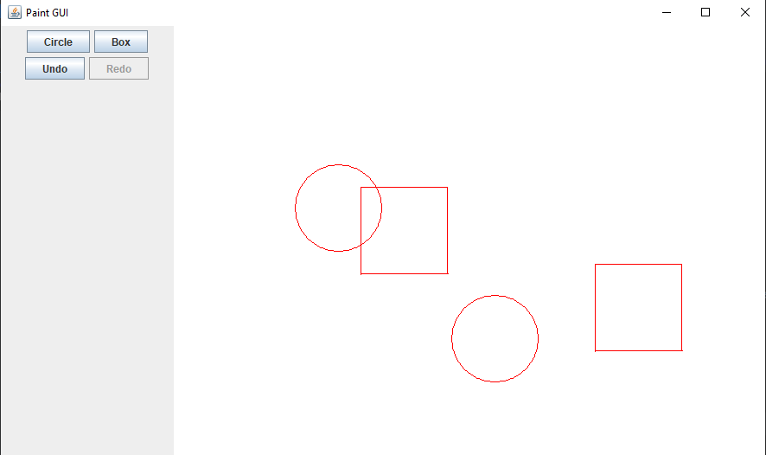

Output2:

Clicked Undo Once. Notice the Box is gone and the Redo Button is enabled.

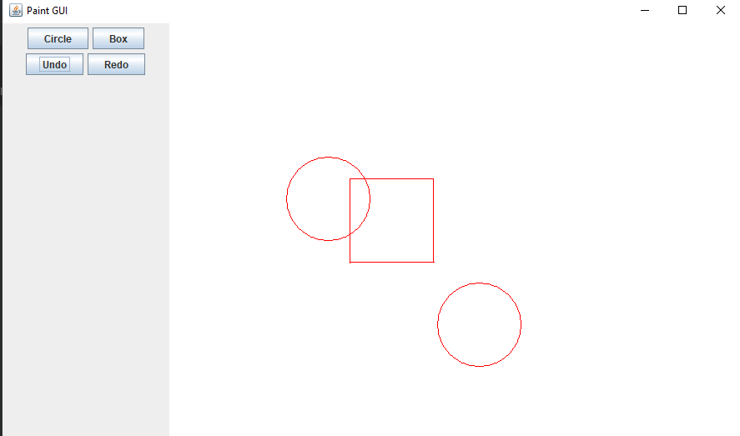

Output3:

Clicked Redo Button. The Box is back and the redo is disabled.

