**Program 1**

Start by reviewing HDFS. You will find that its composition is similar to your local Linux file system. You will use the hadoop fs command when interacting with HDFS.

1. Review the commands available for the Hadoop Distributed File System:
2. Copy file foo.txt from local disk to the user’s directory in HDFS
3. Get a directory listing of the user’s home directory in HDFS
4. Get a directory listing of the HDFS root directory
5. Display the contents of the HDFS file user/fred/bar.txt

a.Review the commands for HDFS

Cmd: hadoop fs

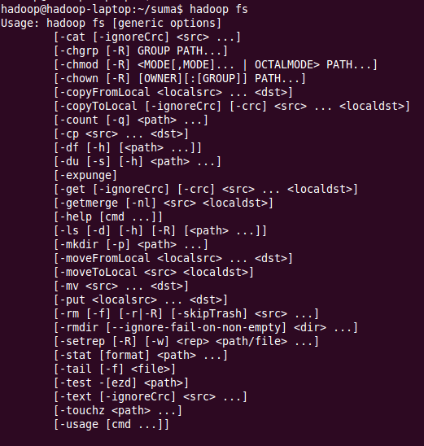

b. Copy file foo.txt from local disk to user’s directory in HDFS

1.First create file foo.txt

Cmd: vi foo.txt



2.Type some contents in the file foo.txt, save and exit by pressing ‘esc’ button where you will come out of text box and then use the cmd (‘:wq!’ to save and exit).

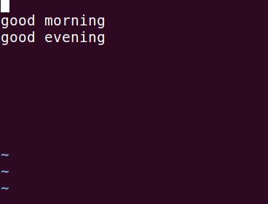

3.In order to copy the file foo1.txt from root directory to user directory in HDFS, use the

Cmd: hadoop fs –put foo1.txt /user



c. Get a directory listing of the user’s Home directory in HDFS

Cmd: hadoop fs -ls /user

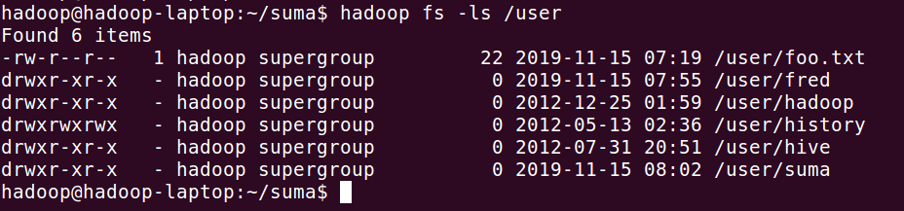

d. Get a directory listing of the HDFS root directory

Cmd: hadoop fs -ls

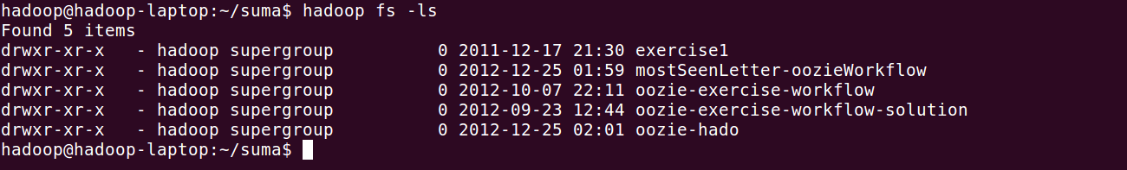

e. Get a directory listing of HDFS file user/fred/bar.txt

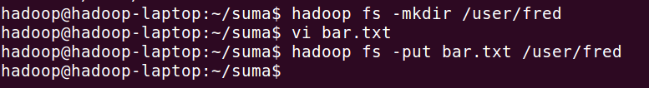

To view the contents in bar.txt

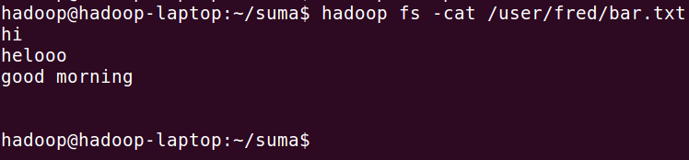

**Program 2**

Start by reviewing HDFS. You will find that its composition is similar to your local Linux file system. You will use the hadoop fs command when interacting with HDFS.

1. Move that file to the local disk, named as baz.txt
2. Create a directory called input under the user’s home directory
3. Delete the directory input old and all its contents
4. Verify the copy by listing the directory contents in HDFS.

a.Move that file to the local disk, named as baz.txt

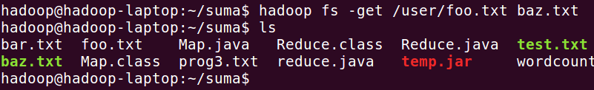

b. Create a directory called input under the user’s home directory

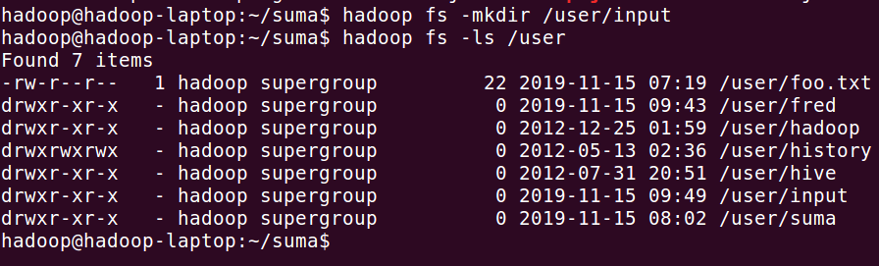

c. Delete the directory input old and all its contents



d. Verify the copy by listing the directory contents in HDFS.

