

GOVERNMENT ARTS AND SCIENCE COLLEGE

19, POONTHOTTAM STREET

THIRUVOTTIYUR ,CHENNAI-19

**FitFlex : Your Personal Fitness Companion.**

**Team ID : NM2025TMID37723**

**Team Size : 5**

**Team Leader : KAUSIKA P**

**Team member : DHARSHINI M**

**Team member : HEMALATHA S**

**Team member : JOTHI S**

**Team member : PRIYA M**

**INDEX**

**> Introduction**

**> Description**

**> Key Features**

**> PRE- REQUISITES**

**> Project Structure**

**> Project Flow**

**> Project demo**

**> Project setup and configuration**

**> Installation of required tools**

**> Project Development**

**> Setup the Routing paths**

**> Project Implementation & Execution**

**FITFLEX: YOUR PERSONAL FITNESS COMPANION**

(React Application)

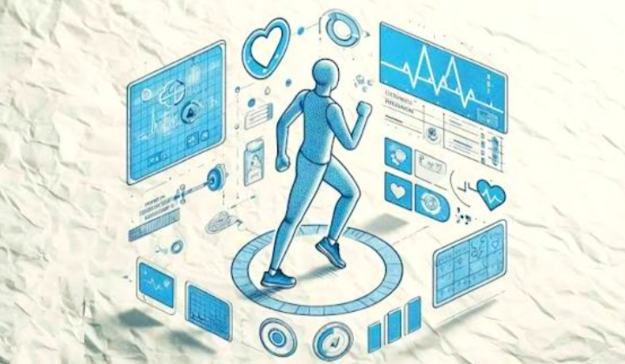

**Introduction:**

Staying fit is no longer just about hitting the gym-it's about having the right guidance, motivation, and tools at your fingertips. FitFlex is designed to be your all-in-one fitness companion, helping you create a healthier lifestyle that's flexible, achievable, and sustainable. With personalized workouts, smart tracking, and expert nutrition guidance, FitFlex adapts to your unique goals and keeps you motivated every step of the way.

**Description:**

**FitFlex - Your Personal Fitness Companion**

FitFlex is your all-in-one fitness partner designed to help you achieve your health goals with ease and motivation. Whether you're aiming to lose weight, build strength, or stay active, FitFlex offers personalized workout plans, nutrition guidance, and progress tracking tailored just for you. With smart reminders, expert tips, and easy-to-follow routines, it keeps you consistent and motivated every step of the way.

Stay flexible with your fitness-anytime, anywhere-with FitFlex, your trusted fitness companion.

**Key Features:**

1.Personalized Workout Plans - Tailored routines for your fitness goals (weight loss, muscle gain, endurance, or overall fitness).

2.Smart Progress Tracking - Monitor calories burned, steps, workouts, and body measurements with easy-to-read stats.

3.Workout Anywhere Home-friendly,

equipment-free, or gym-based routines to match your lifestyle.

4.Motivational Reminders - Daily push

notifications to keep you consistent and on track.

5.Video & Audio Guidance - Step-by-step

instructions to ensure proper form and maximum results.

**PRE-REQUISITES:**

Here are the key prerequisites for developing a frontend application using React.js:

* **Node.js and npm**:

Node.js is a powerful JavaScript runtime environment that allows you to run JavaScript code on the local environment. It provides a scalable and efficient platform for building network applications.

Install Node.js and npm on your development machine, as they are required to run JavaScript on the server-side.

* Download: <https://nodejs.org/en/download/>
* Installation instructions: <https://nodejs.org/en/download/package-manager/>

## **React.js**:

React.js is a popular JavaScript library for building user interfaces. It enables developers to create interactive and reusable UI components, making it easier to build dynamic and responsive web applications.

Install React.js, a JavaScript library for building user interfaces.

* Create a new React app:

npx create-react-app my-react-app

Replace my-react-app with your preferred project name.

* Navigate to the project directory:

cd my-react-app

* Running the React App:

With the React app created, you can now start the development server and see your React application in action.

* Start the development server:

npm start

This command launches the development server, and you can access your React app at http://localhost:3000 in your web browser.

* **HTML, CSS, and JavaScript**: Basic knowledge of HTML for creating the structure of your app, CSS for styling, and JavaScript for client-side interactivity is essential.

* **Version Control**: Use Git for version control, enabling collaboration and tracking changes throughout the development process. Platforms like GitHub or Bitbucket can host your repository.

 • Git: Download and installation instructions can be found at: <https://git-scm.com/downloads>

* **Development Environment**: Choose a code editor or Integrated Development Environment (IDE) that suits your preferences, such as Visual Studio Code, Sublime Text, or WebStorm.

• Visual Studio Code: Download from <https://code.visualstudio.com/download>

• Sublime Text: Download from <https://www.sublimetext.com/download>

• WebStorm: Download from [https://www.jetbrains.com/webstorm/download](https://www.jetbrains.com/webstorm/download%20)

To get the Application project from drive:

Follow below steps:

* **Get the code:**

• Download the code from the drive link given below:

<https://drive.google.com/drive/folders/14f9eBQ5W7VrLdPhP2W6PzOU_HCy8UMex?usp=sharing>

**Install Dependencies:**

• Navigate into the cloned repository directory and install libraries:

cd fitness-app-react

npm install

* **Start the Development Server**:

• To start the development server, execute the following command:

npm start

**Access the App:**

• Open your web browser and navigate to [http://localhost:3000](http://localhost:3000/).

• You should see the application's homepage, indicating that the installation and setup were successful.

 You have successfully installed and set up the application on your local machine. You can now proceed with further customization, development, and testing as needed.

### Project structure:

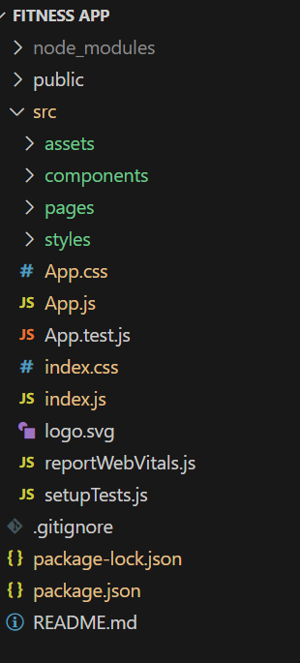    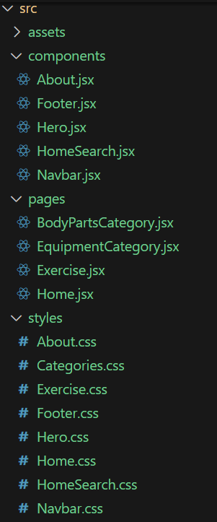

In this project, we’ve split the files into 3 major folders, *Components, Pages and Styles.* In the pages folder, we store the files that acts as pages at different URLs in the application. The components folder stores all the files, that returns the small components in the application. All the styling css files will be stored in the styles folder.

### Project Flow:

**Project demo:**

Before starting to work on this project, let’s see the demo.

Demo link: https://drive.google.com/file/d/1xbzVoqxeJRnvsh0FWv5D16EOANfwZ8U8/view?usp=sharing

Use the code in: <https://drive.google.com/drive/folders/14f9eBQ5W7VrLdPhP2W6PzOU_HCy8UMex?usp=sharing>

Let's Proceed with the project flow for the project development phase

### Project setup and configuration:

* **Installation of required tools**:

1.Open the project folder to install necessary tools

In this project, we use:

* React Js
* React Router Dom
* React Icons
* Bootstrap/tailwind css
* Axios

* For further reference, use the following resources
* <https://react.dev/learn/installation>
* <https://react-bootstrap-v4.netlify.app/getting-started/introduction/>
* <https://axios-http.com/docs/intro>
* <https://reactrouter.com/en/main/start/tutorial>

### Project Development:

* Setup the Routing paths

Setup the clear routing paths to access various files in the application.

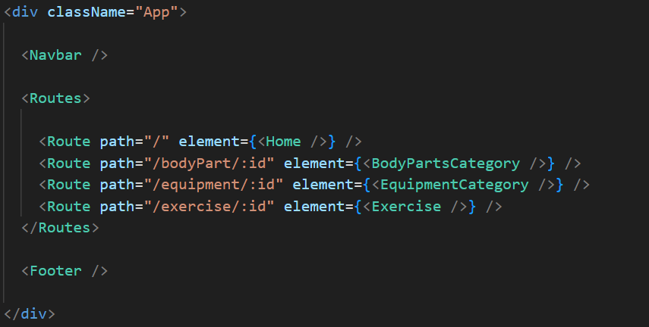

* Develop the Navbar and Hero components
* Code the popular search/categories components and fetch the categories from ***rapid Api***.
* Additionally, we can add the component to subscribe for the newsletter and the footer.
* Now, develop the category page to display various exercises under the category.
* Finally, code the exercise page, where the instructions, other details along with related videos from the YouTube will be displayed.

**Important Code snips:**

* **Fetching available Equipment list & Body parts list**

From the Rapid API hub, we fetch available equipment and list of body parts with an API request.

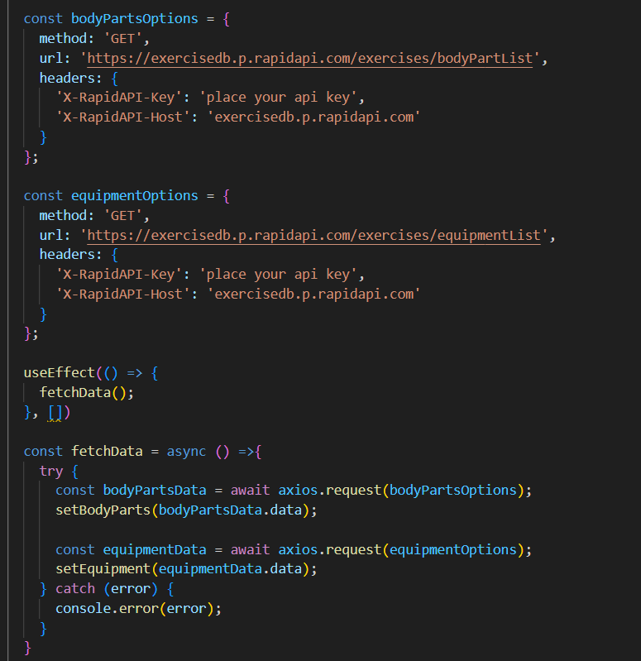

Here's a breakdown of the code:

*Dependencies:*

The code utilizes the following libraries:

Axios: A popular promise-based HTTP client for JavaScript. You can add a link to the official documentation for Axios <https://axios-http.com/>

*API Key:*

Replace 'place your api key' with a placeholder mentioning that the user needs to replace it with their own RapidAPI key. You can mention how to acquire an API key from RapidAPI.

*bodyPartsOptions and equipmentOptions:*

These variables hold configuration options for fetching data from the RapidAPI exercise database.

* *method:* The HTTP method used in the request. In this case, it's set to GET as the code is fetching data from the API.
* *url:* The URL of the API endpoint to fetch data from. Here, it's set to https://exercisedb.p.rapidapi.com/exercises/bodyPartList for fetching a list of body parts and https://exercisedb.p.rapidapi.com/exercises/equipmentList for fetching a list of equipment.
* *headers:* This section contains headers required for making the API request. Here it includes the X-RapidAPI-Key header to provide your API key and the X-RapidAPI-Host header specifying the host of the API.

*fetchData function:*

This function is responsible for fetching data from the API. It makes use of async/await syntax to handle asynchronous operations. First it fetches data for body parts using axios.request(bodyPartsOptions). Then it stores the fetched data in the bodyParts state variable using setBodyParts.

Similarly, it fetches data for equipment using axios.request(equipmentOptions). Then it stores the fetched data in the equipment state variable using setEquipment. In case of any errors during the API request, the catch block logs the error to the console using console.error.

*useEffect Hook:*

The useEffect hook is used to call the fetchData function whenever the component mounts. This ensures that the data is fetched as soon as the component loads.

Overall, the code snippet demonstrates how to fetch data from a RapidAPI exercise database using JavaScript's Axios library.

* **Fetching exercises under particular category**

To fetch the exercises under a particular category, we use the below code.

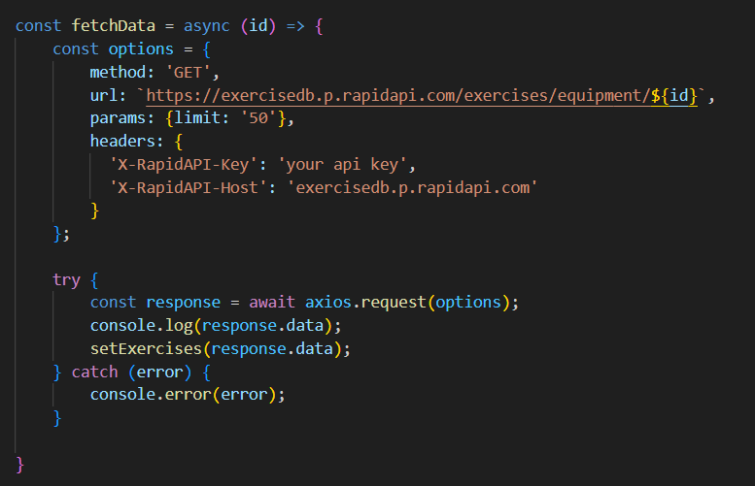

It defines a function called fetchData that fetches data from an exercise database API. Here's a breakdown of the code:

*const options = {...}:*

This line creates a constant variable named options and assigns it an object literal. The object literal contains properties that configure the API request, including:

* method: Set to 'GET', indicating that the API request is a GET request to retrieve data from the server.
* url: Set to https://exercisedb.p.rapidapi.com/exercises/equipment/${id}, which is the URL of the API endpoint for fetching exercise equipment data. The ${id} placeholder will likely be replaced with a specific equipment ID when the function is called.
* params: An object literal with a property limit: '50'. This specifies that you want to retrieve a maximum of 50 exercise equipment results.
* headers: An object literal containing two headers required for making the API request:
* 'X-RapidAPI-Key': Your RapidAPI key, which is used for authentication. You should replace 'your api key' with a placeholder instructing users to replace it with their own API key.
* 'X-RapidAPI-Host': The host of the API, which is 'exercisedb.p.rapidapi.com' in this case.

*const fetchData = async (id) => {...}:*

This line defines an asynchronous function named fetchData that takes an id parameter. This id parameter is likely used to specify the equipment ID for which data needs to be fetched from the API.

*try...catch block:*

* The try...catch block is used to handle the API request.
* The try block contains the code that attempts to fetch data from the API using axios.request(options).
* The await keyword is used before axios.request(options) because the function is asynchronous and waits for the API request to complete before proceeding.
* If the API request is successful, the response data is stored in the response constant variable.
* The console.log(response.data) line logs the fetched data to the console.
* The .then method (not shown in the image) is likely used to process the fetched data after a successful API request.
* The catch block handles any errors that might occur during the API request. If there's an error, it's logged to the console using console.error(error).

* **Fetching Exercise details**

Now, with the help of the Exercise ID, we fetch the details of a particular exercise with API request.

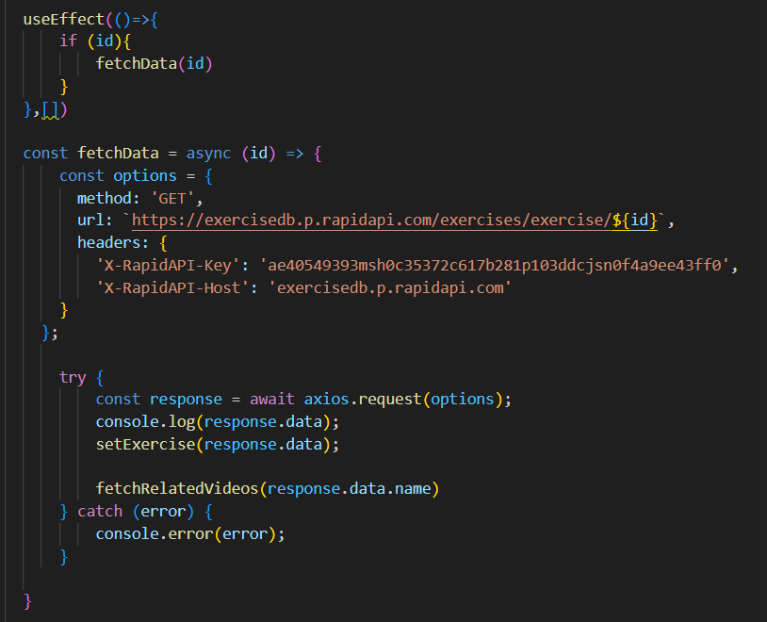

The code snippet demonstrates how to fetch exercise data from an exercise database API using JavaScript's fetch API. Here's a breakdown of the code:

*API Endpoint and Key:*

* Replace 'https://example.com/exercise' with the actual URL of the API endpoint you want to use.
* Replace 'YOUR_API_KEY' with a placeholder instructing users to replace it with their own API key obtained from the API provider.

*async function:*

The code defines an asynchronous function named fetchData that likely takes an id parameter as input. This id parameter might be used to specify the ID of a particular exercise or category of exercises to fetch.

*fetch request:*

Inside the fetchData function, the fetch API is used to make an HTTP GET request to the API endpoint. The function creates a fetch request with the following details:

* Method: GET (to retrieve data from the server)
* URL: The API endpoint URL where exercise data resides.

*Handling the Response:*

* The then method is used to handle the response from the API request. If the request is successful (i.e., status code is 200), the response is converted to JSON format using response.json().
* The .then method then likely processes the fetched exercise data, which might involve storing it in a state variable or using it to populate a user interface.

*Error Handling:*

The .catch method is used to handle any errors that might occur during the API request. If there's an error, it's logged to the console using console.error.

* **Fetching related videos from YouTube**

Now, with the API, we also fetch the videos related to a particular exercise with code given below.

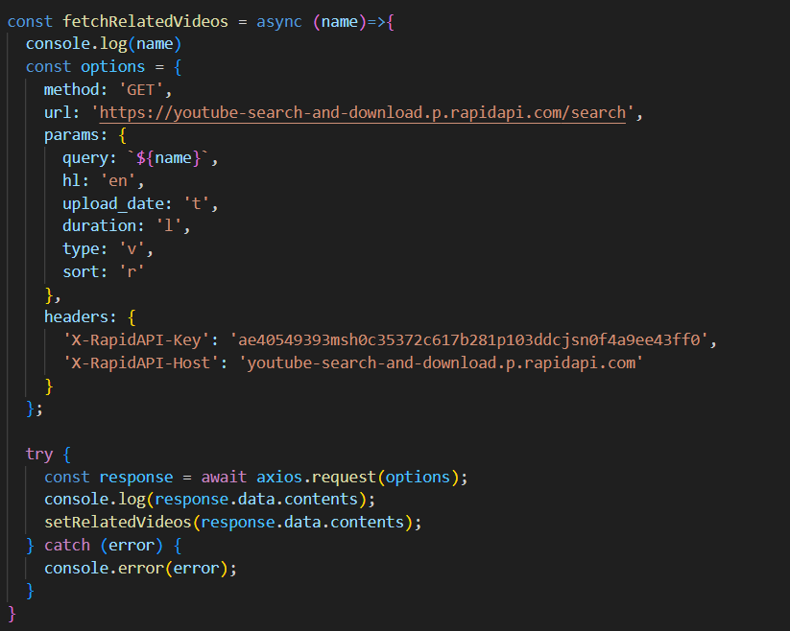

The code snippet shows a function called *fetchRelatedVideos* that fetches data from YouTube using the RapidAPI service. Here's a breakdown of the code:

*fetchRelatedVideos function:*

This function takes a name parameter as input, which is likely the name of a video or a search query.

*API configuration:*

The code creates a constant variable named options and assigns it an object literal containing configuration details for the API request:

* method: Set to 'GET', indicating a GET request to retrieve data from the server.
* url: Set to 'https://youtube-search-and-download.p.rapidapi.com/search', which is the base URL of the RapidAPI endpoint for YouTube search.
* params: An object literal containing parameters for the YouTube search query:
* query: Set to \${name}, a template literal that likely gets replaced with the actual name argument passed to the function at runtime. This specifies the search query for YouTube videos.
* Other parameters like hl (language), sort (sorting criteria), and type (video type) are included but their values are not shown in the snippet.
* headers: An object literal containing headers required for making the API request:
* 'X-RapidAPI-Key': Your RapidAPI key, which is used for authentication. You should replace 'YOUR_API_KEY' with a placeholder instructing users to replace it with their own API key.
* 'X-RapidAPI-Host': The host of the API, which is 'youtube-search-and-download.p.rapidapi.com' in this case.

*Fetching Data (try...catch block):*

* The try...catch block is used to handle the API request.
* The try block contains the code that attempts to fetch data from the API using axios.request(options).
* axios is an external JavaScript library for making HTTP requests. If you don't already use Axios in your project, you'll need to install it using a package manager like npm or yarn.
* The .then method (not shown in the code snippet) is likely used to process the fetched data after a successful API request.
* The catch block handles any errors that might occur during the API request. If there's an error, it's logged to the console using console.error(error).

**Project Implementation & Execution:**

After completing the code, run the react application by using the command “npm start” or “npm run dev” if you are using vite.js

Here are some of the screenshots of the application.

* **Hero component**
* 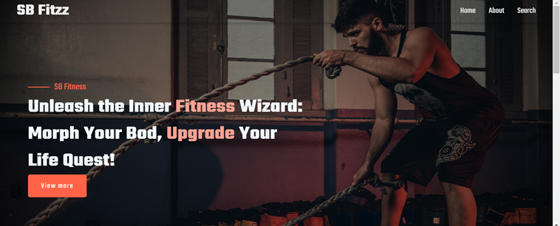
* **About**

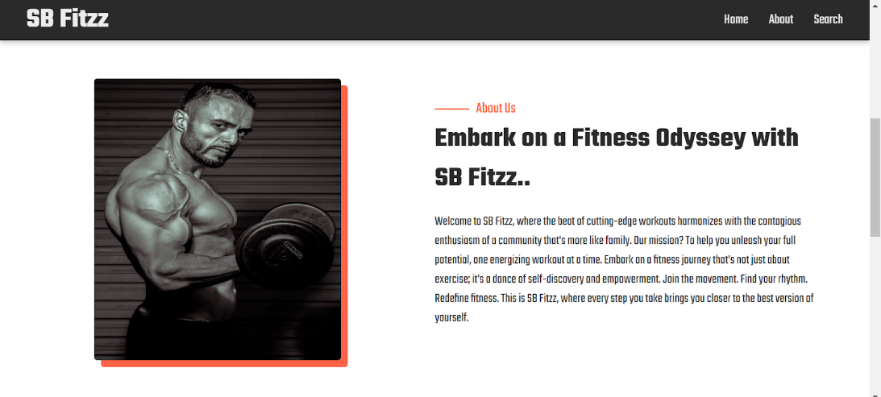

* **Search**



