import com.mongodb.client.MongoClient;
import com.mongodb.client.MongoClients;
import com.mongodb.client.MongoCollection;
import com.mongodb.client.MongoDatabase;
import org.bson.Document;
import org.bson.conversions.Bson;
import java.time.Instant;
import java.util.Arrays;
import java.util.Date;
import java.util.List;
import static com.mongodb.client.model.Aggregates.*;
import static com.mongodb.client.model.Accumulators.*;
import static com.mongodb.client.model.Projections.*;
import static com.mongodb.client.model.Sorts.*;
import static com.mongodb.client.model.Filters.*;
public class MongoDBConn {
public static void main(String[] args) {
String connectionString = "mongodb://localhost:27017";
try (MongoClient mongoClient = MongoClients.create(connectionString)) {
MongoDatabase database = mongoClient.getDatabase("testdb");
System.out.println("Connected successfully to MongoDB!\n");
MongoCollection<Document> collection = database.getCollection("sales");
collection.drop();
List<Document> salesData = Arrays.asList(
new Document("_id", 1).append("item", "Americanos").append("price", 5).append("size", "Short").append("quantity", 22).append("date", Date.from(Instant.parse("2022-01-15T08:00:00Z"))),
new Document("_id", 2).append("item", "Cappuccino").append("price", 6).append("size", "Short").append("quantity", 12).append("date", Date.from(Instant.parse("2022-01-16T09:00:00Z"))),
new Document("_id", 3).append("item", "Lattes").append("price", 15).append("size", "Grande").append("quantity", 25).append("date", Date.from(Instant.parse("2022-01-16T09:05:00Z"))),
new Document("_id", 4).append("item", "Mochas").append("price", 25).append("size", "Tall").append("quantity", 11).append("date", Date.from(Instant.parse("2022-02-17T08:00:00Z"))),
new Document("_id", 5).append("item", "Americanos").append("price", 10).append("size", "Grande").append("quantity", 12).append("date", Date.from(Instant.parse("2022-02-18T21:06:00Z"))),
new Document("_id", 6).append("item", "Cappuccino").append("price", 7).append("size", "Tall").append("quantity", 20).append("date", Date.from(Instant.parse("2022-02-20T10:07:00Z"))),
new Document("_id", 7).append("item", "Lattes").append("price", 25).append("size", "Tall").append("quantity", 30).append("date", Date.from(Instant.parse("2022-02-21T10:08:00Z"))),
new Document("_id", 8).append("item", "Americanos").append("price", 10).append("size", "Grande").append("quantity", 21).append("date", Date.from(Instant.parse("2022-02-22T14:09:00Z"))),
new Document("_id", 9).append("item", "Cappuccino").append("price", 10).append("size", "Grande").append("quantity", 17).append("date", Date.from(Instant.parse("2022-02-23T14:09:00Z"))),
new Document("_id", 10).append("item", "Americanos").append("price", 8).append("size", "Tall").append("quantity", 15).append("date", Date.from(Instant.parse("2022-02-25T14:09:00Z")))
);
collection.insertMany(salesData);
runAndPrint(collection, "1. Average Quantity per Item", Arrays.asList(
group("$item", avg("averageQty", "$quantity"))
));
runAndPrint(collection, "2. Average Quantity Multiplied by 15 (Ascending)", Arrays.asList(
group("$item", avg("averageQty", "$quantity")),
project(fields(include("_id"), computed("averageQty", new Document("$multiply", Arrays.asList("$averageQty", 15))))),
sort(ascending("averageQty"))
));
runAndPrint(collection, "3. Average Amount (Qty * Price) per Item", Arrays.asList(
group("$item", avg("averageAmount", new Document("$multiply", Arrays.asList("$quantity", "$price")))),
sort(ascending("averageAmount"))
));
runAndPrint(collection, "4. Average Amount > 200", Arrays.asList(
group("$item", avg("averageAmount", new Document("$multiply", Arrays.asList("$quantity", "$price")))),
match(gt("averageAmount", 200)),
sort(ascending("averageAmount"))
));
runAndPrint(collection, "5. Count of Documents per Group", Arrays.asList(
group("$item", sum("itemCount", 1))
));
runAndPrint(collection, "6. Groups with More than 1 Document", Arrays.asList(
group("$item", sum("itemCount", 1)),
match(gt("itemCount", 1))
));
runAndPrint(collection, "7. Simple $sum (Total Quantity)", Arrays.asList(
group(null, sum("totalQty", "$quantity"))
));
runAndPrint(collection, "8. Simple $sum Removing _id", Arrays.asList(
group(null, sum("totalQty", "$quantity")),
project(excludeId())
));
runAndPrint(collection, "9. Total Quantity per Group", Arrays.asList(
group("$item", sum("totalQty", "$quantity"))
));
runAndPrint(collection, "10. Total Quantity per Group (Descending)", Arrays.asList(
group("$item", sum("totalQty", "$quantity")),
sort(descending("totalQty"))
));
runAndPrint(collection, "11. Total Quantity > 60 (Descending)", Arrays.asList(
group("$item", sum("totalQty", "$quantity")),
match(gt("totalQty", 60)),
sort(descending("totalQty"))
));
runAndPrint(collection, "12. Total Amount (Qty * Price) Grouped by Size", Arrays.asList(
group("$size", sum("totalAmount", new Document("$multiply", Arrays.asList("$price", "$quantity")))),
sort(descending("totalAmount"))
));
runAndPrint(collection, "13. Max Quantity Overall", Arrays.asList(
group(null, max("maxQty", "$quantity")),
project(excludeId())
));
runAndPrint(collection, "14. Max Quantity per Group", Arrays.asList(
group("$item", max("maxQty", "$quantity"))
));
runAndPrint(collection, "15. Max Amount (Qty * Price) per Group", Arrays.asList(
group("$item", max("maxQty", new Document("$multiply", Arrays.asList("$quantity", "$price"))))
));
runAndPrint(collection, "16. Min Quantity Overall", Arrays.asList(
group(null, min("minQty", "$quantity")),
project(excludeId())
));
runAndPrint(collection, "17. Min Quantity per Group", Arrays.asList(
group("$item", min("minQty", "$quantity"))
));
runAndPrint(collection, "18. Min Amount (Qty * Price) per Group", Arrays.asList(
group("$item", min("minQty", new Document("$multiply", Arrays.asList("$quantity", "$price"))))
));
} catch (Exception e) {
System.out.println("MongoDB Connection or Execution Failed: " + e.getMessage());
}
}
private static void runAndPrint(MongoCollection<Document> collection, String title, List<Bson> pipeline) {
System.out.println("\n=== " + title + " ===");
for (Document doc : collection.aggregate(pipeline)) {
System.out.println(doc.toJson());
}
}
}
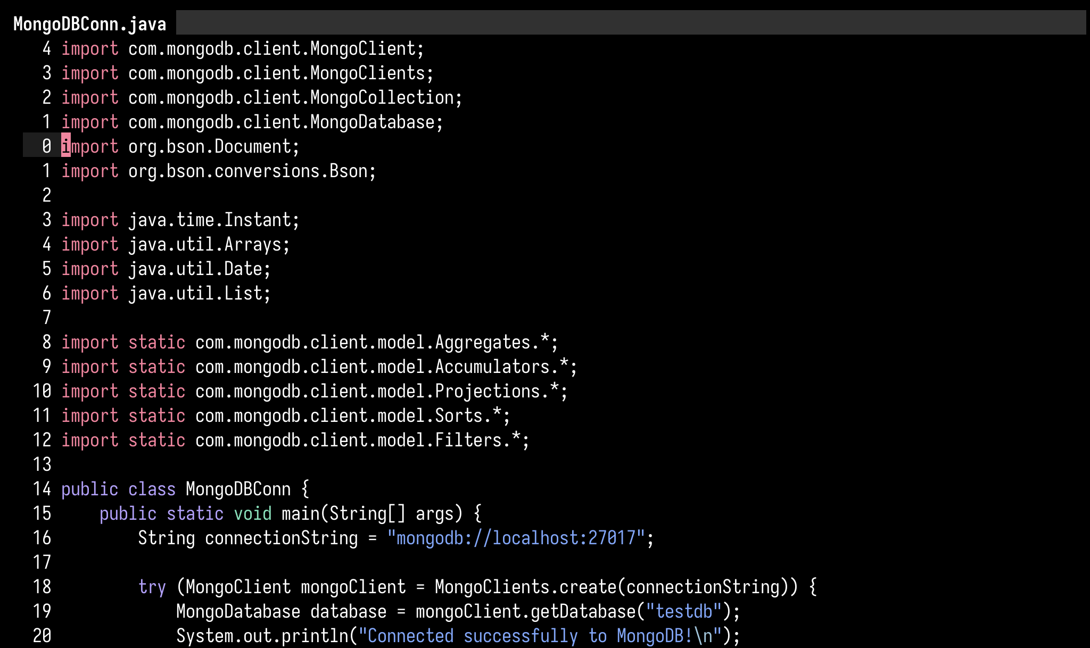
Mongo Conn 1

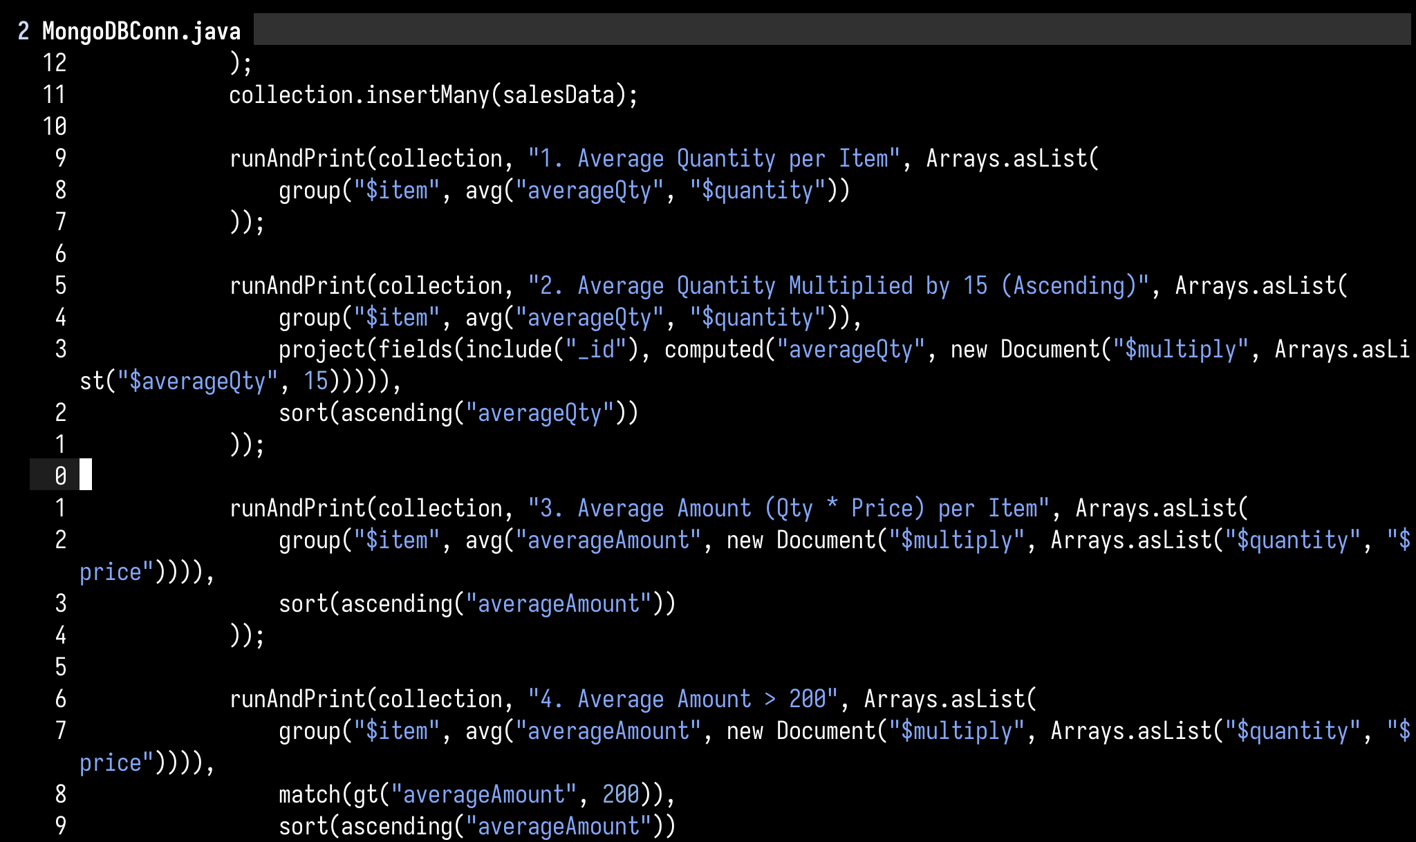
Mongo Conn 2

—

OUTPUT:
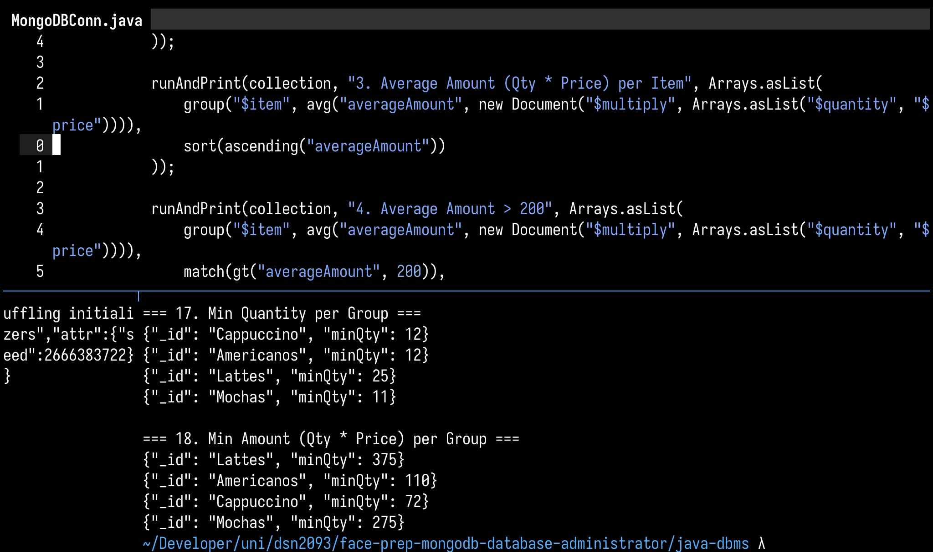
1

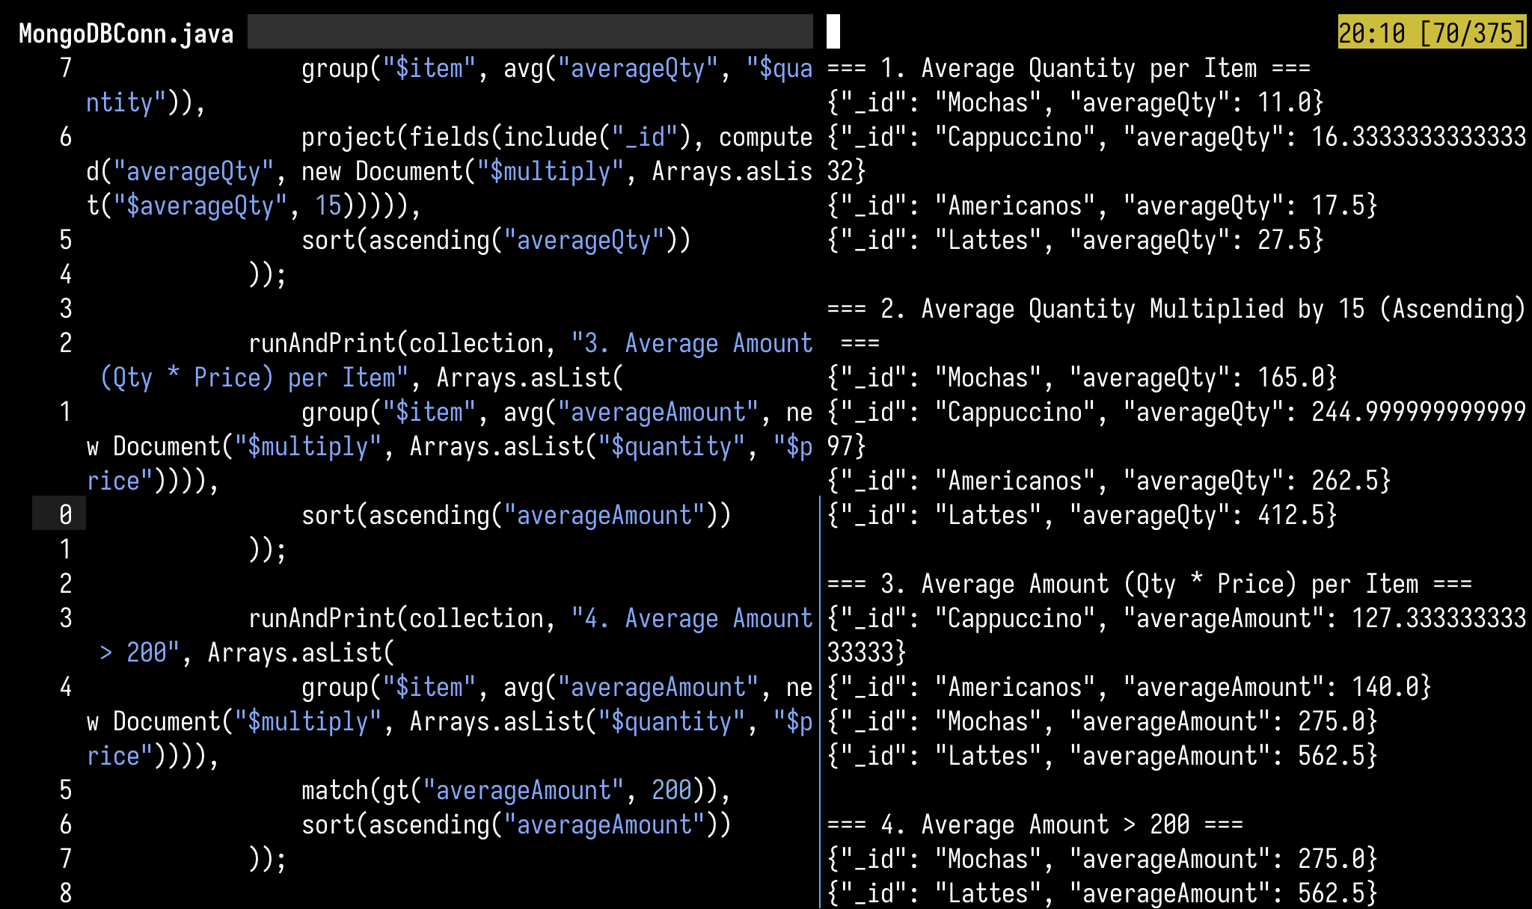
2

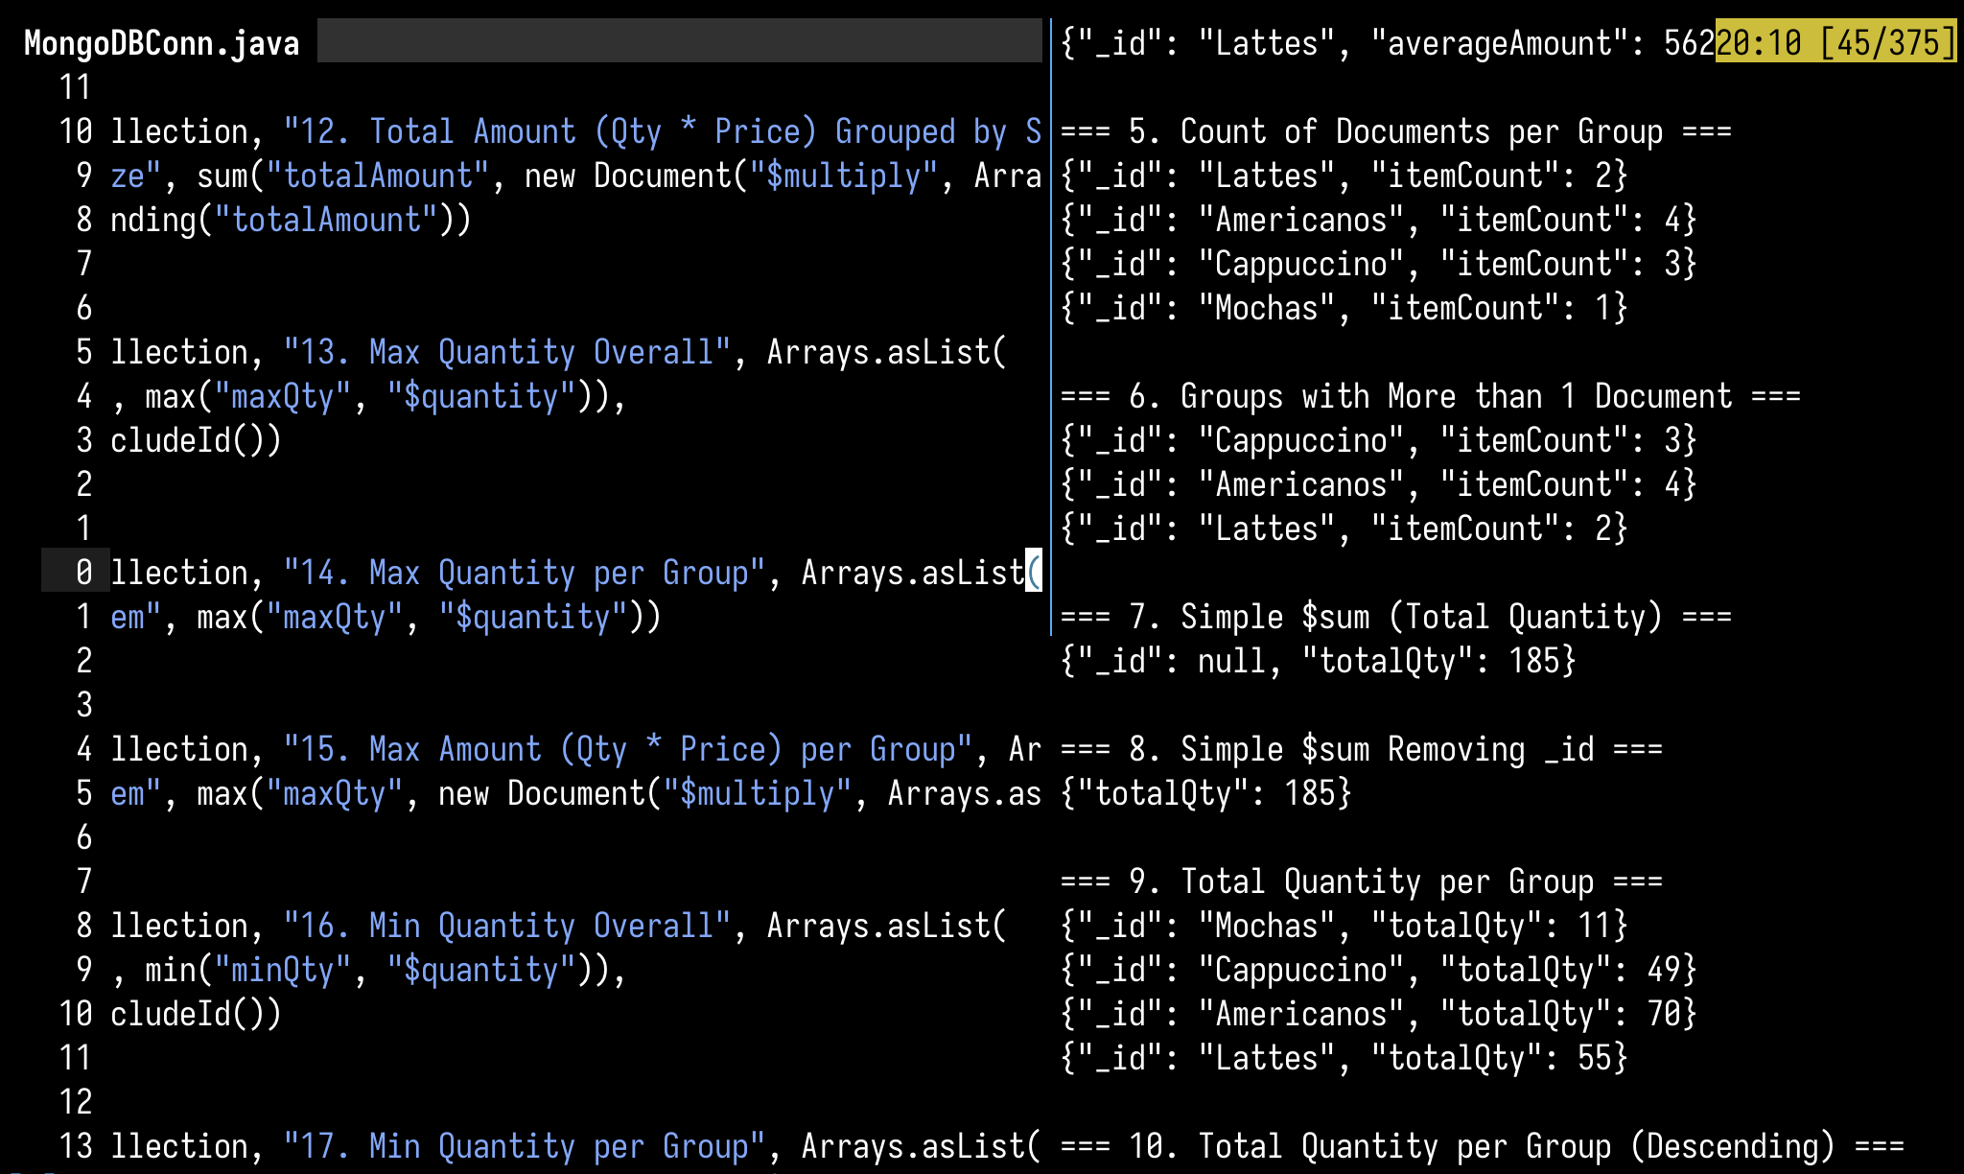
3

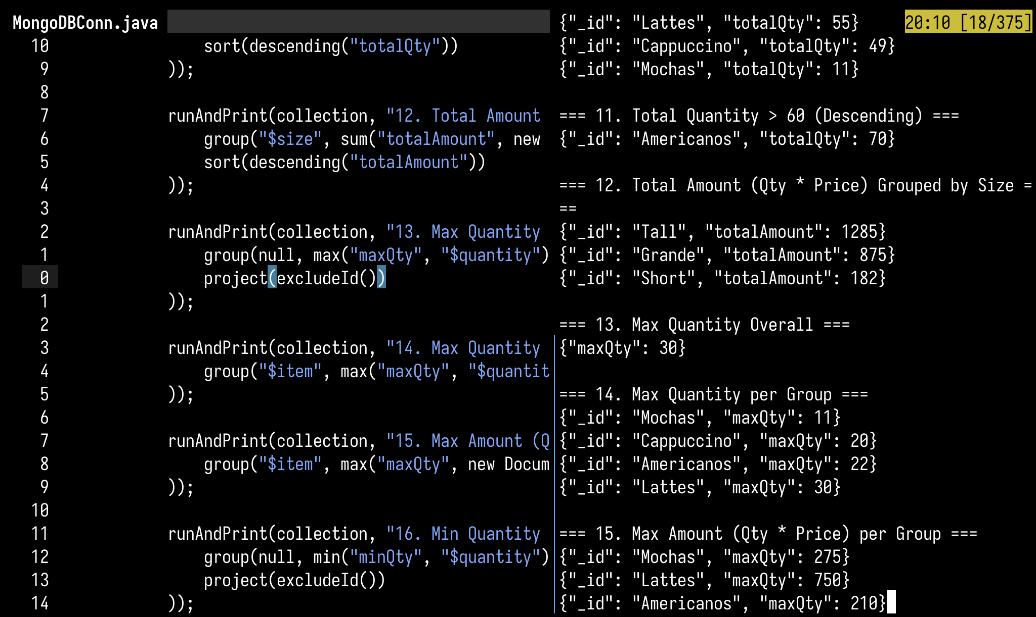
4

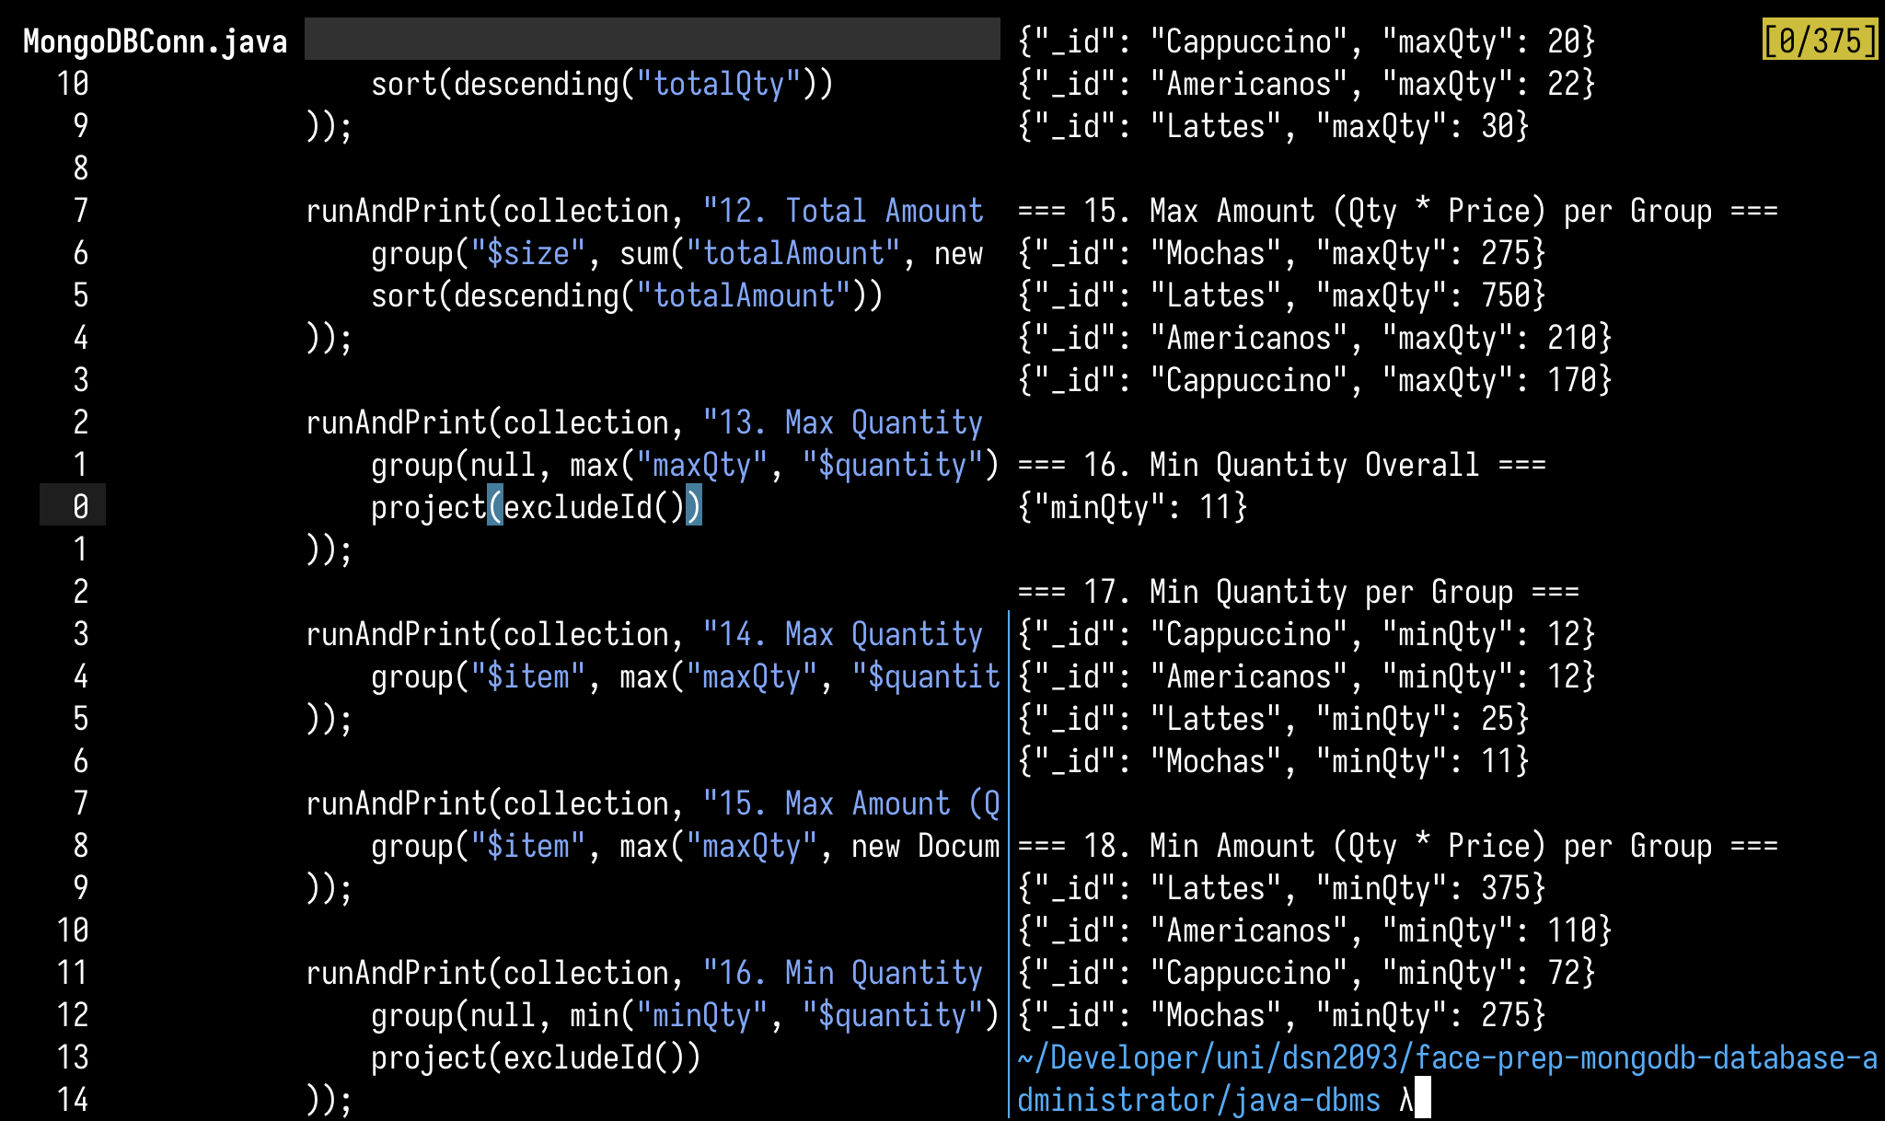
5

