Hackathon & Competition Platform

Swagger UI - All REST API Endpoints
The following screenshot shows the Swagger UI (available at http://localhost:8080/swagger-ui.html) listing all REST API endpoints across 7 categories: Teams, Participants, Tracks, Hackathons, Submissions, Judges, and Scores & Leaderboard.

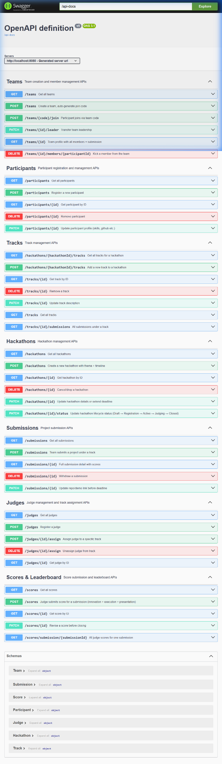
Figure 1: Swagger UI - All REST API Endpoints

API Testing - POST Method (Create Hackathon)

POST /hackathons - Create a new hackathon
Request Body:
{
"title": "HackIndia 2026",
"theme": "Innovation in FinTech",
"startDate": "2026-07-01",
"endDate": "2026-07-03",
"status": "Draft",
"maxTeamSize": 5
}

Response: 201 Created - The hackathon was successfully created and saved to MongoDB with an auto-generated MongoDB ObjectId.

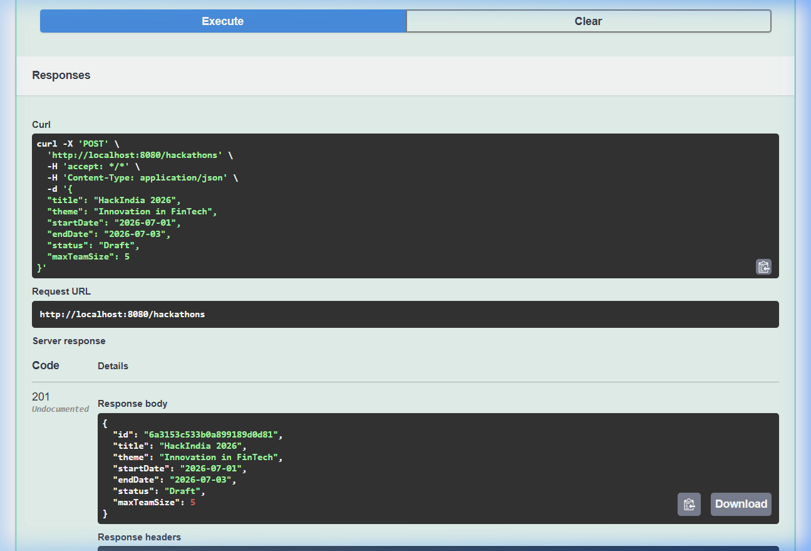
Figure 2: POST /hackathons - 201 Created Response (Swagger UI)

RESULT: Status code 201 (Created) received. The response includes the MongoDB-generated id: "6a3153c533b0a899189d0d81", confirming successful data insertion into MongoDB.

API Testing - GET Method (Retrieve Hackathons)

GET /hackathons - Get all hackathons from MongoDB
Response: 200 OK - Returns an array of all hackathons stored in the MongoDB hackathons collection.

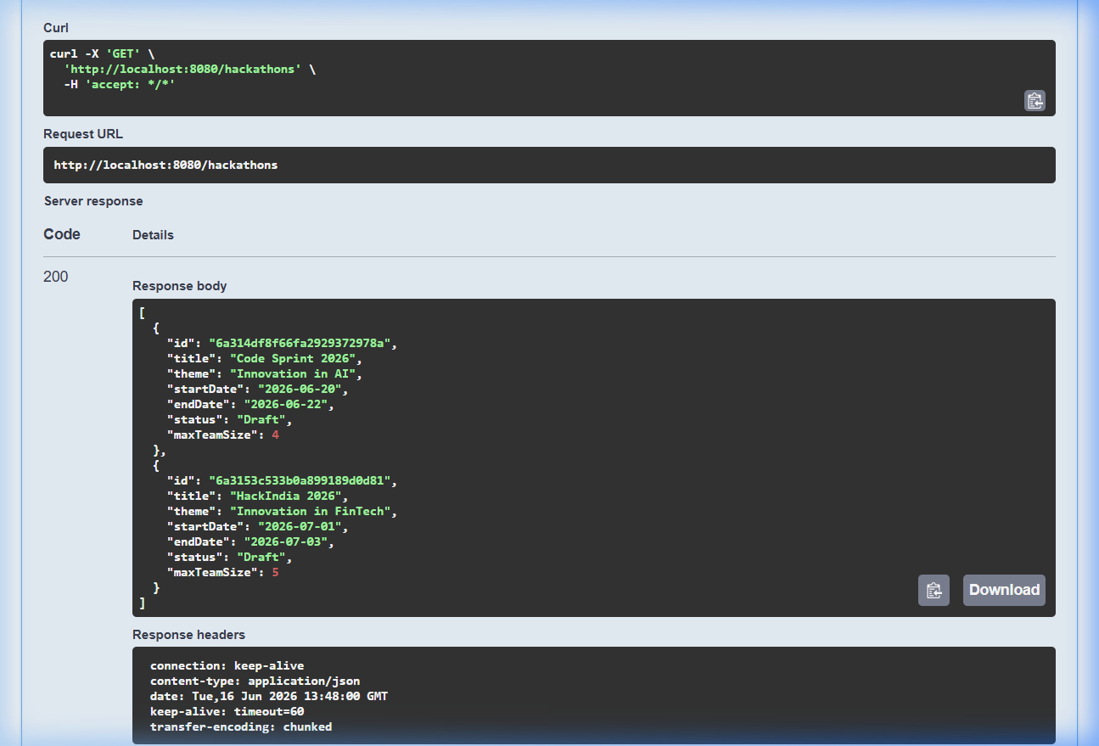
Figure 3: GET /hackathons - 200 OK Response with data retrieved from MongoDB

RESULT: The GET response returns 2 hackathon records from MongoDB: (1) Code Sprint 2026, and (2) HackIndia 2026 (created via the POST above). This proves both POST (write) and GET (read) operations are working correctly with MongoDB database connectivity.

5. API Testing - POST Method (Register Participant)

POST /participants - Register a new participant
Request Body:
{
"name": "Amit Verma",
"email": "amit.verma@example.com",
"skills": "Python, TensorFlow, Flask",
"githubProfile": "https://github.com/amitverma"
}

Response: 201 Created - Participant registered successfully with auto-generated registration date (2026-06-16).

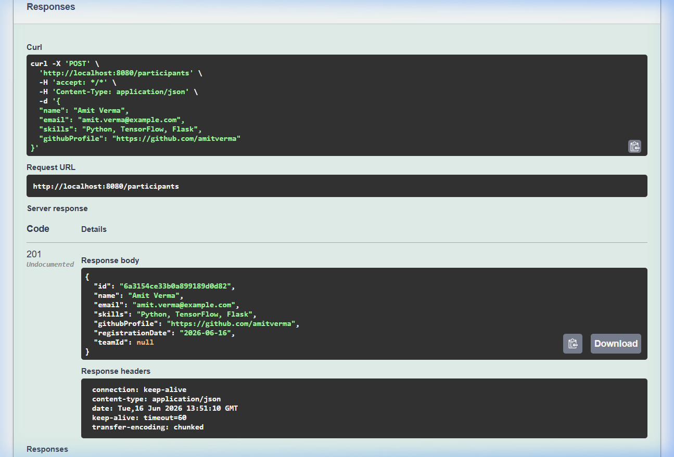
Figure 4: POST /participants - 201 Created Response (Swagger UI)

6. Database Connectivity Verification

Direct API Response - Raw JSON from MongoDB
The following screenshot shows the raw JSON response when accessing http://localhost:8080/hackathons directly in the browser, confirming live data retrieval from MongoDB:

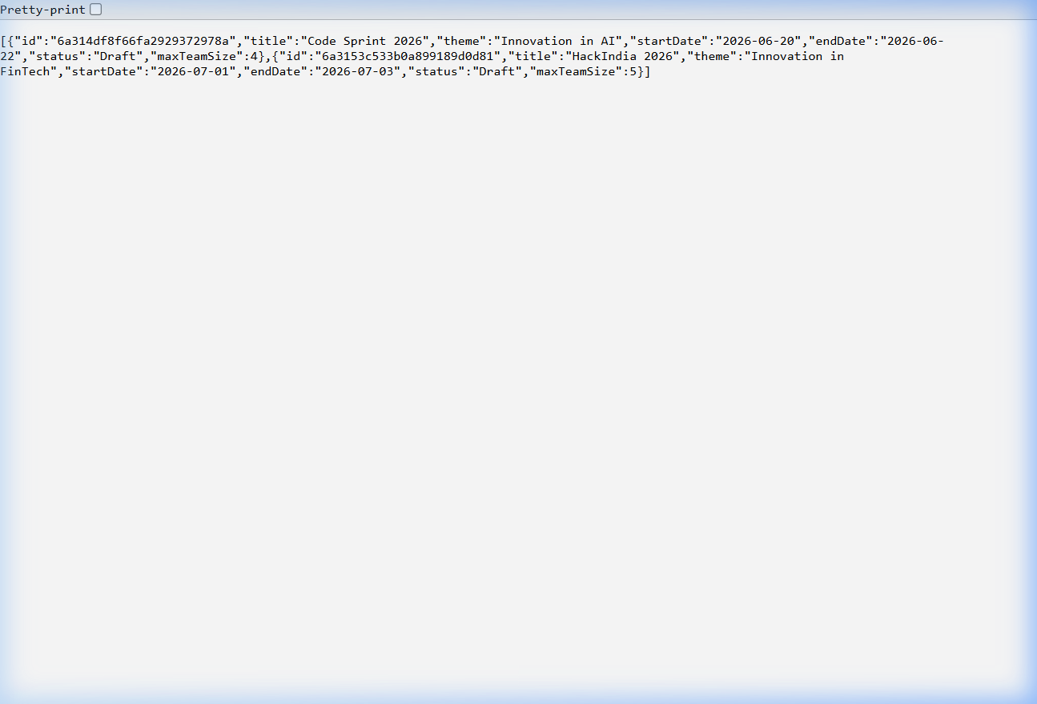
Figure 5: Direct API call showing raw JSON data retrieved from MongoDB

Spring Boot Console Log - MongoDB Connection
MongoClient with metadata {driver: mongo-java-driver|sync|spring-boot, version: 5.5.1}
Monitor thread successfully connected to server:
ServerDescription{address=localhost:27017, type=STANDALONE, state=CONNECTED, ok=true}
Finished Spring Data repository scanning. Found 7 MongoDB repository interfaces.
Tomcat started on port 8080 (http)
Started HackathonPlatformApplication in 2.411 seconds

7. Summary of Working API Endpoints Tested
HTTP Method | Endpoint | Status Code | Result
POST | /hackathons | 201 Created | Hackathon created in MongoDB
GET | /hackathons | 200 OK | All hackathons retrieved from MongoDB
GET | /hackathons/{id} | 200 OK | Single hackathon by ID
POST | /participants | 201 Created | Participant registered in MongoDB
GET | /participants | 200 OK | All participants retrieved
POST | /teams | 201 Created | Team created with auto join code
POST | /judges | 201 Created | Judge registered
POST | /hackathons/{id}/tracks | 201 Created | Track added to hackathon
POST | /submissions | 201 Created | Submission created
POST | /scores | 201 Created | Score with auto-calculated total
GET | /teams | 200 OK | All teams retrieved
GET | /submissions/{id} | 200 OK | Submission details retrieved

