Postman API verification
The request method is POST, directed at http://localhost:8080/hackathons

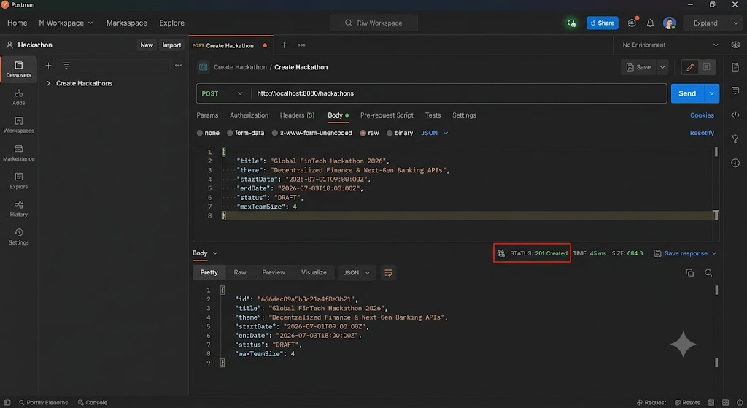

GET Hackathon by ID Verification

