**Table of Contents**

Title Page i

Declaration of the Student ii

Certificate of the Guide iii

Abstract iv

Acknowledgement v

1. **INTRODUCTION**

1.1 Purpose

1.2 Scope

1.3 Software Specifications

1. **Python**
2. **Data Science**
3. **Machine Learning**
4. **RESULTS / OUTPUTS**
5. **SCREENSHOTS**
6. **CONCLUSIONS / RECOMMENDATIONS**

**DECLARATION**

I, Priya Singh, Priya Mukherjee, Araftoz Kaur , student of ‘Bachelor of Engineering in Computer Science-Python with data science and machine learning’, session: 3-june-2019–15-june-2019, NIELIT Ropar , Punjab, hereby declare that the work presented in this Project Work entitled ‘**Predication of students grade’**is the outcome of our own bona fide work and is correct to the best of our knowledge and this work has been undertaken taking care of Engineering Ethics.

**CERTIFICATE**

This is to certify that the work embodies in this dissertation entitled **Predication of student grades in python in machine learning** being submitted by Priya Singh ,Priya Mukherjee and Araftoz Kaur for fulfillment of the requirement for the award of Bachelor **of Engineering** in **Computer Science** discipline to NIELIT, Chandigarh, Punjab during the academic year **2019-2020** is a record of bona fide piece of work, undertaken by the supervision of the undersigned.

**Approved and Supervised by**

**(Anita Budhiraja)**

**Guidance Professor, NIELIT**

**EXTERNAL EXAMINER**

**Signature of External Examiner:**

**(External Examiner's Name)**

**ABSTRACT**

**“Predication of student’s grade”** is one of the core areas of your academics. Usually, it is pursued to manage student grades and their biodata to predict students grades on the basis of their biodata. Predication is part of our daily life.

Furthermore, this project will develop a basic idea of predicting the student grade on basis of their daily routine and biodata. This project also provides data analytics on the basis of data provided.

**ACKNOWLEDGEMENT**

Working in good environment and motivation enhance the quality of the work and we get it from this institute through Python Programming Language Project.

I would like to express my gratitude towards members of my group for their kind co-operation and encouragement which helped me in completion of this project.

My sincere thanks for all the people who had directly or indirectly helped us as to complete the project and for encouraging us to work on such project.

1. **INTRODUCTION**

Data science and Machine learning plays an important role in day-to-day analyses and predication on any particular data. Data science gives easy solution and output to large amount of data. Different libraries can be used to visualize data in python e.g. malplotlib, seaborne e.t.c. to build graphs.Predication is done in student results to get solution if any type give bad impact on student result.

It is important to judge and find what problem can student suffer in daily life due to society and to get quick solution to it.

**1.1Purpose**

The machine learning have been used in our project to analysis what impact students region, family status, their nature etc. put on their grades. It gives quick summary of student grades on the basis of their environment. GUI application can be used for automating different activites in student result report. Tkinter can be used to maintain and view dataset to make user it easily understandable by user. With this application they can fill data in particular for and can get predication according to data filled.

**1.2 Scope**

Student entry form gives easy and fast predication on the basis of environment. The data is filled by a particular person in entry form. The result by predication is given to the that person.

### Python

Python is a popular programming language. It was created by Guido van Rossum, and released in 1991.

It is used for:

* web development (server-side),
* software development,
* mathematics,
* system scripting

**Python libraries you will need:**

**NumPy**

NumPy is shortened from Numerical Python, it is the most universal and versatile library both for pros and beginners. Using this tool you are up to operate with multi-dimensional arrays and matrices with ease and comfort. Such functions like linear algebra operations and numerical conversions are also available.

**Pandas**

Pandas is a well-known and high-performance tool for presenting data frames. Using it you can load data from almost any source, calculate various functions and create new parameters, build queries to data using aggregate functions akin to SQL. What is more, there are various matrix transformation functions, a sliding window method and other methods for obtaining information from data. So it’s totally an indispensable thing in the arsenal of a good specialist.

**Matplotlib**

Matplotlib is a flexible library for creating graphs and visualization. It is powerful but somewhat heavy-weight. At this point, you can skip Matplotlib and use Seaborn to get started (see Seaborn below).

**Scikit-Learn**

I can say it’s the most well-designed ML package I’ve observed so far. It implements a wide-range of machine-learning algorithms and makes it comfortable to plug them into actual applications. You can use a whole slew of functions here like regression, clustering, model selection, preprocessing, classification and more. So, it’s totally worth learning and using. The great advantage here is the high speed of work. So it’s not surprising why such leading platforms like Spotify, Booking.com, J.P.Morgan are using scikit-learn.

### Machine Learning

Machine learning is a subfield of artificial intelligence (AI). The goal of machine learning generally is to understand the structure of data and fit that data into models that can be understood and utilized by people.

Although machine learning is a field within computer science, it differs from traditional computational approaches. In traditional computing, algorithms are sets of explicitly programmed instructions used by computers to calculate or problem solve. Machine learning algorithms instead allow for computers to train on data inputs and use statistical analysis in order to output values that fall within a specific range. Because of this, machine learning facilitates computers in building models from sample data in order to automate decision-making processes based on data inputs.

Any technology user today has benefitted from machine learning. Facial recognition technology allows social media platforms to help users tag and share photos of friends. Optical character recognition (OCR) technology converts images of text into movable type. Recommendation engines, powered by machine learning, suggest what movies or television shows to watch next based on user preferences. Self-driving cars that rely on machine learning to navigate may soon be available to consumers.

First of all, you need to know that there are various  **stages of machine learning**:

* data collection
* data sorting
* data analysis
* algorithm development
* checking algorithm generated
* the use of an algorithm to further conclusion

To look for patterns, various algorithms are used, which are divided into  **two groups**:

* Unsupervised learning
* Supervised learning

With **Unsupervised learning**, your machine receives only a set of input data. Thereafter, the machine is up to determine the relationship between the entered data and any other hypothetical data. Unlike supervised learning, where the machine is provided with some verification data for learning, independent Unsupervised learning implies that the computer itself will find patterns and relationships between different data sets. Unsupervised learning can be further divided into clustering and association.

**Supervised learning**  implies the computer ability to recognize elements based on the provided samples. The computer studies it and develops the ability to recognize new data based on this data. For example, you can train your computer to filter spam messages based on previously received information.

Some **Supervised learning algorithms** include:

* Decision trees
* Support-vector machine
* Naive Bayes classifier
* k-nearest neighbors
* linear regression

Screenshots of project

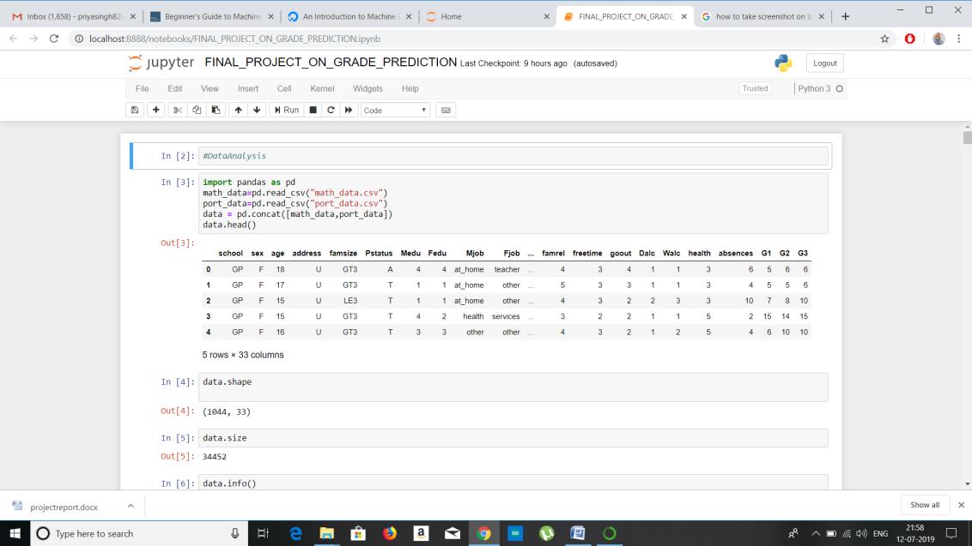

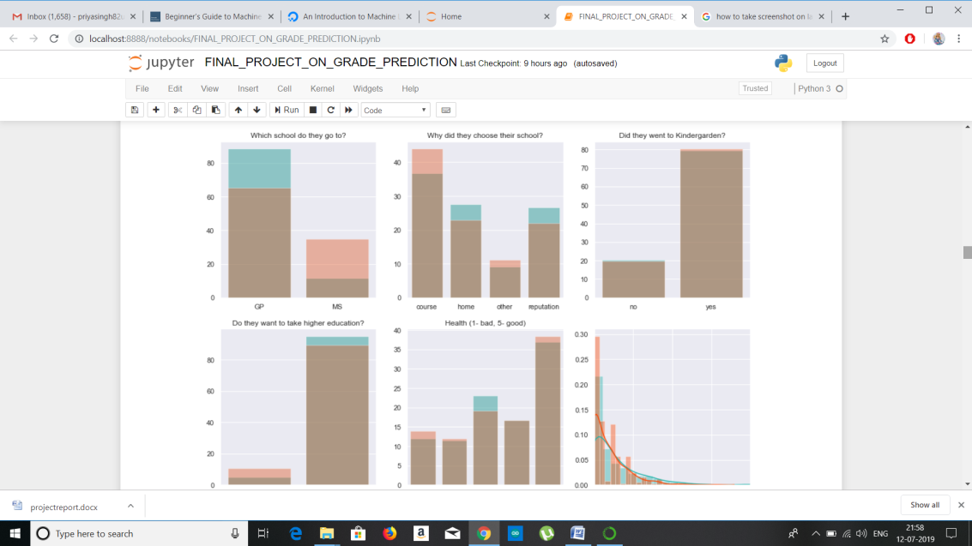

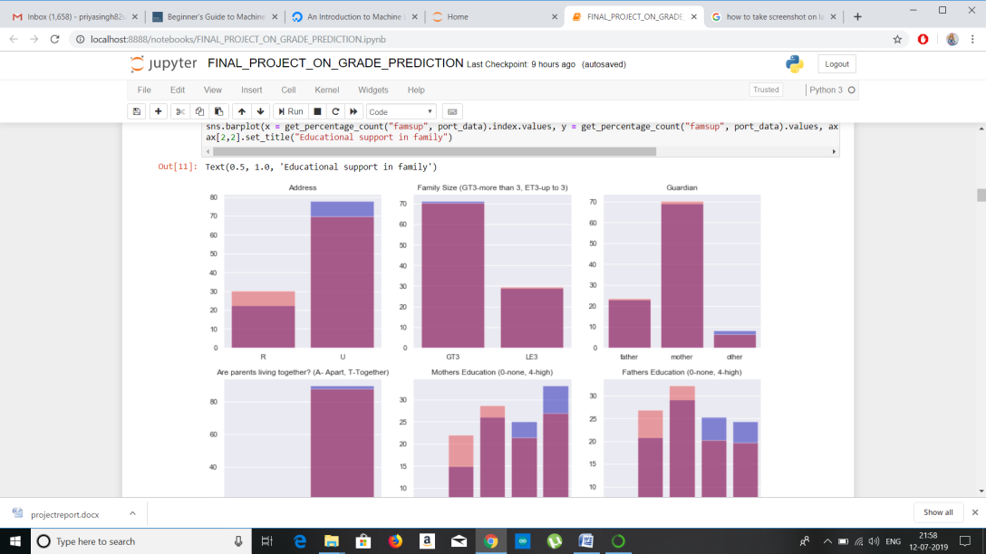

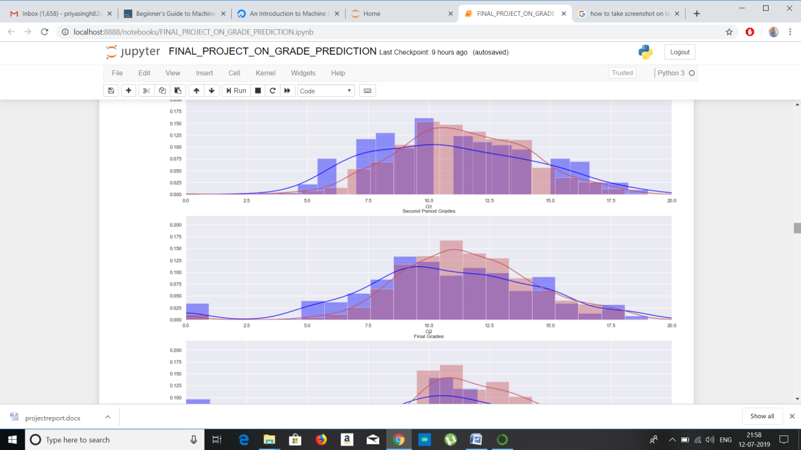

**RESULT AND CONCLUSION**

This payroll management system as an application has it all to satisfy the current needs and demands of any organization, its employees and administrators. The system calculates the Grade of students based on their habbits . It is very flexible and adaptable to changing user requirements, so new features and modules can be easily incorporated into the system in future if required.