CAN A GUEST IN THE NASAL CAVITY CAUSE SO MUCH HAVOC?

- Introduction
Ectopic supernumerary teeth in the nasal cavity are rare, occurring with an incidence of approximately 0.1–1%.
- Case presentation
A 41-year-old male patient, with a history of facial trauma, presented with nasal obstruction and recurrent blood-stained nasal discharge.
- Physical examination showed a deviated septum and a white mass in the right nasal cavity.
- Diagnostic nasal endoscopy revealed a polypoidal, granulomatous, pyogenic mass over the caudal septum. 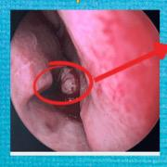
- CT imaging confirmed the diagnosis of an ectopic tooth in the right nasal floor, along with septal deviation and hypertrophy of the right inferior turbinate.
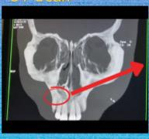
Surgical extraction was carried out using a modified Caldwell-Luc operation. The mass was removed successfully, minimizing complications by employing careful mucoperiosteal techniques.
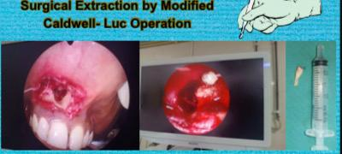
- Outcome
Postoperative recovery was uneventful with resolution of symptoms. The patient experienced no major complications such as septal perforation or naso-oral fistula.
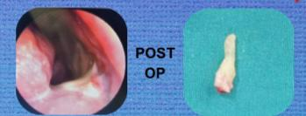
- Discussion
Intranasal supernumerary teeth arise from abnormal development of dental tissue, possibly due to hyperactivity of the dental lamina, trauma, infections, craniofacial anomalies (like cleft lip/palate), or genetic syndromes.
- Management
Endoscopic Approach
•Preferred for most intranasal supernumerary teeth. Ideal when the tooth is superficial and not deeply embedded.

Modified Caldwell-Luc Operation
•Used when the tooth is located deep in the nasal floor or maxillary sinus, when associated with extensive pathology such as a cyst or chronic infection, where endoscopic access is limited.
Intraoral/Nasal Combined Approach
•When teeth extend from the palate or incisive canal into the nasal cavity, or are impacted partly within the maxilla. Collaboration between oral and ENT surgeons may be needed for complex cases.
- Conclusion
Intranasal supernumerary teeth should be considered in patients with unexplained nasal obstruction and epistaxis
- Keywords
Epistaxis , ectopic tooth, Modified Cadwell luc operation,

