“The Fungal Sinusitis That Wasn’t: Unveiling a Silent Carcinoma”
DR.MARIA AMIRUTHA
PROF. DR.RANJANAKUMARI MS ENT, DLO
Background:
Sinonasal malignancies are uncommon and often mimic benign or infective conditions, leading to diagnostic delays. Fungal sinusitis is a frequent differential in unilateral maxillary sinus disease, and radiological overlap can further complicate early detection. This case highlights the importance of maintaining high suspicion and performing timely histopathological evaluation when clinical progression seems atypical.
Case Presentation:
A 57-year-old male presented with a 20-day history of thick, yellowish, blood-stained left-sided nasal discharge and watering of the left eye. There was no history of trauma, dental infection, or visual disturbances. Clinical examination revealed thick purulent discharge in the left nasal cavity, left maxillary tenderness, and deviated nasal septum to the right, with no neck nodes or facial swelling.
Diagnostic Workup:
Diagnostic nasal endoscopy showed medialised uncinate process, concha bullosa, and discharge in the middle meatus. CT PNS demonstrated complete soft-tissue opacity of the left maxillary sinus, extension into the nasal cavity, widened infundibulum, and osteomeatal complex obstruction, findings initially suggestive of fungal sinusitis. No intraorbital or buccal space involvement was noted.
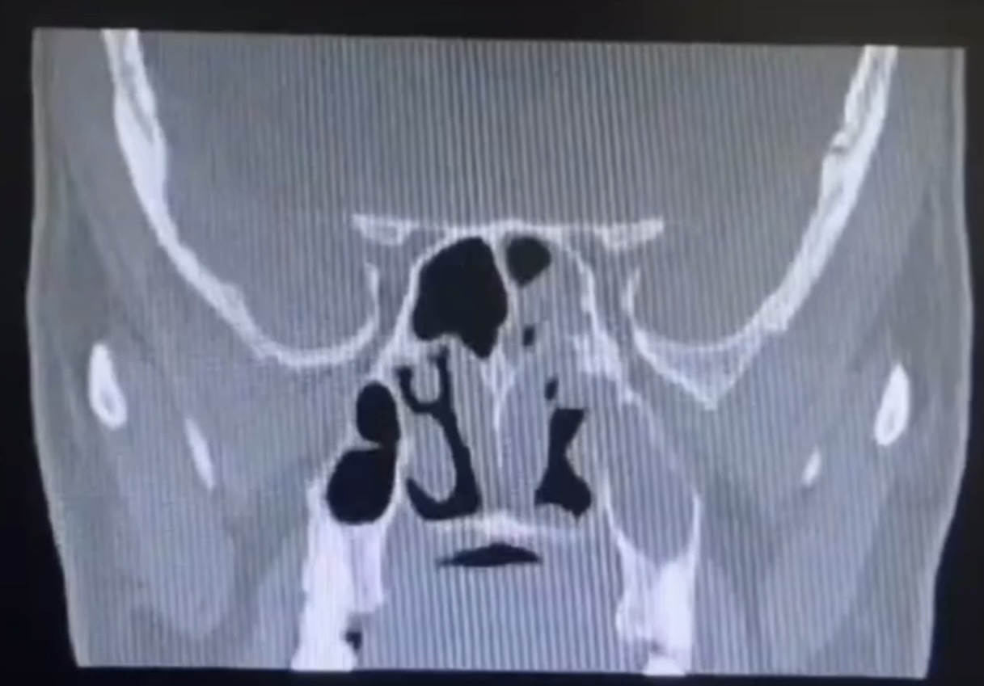
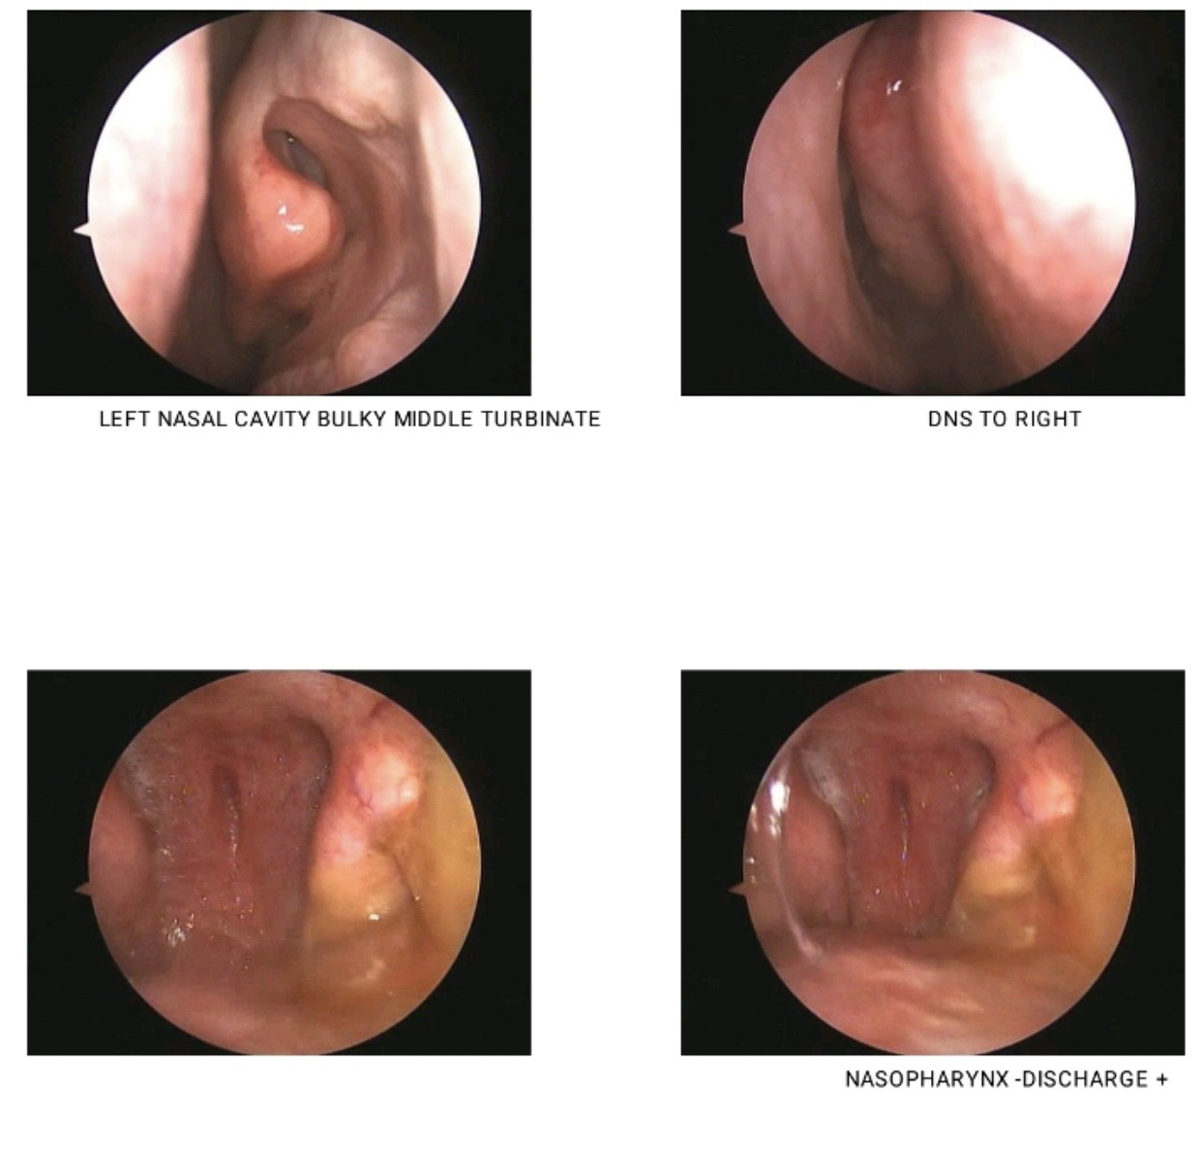

Intervention:
The patient underwent endoscopic polypectomy under GA, during which fungal debris and polypoidal tissue were removed using a microdebrider. As the procedure progressed, a deeper fleshy mass was visualised within the left maxillary antrum. This was excised and sent for histopathology.
Outcome:
Histopathological examination confirmed carcinoma ex-sinonasal papilloma – squamous cell carcinoma (non-keratinising type), explaining the atypical features and persistent symptoms.
Conclusion:
This case illustrates how sinonasal malignancy may masquerade as fungal or inflammatory
sinusitis. Even when imaging favours a benign diagnosis, intraoperative suspicion and routine biopsy remain essential for identifying hidden malignancy and guiding appropriate management.

