TEELABS

Lead :
* LEAD FILTER -- DEFAULT OPEN

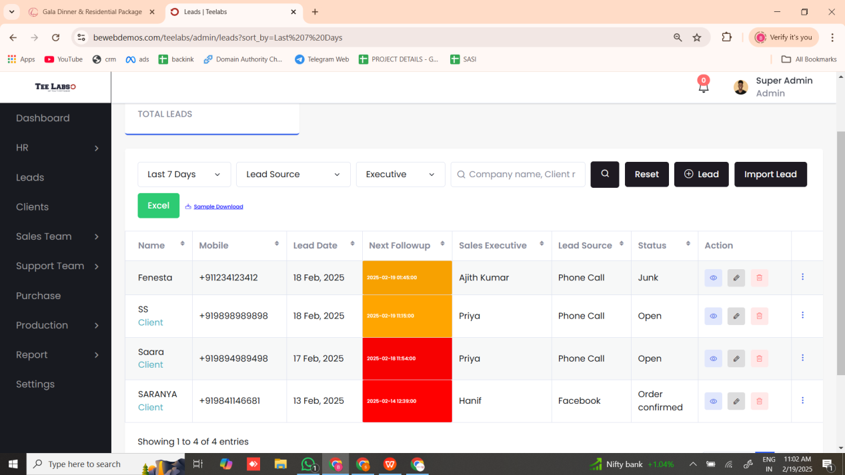

* CONVERT TO CLIENT -- DETAILS NOT SHOWN IN LEAD



WANT TO SHOW ONLY IN CLIENT

* LEAD -- COMPANY -- OTHER --- NEW BOX WANT TO OPEN

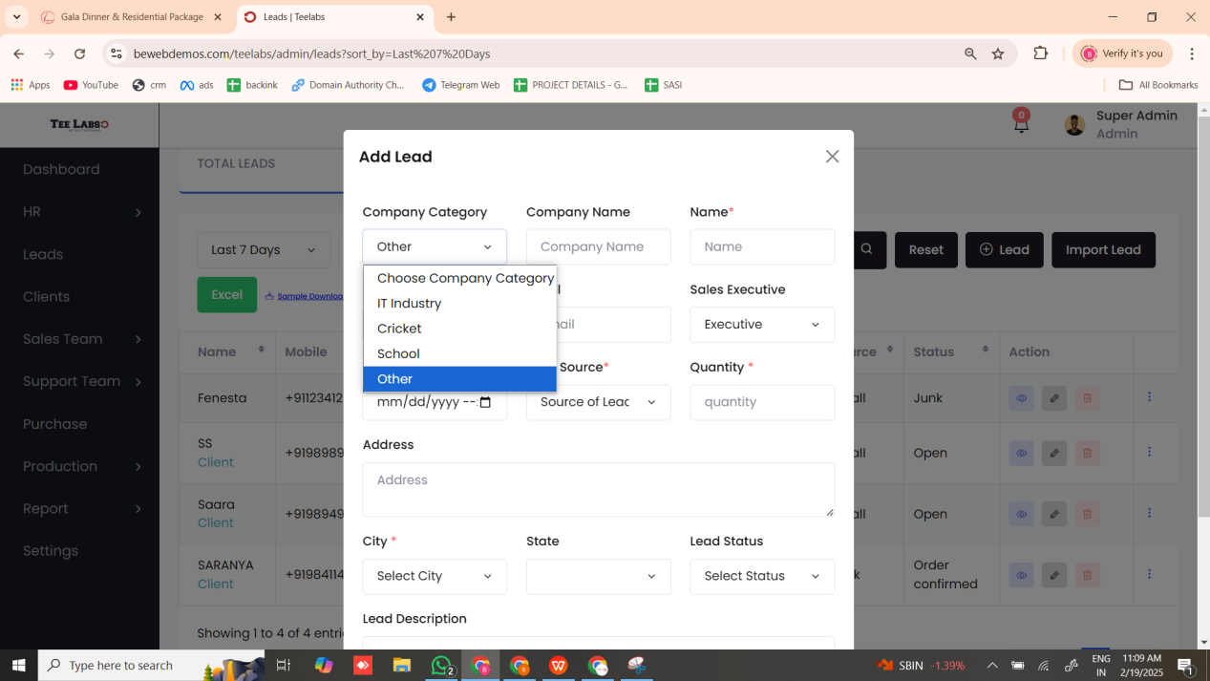

* CITY -- OTHER -- NEW BOX OPEN
(WE ADD CITY OPTION IN SETTINGS -- SO YOU CAN ADD CITIES IN SETTINGS )

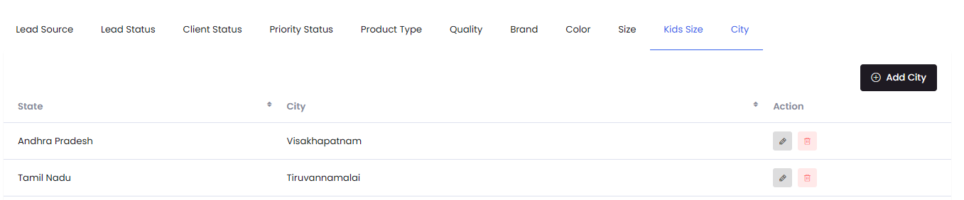

ORDER
* DUPLICATE -- SIZE LIST CHANGED FOR KIDS
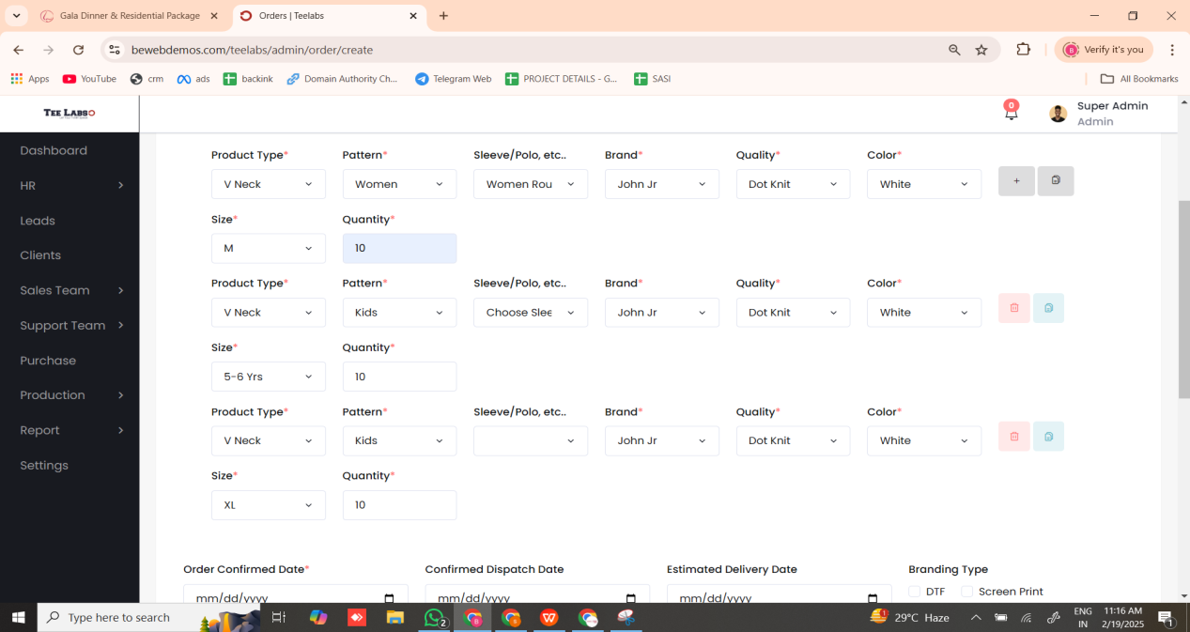

* BRANDING TYPE -- EDIT ( SELECTED LIST NOT SHOWN )

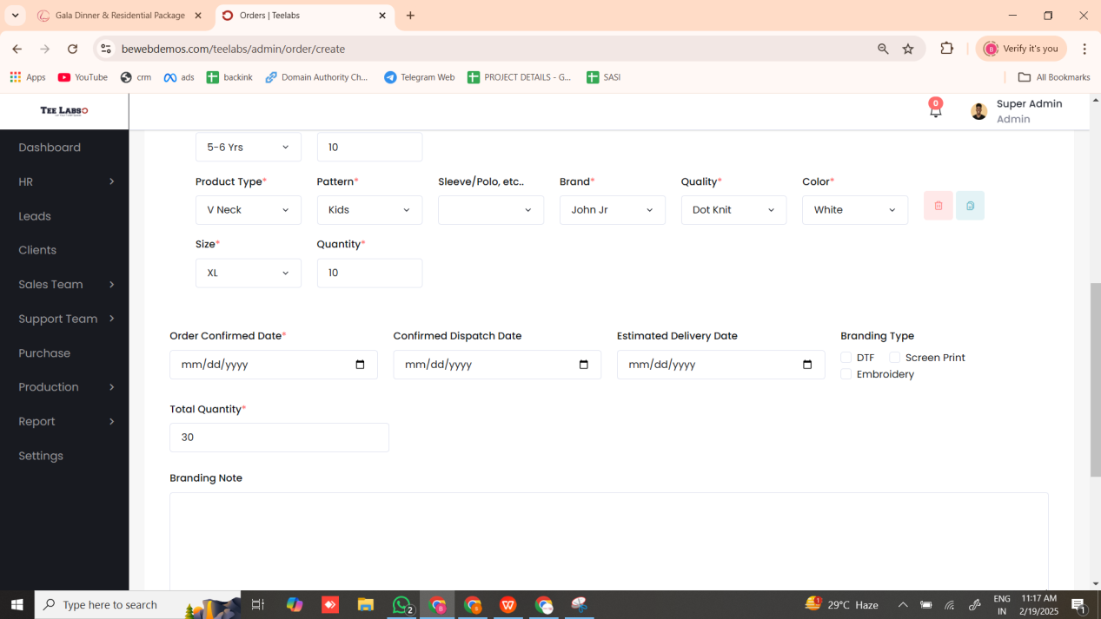

* ORDER EXCEL -- ADD --BRANDING NOTE , TOTAL QUANTITY , BRANDING TYPE , ORDER NOTE

ORDER SHEET

* NAME& NO --- NEXT TO RIGHT SLEEVE
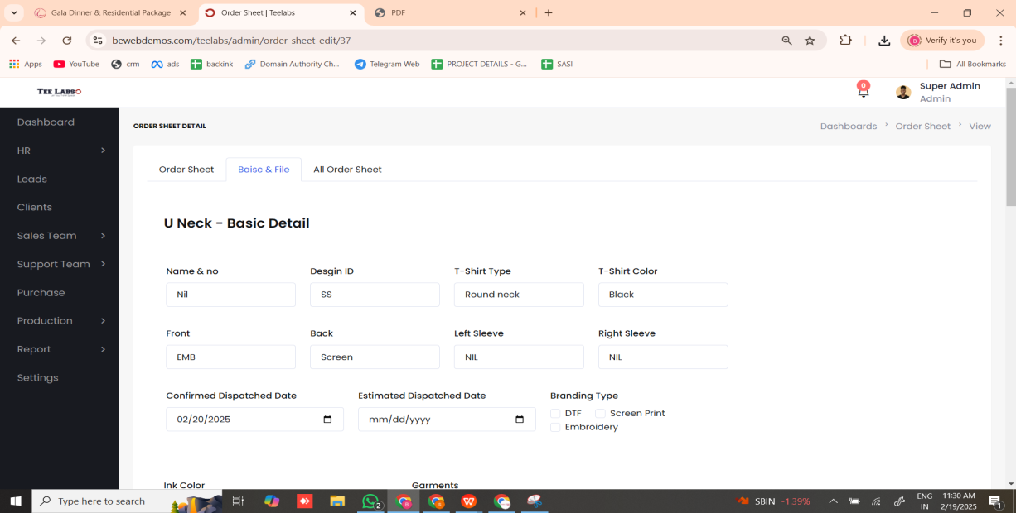

* COLOUR PICKER -- ADD FOR INK COLOR AND GARMENTS
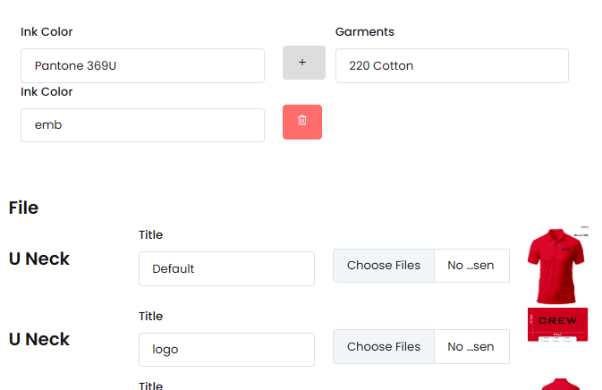

* INK AND GARMENTS COLOUR DIFFERENT FOR FRONT AND BACK SHEET -- SO WANT TO ADD



* CHANGE PHOTO SIZE & WIDTH -- AND MENTION THE SIZE

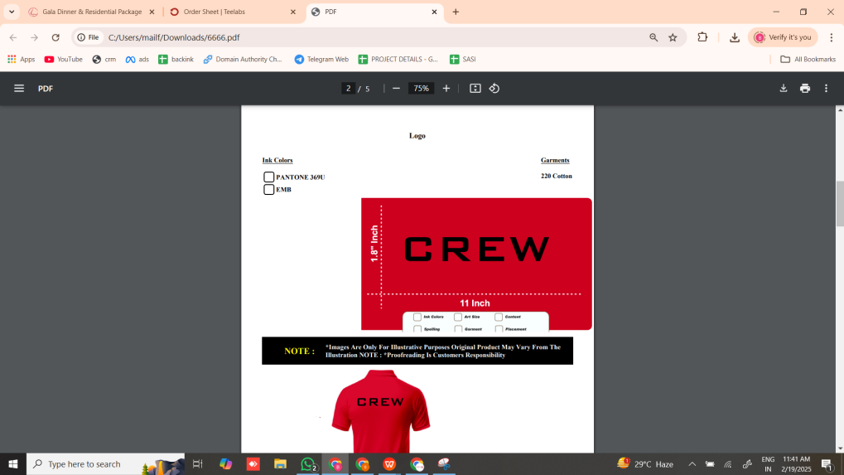

PRIORITY
* EXCEL --

PURCHASE

* REMOVE BRAND , QUALITY --- IN COLLAR , CUFF , OTHER
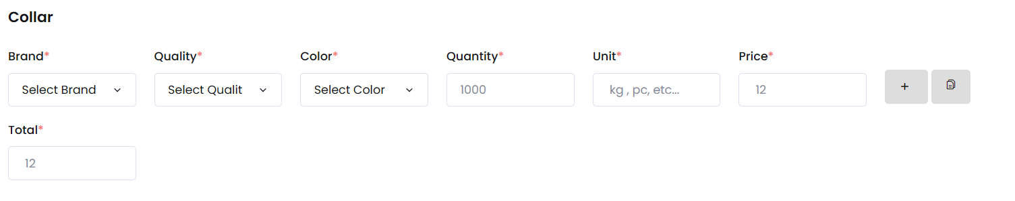

* order date wise filter
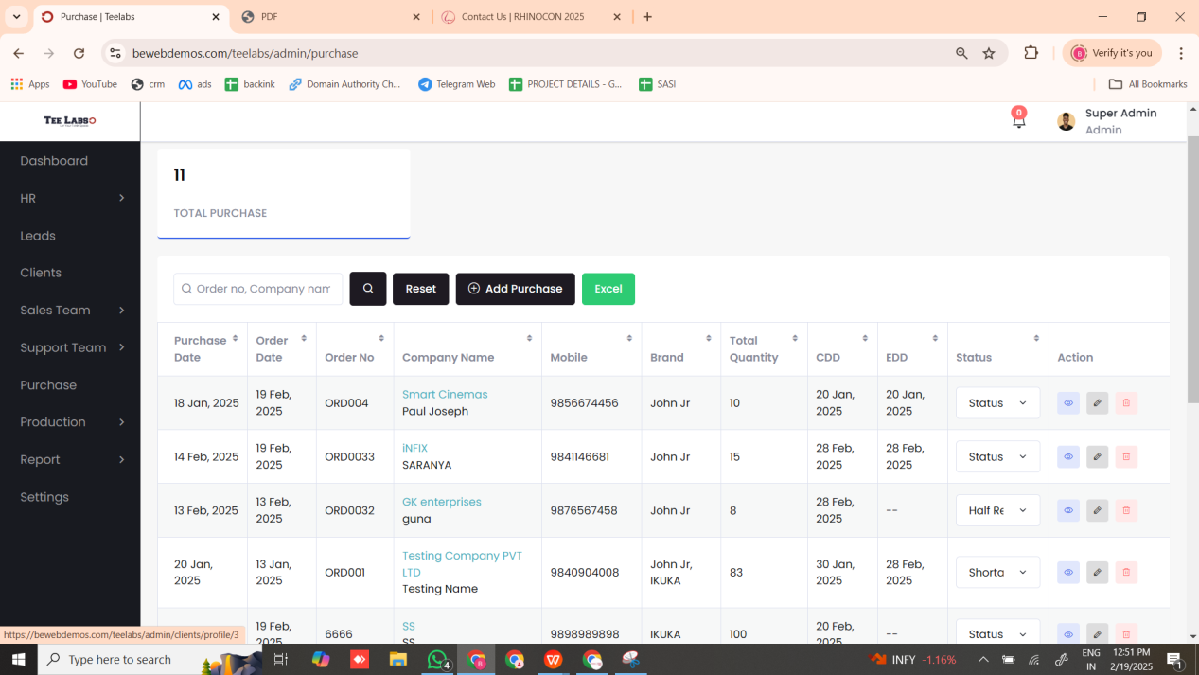

PRODUCTION

* WORK ORDER SHEET TITLE ---> FOR ALL DUPLICATES
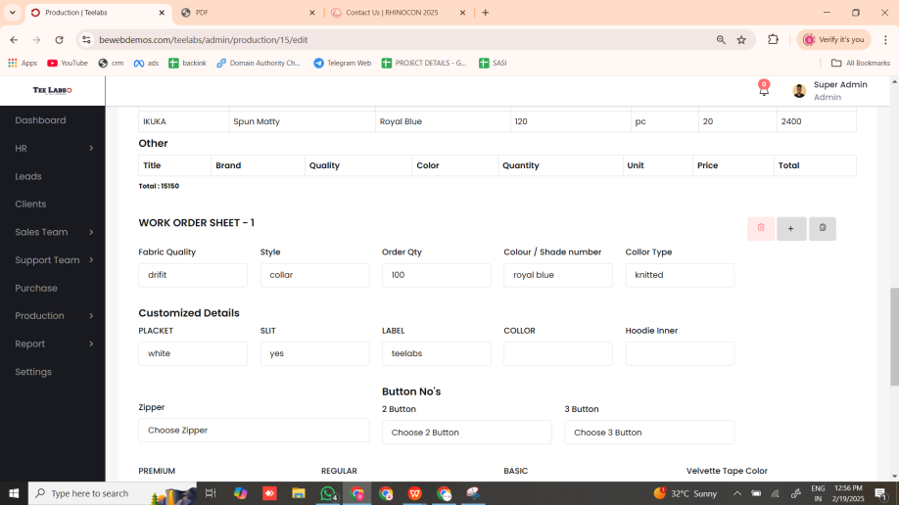
TITLE

* ADD ORDER SHEET FRONT PAGE WITH WORK ORDER SHEET

FABRIC RECEIVED

* FABRIC RECEIVED EXCEL
* ENTER QUANTITY MANUAL WITHOUT BALANCE

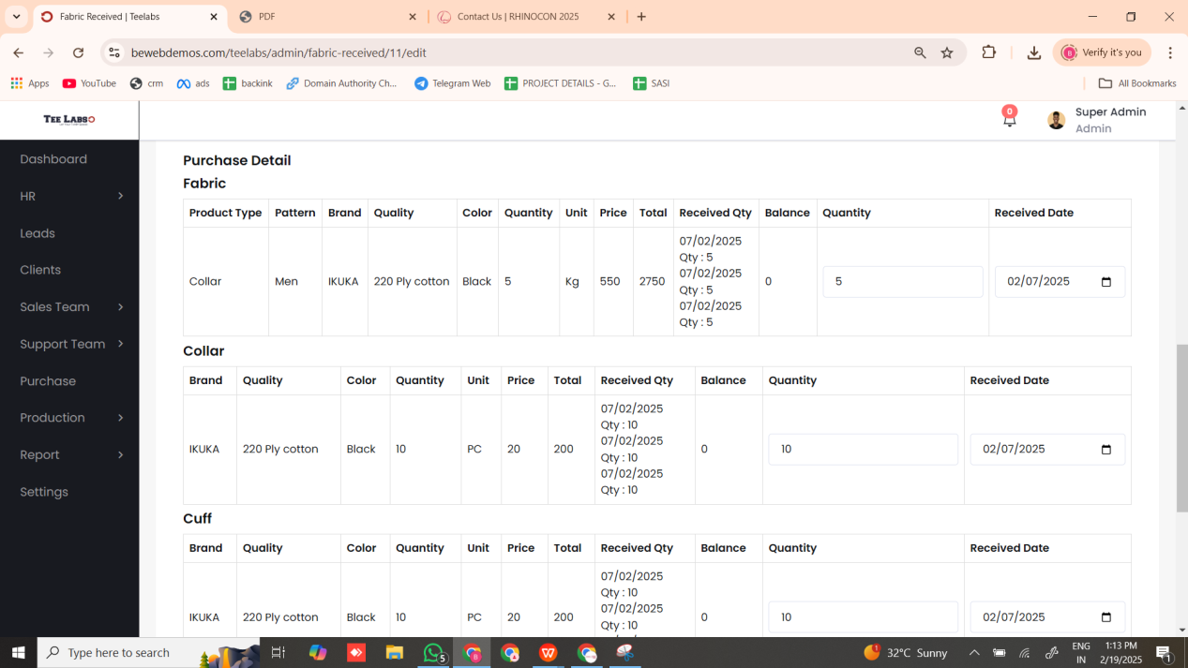

FABRIC USAGE

* PATTERN AND COLOUR TITLE WANT TO SHOW EVERY TIME

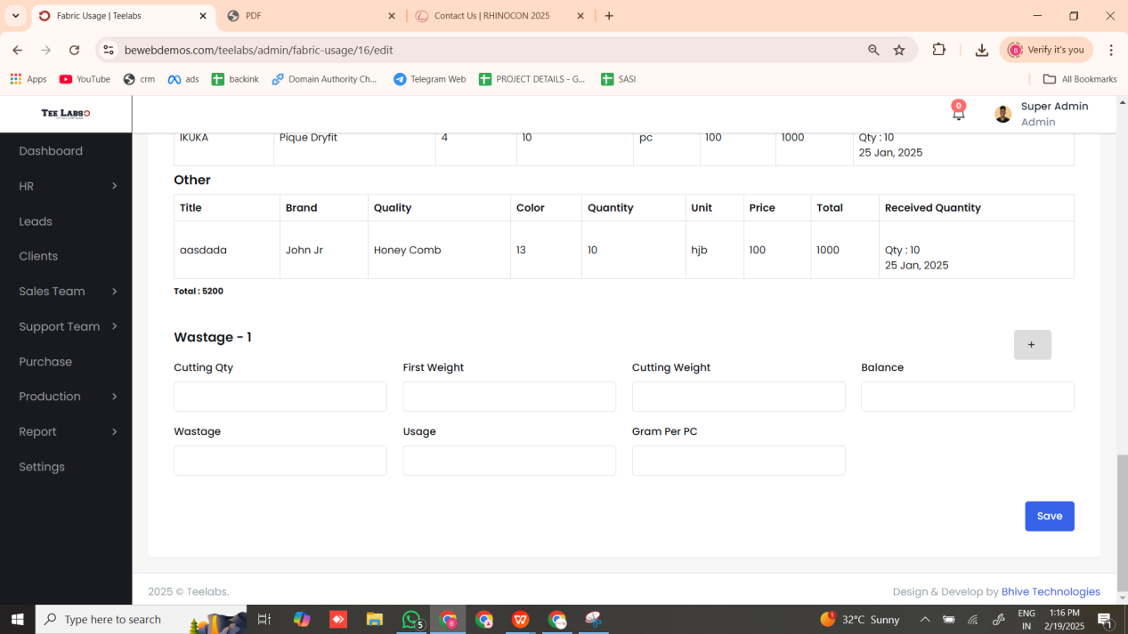

INTERNAL DELIVERY

* DATE MANDATORY

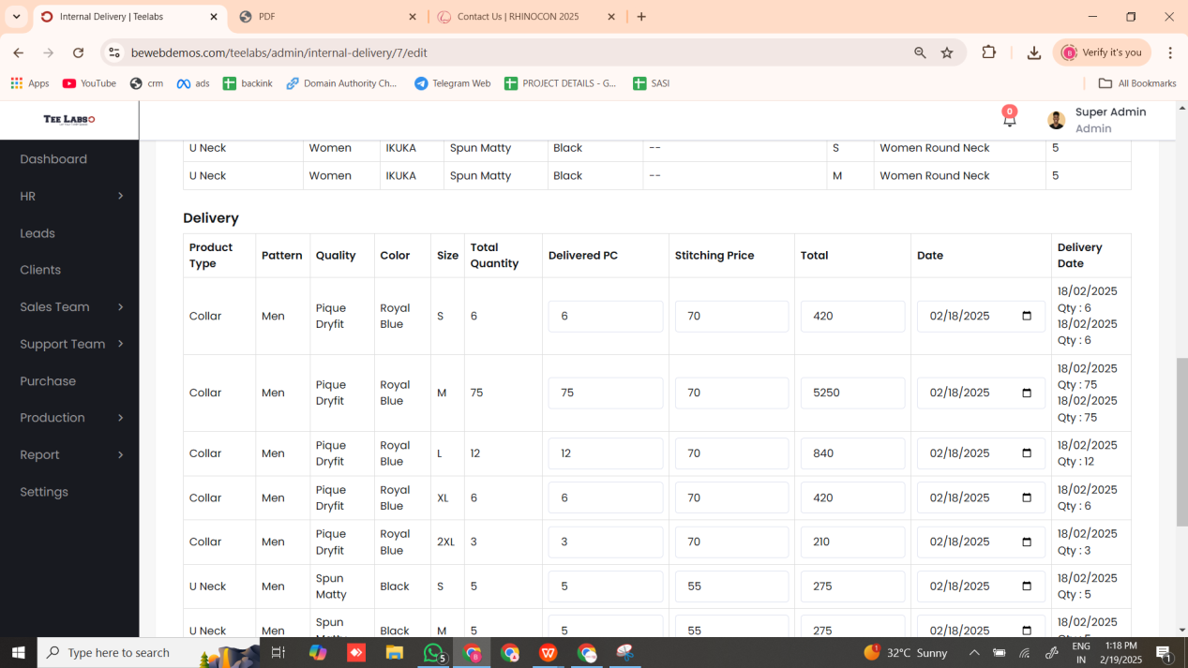

BRANDING TYPE
* BRANDING VALUE WANT TO SHOW IN ORDER -- AMOUNT
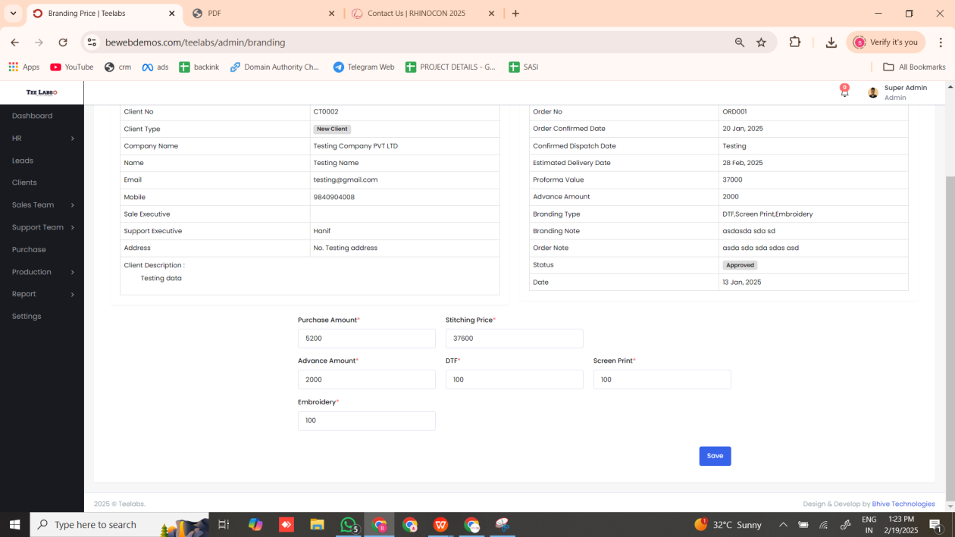

NEW CHANGES

SETTINGS

* SIZE CHART LIST WANT TO ADD IN SETTINGS - FOR CUSTOMIZATION

PURCHASE
* PURCHASE DATE WANT TO ADD FOR EVERY TIME WE PURCHASE
* VIEW ALL PURCHASE PRODUCT WITH DATE

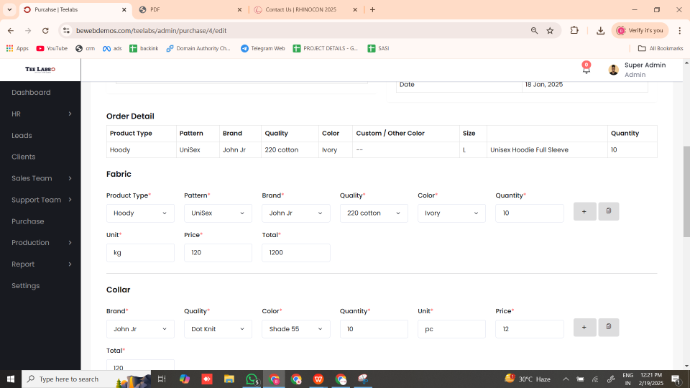

* FABRIC USAGE EXCEL

* DELIVERY -- AVG AMOUNT FOR ALL PATTERNS

