**CSE4019 – DIGITAL IMAGE PROCESSING**

**J Component Report**

A project report titled

**EMOTION BASED MUSIC PLAYER**

By

**Reg. No** 19BPS1054 **Name** Priyadarshini .S

**Reg. No** 19BPS1108 **Name** Kaavyaa .R.M

**Reg. No** 19BCE1858 **Name** Shruti Kute

BACHELOR OF TECHNOLOGY

IN

COMPUTER SCIENCE AND ENGINEERING

Submitted to

**Dr. S.Geetha**

**School of Computer Science and Engineering**



December 2021

**Abstract**

Human demeanour assumes a fundamental part in deciding the present status and disposition of an individual, it helps in removing and understanding the feeling that an individual has dependent on different elements of the face like eyes, cheeks, brow or even through the bend of the grin. Music is essentially an artistic expression that mitigates and quiets human cerebrum and body. Taking these two angles and mixing them together our project manages distinguishing feeling of a person through look and playing music as indicated by the disposition identified that will reduce the temperament or essentially quiet the individual and can likewise get speedier melody as per the mind-set, saving time from looking into changed tunes and equal fostering a product that can be utilized anyplace with the assistance of giving the usefulness of playing music as per the feeling recognized. By fostering a proposal framework, it could help a user to settle on a choice in regards to which music one ought to pay attention to assisting the client with lessening his/her feelings of anxiety. The user would not need to burn through any time in looking or to search up for tunes and the best track matching the user's mind-set is identified, and tunes would be displayed to the user as indicated by his/her temperament. The picture of the user is caught with the assistance of a webcam. The user's image is taken and afterward according to the state of mind/feeling of the user a suitable melody from the playlist of the user is shown matching the user's necessity.

**Introduction**

Music assumes an exceptionally essential part in lifting an individual 's life as it is a significant mode of amusement for music sweethearts and audience members. In today 's world, with the expanding headways in the field of media and innovation, different music players have been created with highlights like quick forward, converse, variable playback speed, sort characterization, streaming playback with multicast streams and including volume balance, and so on These elements may fulfill the user 's essential necessities, yet the user must face the undertaking of physically perusing the playlist of tunes and pick melodies upheld their present state of mind and conduct. Feeling based music player is a clever methodology that assists the user with consequently playing tunes as per the emotions of the user. It perceives the facial emotions of the user and plays the tunes as indicated by their feeling. The emotions are perceived utilizing an AI technique EMO calculation. The human face is a significant organ of an individual 's body and it particularly assumes a significant part in extraction of an individual 's practices and enthusiastic state. The webcam catches the picture of the user. It then, at that point, removes the facial elements of the user from the caught picture. Look arranged into 2, grinning and not grinning. The premier idea of this project is to naturally play melodies dependent on the emotions of the user. It expects to give user-favoured music regard to the emotions recognized. In existing framework user needs to physically choose the tunes, haphazardly played melodies may not match to the state of mind of the user, user needs to order the tunes into different emotions and afterward for playing the tunes user needs to physically choose a specific feeling. As indicated by the feeling, the music will be played from the predefined registries.

Each sub-directory contains melodies that compares to the feeling. Melodies in the sub envelopes can be changed/supplanted or erased by the software engineer contingent upon the prerequisites of user. On occasion it is conceivable that user may like various types of tunes in specific temperament. For instance, when a user's feeling is identified to be Sad, then, at that point, it is absolutely users decision what sort of mind-set does he/she needs. There are two prospects in this situation:

a) User wants to continue his/her sad mood.

b) User wants to elevate his/her mood and wants to be happy.

**PROPOSED WORK**

Presently, there are numerous music players. Some of the intriguing players among them are

● Saavan and Spotify

These operation gives a good user availability features to play songs and recommends user with other songs of same journal

● Moodfuse-In this operation, user should manually enter mood that wants to be heard and moodfuse recommends the songs-list.

● Steromood- User should select his mood manually by opting the moods from the list and the player plays music from YouTube.

The proposed system can descry the facial expressions of the user and emotion he is from her/his facial expressions prize the facial milestones, which would also be classified to get a particular emotion of the user. Once the emotion has been classified the songs matching the user's feelings would be shown to the user and a song from that category will be played.

**Literature Survey**

There are several applications that gives facilities and services for music playlist generation or play a specific song and during this process all manual work is involved. Now to supply there are various techniques and approaches are proposed and developed to classify human spirit of behavior. The proposed approaches have only focused on just some of the essential emotions using complex techniques like Viola and Jones.

Several research papers giving a quick about the thought are:

[1] during this paper ,Authors states that ,Music plays a very important role in human's lifestyle and within the fashionable advanced technologies. Usually, the user has got to face the task of manually browsing through the playlist of songs to pick . Here we are proposing an efficient and accurate model, which may generate a playlist supported current spirit and behavior of the user. Existing methods for automating the playlist generation process are computationally slow, less accurate and sometimes even require use of additional hardware like EEG or sensors. Speech is that the foremost ancient and natural way of expressing feelings, emotions and mood and its and its processing requires high computational, time, and cost. This system supported real-time extraction of facial expressions also as extracting audio features from songs to classify into a specific emotion which can generate a playlist automatically such the computation cost is comparatively low.

[2] This paper proposes an intelligent agent that sorts a music collection supported the emotions conveyed by each song then suggests an appropriate playlist to the user supported his/her current mood. The user's local music collection is initially clustered supported the emotion the song conveys, i.e. the mood of the song. This is often calculated taking into consideration the lyrics of the song, also because the melody. Whenever the user wishes to urge a mood-based playlist, the user takes a picture of themselves at that instant. This image is subjected to facial detection and emotion recognition techniques, recognizing the emotion of the user. The music that best matches this emotion is then recommended to the user as a playlist.

[3] during this paper , Authors states that , Nowadays, people tend to increasingly have more stress thanks to the bad economy, high living expenses, etc. taking note of music could also be a key activity that assists to reduce stress. However, it's getting to be unhelpful if the music doesn't suit this emotion of the listener. Moreover, there is no music player which is during a position to select songs supported the user emotion. To unravel this problem, this paper proposes an emotion-based music player, which is during a position to suggest songs supported the user's emotions; sad, happy, neutral and angry. The appliance receives either the user's pulse or facial image from a wise band or mobile camera. It then uses the classification method to identify the user's emotion. This paper presents 2 kinds of the classification method; the center rate-based and thus the facial image-based methods. Then, the appliance returns songs which have the same mood because the user's emotion. The experimental results show that the proposed approach is during a position to precisely classify the happy emotion because the center rate range of this emotion is wide.

[4] Authors says that, Digital audio is simple to record, play, process, and manage. Its ubiquity means devices for handling it are cheap, letting more people record and play music and speech. Additionally , the online has improved access to recorded audio. So, the number of recorded music that people own has rapidly increased. Most current audio players compress audio files and store them in internal memory. Because storage costs have consistently declined, the number of music which can be stored has rapidly increased. A player with 16 Gbytes of memory can hold approximately 3,200 songs if each song is stored in compressed format and occupies 5 Mbytes. Effectively organizing such large volumes of music is difficult. People often listen repeatedly to alittle number of favorite songs, while others remain un justifiably neglected. We've developed Affection, an efficient system for managing music collections. Affection groups pieces of music that convey similar emotions and labels each group with a corresponding icon. These icons let listeners easily select music according to its emotional

**METHODOLOGY**

* We collect 4000+ images of facial expression and convert them to grayscale images with dimensions 48 *48
* We use Tensorflow based Mobilenet a concept of transfer learning to train our model.
* We then train an emotion model, emotion model is a model that classifies facial expressions based on 7 different labels :

Angry

Sad

Happy

Neutral

Disgusted

Fearful

Surprised

* To predict emotion Convolutional Neural Network (CNN) will be used.
* We obtain frames from real time video from our webcam
* We provide the input into our neural network feed input which gives us our detection.
* Based on the detected emotion A song under the label of the detected emotion will be played.

**EXPERIMENTAL SETUP**

Dataset:

<https://www.kaggle.com/ananthu017/emotion-detection-fer>

The dataset contain 4000+ examples of 48x48 pixel gray scale images of faces divided into train and test dataset. Images are categorized supported the emotion shown within the facial expressions (happiness, neutral, sadness, anger, surprise, disgust, fear).

REQUIREMENTS:

The following are the minimum requirements to develop this application

1. Hardware requirements

● Processor : 2 GHz

● RAM : min 1 GB

2.Software Requirements

Google Colaboratory

Google Drive

Model:

• Tensorflow

**RESULTS**

This study proposes a music recommendation system which extracts the image of the user, which is captured with the assistance of a camera attached to the computing platform.

**Training of the model:**

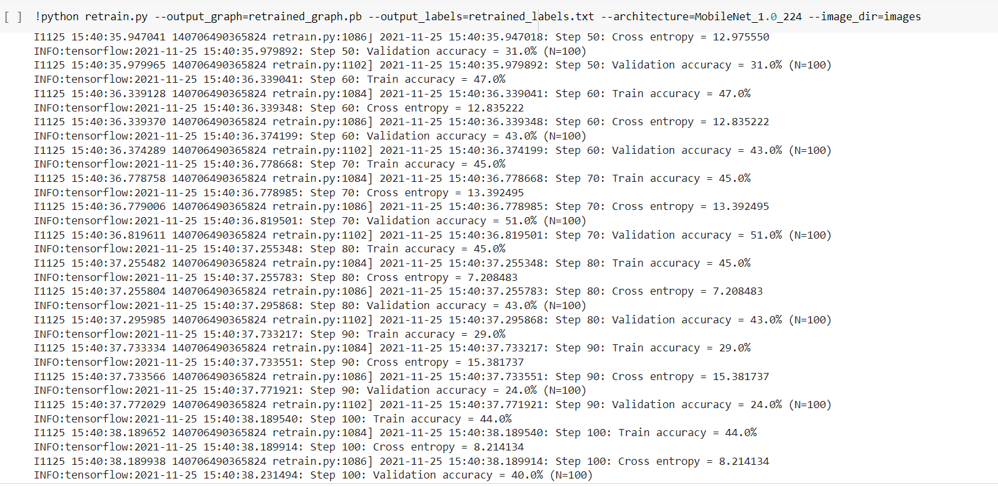

Once the image has been captured, the captured frame of the image from webcam feed is then being converted to a grayscale image to enhance the

performance of the classifier that's wont to identify the face present within the picture.

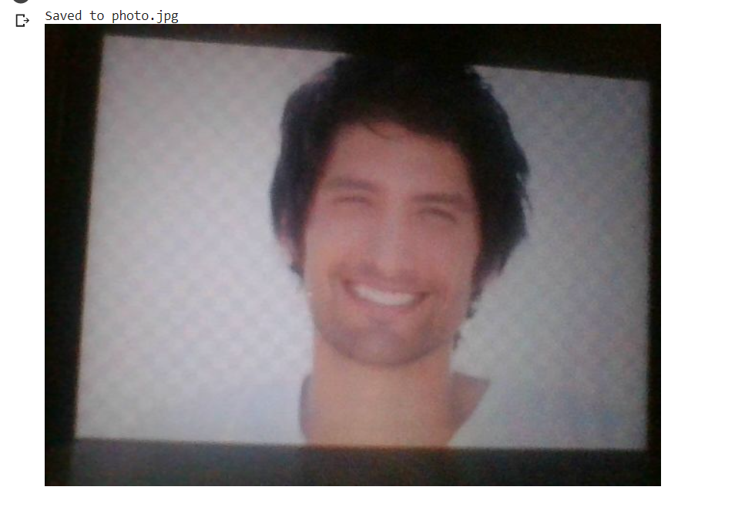

Once the conversion is complete, the image is shipped to the classifier algorithm which,with the assistance of feature extraction techniques is in a position to extract the face from the frame of the web camera feed.

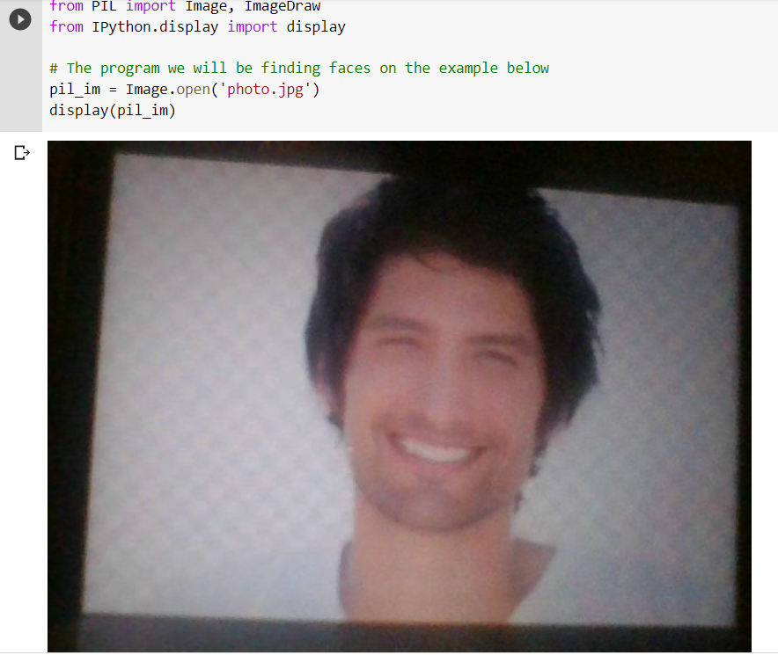

Once the face is extracted individual features from the face is extracted and is sent to the trained network to detect the emotion expressed by the user and it plays a song from the folder of the detected emotion.

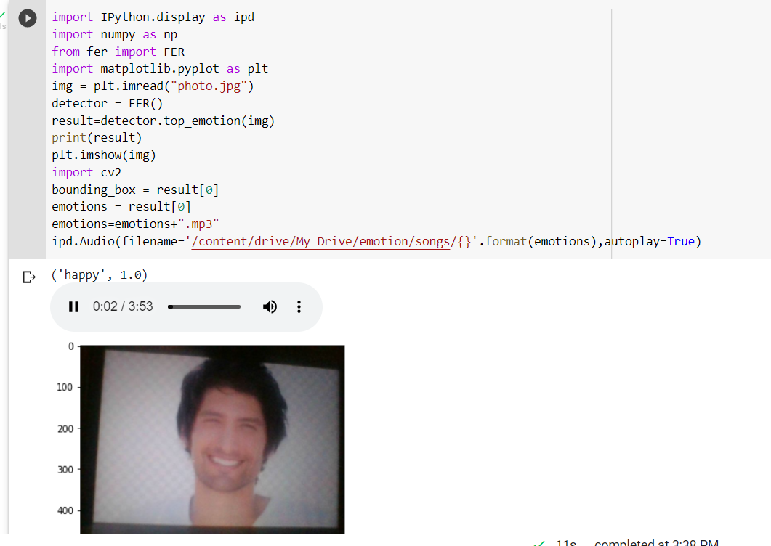

**Conclusion**

The Emotion-Based Music Player is utilized to automate and give a superior music player experience for the end user. The application tackles the essential necessities of music listeners without alarming them as existing applications do: it utilizes increment the connection of the framework with the user in numerous ways. It facilitates crafted by the end – user by catching the picture utilizing a camera, deciding their feeling, and recommending an altered play-list through a further developed and intuitive framework. The user will likewise be informed of songs that are not being played, to assist them with opening up extra room.

**References**

1.  Mellouk, Wafa & Wahida, Handouzi. (2020). Facial emotion recognition using deep learning: review and insights. Procedia Computer Science. 175. 689-694. 10.1016/j.procs.2020.07.101.

2.H. Immanuel James, J. James Anto Arnold, J. Maria Masilla Ruban, M. Tamilarasan, R. Saranya” EMOTION BASED MUSIC RECOMMENDATION SYSTEM”: p- ISSN: 2395-0072 , IRJET 2019

3.Hafeez Kabani, Sharik Khan , Omar Khan , Shabana Tadvi”Emotion Based Music Player” International Journal of Engineering Research and General Science Volume 3, Issue 1, January-February , 2015

4. Mehendale, N. Facial emotion recognition using convolutional neural networks (FERC). *SN Appl. Sci.* **2,**446 (2020). <https://doi.org/10.1007/s42452-020-2234-1>