WoundSense
A Smart Wound-Healing Monitoring and Early Infection-Risk Detection System

Project Type: Science & Health Project
Prepared by: Priya Kumari
School: PREMIER ACADEMY

1. Project Overview
WoundSense is a smart wound-healing monitoring system designed to demonstrate how simple sensors and electronic components can be used to observe changes around a wound.

The model uses a simulated wound rather than a real human wound. Sensors are placed around the simulated wound to monitor conditions such as temperature and moisture. A pH-related change can also be demonstrated as an additional indicator.

The readings collected by the sensors are sent to a small microcontroller, such as an Arduino. The microcontroller processes the readings and compares them with predefined ranges used for the demonstration. Depending on the readings, the system can show different conditions such as Normal, Monitor, or Potential Infection Risk through LEDs, a display, or an optional buzzer.

The main idea behind WoundSense is to demonstrate how technology could help monitor changes in a wound environment and provide an early indication that something unusual may need attention.

2. Introduction
Wounds are a normal part of life. Small cuts, scratches, burns, and other injuries can occur for many different reasons. Normally, the body begins a natural healing process after an injury.

During healing, conditions around a wound can change. Temperature, moisture, and other properties of the wound environment may provide useful information about what is happening.

Sometimes, unusual changes may occur before a person clearly notices that something is wrong. This creates an opportunity for technology to help with continuous monitoring.

WoundSense was developed to demonstrate this idea through a simple science model.

Instead of simply looking at a wound, the system uses sensors to collect information. The information is then processed electronically and converted into an easy-to-understand warning.

The project combines basic ideas from biology, chemistry, electronics, and computing to create a health-related science model.

3. Problem Statement
A wound normally changes as it heals, but some changes may be difficult to notice immediately.

Traditional observation mainly depends on visually checking the wound and noticing changes such as unusual redness, swelling, warmth, or other signs.

WoundSense explores a different approach: using sensors to monitor measurable conditions around a wound continuously.

The purpose is not to diagnose an infection, but to demonstrate how a monitoring system could identify unusual patterns and provide an early warning for further attention.

4. Aim of the Project
The aim of WoundSense is:

To demonstrate a simple sensor-based system that monitors a simulated wound and provides an early indication when measured conditions may suggest an increased risk of infection.

5. Objectives
The main objectives of the project are:
1. To demonstrate how a wound environment can be monitored using sensors.
2. To monitor changes in temperature around a simulated wound.
3. To monitor moisture conditions around a simulated wound.
4. To demonstrate how pH-related changes can be considered as an additional factor.
5. To send sensor readings to a microcontroller such as an Arduino.
6. To process the collected readings and compare them with predefined demonstration ranges.
7. To display the monitoring status using LEDs, a display, or an optional buzzer.
8. To demonstrate how technology could help identify unusual wound conditions at an earlier stage.
9. To create a simple and understandable health-related science model.

6. Scientific Principle
The human body has a natural process for repairing damaged tissue. During this process, the environment around a wound can change.
Some measurable factors include:

#Temperature
Temperature around a wound can change because of inflammation and other processes occurring in the body.
An unusual increase in temperature can sometimes be associated with inflammation or infection, although temperature alone cannot confirm an infection.

#Moisture
Moisture is also an important part of the wound environment.
A wound that is too dry or has excessive fluid can have different effects on the healing environment. Therefore, monitoring moisture can provide useful information.

#pH
pH describes how acidic or alkaline a substance is.
The pH of a wound environment can change during the healing process. Some chronic or infected wounds may show changes toward a more alkaline environment.
However, pH alone cannot be used to diagnose infection.

Combining Different Measurements
One of the important ideas behind WoundSense is that one measurement should not be treated as proof of infection.
Instead, the system demonstrates how multiple measurements can be considered together.
For example:
Temperature + Moisture + pH-related change → Pattern of unusual conditions → Warning
This makes the model more meaningful than relying on only one sensor

7. Basic System Design
The working process of WoundSense can be represented as:
Simulated Wound → Sensors → Arduino / Microcontroller → Data Processing → Display / Warning
The system has four main stages:
Stage 1: Monitoring
Sensors are placed around the simulated wound.

Stage 2: Data Collection
The sensors collect information about conditions such as temperature and moisture.

Stage 3: Data Processing
The Arduino or another microcontroller receives the readings and compares them with predefined demonstration ranges.

Stage 4: Warning
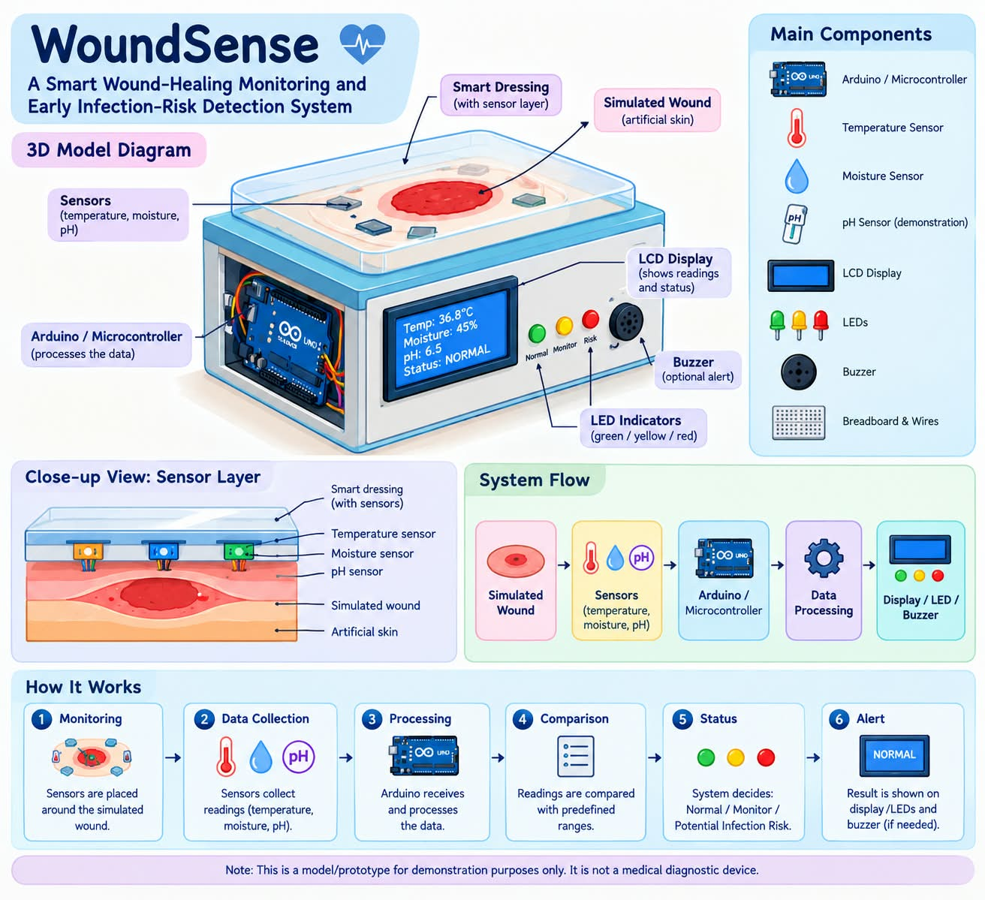
The system displays a simple status using LEDs, a screen, or an optional buzzer.

8. Model Structure
The physical model consists of several main
sections.

8.1 Simulated Skin
-A piece of artificial material represents the skin.
-A simulated wound is created on its surface.
-This allows the project to demonstrate wound
monitoring without using a real wound.

8.2 Smart Dressing
A removable or transparent dressing can be
placed over the simulated wound.
The sensor layer can be positioned around or underneath this dressing.
The concept represents how future smart dressings could contain small sensors.
8.3 Sensors
Sensors are used to collect information from the simulated wound environment.
The main measurements demonstrated by the model are:
Temperature
Moisture
pH-related changes

8.4 Arduino / Microcontroller
The Arduino acts as the control unit of the project.
It receives information from the sensors and processes the readings.

8.5 Display
An LCD or similar display can show the current monitoring status.
For example:
NORMAL
MONITOR
POTENTIAL INFECTION RISK

8.6 LED Indicators
Different LEDs can make the system easier to understand.
Green: Normal condition
Yellow: Monitor the condition
Red: Potential infection-risk pattern

8.7 Optional Buzzer
A buzzer can be used as an additional warning when the system reaches the highest warning level.

9. Components
The project can include the following components:
-Arduino [microcontroller]
-Temperature sensor
-Moisture sensor
-pH-related demonstration setup
-LCD or small display
-LEDs
-Buzzer
-Connecting wires
-Breadboard
-Power supply
-Artificial skin / model surface
-Simulated wound material
-Dressing material
-Supporting cardboard, foam board, or other model-building material

10. Working Process
The working process of WoundSense can be explained in the following steps.
Step 1: Creating the Simulated Wound
A wound is represented on an artificial skin surface.
The model is designed so that no real human skin or real wound is involved.

Step 2: Placing the Sensors
Sensors are positioned around the simulated wound.
The sensors represent the type of monitoring that could potentially be included in a smart dressing.

Step 3: Collecting Information
The sensors collect readings related to the conditions being demonstrated.
These can include temperature and moisture, along with a demonstration of pH-related changes.

Step 4: Sending the Readings
The sensor readings are transferred to the Arduino or microcontroller.

Step 5: Processing the Information
The microcontroller compares the readings with predefined ranges created for the demonstration.
The system does not simply ask whether one reading is high or low. The concept is to observe whether the overall pattern appears unusual.

Step 6: Showing the Result
The system displays a simple status.
For example:
Green → Normal
Yellow → Monitor
Red → Potential Infection Risk
Step 7: Providing an Alert

If the readings show an unusual pattern, the system can activate a red LED or optional buzzer.
This represents an early warning rather than a medical diagnosis.

11. Example Demonstration
The model can demonstrate three basic situations.
Situation 1: Normal
The sensor readings remain within the expected demonstration range.
Output:
Green LED
Status: NORMAL
This represents a condition in which no unusual pattern is being demonstrated.

Situation 2: Monitor
One or more readings begin to change.
Output:
Yellow LED
Status: MONITOR
This indicates that the condition has changed and should be observed more closely.

Situation 3: Potential Infection Risk
Several readings show an unusual pattern according to the demonstration settings.
Output:
Red LED
Status: POTENTIAL INFECTION RISK
The system can also activate a buzzer.

This does not mean that the model has medically diagnosed an infection. It means that the readings have produced a pattern that the model is programmed to flag for further attention.

12. Example System Flow
The complete concept can be represented as:
WOUND
↓
Temperature Sensor + Moisture Sensor + pH Demonstration
↓
Arduino / Microcontroller
↓
Reading Comparison
↓
Condition Classification
↓
Normal / Monitor / Potential Infection Risk
↓
LED / Display / Buzzer

13. Why Multiple Measurements Are Useful
An important feature of WoundSense is the use of multiple types of information.
If the system relied only on temperature, it could produce a warning because of a change that has nothing to do with infection.
Similarly, moisture can change for several reasons.
pH can also change because of different conditions.
Therefore, WoundSense demonstrates the idea of looking at multiple measurements together.
This makes the concept more realistic because health-related conditions are often more complicated than a single number.

14. Innovation of the Project
The main idea behind WoundSense is combining simple sensors with wound monitoring.
Instead of treating a dressing as something that only covers a wound, the project demonstrates the concept of a smart dressing that could potentially monitor the wound environment.
The model connects:
Health + Sensors + Electronics + Data + Early Warning
The project also demonstrates how information that is normally invisible or difficult to observe can be converted into a simple electronic signal.

15. Possible Applications
The concept demonstrated by WoundSense could have several possible future applications:
-Smart Dressings
-Future dressings could potentially contain small sensors that monitor wound conditions.
-Health Monitoring
-Sensor-based systems could help track changes over time.
-Remote Monitoring
-A future version could send readings to a mobile phone or computer.
-Hospital and Care Settings.
-With proper development and testing, similar concepts could potentially support healthcare professionals in monitoring wounds.
-Health Education
-The model can also be used to teach students about wounds, sensors, electronics, and health technology.

16. Future Scope
WoundSense could be developed further in several ways.
16.1 More Accurate Sensors

Future versions could use more accurate and reliable sensors designed specifically for wound monitoring.

16.2 Mobile Application
The system could be connected to a mobile application.
The application could display readings and changes over time.

16.3 Data Storage
The system could store previous readings.
This would make it possible to observe whether conditions are improving or changing.

16.4 Wireless Monitoring
A future version could transmit information wirelessly.
This could allow readings to be viewed from another device.

16.5 Improved Data Analysis
More advanced software could study patterns in several measurements instead of relying only on fixed ranges.

16.6 Smart Dressing
The sensors could eventually be made smaller and integrated into a specially designed dressing.

17. Limitations
WoundSense is a science model and prototype concept, so it has important limitations.
1. It does not medically diagnose infection.
2. A temperature change alone cannot confirm infection.
3. A moisture change alone cannot confirm infection.
4. A pH change alone cannot confirm infection.
5. The project uses a simulated wound rather than real human tissue.
6. The demonstration ranges used by the model are not medical treatment or diagnostic thresholds.
7. A real medical device would require extensive testing and professional validation.
8. Real wound-monitoring equipment would need safe, sterile, and suitable materials.
9. The prototype is intended to demonstrate an idea rather than function as a clinical device.

18. Safety Considerations
The WoundSense model is designed for demonstration purposes.
The simulated wound should be used instead of a real wound.
The prototype should never be placed directly on an actual wound or used to make a medical decision.

A real wound-monitoring device would require:
Safe materials
Sterile components
Appropriate sensors
Accurate calibration
Electrical safety
Laboratory testing
Medical evaluation
Professional approval before real-world use

19. Educational Value

WoundSense demonstrates how different areas of science can work together.

Biology
The project introduces the process of wound healing and factors that can change around a wound.

Chemistry
The project introduces the concept of pH and changes in the wound environment.

Physics
Temperature and sensor measurements demonstrate the use of physical measurements.

Electronics
Sensors, LEDs, displays, wires, and microcontrollers demonstrate basic electronic systems.

Computing
The Arduino processes sensor information and converts it into an understandable output.
Therefore, WoundSense demonstrates how science can move from an observation to a practical model.

20. Project Significance
The significance of WoundSense is not that it creates a complete medical device.
Its importance lies in demonstrating a simple idea:
> If a condition can be measured, it can potentially be monitored.
The project shows how sensors can turn changes in the environment into useful information.
It also demonstrates the potential of technology to help people notice unusual changes earlier, while recognizing that professional medical assessment is still necessary.

21. Conclusion
WoundSense is a science and health project that demonstrates a smart approach to monitoring wound conditions.
The model uses a simulated wound, sensors, a microcontroller, and simple warning outputs to show how changes in temperature, moisture, and pH-related conditions can be monitored.
The system processes these readings and provides a simple status such as Normal, Monitor, or Potential Infection Risk.
The project does not attempt to replace doctors or diagnose infections. Instead, it demonstrates how science and technology could be used to monitor health-related conditions and provide useful early warnings.

WoundSense therefore presents a simple but meaningful concept: using sensors and data to make changes around a wound easier to observe.

22. Short Project Description
WoundSense is a smart wound-healing monitoring and early infection-risk detection system. It uses sensors to monitor conditions such as temperature and moisture around a simulated wound, processes the readings through a microcontroller, and provides a simple warning when an unusual pattern is detected.

23. One-Line Description
A smart system that monitors wound conditions to track healing and identify potential signs of infection at an early stage

24. Project Presentation Statement
If the project needs to be described briefly during an exhibition:
> WoundSense is a sensor-based wound-monitoring model. It uses temperature and moisture monitoring, along with a pH-related demonstration, to observe changes around a simulated wound. The readings are processed by an Arduino, which gives a simple status through LEDs or a display. The purpose is not to diagnose infection, but to demonstrate how technology could identify unusual patterns and provide an early warning for further attention.

25. Project Documentation Record
Project Name: WoundSense
Full Title :WoundSense: A Smart Wound-Healing Monitoring and Early Infection-Risk Detection System
Project Type: Science & Health Project
Prepared by: Priya Kumari
School / Institution: PREMIER ACADEMY
Award / Position: 1st

