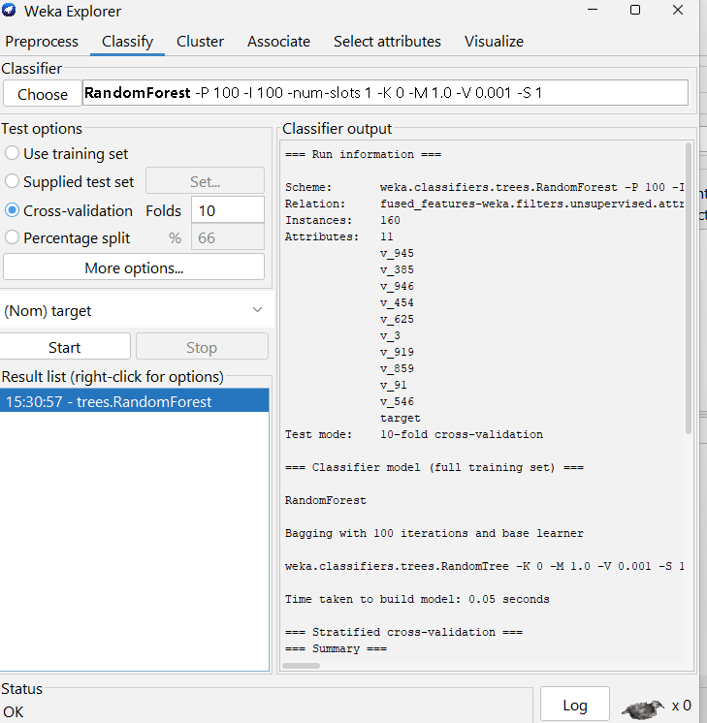

== Run information ===

Scheme: weka.classifiers.trees.RandomForest -P 100 -I 100 -num-slots 1 -K 0 -M 1.0 -V 0.001 -S 1
Relation: fused_features-weka.filters.unsupervised.attribute.NumericToNominal-Rlast-weka.filters.unsupervised.attribute.ReplaceMissingValues-weka.filters.unsupervised.attribute.Normalize-S1.0-T0.0-weka.filters.supervised.attribute.AttributeSelection-Eweka.attributeSelection.ReliefFAttributeEval -M -1 -D 1 -K 10-Sweka.attributeSelection.Ranker -T -1.7976931348623157E308 -N 50-weka.filters.supervised.attribute.AttributeSelection-Eweka.attributeSelection.ReliefFAttributeEval -M -1 -D 1 -K 10-Sweka.attributeSelection.Ranker -T -1.7976931348623157E308 -N 10
Instances: 160
Attributes: 11
v_945
v_385
v_946
v_454
v_625
v_3
v_919
v_859
v_91
v_546
target
Test mode: 10-fold cross-validation

=== Classifier model (full training set) ===

RandomForest

Bagging with 100 iterations and base learner

weka.classifiers.trees.RandomTree -K 0 -M 1.0 -V 0.001 -S 1 -do-not-check-capabilities

Time taken to build model: 0.05 seconds

=== Stratified cross-validation ===
=== Summary ===

Correctly Classified Instances 81 50.625 %
Incorrectly Classified Instances 79 49.375 %
Kappa statistic 0.0125
Mean absolute error 0.4766
Root mean squared error 0.5433
Relative absolute error 95.3125 %
Root relative squared error 108.6535 %
Total Number of Instances 160

=== Detailed Accuracy By Class ===

TP Rate FP Rate Precision Recall F-Measure MCC ROC Area PRC Area Class
0.450 0.438 0.507 0.450 0.477 0.013 0.547 0.548 0
0.563 0.550 0.506 0.563 0.533 0.013 0.547 0.579 1
Weighted Avg. 0.506 0.494 0.506 0.506 0.505 0.013 0.547 0.564

=== Confusion Matrix ===

a b <-- classified as
36 44 | a = 0
35 45 | b = 1

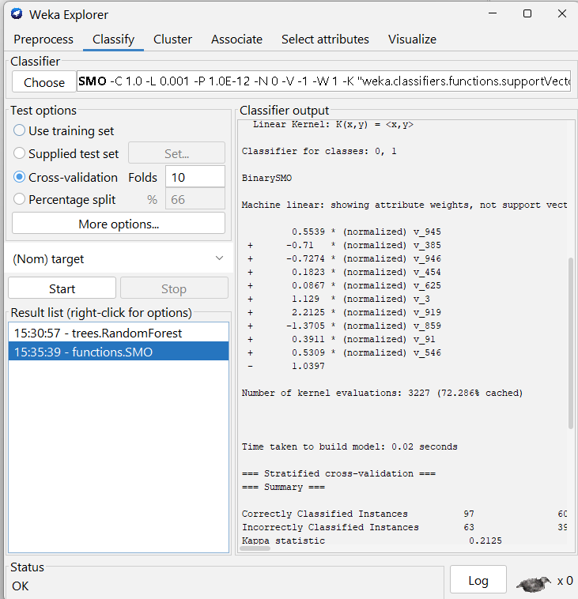

=== Run information ===

Scheme: weka.classifiers.functions.SMO -C 1.0 -L 0.001 -P 1.0E-12 -N 0 -V -1 -W 1 -K "weka.classifiers.functions.supportVector.PolyKernel -E 1.0 -C 250007" -calibrator "weka.classifiers.functions.Logistic -R 1.0E-8 -M -1 -num-decimal-places 4"
Relation: fused_features-weka.filters.unsupervised.attribute.NumericToNominal-Rlast-weka.filters.unsupervised.attribute.ReplaceMissingValues-weka.filters.unsupervised.attribute.Normalize-S1.0-T0.0-weka.filters.supervised.attribute.AttributeSelection-Eweka.attributeSelection.ReliefFAttributeEval -M -1 -D 1 -K 10-Sweka.attributeSelection.Ranker -T -1.7976931348623157E308 -N 50-weka.filters.supervised.attribute.AttributeSelection-Eweka.attributeSelection.ReliefFAttributeEval -M -1 -D 1 -K 10-Sweka.attributeSelection.Ranker -T -1.7976931348623157E308 -N 10
Instances: 160
Attributes: 11
v_945
v_385
v_946
v_454
v_625
v_3
v_919
v_859
v_91
v_546
target
Test mode: 10-fold cross-validation

=== Classifier model (full training set) ===

SMO

Kernel used:
Linear Kernel: K(x,y) = <x,y>

Classifier for classes: 0, 1

BinarySMO

Machine linear: showing attribute weights, not support vectors.

0.5539 * (normalized) v_945
+ -0.71 * (normalized) v_385
+ -0.7274 * (normalized) v_946
+ 0.1823 * (normalized) v_454
+ 0.0867 * (normalized) v_625
+ 1.129 * (normalized) v_3
+ 2.2125 * (normalized) v_919
+ -1.3705 * (normalized) v_859
+ 0.3911 * (normalized) v_91
+ 0.5309 * (normalized) v_546
- 1.0397

Number of kernel evaluations: 3227 (72.286% cached)

Time taken to build model: 0.02 seconds

=== Stratified cross-validation ===
=== Summary ===

Correctly Classified Instances 97 60.625 %
Incorrectly Classified Instances 63 39.375 %
Kappa statistic 0.2125
Mean absolute error 0.3937
Root mean squared error 0.6275
Relative absolute error 78.75 %
Root relative squared error 125.499 %
Total Number of Instances 160

=== Detailed Accuracy By Class ===

TP Rate FP Rate Precision Recall F-Measure MCC ROC Area PRC Area Class
0.638 0.425 0.600 0.638 0.618 0.213 0.606 0.564 0
0.575 0.363 0.613 0.575 0.594 0.213 0.606 0.565 1
Weighted Avg. 0.606 0.394 0.607 0.606 0.606 0.213 0.606 0.564

=== Confusion Matrix ===

a b <-- classified as
51 29 | a = 0
34 46 | b = 1

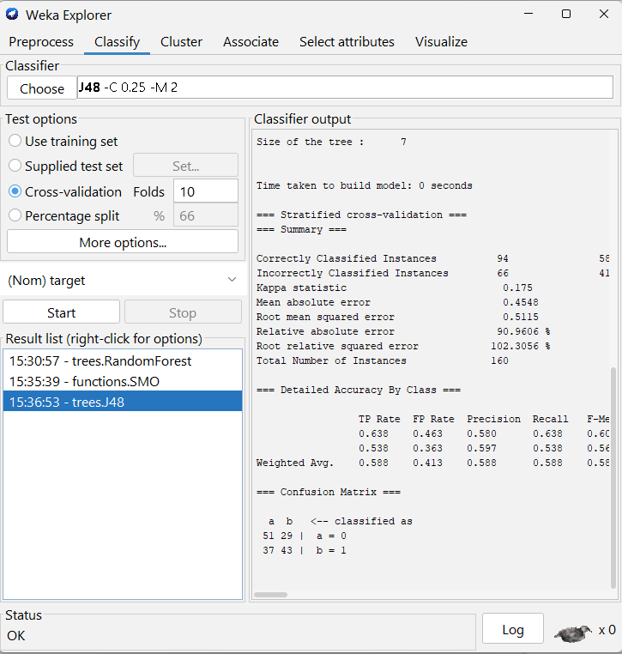

=== Run information ===

Scheme: weka.classifiers.trees.J48 -C 0.25 -M 2
Relation: fused_features-weka.filters.unsupervised.attribute.NumericToNominal-Rlast-weka.filters.unsupervised.attribute.ReplaceMissingValues-weka.filters.unsupervised.attribute.Normalize-S1.0-T0.0-weka.filters.supervised.attribute.AttributeSelection-Eweka.attributeSelection.ReliefFAttributeEval -M -1 -D 1 -K 10-Sweka.attributeSelection.Ranker -T -1.7976931348623157E308 -N 50-weka.filters.supervised.attribute.AttributeSelection-Eweka.attributeSelection.ReliefFAttributeEval -M -1 -D 1 -K 10-Sweka.attributeSelection.Ranker -T -1.7976931348623157E308 -N 10
Instances: 160
Attributes: 11
v_945
v_385
v_946
v_454
v_625
v_3
v_919
v_859
v_91
v_546
target
Test mode: 10-fold cross-validation

=== Classifier model (full training set) ===

J48 pruned tree
------------------

v_91 <= 0.841352
| v_919 <= 0.873307
| | v_385 <= 0.13284: 1 (44.0/16.0)
| | v_385 > 0.13284: 0 (89.0/27.0)
| v_919 > 0.873307: 1 (18.0/2.0)
v_91 > 0.841352: 1 (9.0)

Number of Leaves : 4

Size of the tree : 7

Time taken to build model: 0 seconds

=== Stratified cross-validation ===
=== Summary ===

Correctly Classified Instances 94 58.75 %
Incorrectly Classified Instances 66 41.25 %
Kappa statistic 0.175
Mean absolute error 0.4548
Root mean squared error 0.5115
Relative absolute error 90.9606 %
Root relative squared error 102.3056 %
Total Number of Instances 160

=== Detailed Accuracy By Class ===

TP Rate FP Rate Precision Recall F-Measure MCC ROC Area PRC Area Class
0.638 0.463 0.580 0.638 0.607 0.176 0.608 0.574 0
0.538 0.363 0.597 0.538 0.566 0.176 0.608 0.603 1
Weighted Avg. 0.588 0.413 0.588 0.588 0.586 0.176 0.608 0.589

=== Confusion Matrix ===

a b <-- classified as
51 29 | a = 0
37 43 | b = 1

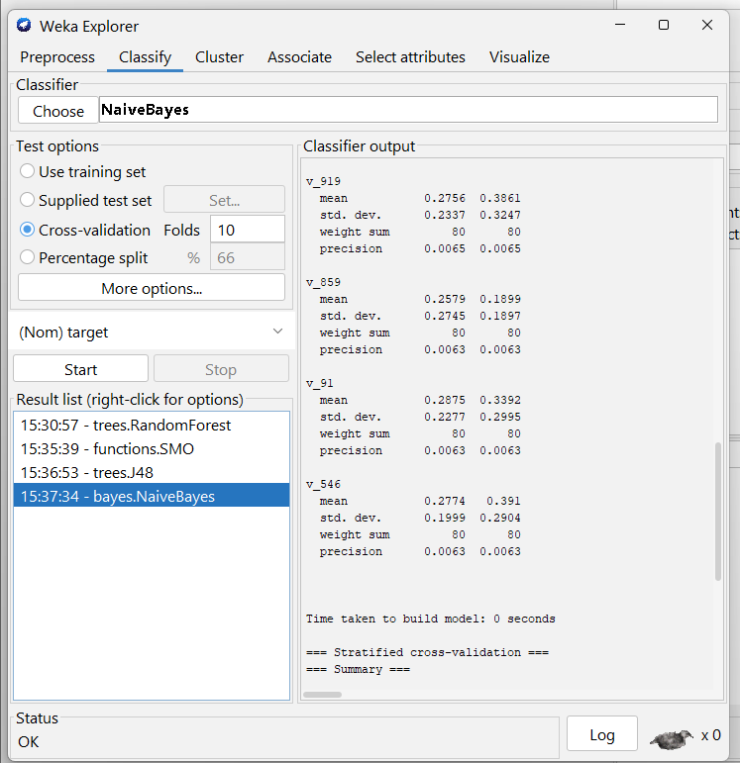

=== Run information ===

Scheme: weka.classifiers.bayes.NaiveBayes
Relation: fused_features-weka.filters.unsupervised.attribute.NumericToNominal-Rlast-weka.filters.unsupervised.attribute.ReplaceMissingValues-weka.filters.unsupervised.attribute.Normalize-S1.0-T0.0-weka.filters.supervised.attribute.AttributeSelection-Eweka.attributeSelection.ReliefFAttributeEval -M -1 -D 1 -K 10-Sweka.attributeSelection.Ranker -T -1.7976931348623157E308 -N 50-weka.filters.supervised.attribute.AttributeSelection-Eweka.attributeSelection.ReliefFAttributeEval -M -1 -D 1 -K 10-Sweka.attributeSelection.Ranker -T -1.7976931348623157E308 -N 10
Instances: 160
Attributes: 11
v_945
v_385
v_946
v_454
v_625
v_3
v_919
v_859
v_91
v_546
target
Test mode: 10-fold cross-validation

=== Classifier model (full training set) ===

Naive Bayes Classifier

Class
Attribute 0 1
(0.5) (0.5)
===============================
v_945
mean 0.4264 0.5521
std. dev. 0.2915 0.3224
weight sum 80 80
precision 0.0063 0.0063

v_385
mean 0.3979 0.4061
std. dev. 0.2787 0.3062
weight sum 80 80
precision 0.0063 0.0063

v_946
mean 0.4292 0.3961
std. dev. 0.2627 0.1711
weight sum 80 80
precision 0.0063 0.0063

v_454
mean 0.389 0.39
std. dev. 0.2691 0.2355
weight sum 80 80
precision 0.0063 0.0063

v_625
mean 0.2813 0.3233
std. dev. 0.246 0.2564
weight sum 80 80
precision 0.0063 0.0063

v_3
mean 0.3969 0.435
std. dev. 0.2876 0.3028
weight sum 80 80
precision 0.0063 0.0063

v_919
mean 0.2756 0.3861
std. dev. 0.2337 0.3247
weight sum 80 80
precision 0.0065 0.0065

v_859
mean 0.2579 0.1899
std. dev. 0.2745 0.1897
weight sum 80 80
precision 0.0063 0.0063

v_91
mean 0.2875 0.3392
std. dev. 0.2277 0.2995
weight sum 80 80
precision 0.0063 0.0063

v_546
mean 0.2774 0.391
std. dev. 0.1999 0.2904
weight sum 80 80
precision 0.0063 0.0063

Time taken to build model: 0 seconds

=== Stratified cross-validation ===
=== Summary ===

Correctly Classified Instances 105 65.625 %
Incorrectly Classified Instances 55 34.375 %
Kappa statistic 0.3125
Mean absolute error 0.3853
Root mean squared error 0.4982
Relative absolute error 77.0598 %
Root relative squared error 99.6449 %
Total Number of Instances 160

=== Detailed Accuracy By Class ===

TP Rate FP Rate Precision Recall F-Measure MCC ROC Area PRC Area Class
0.750 0.438 0.632 0.750 0.686 0.318 0.697 0.672 0
0.563 0.250 0.692 0.563 0.621 0.318 0.697 0.698 1
Weighted Avg. 0.656 0.344 0.662 0.656 0.653 0.318 0.697 0.685

=== Confusion Matrix ===

a b <-- classified as
60 20 | a = 0
35 45 | b = 1

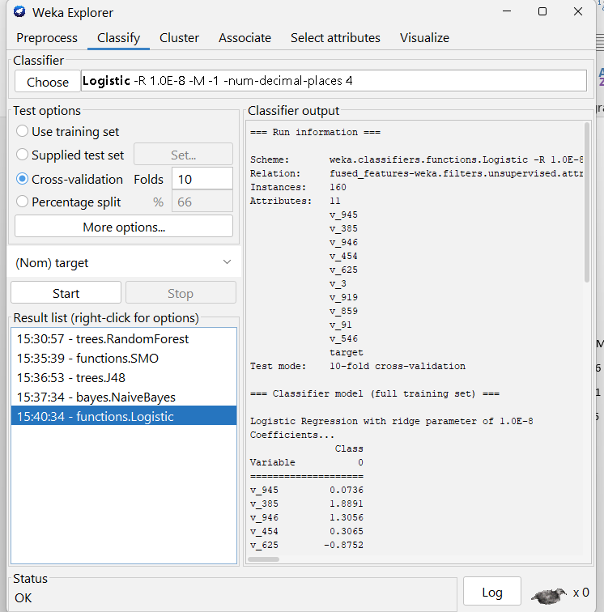

=== Run information ===

Scheme: weka.classifiers.functions.Logistic -R 1.0E-8 -M -1 -num-decimal-places 4
Relation: fused_features-weka.filters.unsupervised.attribute.NumericToNominal-Rlast-weka.filters.unsupervised.attribute.ReplaceMissingValues-weka.filters.unsupervised.attribute.Normalize-S1.0-T0.0-weka.filters.supervised.attribute.AttributeSelection-Eweka.attributeSelection.ReliefFAttributeEval -M -1 -D 1 -K 10-Sweka.attributeSelection.Ranker -T -1.7976931348623157E308 -N 50-weka.filters.supervised.attribute.AttributeSelection-Eweka.attributeSelection.ReliefFAttributeEval -M -1 -D 1 -K 10-Sweka.attributeSelection.Ranker -T -1.7976931348623157E308 -N 10
Instances: 160
Attributes: 11
v_945
v_385
v_946
v_454
v_625
v_3
v_919
v_859
v_91
v_546
target
Test mode: 10-fold cross-validation

=== Classifier model (full training set) ===

Logistic Regression with ridge parameter of 1.0E-8
Coefficients...
Class
Variable 0
====================
v_945 0.0736
v_385 1.8891
v_946 1.3056
v_454 0.3065
v_625 -0.8752
v_3 -0.2605
v_919 -2.3951
v_859 2.7457
v_91 -1.719
v_546 -0.6265
Intercept -0.1576

Odds Ratios...
Class
Variable 0
====================
v_945 1.0763
v_385 6.6134
v_946 3.6898
v_454 1.3586
v_625 0.4168
v_3 0.7707
v_919 0.0912
v_859 15.5752
v_91 0.1793
v_546 0.5344

Time taken to build model: 0 seconds

=== Stratified cross-validation ===
=== Summary ===

Correctly Classified Instances 96 60 %
Incorrectly Classified Instances 64 40 %
Kappa statistic 0.2
Mean absolute error 0.4519
Root mean squared error 0.4942
Relative absolute error 90.3768 %
Root relative squared error 98.8394 %
Total Number of Instances 160

=== Detailed Accuracy By Class ===

TP Rate FP Rate Precision Recall F-Measure MCC ROC Area PRC Area Class
0.563 0.363 0.608 0.563 0.584 0.201 0.635 0.609 0
0.638 0.438 0.593 0.638 0.614 0.201 0.635 0.612 1
Weighted Avg. 0.600 0.400 0.601 0.600 0.599 0.201 0.635 0.611

=== Confusion Matrix ===

a b <-- classified as
45 35 | a = 0
29 51 | b = 1

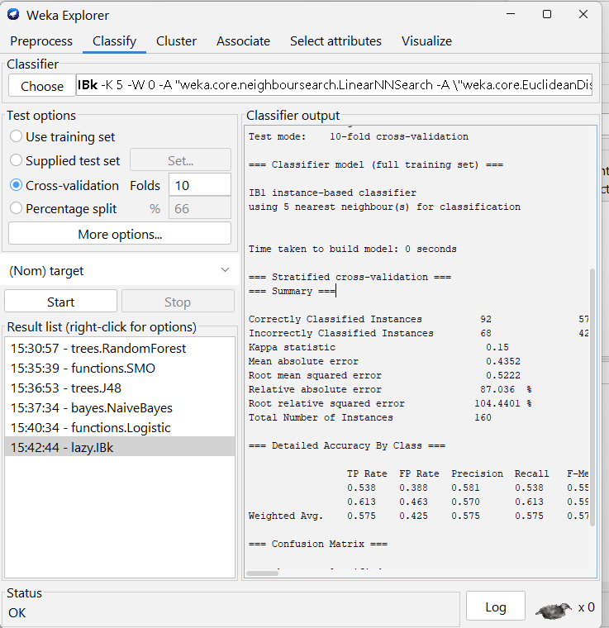

== Run information ===

Scheme: weka.classifiers.lazy.IBk -K 5 -W 0 -A "weka.core.neighboursearch.LinearNNSearch -A \"weka.core.EuclideanDistance -R first-last\""
Relation: fused_features-weka.filters.unsupervised.attribute.NumericToNominal-Rlast-weka.filters.unsupervised.attribute.ReplaceMissingValues-weka.filters.unsupervised.attribute.Normalize-S1.0-T0.0-weka.filters.supervised.attribute.AttributeSelection-Eweka.attributeSelection.ReliefFAttributeEval -M -1 -D 1 -K 10-Sweka.attributeSelection.Ranker -T -1.7976931348623157E308 -N 50-weka.filters.supervised.attribute.AttributeSelection-Eweka.attributeSelection.ReliefFAttributeEval -M -1 -D 1 -K 10-Sweka.attributeSelection.Ranker -T -1.7976931348623157E308 -N 10
Instances: 160
Attributes: 11
v_945
v_385
v_946
v_454
v_625
v_3
v_919
v_859
v_91
v_546
target
Test mode: 10-fold cross-validation

=== Classifier model (full training set) ===

IB1 instance-based classifier
using 5 nearest neighbour(s) for classification

Time taken to build model: 0 seconds

=== Stratified cross-validation ===
=== Summary ===

Correctly Classified Instances 92 57.5 %
Incorrectly Classified Instances 68 42.5 %
Kappa statistic 0.15
Mean absolute error 0.4352
Root mean squared error 0.5222
Relative absolute error 87.036 %
Root relative squared error 104.4401 %
Total Number of Instances 160

=== Detailed Accuracy By Class ===

TP Rate FP Rate Precision Recall F-Measure MCC ROC Area PRC Area Class
0.538 0.388 0.581 0.538 0.558 0.150 0.622 0.610 0
0.613 0.463 0.570 0.613 0.590 0.150 0.622 0.582 1
Weighted Avg. 0.575 0.425 0.575 0.575 0.574 0.150 0.622 0.596

=== Confusion Matrix ===

a b <-- classified as
43 37 | a = 0
31 49 | b = 1

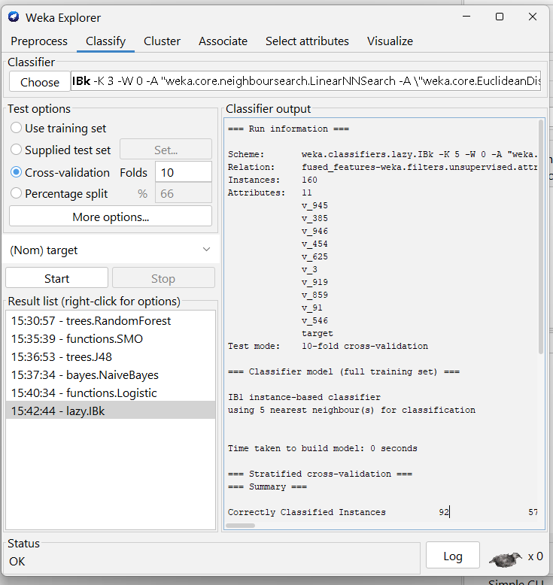

== Run information ===

Scheme: weka.classifiers.lazy.IBk -K 5 -W 0 -A "weka.core.neighboursearch.LinearNNSearch -A \"weka.core.EuclideanDistance -R first-last\""
Relation: fused_features-weka.filters.unsupervised.attribute.NumericToNominal-Rlast-weka.filters.unsupervised.attribute.ReplaceMissingValues-weka.filters.unsupervised.attribute.Normalize-S1.0-T0.0-weka.filters.supervised.attribute.AttributeSelection-Eweka.attributeSelection.ReliefFAttributeEval -M -1 -D 1 -K 10-Sweka.attributeSelection.Ranker -T -1.7976931348623157E308 -N 50-weka.filters.supervised.attribute.AttributeSelection-Eweka.attributeSelection.ReliefFAttributeEval -M -1 -D 1 -K 10-Sweka.attributeSelection.Ranker -T -1.7976931348623157E308 -N 10
Instances: 160
Attributes: 11
v_945
v_385
v_946
v_454
v_625
v_3
v_919
v_859
v_91
v_546
target
Test mode: 10-fold cross-validation

=== Classifier model (full training set) ===

IB1 instance-based classifier
using 5 nearest neighbour(s) for classification

Time taken to build model: 0 seconds

=== Stratified cross-validation ===
=== Summary ===

Correctly Classified Instances 92 57.5 %
Incorrectly Classified Instances 68 42.5 %
Kappa statistic 0.15
Mean absolute error 0.4352
Root mean squared error 0.5222
Relative absolute error 87.036 %
Root relative squared error 104.4401 %
Total Number of Instances 160

=== Detailed Accuracy By Class ===

TP Rate FP Rate Precision Recall F-Measure MCC ROC Area PRC Area Class
0.538 0.388 0.581 0.538 0.558 0.150 0.622 0.610 0
0.613 0.463 0.570 0.613 0.590 0.150 0.622 0.582 1
Weighted Avg. 0.575 0.425 0.575 0.575 0.574 0.150 0.622 0.596

=== Confusion Matrix ===

a b <-- classified as
43 37 | a = 0
31 49 | b = 1

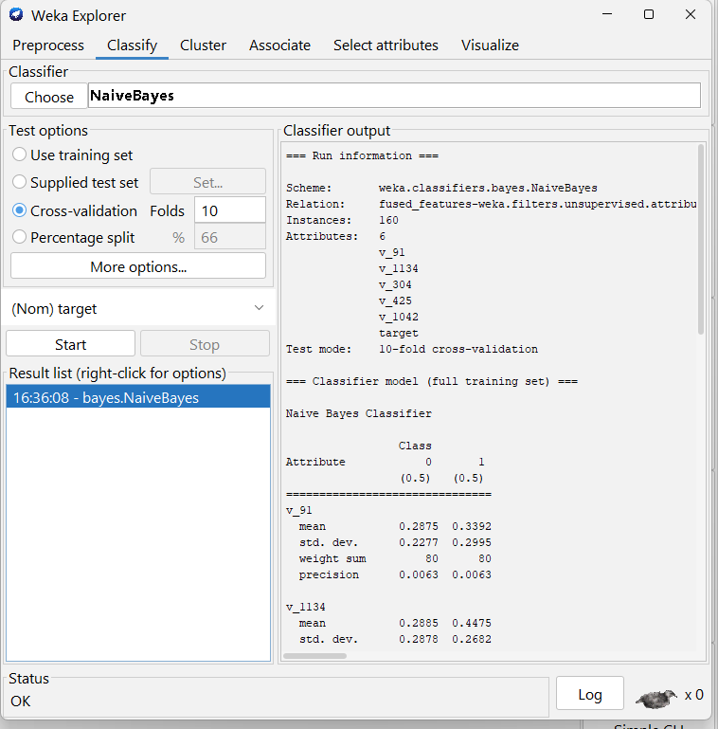

== Run information ===

Scheme: weka.classifiers.bayes.NaiveBayes
Relation: fused_features-weka.filters.unsupervised.attribute.NumericToNominal-Rlast-weka.filters.unsupervised.attribute.ReplaceMissingValues-weka.filters.unsupervised.attribute.Normalize-S1.0-T0.0-weka.filters.supervised.attribute.AttributeSelection-Eweka.attributeSelection.ReliefFAttributeEval -M -1 -D 1 -K 10-Sweka.attributeSelection.Ranker -T -1.7976931348623157E308 -N 5
Instances: 160
Attributes: 6
v_91
v_1134
v_304
v_425
v_1042
target
Test mode: 10-fold cross-validation

=== Classifier model (full training set) ===

Naive Bayes Classifier

Class
Attribute 0 1
(0.5) (0.5)
===============================
v_91
mean 0.2875 0.3392
std. dev. 0.2277 0.2995
weight sum 80 80
precision 0.0063 0.0063

v_1134
mean 0.2885 0.4475
std. dev. 0.2878 0.2682
weight sum 80 80
precision 0.0064 0.0064

v_304
mean 0.4134 0.5654
std. dev. 0.2667 0.2809
weight sum 80 80
precision 0.0063 0.0063

v_425
mean 0.4133 0.5397
std. dev. 0.2599 0.2994
weight sum 80 80
precision 0.0063 0.0063

v_1042
mean 0.3314 0.1452
std. dev. 0.2856 0.1985
weight sum 80 80
precision 0.0063 0.0063

Time taken to build model: 0 seconds

=== Stratified cross-validation ===
=== Summary ===

Correctly Classified Instances 109 68.125 %
Incorrectly Classified Instances 51 31.875 %
Kappa statistic 0.3625
Mean absolute error 0.3722
Root mean squared error 0.4931
Relative absolute error 74.4349 %
Root relative squared error 98.6112 %
Total Number of Instances 160

=== Detailed Accuracy By Class ===

TP Rate FP Rate Precision Recall F-Measure MCC ROC Area PRC Area Class
0.613 0.250 0.710 0.613 0.658 0.366 0.707 0.691 0
0.750 0.388 0.659 0.750 0.702 0.366 0.707 0.687 1
Weighted Avg. 0.681 0.319 0.685 0.681 0.680 0.366 0.707 0.689

=== Confusion Matrix ===

a b <-- classified as
49 31 | a = 0
20 60 | b = 1

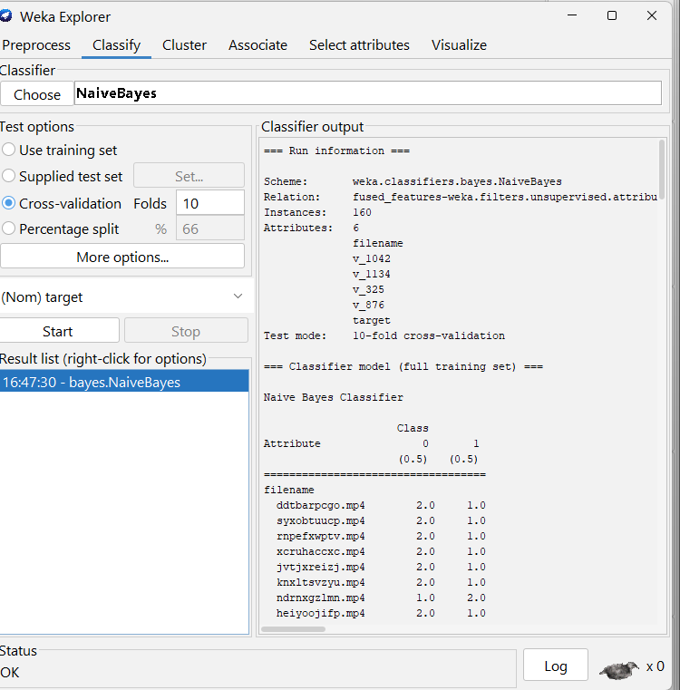

=== Run information ===

Scheme: weka.classifiers.bayes.NaiveBayes
Relation: fused_features-weka.filters.unsupervised.attribute.NumericToNominal-Rlast-weka.filters.unsupervised.attribute.ReplaceMissingValues-weka.filters.unsupervised.attribute.Normalize-S1.0-T0.0-weka.filters.supervised.attribute.AttributeSelection-Eweka.attributeSelection.InfoGainAttributeEval-Sweka.attributeSelection.Ranker -T -1.7976931348623157E308 -N 5
Instances: 160
Attributes: 6
filename
v_1042
v_1134
v_325
v_876
target
Test mode: 10-fold cross-validation

=== Classifier model (full training set) ===

Naive Bayes Classifier

Class
Attribute 0 1
(0.5) (0.5)
===================================
filename
ddtbarpcgo.mp4 2.0 1.0
syxobtuucp.mp4 2.0 1.0
rnpefxwptv.mp4 2.0 1.0
xcruhaccxc.mp4 2.0 1.0
jvtjxreizj.mp4 2.0 1.0
knxltsvzyu.mp4 2.0 1.0
ndrnxgzlmn.mp4 1.0 2.0
heiyoojifp.mp4 2.0 1.0
xdezcezszc.mp4 2.0 1.0
khtwrijuqn.mp4 2.0 1.0
exseruhiuk.mp4 2.0 1.0
ucthmsajay.mp4 2.0 1.0
mfgswvvnba.mp4 1.0 2.0
aayrffkzxn.mp4 2.0 1.0
dxfdovivlw.mp4 2.0 1.0
ltqghwybkf.mp4 1.0 2.0
wlyfcpecea.mp4 1.0 2.0
nhsijqpoda.mp4 2.0 1.0
vzockawbyi.mp4 1.0 2.0
muhgixhdmd.mp4 1.0 2.0
achdeirhym.mp4 1.0 2.0
nphtrwjtff.mp4 1.0 2.0
qlueobbhbc.mp4 1.0 2.0
lbsltufgrh.mp4 1.0 2.0
lxnqzocgaq.mp4 1.0 2.0
uqtqhiqymz.mp4 2.0 1.0
gfkdvulbfo.mp4 1.0 2.0
lokzwdldxp.mp4 2.0 1.0
dpevefkefv.mp4 2.0 1.0
ybbrkacebd.mp4 2.0 1.0
ofquuujxmu.mp4 1.0 2.0
wynotylpnm.mp4 2.0 1.0
ngvcqxjhyb.mp4 2.0 1.0
jytrvwlewz.mp4 2.0 1.0
rnxnytbudq.mp4 1.0 2.0
jdfaxqtpjk.mp4 1.0 2.0
sjwedraykt.mp4 1.0 2.0
hsbwhlolsn.mp4 2.0 1.0
dvrnrzlqdo.mp4 1.0 2.0
wzrhdvpktx.mp4 1.0 2.0
fufcmupzen.mp4 2.0 1.0
doniqevxeg.mp4 2.0 1.0
alnkzqihau.mp4 1.0 2.0
apedduehoy.mp4 2.0 1.0
ptgpqdnxtd.mp4 1.0 2.0
oibtsgqujh.mp4 1.0 2.0
jzupayeuln.mp4 2.0 1.0
vhpjdjspre.mp4 1.0 2.0
ybnucgidtu.mp4 2.0 1.0
wclvkepakb.mp4 2.0 1.0
runmncglnj.mp4 1.0 2.0
fopjiyxiqd.mp4 2.0 1.0
exxqlfpnbz.mp4 2.0 1.0
vmxfwxgdei.mp4 2.0 1.0
gkqitjodaa.mp4 1.0 2.0
prdrkaxeob.mp4 2.0 1.0
lnhkjhyhvw.mp4 2.0 1.0
fdpisghkmd.mp4 2.0 1.0
qyqufaskjs.mp4 2.0 1.0
xmkwsnuzyq.mp4 2.0 1.0
oakntpdygb.mp4 1.0 2.0
didzujjhtg.mp4 2.0 1.0
kzezrsewki.mp4 1.0 2.0
fnslimfagb.mp4 2.0 1.0
qloyrbpobv.mp4 1.0 2.0
vokrpfjpeb.mp4 2.0 1.0
hicjuubiau.mp4 2.0 1.0
meiyjcknbl.mp4 1.0 2.0
yxvmusxvcz.mp4 2.0 1.0
bkcztuqxbp.mp4 1.0 2.0
rptqbxpesg.mp4 1.0 2.0
nwvloufjty.mp4 1.0 2.0
untxvzuldz.mp4 1.0 2.0
kxhwssipyi.mp4 1.0 2.0
apvzjkvnwn.mp4 2.0 1.0
ynrueopehk.mp4 1.0 2.0
xchzardbfa.mp4 2.0 1.0
lbxbstcwwl.mp4 1.0 2.0
eiwtggvtfp.mp4 2.0 1.0
mpuugiqewv.mp4 1.0 2.0
jxqibxwhlc.mp4 1.0 2.0
jjxzidyitl.mp4 1.0 2.0
oykagryjjd.mp4 1.0 2.0
vtunvalyji.mp4 2.0 1.0
dahvuijxob.mp4 1.0 2.0
chqqxfuuzi.mp4 2.0 1.0
dhjnjkzuhq.mp4 2.0 1.0
ldtgofdaqg.mp4 2.0 1.0
gyosvoeamf.mp4 1.0 2.0
xugmhbetrw.mp4 2.0 1.0
uhakqelqri.mp4 1.0 2.0
hplxtssgnz.mp4 2.0 1.0
lwqkgvyeas.mp4 1.0 2.0
sylnrepacf.mp4 2.0 1.0
gcdtglsoqj.mp4 2.0 1.0
ncqjcvgayx.mp4 1.0 2.0
sttnfyptum.mp4 2.0 1.0
ywcfkvqemt.mp4 1.0 2.0
srfefmyjvt.mp4 2.0 1.0
ekkheaisuo.mp4 1.0 2.0
xkfliqnmwt.mp4 2.0 1.0
jranrlmuyk.mp4 1.0 2.0
yexeazbqig.mp4 2.0 1.0
tjdxwdoumt.mp4 1.0 2.0
zwsbdiyrpg.mp4 1.0 2.0
xymeodlrhb.mp4 1.0 2.0
wmoigsbnem.mp4 1.0 2.0
fgobmbcami.mp4 2.0 1.0
lbwzzntrcc.mp4 1.0 2.0
bwsytelwkm.mp4 1.0 2.0
xtaktzlrme.mp4 1.0 2.0
hivnldfvyl.mp4 2.0 1.0
uprwuohbwx.mp4 2.0 1.0
mfvqmuulak.mp4 1.0 2.0
ksjpgrujqv.mp4 1.0 2.0
lrjxcwrzls.mp4 1.0 2.0
uuexerjsmk.mp4 1.0 2.0
acdkfksyev.mp4 1.0 2.0
ewknjjmzqb.mp4 1.0 2.0
xewwsdhdro.mp4 1.0 2.0
wcqvzujamg.mp4 2.0 1.0
yljecirelf.mp4 2.0 1.0
ilflslfgbn.mp4 1.0 2.0
pqdeutauqc.mp4 2.0 1.0
tmjcigspif.mp4 1.0 2.0
gfoozygynw.mp4 1.0 2.0
rktrpsdlci.mp4 2.0 1.0
prmwoaeeng.mp4 2.0 1.0
esjdyghhog.mp4 1.0 2.0
msfssnmldu.mp4 1.0 2.0
rmuxlgsedw.mp4 2.0 1.0
lnjkpdviqb.mp4 2.0 1.0
jawgcggquk.mp4 2.0 1.0
qjvjkojjkl.mp4 1.0 2.0
gbgtzspdnv.mp4 1.0 2.0
iocjgjemeb.mp4 1.0 2.0
kqlvggiqee.mp4 2.0 1.0
fzvpbrzssi.mp4 2.0 1.0
ratscdfvdk.mp4 1.0 2.0
onbgbghesu.mp4 2.0 1.0
rmufsuogzn.mp4 2.0 1.0
srnseorykn.mp4 1.0 2.0
xawrxpyoau.mp4 1.0 2.0
lzbmwwejxb.mp4 2.0 1.0
vinguynpez.mp4 1.0 2.0
psjfwjzrrh.mp4 2.0 1.0
scrbqgpvzz.mp4 1.0 2.0
yeouperxzc.mp4 1.0 2.0
upmgtackuf.mp4 2.0 1.0
vrgubwmtyo.mp4 1.0 2.0
gnmmhlbzge.mp4 2.0 1.0
haxnhfvqvs.mp4 1.0 2.0
qnlyrlrnmn.mp4 1.0 2.0
zvsivkdkak.mp4 1.0 2.0
nrnklcxdzq.mp4 2.0 1.0
eppyqpgewp.mp4 2.0 1.0
slkqbehdcq.mp4 1.0 2.0
fsaronfupy.mp4 2.0 1.0
vpmyeepbep.mp4 2.0 1.0
lsmnqsnqld.mp4 2.0 1.0
[total] 240.0 240.0

v_1042
mean 0.3314 0.1452
std. dev. 0.2856 0.1985
weight sum 80 80
precision 0.0063 0.0063

v_1134
mean 0.2885 0.4475
std. dev. 0.2878 0.2682
weight sum 80 80
precision 0.0064 0.0064

v_325
mean 0.1932 0.1
std. dev. 0.1901 0.0684
weight sum 80 80
precision 0.0063 0.0063

v_876
mean 0.2314 0.1189
std. dev. 0.2155 0.1482
weight sum 80 80
precision 0.0063 0.0063

Time taken to build model: 0 seconds

=== Stratified cross-validation ===
=== Summary ===

Correctly Classified Instances 108 67.5 %
Incorrectly Classified Instances 52 32.5 %
Kappa statistic 0.35
Mean absolute error 0.3413
Root mean squared error 0.5018
Relative absolute error 68.2625 %
Root relative squared error 100.3663 %
Total Number of Instances 160

=== Detailed Accuracy By Class ===

TP Rate FP Rate Precision Recall F-Measure MCC ROC Area PRC Area Class
0.550 0.200 0.733 0.550 0.629 0.361 0.724 0.763 0
0.800 0.450 0.640 0.800 0.711 0.361 0.724 0.665 1
Weighted Avg. 0.675 0.325 0.687 0.675 0.670 0.361 0.724 0.714

=== Confusion Matrix ===

a b <-- classified as
44 36 | a = 0
16 64 | b = 1
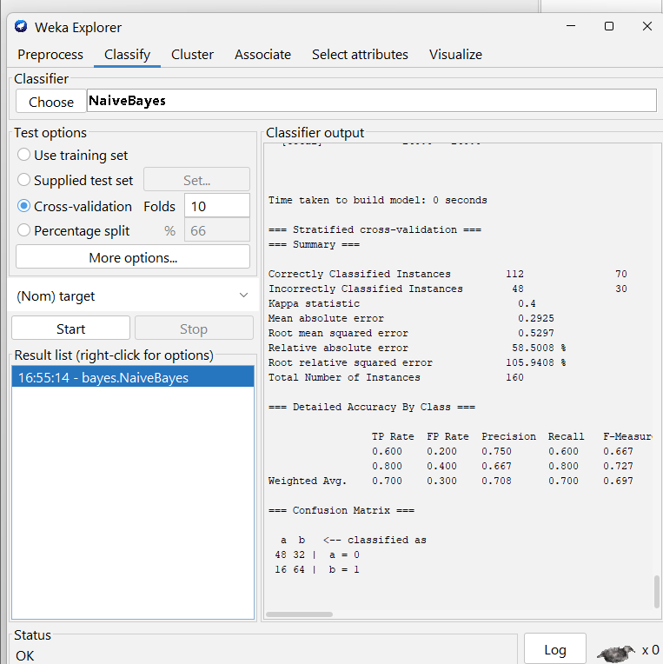

=== Run information ===

Scheme: weka.classifiers.bayes.NaiveBayes
Relation: fused_features-weka.filters.unsupervised.attribute.NumericToNominal-Rlast-weka.filters.unsupervised.attribute.ReplaceMissingValues-weka.filters.unsupervised.attribute.Normalize-S1.0-T0.0-weka.filters.supervised.attribute.AttributeSelection-Eweka.attributeSelection.CfsSubsetEval -P 1 -E 1-Sweka.attributeSelection.BestFirst -D 1 -N 5
Instances: 160
Attributes: 29
v_10
v_45
v_167
v_184
v_254
v_320
v_325
v_670
v_810
v_831
v_836
v_853
v_876
v_957
v_1042
v_1087
v_1108
v_1209
v_1230
a_103
a_139
a_177
text_40
text_lot
text_need art
text_really
text_work
filename
target
Test mode: 10-fold cross-validation

=== Classifier model (full training set) ===

Naive Bayes Classifier

Class
Attribute 0 1
(0.5) (0.5)
===================================
v_10
mean 0.3767 0.3311
std. dev. 0.2242 0.2902
weight sum 80 80
precision 0.0063 0.0063

v_45
mean 0.2819 0.3082
std. dev. 0.2165 0.1629
weight sum 80 80
precision 0.0063 0.0063

v_167
mean 0.2784 0.1525
std. dev. 0.2898 0.181
weight sum 80 80
precision 0.0063 0.0063

v_184
mean 0.1859 0.183
std. dev. 0.241 0.3056
weight sum 80 80
precision 0.0067 0.0067

v_254
mean 0.1082 0.059
std. dev. 0.1562 0.0907
weight sum 80 80
precision 0.0064 0.0064

v_320
mean 0.3399 0.4245
std. dev. 0.2432 0.2413
weight sum 80 80
precision 0.0063 0.0063

v_325
mean 0.1932 0.1
std. dev. 0.1901 0.0684
weight sum 80 80
precision 0.0063 0.0063

v_670
mean 0.1415 0.0776
std. dev. 0.1988 0.068
weight sum 80 80
precision 0.0063 0.0063

v_810
mean 0.4616 0.4948
std. dev. 0.2616 0.2135
weight sum 80 80
precision 0.0063 0.0063

v_831
mean 0.259 0.1379
std. dev. 0.282 0.2139
weight sum 80 80
precision 0.0063 0.0063

v_836
mean 0.4219 0.3331
std. dev. 0.2397 0.1868
weight sum 80 80
precision 0.0063 0.0063

v_853
mean 0.5066 0.4514
std. dev. 0.2731 0.2413
weight sum 80 80
precision 0.0063 0.0063

v_876
mean 0.2314 0.1189
std. dev. 0.2155 0.1482
weight sum 80 80
precision 0.0063 0.0063

v_957
mean 0.3633 0.4436
std. dev. 0.2409 0.2141
weight sum 80 80
precision 0.0063 0.0063

v_1042
mean 0.3314 0.1452
std. dev. 0.2856 0.1985
weight sum 80 80
precision 0.0063 0.0063

v_1087
mean 0.2775 0.1815
std. dev. 0.2604 0.1769
weight sum 80 80
precision 0.0067 0.0067

v_1108
mean 0.2407 0.1297
std. dev. 0.2368 0.177
weight sum 80 80
precision 0.0063 0.0063

v_1209
mean 0.2594 0.1564
std. dev. 0.2141 0.1125
weight sum 80 80
precision 0.0063 0.0063

v_1230
mean 0.1532 0.1017
std. dev. 0.1791 0.1675
weight sum 80 80
precision 0.0063 0.0063

a_103
mean 0.5257 0.6206
std. dev. 0.2314 0.194
weight sum 80 80
precision 0.0106 0.0106

a_139
mean 0.3801 0.3588
std. dev. 0.1828 0.1243
weight sum 80 80
precision 0.0106 0.0106

a_177
mean 0.4636 0.4415
std. dev. 0.217 0.1516
weight sum 80 80
precision 0.0106 0.0106

text_40
mean 0 0.075
std. dev. 0.1667 0.2634
weight sum 80 80
precision 1 1

text_lot
mean 0.0925 0.0225
std. dev. 0.2494 0.114
weight sum 80 80
precision 0.1 0.1

text_need art
mean 0 0.0375
std. dev. 0.1667 0.19
weight sum 80 80
precision 1 1

text_really
mean 0.0656 0.0177
std. dev. 0.1732 0.0693
weight sum 80 80
precision 0.0833 0.0833

text_work
mean 0.075 0.0143
std. dev. 0.2474 0.0892
weight sum 80 80
precision 0.1429 0.1429

filename
ddtbarpcgo.mp4 2.0 1.0
syxobtuucp.mp4 2.0 1.0
rnpefxwptv.mp4 2.0 1.0
xcruhaccxc.mp4 2.0 1.0
jvtjxreizj.mp4 2.0 1.0
knxltsvzyu.mp4 2.0 1.0
ndrnxgzlmn.mp4 1.0 2.0
heiyoojifp.mp4 2.0 1.0
xdezcezszc.mp4 2.0 1.0
khtwrijuqn.mp4 2.0 1.0
exseruhiuk.mp4 2.0 1.0
ucthmsajay.mp4 2.0 1.0
mfgswvvnba.mp4 1.0 2.0
aayrffkzxn.mp4 2.0 1.0
dxfdovivlw.mp4 2.0 1.0
ltqghwybkf.mp4 1.0 2.0
wlyfcpecea.mp4 1.0 2.0
nhsijqpoda.mp4 2.0 1.0
vzockawbyi.mp4 1.0 2.0
muhgixhdmd.mp4 1.0 2.0
achdeirhym.mp4 1.0 2.0
nphtrwjtff.mp4 1.0 2.0
qlueobbhbc.mp4 1.0 2.0
lbsltufgrh.mp4 1.0 2.0
lxnqzocgaq.mp4 1.0 2.0
uqtqhiqymz.mp4 2.0 1.0
gfkdvulbfo.mp4 1.0 2.0
lokzwdldxp.mp4 2.0 1.0
dpevefkefv.mp4 2.0 1.0
ybbrkacebd.mp4 2.0 1.0
ofquuujxmu.mp4 1.0 2.0
wynotylpnm.mp4 2.0 1.0
ngvcqxjhyb.mp4 2.0 1.0
jytrvwlewz.mp4 2.0 1.0
rnxnytbudq.mp4 1.0 2.0
jdfaxqtpjk.mp4 1.0 2.0
sjwedraykt.mp4 1.0 2.0
hsbwhlolsn.mp4 2.0 1.0
dvrnrzlqdo.mp4 1.0 2.0
wzrhdvpktx.mp4 1.0 2.0
fufcmupzen.mp4 2.0 1.0
doniqevxeg.mp4 2.0 1.0
alnkzqihau.mp4 1.0 2.0
apedduehoy.mp4 2.0 1.0
ptgpqdnxtd.mp4 1.0 2.0
oibtsgqujh.mp4 1.0 2.0
jzupayeuln.mp4 2.0 1.0
vhpjdjspre.mp4 1.0 2.0
ybnucgidtu.mp4 2.0 1.0
wclvkepakb.mp4 2.0 1.0
runmncglnj.mp4 1.0 2.0
fopjiyxiqd.mp4 2.0 1.0
exxqlfpnbz.mp4 2.0 1.0
vmxfwxgdei.mp4 2.0 1.0
gkqitjodaa.mp4 1.0 2.0
prdrkaxeob.mp4 2.0 1.0
lnhkjhyhvw.mp4 2.0 1.0
fdpisghkmd.mp4 2.0 1.0
qyqufaskjs.mp4 2.0 1.0
xmkwsnuzyq.mp4 2.0 1.0
oakntpdygb.mp4 1.0 2.0
didzujjhtg.mp4 2.0 1.0
kzezrsewki.mp4 1.0 2.0
fnslimfagb.mp4 2.0 1.0
qloyrbpobv.mp4 1.0 2.0
vokrpfjpeb.mp4 2.0 1.0
hicjuubiau.mp4 2.0 1.0
meiyjcknbl.mp4 1.0 2.0
yxvmusxvcz.mp4 2.0 1.0
bkcztuqxbp.mp4 1.0 2.0
rptqbxpesg.mp4 1.0 2.0
nwvloufjty.mp4 1.0 2.0
untxvzuldz.mp4 1.0 2.0
kxhwssipyi.mp4 1.0 2.0
apvzjkvnwn.mp4 2.0 1.0
ynrueopehk.mp4 1.0 2.0
xchzardbfa.mp4 2.0 1.0
lbxbstcwwl.mp4 1.0 2.0
eiwtggvtfp.mp4 2.0 1.0
mpuugiqewv.mp4 1.0 2.0
jxqibxwhlc.mp4 1.0 2.0
jjxzidyitl.mp4 1.0 2.0
oykagryjjd.mp4 1.0 2.0
vtunvalyji.mp4 2.0 1.0
dahvuijxob.mp4 1.0 2.0
chqqxfuuzi.mp4 2.0 1.0
dhjnjkzuhq.mp4 2.0 1.0
ldtgofdaqg.mp4 2.0 1.0
gyosvoeamf.mp4 1.0 2.0
xugmhbetrw.mp4 2.0 1.0
uhakqelqri.mp4 1.0 2.0
hplxtssgnz.mp4 2.0 1.0
lwqkgvyeas.mp4 1.0 2.0
sylnrepacf.mp4 2.0 1.0
gcdtglsoqj.mp4 2.0 1.0
ncqjcvgayx.mp4 1.0 2.0
sttnfyptum.mp4 2.0 1.0
ywcfkvqemt.mp4 1.0 2.0
srfefmyjvt.mp4 2.0 1.0
ekkheaisuo.mp4 1.0 2.0
xkfliqnmwt.mp4 2.0 1.0
jranrlmuyk.mp4 1.0 2.0
yexeazbqig.mp4 2.0 1.0
tjdxwdoumt.mp4 1.0 2.0
zwsbdiyrpg.mp4 1.0 2.0
xymeodlrhb.mp4 1.0 2.0
wmoigsbnem.mp4 1.0 2.0
fgobmbcami.mp4 2.0 1.0
lbwzzntrcc.mp4 1.0 2.0
bwsytelwkm.mp4 1.0 2.0
xtaktzlrme.mp4 1.0 2.0
hivnldfvyl.mp4 2.0 1.0
uprwuohbwx.mp4 2.0 1.0
mfvqmuulak.mp4 1.0 2.0
ksjpgrujqv.mp4 1.0 2.0
lrjxcwrzls.mp4 1.0 2.0
uuexerjsmk.mp4 1.0 2.0
acdkfksyev.mp4 1.0 2.0
ewknjjmzqb.mp4 1.0 2.0
xewwsdhdro.mp4 1.0 2.0
wcqvzujamg.mp4 2.0 1.0
yljecirelf.mp4 2.0 1.0
ilflslfgbn.mp4 1.0 2.0
pqdeutauqc.mp4 2.0 1.0
tmjcigspif.mp4 1.0 2.0
gfoozygynw.mp4 1.0 2.0
rktrpsdlci.mp4 2.0 1.0
prmwoaeeng.mp4 2.0 1.0
esjdyghhog.mp4 1.0 2.0
msfssnmldu.mp4 1.0 2.0
rmuxlgsedw.mp4 2.0 1.0
lnjkpdviqb.mp4 2.0 1.0
jawgcggquk.mp4 2.0 1.0
qjvjkojjkl.mp4 1.0 2.0
gbgtzspdnv.mp4 1.0 2.0
iocjgjemeb.mp4 1.0 2.0
kqlvggiqee.mp4 2.0 1.0
fzvpbrzssi.mp4 2.0 1.0
ratscdfvdk.mp4 1.0 2.0
onbgbghesu.mp4 2.0 1.0
rmufsuogzn.mp4 2.0 1.0
srnseorykn.mp4 1.0 2.0
xawrxpyoau.mp4 1.0 2.0
lzbmwwejxb.mp4 2.0 1.0
vinguynpez.mp4 1.0 2.0
psjfwjzrrh.mp4 2.0 1.0
scrbqgpvzz.mp4 1.0 2.0
yeouperxzc.mp4 1.0 2.0
upmgtackuf.mp4 2.0 1.0
vrgubwmtyo.mp4 1.0 2.0
gnmmhlbzge.mp4 2.0 1.0
haxnhfvqvs.mp4 1.0 2.0
qnlyrlrnmn.mp4 1.0 2.0
zvsivkdkak.mp4 1.0 2.0
nrnklcxdzq.mp4 2.0 1.0
eppyqpgewp.mp4 2.0 1.0
slkqbehdcq.mp4 1.0 2.0
fsaronfupy.mp4 2.0 1.0
vpmyeepbep.mp4 2.0 1.0
lsmnqsnqld.mp4 2.0 1.0
[total] 240.0 240.0

Time taken to build model: 0 seconds

=== Stratified cross-validation ===
=== Summary ===

Correctly Classified Instances 112 70 %
Incorrectly Classified Instances 48 30 %
Kappa statistic 0.4
Mean absolute error 0.2925
Root mean squared error 0.5297
Relative absolute error 58.5008 %
Root relative squared error 105.9408 %
Total Number of Instances 160

=== Detailed Accuracy By Class ===

TP Rate FP Rate Precision Recall F-Measure MCC ROC Area PRC Area Class
0.600 0.200 0.750 0.600 0.667 0.408 0.729 0.742 0
0.800 0.400 0.667 0.800 0.727 0.408 0.730 0.653 1
Weighted Avg. 0.700 0.300 0.708 0.700 0.697 0.408 0.729 0.698

=== Confusion Matrix ===

a b <-- classified as
48 32 | a = 0
16 64 | b = 1

