Architectural Palimpsests: Adaptive Reuse of Berlin's War-Damaged Fabric in the Changing Cityscape

1. Introduction
In 1945, many renowned European cities had been severely destroyed by air raids and ground fighting during the Second World War (Diefendorf, 1989). Germany experienced some of the most extensive urban destruction after more than three years of Allied bombing, with damage affecting not only military and administrative facilities but also industrial, commercial and residential areas (Diefendorf, 1989). Berlin was one of the major targets, with approximately 45,500 tons of bombs dropped on the city (Kappner, 2018). The scale of destruction was substantial: the first postwar census estimated that 27,679 buildings had been damaged, including 501,795 flats that were beyond repair (Kappner, 2018; Statistisches Amt der Stadt Berlin, 1947). The destruction therefore extended beyond individual buildings to the wider urban fabric, leaving large parts of the city to be reconstructed, repaired or reconfigured, as in many other post-war contexts across the globe (Larkham & Adams, 2022).
The reconstruction of European cities after the war involved more than the physical replacement of destroyed buildings. It became a process through which cities addressed immediate practical needs while creating opportunities for urban transformation, and tensions between preservation and modernisation (Diefendorf, 1989). Decisions about what to rebuild, what to preserve and what to replace significantly transformed the pre-war urban landscape. In some cases, war-damaged buildings and ruins became carriers of cultural heritage, while reconstruction could simultaneously produce new forms of heritage by reinterpreting or reproducing historically significant structures (Larkham & Adams, 2022). Post-war European cities therefore emerged through an ongoing negotiation between destruction, preservation, continuity and transformation.
This tension remains relevant to the contemporary treatment of surviving war-damaged buildings. Instead of simply restoring buildings to their pre-war condition, adaptive reuse offers an alternative approach in which existing structures are given new functions while retaining elements of their historical and architectural character (Langston & Shen, 2007; Mısırlısoy & Günçe, 2016). Such interventions allow buildings to remain active parts of the contemporary city while preserving the material evidence of their past. However, adaptive reuse also presents architectural and regulatory challenges (Langston & Shen, 2007; Mısırlısoy & Günçe, 2016). Examples such as the Berlin Parliament Building, Berlin's KulturBrauerei and Santral Istanbul demonstrate how historic structures can accommodate new functions through architectural interventions and additions (Cenik & Sirel, 2022; Holland, 2023). Another example is the Alte Pinakothek in Munich, which Hans Döllgast reconstructed and transformed after severe wartime damage. He preserved visible traces of the destruction as a reminder of the building's past, so that the destruction itself became part of its architectural identity (Sorbo, 2019).
The question of how such buildings can be integrated into contemporary urban development is also connected to the broader challenge of renovating Europe's existing building stock. Many post-war residential buildings were built using standardised methods in large housing districts, making them suitable for coordinated, large-scale renovation (Lihtmaa & Kalamees, 2024). However, current European renovation policies largely focus on individual buildings and scattered improvements (Baek & Park, 2012; Lihtmaa & Kalamees, 2024). The EU aims to address climate change by reducing energy use and greenhouse gas emissions, especially in the building sector, which accounts for 36% of its energy consumption and CO₂ emissions (Baek & Park, 2012; Di Turi & Stefanizzi, 2015; Mišík et al., 2024). Mass renovation can improve energy efficiency more effectively than mass construction, and prefabricated façade and insulation components make the process faster and more efficient (Kylili & Fokaides, 2015; Lihtmaa & Kalamees, 2024). Accordingly, the EU Energy Efficiency Directive 2012/27/EU promotes the acceleration of building renovation to improve energy efficiency (European Union, 2012). For historically significant or damaged buildings, however, efficiency cannot be considered independently of architectural character, cultural memory and the relationship between the building and its surrounding urban fabric. Renovating such a structure is therefore challenging: an intervention must improve its contemporary use while maintaining meaningful relationships with the history and identity of the place.
This design research consequently investigated the adaptive reuse of Berlin's war-damaged urban fabric within the changing cityscape, taking Kärntener Straße 26 in Berlin-Schöneberg as a case. It aimed to:
- analyse the impact of structural renovation on the evolving urban landscape;
- assess potential adaptive reuse options for war-damaged buildings;
- develop efficient spatial configurations and user-oriented design solutions; and
- develop several functional models that integrate the site's tangible and intangible cultural heritage with its surrounding context.

2. Theoretical Framework
The treatment of war-damaged buildings raises a question that is theoretical as well as technical: what should remain of a building's history when it is adapted for new use? This section draws on theories of the city as collective memory, the urban palimpsest, nostalgia and heritage value, atmosphere and everyday urban life, and adaptive reuse. Together they define the position that guided the design.

2.1 The City as Collective Memory
Rossi (1982) described the city as the locus of collective memory. In his account, urban artefacts such as streets, plots and building types persist over time even as their functions change, and this permanence of form gives the city its identity. Rossi's argument provides an important basis for adaptive reuse: the form of a Gründerzeit perimeter block can outlast the uses for which it was built and still carry the memory of the place. After 1945, German cities faced exactly this choice between restoring their historic form and replacing it with modern urban plans (Diefendorf, 1993). The partly destroyed residential buildings that survived this period are therefore not only housing stock but fragments of the collective memory that Rossi located in the city's persistent forms.

2.2 Berlin as an Urban Palimpsest
Huyssen (2003) described Berlin as a palimpsest: a city in which successive historical layers are overwritten but never fully erased, so that traces of earlier periods remain legible beneath later ones. In this view, war damage is not simply a loss to be repaired. It is one of the city's historical layers, and it can become heritage in its own right (Larkham & Adams, 2022). This perspective extends beyond famous monuments to ordinary residential streets. In Schöneberg, wartime destruction varied sharply from one block to the next (Kappner, 2018), and the resulting mix of surviving buildings, gaps, exposed firewalls and post-war infill still records this uneven history. The everyday streetscape is therefore itself a document of the war, and the title of this paper refers to this layered condition.

2.3 Nostalgia, Ruins and Heritage Value
How such layers should be treated is a question of value. Riegl (1903/1982) showed that monuments carry competing values: age value, found in the visible marks of time and decay, conflicts with use value and newness value, which call for repair and a complete appearance. War-damaged housing makes this conflict especially sharp, because a building that carries historical evidence must also be safe, efficient and comfortable to live in.
Boym's (2001) distinction between two forms of nostalgia clarifies the choice. Restorative nostalgia seeks to rebuild the lost past exactly as it was, while reflective nostalgia dwells on ruins and fragments and accepts the passage of time. Restoring a damaged building to its pre-war appearance follows the restorative logic and hides the war. Keeping its scars legible follows the reflective logic. Conservation doctrine supports the second approach: the Venice Charter requires that new work be distinguishable from historic fabric, so that the building's history is not falsified, and it recognises that giving monuments a socially useful function supports their conservation (ICOMOS, 1964). Döllgast's Alte Pinakothek, where bomb damage was repaired in plain brickwork rather than copied ornament, is a built example of this reflective approach (Sorbo, 2019).

2.4 Atmosphere and Everyday Life
Heritage is not only read but felt. Böhme (2017) argued that architecture is experienced primarily as atmosphere: a felt quality of space produced by materials, light, sound and proportion. For a war-damaged building, the contrast between scarred historic surfaces and new materials shapes the atmosphere that residents and passers-by experience every day. The design of that contrast is therefore an experiential decision as well as a conservation decision.
At the scale of the street, Gehl (2011) showed that urban life depends on the quality of the spaces between buildings: active ground floors, human scale and continuous, permeable edges encourage people to stay and meet. From this perspective, restoring the continuity of a broken street wall is a social as well as a formal question. It supports the mixed-use ground floors and street life that characterise Gründerzeit quarters.

2.5 Adaptive Reuse as Design Strategy
Adaptive reuse offers the practical means to reconcile these positions. Brooker and Stone (2004) distinguished three ways of working with an existing building: intervention, in which old and new become interdependent; insertion, in which a new element is placed within the existing structure; and installation, in which new elements sit lightly and reversibly within it. Plevoets and Van Cleempoel (2019) argued that adaptive reuse has become a discipline in its own right, in which the character of the existing building actively shapes the new design. Langston and Shen (2007) and Mısırlısoy and Günçe (2016) added technical, economic and regulatory dimensions, showing that successful reuse must balance heritage meaning with performance and viability.

2.6 Position of This Research
Drawing on these theories, this research took a reflective rather than restorative position. It treated the perimeter block and the street wall as permanent urban forms that carry collective memory (Rossi, 1982) and support everyday street life (Gehl, 2011). It treated the war damage as a legitimate historical layer of the urban palimpsest (Huyssen, 2003) with its own age value (Riegl, 1903/1982). And it required new interventions to remain distinguishable from the historic fabric (ICOMOS, 1964). The design therefore tested a strategy of visible completion: contemporary roof extensions and insertions restore the continuity of the street wall and add housing, while the scars of war remain legible and shape the atmosphere of the building (Böhme, 2017). Kärntener Straße 26 thus served as a design-based test of a theoretical proposition: that the adaptive reuse of war-damaged housing can meet contemporary needs for density and economic value without erasing the memory of the city.

3. Methodology

3.1 Site Description
Schöneberg was originally a farming village. It became part of the rapidly expanding Berlin metropolis in 1861, and its population grew from 4,500 to 175,000. It gained municipal independence in 1898 and became a desirable residential area for Berliners. During the late-nineteenth-century Gründerzeit, a period of rapid industrial expansion, it developed as a residential quarter that attracted a growing community of artists and writers. In 1920 Schöneberg was incorporated into Greater Berlin and merged with Friedenau to form a single administrative district (Hess-Lüttich, 2025). During the Second World War the area was severely damaged, with the extent of destruction varying between street blocks regardless of citywide population-density patterns (Kappner, 2018).
The study site at Kärntener Straße 26 lies within this dense Gründerzeit urban fabric (Figure 1). The street, named Maxstraße from 1899 until 1963 (Kauperts, n.d.), is a quiet residential route connecting Hauptstraße with the area south of the Ringbahn. Its surroundings are characterised by multi-family housing, mixed-use ground floors, historic buildings, and newer or renovated residential structures (Figure 2). In Gründerzeit quarters such as Schöneberg, there is an urgent need to transform war-damaged spaces into high-quality housing while keeping Berlin's architectural and historical identity and creating real estate value. This research therefore investigated adaptive transformation as a sustainable approach to revitalisation, meeting contemporary spatial needs while preserving historical significance.
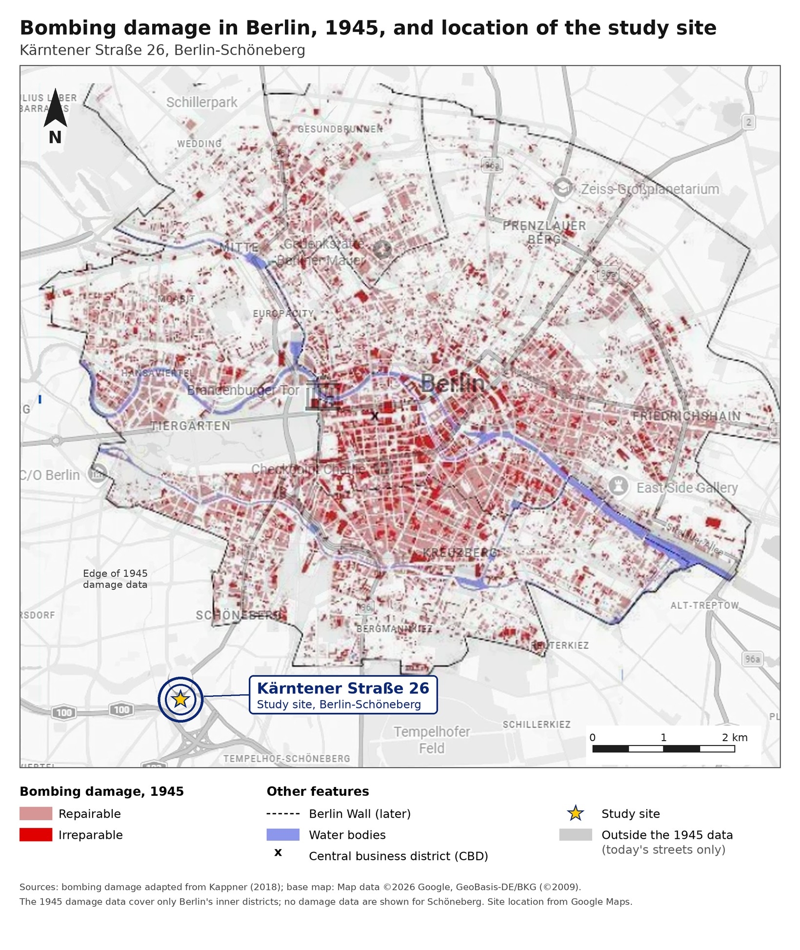
Figure 1. Bombing damage in Berlin's inner districts in 1945 and the location of the study site, Kärntener Straße 26. Damage data modified from Kappner (2018); base map © Google (2025).
Insert photograph of Kärntener Straße 26 here.
Figure 2. Kärntener Straße 26, Berlin-Schöneberg, present condition. Photograph by the author (year).

3.2 Procedure
The research began with a feasibility assessment of the war-damaged building. It then developed alternative architectural models that addressed the economic potential of the existing space while integrating the tangible and intangible heritage of its urban context. The study followed a qualitative single-case-study design (Yin, 2018) combined with research-by-design (Groat & Wang, 2013).
First, six detailed maps of Berlin, dating from 1932 to 2025, were collected and compared to trace the historical transformation of the urban fabric, following Conzen's (1960) town-plan approach. Three drawings of the study building, dated 1936, 1950 and 2010, were then compiled to examine how the building changed before and after the war.
Next, the analysis focused on the surrounding built environment. This included the façades of neighbouring buildings, their construction materials and roof structures, and the area's social and economic development. These aspects were investigated through on-site observation, supplemented by visual analysis in Google Maps. A road network analysis was also carried out to assess the spatial organisation of the surrounding streets and their relationship to the study building.
Two design questions guided the following stage. The first was whether converting the war-damaged building into high-density housing would be financially viable, given functional zoning requirements and current market conditions. The second was whether contemporary materials and roof extensions could restore the continuity of the street wall while keeping the traces of war damage visible as part of the building's historical identity.
In response, several architectural design models were developed in AutoCAD. They explored alternative spatial configurations, building forms and design strategies suited to the site's historical context, spatial constraints and functional requirements. After a comparative evaluation of these alternatives, the selected design was developed in detail in Revit. Three-dimensional visualisations illustrate its architectural form, materials and spatial relationships within the surrounding urban context.

3.3 Limitations
As a single case study, the findings cannot be generalised statistically, although they offer transferable lessons for similar war-damaged Gründerzeit buildings in Berlin. Some historical records and drawings were incomplete, so parts of the building's past condition had to be interpreted from the available evidence. The social and economic assessment relied mainly on observation, and the assessment of financial viability was indicative rather than a formal market valuation.

4. Results and Discussion
To be written from the thesis findings. Suggested structure:
- 4.1 Historical transformation of the urban fabric (six maps, 1932–2025)
- 4.2 Changes to the building (drawings of 1936, 1950 and 2010)
- 4.3 Context analysis (façades, materials, roofs, land use, road network)
- 4.4 Design alternatives and their comparison
- 4.5 Final design, discussed in relation to the theoretical framework (Section 2)

5. Conclusion
To be written once the results are added: main findings, contribution, and directions for further (PhD) research.

References
Baek, C. H., & Park, S. H. (2012). Changes in renovation policies in the era of sustainability. Energy and Buildings, 47, 485–496.
Böhme, G. (2017). Atmospheric architectures: The aesthetics of felt spaces (A.-Chr. Engels-Schwarzpaul, Ed. & Trans.). Bloomsbury Academic.
Boym, S. (2001). The future of nostalgia. Basic Books.
Brooker, G., & Stone, S. (2004). Rereadings: Interior architecture and the design principles of remodelling existing buildings. RIBA Enterprises.
Cenik, I., & Sirel, A. (2022). Importance of international treaties and declarations for adaptive reuse in historical buildings: Berlin Parliament Building and Santral Istanbul examples. Journal of Education, Society and Behavioural Science, 35(8), 67–84.
Conzen, M. R. G. (1960). Alnwick, Northumberland: A study in town-plan analysis (Publication No. 27). Institute of British Geographers.
Di Turi, S., & Stefanizzi, P. (2015). Energy analysis and refurbishment proposals for public housing in the city of Bari, Italy. Energy Policy, 79, 58–71.
Diefendorf, J. M. (1989). Urban reconstruction in Europe after World War II. Urban Studies, 26(1), 128–143.
Diefendorf, J. M. (1993). In the wake of war: The reconstruction of German cities after World War II. Oxford University Press.
European Union. (2012). Directive 2012/27/EU of the European Parliament and of the Council of 25 October 2012 on energy efficiency, amending Directives 2009/125/EC and 2010/30/EU and repealing Directives 2004/8/EC and 2006/32/EC. Official Journal of the European Union, L 315, 1–56.
Gehl, J. (2011). Life between buildings: Using public space (J. Koch, Trans.). Island Press.
Groat, L., & Wang, D. (2013). Architectural research methods (2nd ed.). Wiley.
Hess-Lüttich, E. W. (2025). Queer Spaces. Ein Stadtviertel im Zeichen des Regenbogens: Subkultur in Schöneberg. In Tabus und Tabubrüche als Symptome gesellschaftlicher Verhältnisse (pp. 151–177). Springer Fachmedien Wiesbaden.
Holland, H. (2023, June 22). Adaptive re-use at Berlin's KulturBrauerei. Berlin Blog, New York University. https://wp.nyu.edu/berlinblog/holland/
Huyssen, A. (2003). Present pasts: Urban palimpsests and the politics of memory. Stanford University Press.
ICOMOS. (1964). International charter for the conservation and restoration of monuments and sites (The Venice Charter). ICOMOS.
Kappner, K. (2018). Persistent shocks to urban density: Evidence from the Berlin air raids. Economics Letters, 168, 37–41.
Kauperts. (n.d.). Kärntener Straße in Berlin. Retrieved from https://berlin.kauperts.de/Strassen/Kaerntener-Strasse-10827-Berlin/
Kylili, A., & Fokaides, P. A. (2015). European smart cities: The role of zero energy buildings. Sustainable Cities and Society, 15, 86–95.
Langston, C., & Shen, L. Y. (2007). Application of the adaptive reuse potential model in Hong Kong: A case study of Lui Seng Chun. International Journal of Strategic Property Management, 11(4), 193–207.
Larkham, P. J., & Adams, D. (2022). Relics of war: Damaged structures and their replacement or management in modern landscapes. Sustainability, 14(20), 13513.
Lihtmaa, L., & Kalamees, T. (2024). Emerging renovation strategies and technical solutions for mass-construction of residential districts built after World War II in Europe. Energy Strategy Reviews, 51, 101282.
Mišík, M., Oravcová, V., & Vicenová, R. (2024). Energy efficiency of buildings in Central and Eastern Europe: Room for improvement. Energy Efficiency, 17(4), 32.
Mısırlısoy, D., & Günçe, K. (2016). Adaptive reuse strategies for heritage buildings: A holistic approach. Sustainable Cities and Society, 26, 91–98.
Plevoets, B., & Van Cleempoel, K. (2019). Adaptive reuse of the built heritage: Concepts and cases of an emerging discipline. Routledge.
Riegl, A. (1982). The modern cult of monuments: Its character and its origin (K. W. Forster & D. Ghirardo, Trans.). Oppositions, 25, 21–51. (Original work published 1903)
Rossi, A. (1982). The architecture of the city (D. Ghirardo & J. Ockman, Trans.). MIT Press.
Sorbo, E. (2019). Restoration, strengthening and planning in Italian and German reconstruction after World War II: Essay in three steps. Journal of Civil Engineering and Architecture, 13(135), 115–124.
Statistisches Amt der Stadt Berlin. (1947). Berlin in Zahlen 1946–1947. Das Neue Berlin Verlagsgesellschaft.
Yin, R. K. (2018). Case study research and applications: Design and methods (6th ed.). SAGE.

