## Corporate

# **AUTOSAR Layered Architecture**

In AUTOSAR, software is componentized and application software reusability is improved. AUTOSAR's layered architecture and details of each layer are shown below.

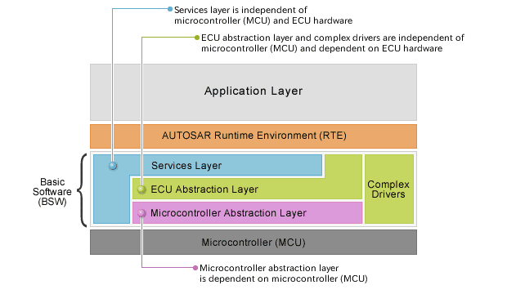

AUTOSAR Layered Architecture

## **Description of Layers**

| Layer name | | Overview | Purpose | Features | |
| --- | --- | --- | --- | --- | --- |
| Mounting | High-order interface |
| Runtime Environment (RTE) | | Middleware layer providing communication services for AUTOSAR software components (SWC) and applications containing AUTOSAR sensor/actuator parts. | Make AUTOSAR software components (SWC) independent of mapping to specific ECU. | Specialized for ECU and application. Generated for each ECU. | Interface is completely independent of ECU. |
| Basic Software (BSW) | Services Layer | Highest basic software layer; provides the following functions:   * OS * Vehicle network communications and management * Memory service (NVRAM management) * Diagnostic service (including UDS <protocol> communication and error memory) * ECU state management | Provide basic services and basic software modules for applications. | Specialized for microcontroller (MCU), part of ECU hardware, and application. | Interface is independent of microcontroller (MCU) and ECU hardware. |
| ECU Abstraction Layer | Interface with MCAL (including external device driver); provides the following:   * Access to peripherals and devices irrespective of whether they are inside or outside the microcontroller (MCU) * API for interfacing with microcontroller (MCU) (port pins, interface type) | Make upper software layer independent of ECU hardware layout. | Mounting is independent of microcontroller (MCU) and dependent on ECU hardware | Interface is independent of microcontroller (MCU) and ECU hardware. |
| Complex Drivers | Layer used for complex functions not found on other layers. This layer accesses the microcontroller (MCU) directly. Examples: Injection control, control of electrical values, position increase detection, etc. | Fulfills special functions and timing requirements needed to operate complex sensors and actuators. | Highly dependent on microcontroller (MCU), ECU and application. | Interface is standardized and mounted according to AUTOSAR (AUTOSAR interface). |
| Microcontroller Abstraction Layer (MCAL) | Software module that directly accesses on-chip microcontroller (MCU) peripheral modules and external devices that are mapped to memory. | Make upper software layer independent of microcontroller (MCU). | Dependent on microcontroller (MCU). | Interface is independent of standardized microcontroller (MCU). |

* [Overview](https://www.renesas.com/us/en/about/profile)
* [Careers](https://jobs.renesas.com/)
* [Investors](https://www.renesas.com/us/en/about/investor-relations)
* [News](https://www.renesas.com/us/en/about/press-center)
* [Sustainability](https://www.renesas.com/us/en/about/company/sustainability)
* [Contact](https://www.renesas.com/us/en/contact-us)
* [Blogs](https://www.renesas.com/us/en/blogs)
* [Videos](https://www.renesas.com/us/en/about/press-room/videos)
* [Website Feedback](https://www.renesas.com/us/en/websitefeedback)

## **Top Tools**

* [e² studio](https://www.renesas.com/us/en/software-tool/e-studio)
* [CS+](https://www.renesas.com/us/en/software-tool/cs)
* [MCU / MPU Selection Tool](https://www.renesas.com/us/en/products/microcontrollers-microprocessors/mcu-mpu-selection-tool)
* [iSim:PE Offline Simulation Tool](https://www.renesas.com/us/en/software-tool/isimpe-offline-simulation-tool)
* [PowerCompass Multi-Rail Design Tool](https://powercompass.renesas.com/)
* [PowerNavigator](https://www.renesas.com/us/en/software-tool/powernavigator-software)
* [Timing Commander](https://www.renesas.com/us/en/products/clocks-timing/timing-commander-software-download-resource-guide)
* [Lab on the Cloud](https://www.renesas.com/us/en/labonthecloud)

## **Buy/Sample**

* [Sales Support](https://www.renesas.com/us/en/contact-us)
* [Free Sample Request](https://www.renesas.com/us/en/buy-sample/free-samples)
* [Check Product Availability](https://www.renesas.com/us/en/buy-sample/check-inventory)
* [Sales and Distributor Directory](https://www.renesas.com/us/en/buy-sample/locations)
* [ROM Ordering](https://www.renesas.com/us/en/products/rom-ordering)

## **Language**

* [English](https://www.renesas.com/us/en/application/automotive/common-automotive-technologies/autosar/autosar-layered-architecture)
* [中文](https://www.renesas.com/us/zh/application/automotive/common-automotive-technologies/autosar/autosar-layered-architecture)
* [日本語](https://www.renesas.com/us/ja/application/automotive/common-automotive-technologies/autosar/autosar-layered-architecture)

## **Region**

       Americas       Brazil       Europe/Middle East/Africa       Japan       Mainland China/Hong Kong Region       Singapore/South & Southeast Asia/Oceania       India       South Korea       Taiwan Region

* [**YouTube**](http://www.youtube.com/RenesasPresents)
* [**Twitter**](https://www.renesas.com/twitter)
* [**Facebook**](https://www.facebook.com/RenesasElectronics)
* [**Instagram**](https://www.instagram.com/renesas_global)
* [**LinkedIn**](https://www.linkedin.com/company/renesas)

©2022 Renesas Electronics Corporation.

* [**Notices & Terms**](https://www.renesas.com/us/en/legal-notices)

## **Legal footer**

* [**Privacy Policy**](https://www.renesas.com/legal/privacy)