Front-End UI/UX Mini Project

* Project Title: Event Registration Page
* Submitted By:
* PRIYAVARSEINEE ANTHIYUR SOMASUNDARAM

ROLL NUMBER : 2462127

[priyavarseinee.anthiyur@btech.christuniversity.in](mailto:priyavarseinee.anthiyur@btech.christuniversity.in)

* JINKALA SHAHANAZ

ROLL NUMBER : 2462086

[jinkala.shahanaz@btech.christuniversity.in](mailto:jinkala.shahanaz@btech.christuniversity.in)

* Course: UI/UX Design Fundamentals
* Instructor Name: Faculty Name
* Institution: Christ University
* Date of Submission: 10/08/2025

2)Abstract:

* What the project is about:

This project involves designing and developing an Event Registration Page that allows users to register for events by entering their details, choosing the event type, and submitting the form through a clean and organized interface.

* Key goal of the project:

To create a responsive, accessible, and user-friendly registration page that works seamlessly across desktop, tablet, and mobile devices.

* Core technologies used:

HTML5 for semantic content structure

CSS3 for styling, layout design, and responsiveness

* Final outcome and usefulness:

Delivered a functional, visually appealing, and mobile-friendly registration page that is ready for backend integration. It demonstrates UI/UX best practices, enhances user accessibility, and can serve as a core module in a complete event management system.

3)Objectives:

* Design a user-friendly interface using modern UI/UX principles to ensure ease of navigation and a smooth registration process.
* Develop a fully responsive layout that adapts seamlessly to desktop, tablet, and mobile devices using only HTML and CSS.
* Implement structured HTML5 semantic elements for improved accessibility, maintainability, and SEO compatibility.
* Apply CSS styling to establish branding, enhance layout, and ensure consistent visual appeal across devices.
* Ensure accessibility and readability by using high-contrast colors, legible fonts, and proper form labeling for all users, including those with disabilities.

4)Scope of the Project:

* The project focuses exclusively on the front-end design of an Event Registration Page.
* It does not include backend processing or database integration for form submissions.
* The design is optimized for multiple devices, including desktop, tablet, and mobile screens, using responsive design principles.
* Only open-source tools and pure HTML5 and CSS3 code were used — no external frameworks or libraries.
* The page layout and form fields are structured to allow future integration with backend systems for data handling and storage.

5)Tools & Technologies Used:

|  |  |
| --- | --- |
| Tool/Technology | Purpose |
| HTML5 | Markup and structure of the registration page |
| CSS3 | Styling and layout management |
| VS Code | Code editor for development |
| Chrome DevTools | Testing and debugging |

6)HTML Structure Overview

* The page uses semantic HTML5 tags such as <header>, <main>, <section>, <form>, and <footer> for clarity and accessibility.
* The <header> contains the project title “Event Registration” to immediately inform users of the page’s purpose.
* The <main> section includes the event registration form with fields for:
* Full Name
* Email Address
* Contact Number
* Event Type (dropdown)
* Preferred Date
* Form elements (<input>, <select>, <button>) are grouped and labeled properly for better usability.
* The <footer> contains contact information for event support.
* The structure is organized to support responsiveness and future backend integration without requiring major changes.

7)CSS Styling Strategy:

* An external CSS file (style.css) is used to separate styling from structure for better maintainability.
* Layout Techniques:
* Flexbox is used for aligning form elements and ensuring consistent spacing.
* Media Queries adjust layout for desktop, tablet, and mobile screen sizes.
* Color Scheme & Branding:
* Green header and button colors for a friendly and professional look.
* High-contrast text for readability.
* Typography:
* Simple, sans-serif fonts for clarity.
* Relative units (em/rem) for scalable font sizing.
* Interactive Elements:
* Hover effects on buttons for better user feedback.
* Focus styles on form inputs to guide user interaction.
* Responsive Approach:

Mobile-first design ensures that the layout is optimized for smaller devices first, then adapted for larger screens.

8)Key Features:

Feature Description

* Responsive Design: Adapts seamlessly to desktop, tablet, and

mobile screen sizes using CSS media queries.

* User-Friendly Form: Clearly labeled input fields, dropdowns, and

buttons with logical grouping for easy

navigation.

* Accessible Design: High-contrast colors, readable fonts, and

proper form labels ensure usability for

all users, including those with disabilities.

* Structured Layout: Clean separation of header, main content, and

footer for better readability and maintenance.

* Ready for Backend Integration: Form structure is designed to connect easily

with backend systems for data processing

and storage.

* Consistent Styling: Uses external CSS for uniform colors, fonts,

and spacing throughout the page.

* Interactive Elements Hover effects on buttons and focus styles on

inputs for improved user experience.

* Mobile-First Approach Layout and styling are designed starting from

mobile devices, then scaled up for

larger screens.

9)Challenges Faced & Solutions:

* Form layout breaking on smaller

screens Applied mobile-first CSS media queries

to adjust form width, stack elements

vertically, and improve spacing on small

devices.

* Aligning form elements

consistently Used FlexBox for alignment instead of

floats, ensuring consistent instead of

spacing and alignment across all

screen sizes.

* Maintaining readability on

different devices Implemented relative font units

(em/rem) and adjusted padding/

margin for scalable text and elements.

* Lack of form interactivity

without JavaScript Structured the HTML to allow

easy addition of JavaScript

validation in future development.

* Managing consistent colors

and themes Used CSS variables for theme colors,

making it easy to update and

maintain branding.

10)Outcome:

* Successfully developed a fully responsive Event Registration Page using only HTML5 and CSS3.
* Achieved a clean and professional UI with consistent styling across all devices.
* Improved accessibility through semantic HTML elements, proper labels, and high-contrast colors.
* Designed the form structure to be ready for backend integration without major changes.
* Enhanced practical skills in front-end design, responsiveness, and user interface optimization.

11)Future Enhancements:

* Add JavaScript-based form validation to check inputs before submission.
* Integrate backend functionality to store registration data in a database.
* Provide a confirmation message or email after successful registration.
* Implement dark mode/light mode toggle for user preference.
* Add animations and transitions to enhance the visual appeal of the form.

12)Sample Code:

Register.html

<!DOCTYPE html>

<html lang="en">

<head>

<meta charset="UTF-8">

<meta name="viewport" content="width=device-width, initial-scale=1.0">

<title>Event Registration</title>

<link rel="stylesheet" href="css/style.css">

</head>

<body>

<header>

<h1>Event Registration</h1>

</header>

<main>

<form action="confirmation.html" method="get" class="registration-form">

<label for="name">Full Name:</label>

<input type="text" id="name" name="name" required>

<label for="email">Email Address:</label>

<input type="email" id="email" name="email" required>

<label for="phone">Phone Number:</label>

<input type="tel" id="phone" name="phone" pattern="[0-9]{10}" placeholder="10-digit number" required>

<label for="event">Select Event:</label>

<select id="event" name="event" required>

<option value="">--Choose an event--</option>

<option value="Tech Conference">Tech Conference</option>

<option value="Art Workshop">Art Workshop</option>

<option value="Music Festival">Music Festival</option>

</select>

<label for="notes">Additional Notes:</label>

<textarea id="notes" name="notes" rows="4"></textarea>

<button type="submit">Register</button>

</form>

</main>

<footer>

<p>&copy; 2025 Event Organization</p>

</footer>

</body>

</html>

Confirmation.html

<!DOCTYPE html>

<html lang="en">

<head>

<meta charset="UTF-8">

<meta name="viewport" content="width=device-width, initial-scale=1.0">

<title>Registration Confirmation</title>

<link rel="stylesheet" href="css/style.css">

</head>

<body>

<header>

<h1>Registration Successful!</h1>

</header>

<main>

<p>Thank you for registering. Here are your details:</p>

<ul>

<li><strong>Name:</strong> <span id="confName"></span></li>

<li><strong>Email:</strong> <span id="confEmail"></span></li>

<li><strong>Phone:</strong> <span id="confPhone"></span></li>

<li><strong>Event:</strong> <span id="confEvent"></span></li>

<li><strong>Notes:</strong> <span id="confNotes"></span></li>

</ul>

<a href="register.html" class="back-btn">Register Another</a>

</main>

<footer>

<p>&copy; 2025 Event Organization</p>

</footer>

<script>

const params = new URLSearchParams(window.location.search);

document.getElementById("confName").textContent = params.get("name");

document.getElementById("confEmail").textContent = params.get("email");

document.getElementById("confPhone").textContent = params.get("phone");

document.getElementById("confEvent").textContent = params.get("event");

document.getElementById("confNotes").textContent = params.get("notes");

</script>

</body>

</html>

Css/style.css

/* General Page Styling */

body {

font-family: Arial, sans-serif;

margin: 0;

padding: 0;

background: #f4f6f9;

color: #333;

}

header, footer {

background: #4CAF50;

color: white;

text-align: center;

padding: 1rem 0;

}

main {

padding: 1rem;

}

/* Form Styling */

.registration-form {

background: white;

max-width: 500px;

margin: auto;

padding: 1.5rem;

border-radius: 8px;

box-shadow: 0 2px 6px rgba(0,0,0,0.2);

}

label {

display: block;

margin-top: 1rem;

font-weight: bold;

}

input, select, textarea {

width: 100%;

padding: 0.5rem;

margin-top: 0.3rem;

border: 1px solid #ccc;

border-radius: 5px;

}

input:focus, select:focus, textarea:focus {

outline: none;

border-color: #4CAF50;

box-shadow: 0 0 5px rgba(76,175,80,0.5);

}

button {

background: #4CAF50;

color: white;

padding: 0.7rem;

border: none;

border-radius: 5px;

margin-top: 1rem;

cursor: pointer;

width: 100%;

font-size: 1rem;

}

button:hover {

background: #45a049;

}

/* Confirmation Page */

ul {

list-style: none;

padding: 0;

}

.back-btn {

display: inline-block;

background: #4CAF50;

color: white;

padding: 0.5rem 1rem;

margin-top: 1rem;

text-decoration: none;

border-radius: 5px;

}

.back-btn:hover {

background: #45a049;

}

/* Responsive Design */

@media (max-width: 600px) {

.registration-form {

padding: 1rem;

}

}

13)Screenshot of Final Output:

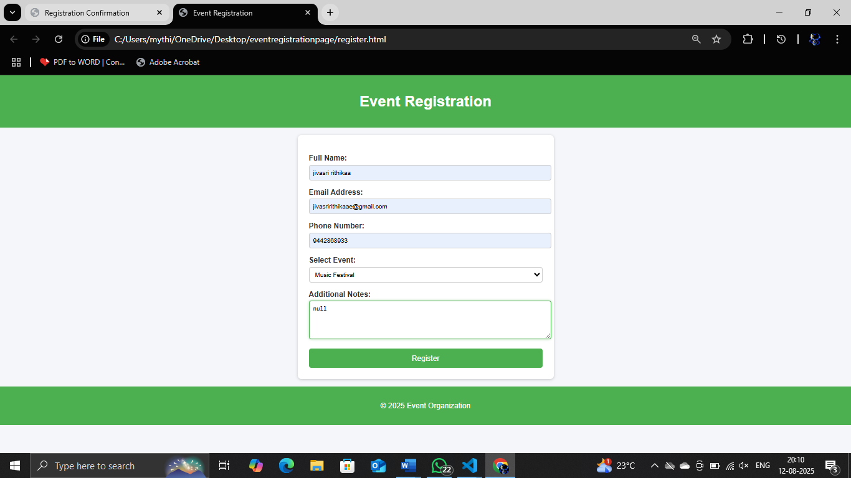

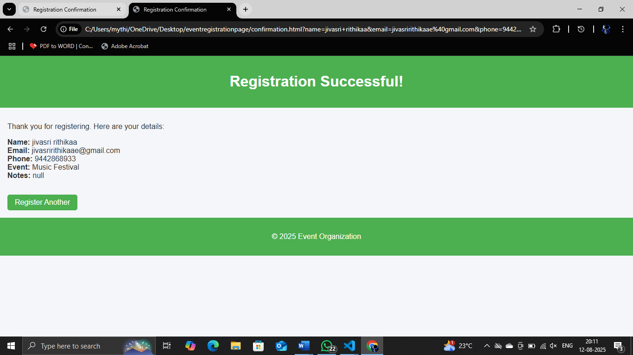

14)Conclusion:

The Event Registration Page successfully delivers a clean, responsive, and accessible platform for users to register for events. Built with HTML5 and CSS3, it ensures a user-friendly experience across desktop, tablet, and mobile devices. The use of semantic elements, structured layout, and consistent styling enhances both usability and maintainability. While currently a static front-end solution, its design is fully prepared for future backend integration to enable data storage and form processing. This project demonstrates effective application of UI/UX principles, resulting in a functional and visually appealing registration interface.

15)References:

* L&T EduTech LMS: https://learn.lntedutech.com/Landing/MyCourse
* Mozilla Developer Network (MDN) – HTML5 Guide: https://developer.mozilla.org/en-US/docs/Web/HTML
* Mozilla Developer Network (MDN) – CSS3 Guide: https://developer.mozilla.org/en-US/docs/Web/CSS
* W3C – Web Content Accessibility Guidelines (WCAG): https://www.w3.org/WAI/standards-guidelines/wcag/