**Front-End UI/UX Mini Project**

**Project Submission Template**

**1. Title Page**

* **Project Title**: *e.g., "Responsive Portfolio Website for a Freelancer"*
* **Submitted By**: 
  + *Team Members-*

1. Jinkala Shahanz
2. Priyavarseinee Anthiyur Somasundaram
   * *Roll Number-*
3. *2462086*
4. *2462127*
   * *College-E-mailid*
5. *jinkala.shahanz@btech.christuniversity.in*
6. *priyavarseinee.anthiyur@btech.christuniversity.in*

* **Course**: *e.g., UI/UX Design Fundamentals*
* **Instructor Name**: *Dheeraj*
* **Institution**: *e.g., Christ University*
* **Date of Submission**: *25/09/2025*

**2. Abstract**

**The Interactive Quiz Application is a web-based project designed to engage users through a dynamic and responsive personality assessment quiz. The main goal of this project is to create an interactive platform where users can answer multiple-choice questions and receive immediate feedback, enhancing the overall learning and assessment experience. The application features a countdown timer for each question, a visual progress bar to track advancement, and a scoring system that calculates the user’s personality result based on their responses. Built using HTML, CSS, JavaScript, Bootstrap, and jQuery, the quiz ensures a seamless experience across desktop, tablet, and mobile devices. The project emphasizes frontend development, DOM manipulation, and responsive UI design while maintaining simplicity and usability. The final outcome is a fully functional quiz that not only entertains users but also demonstrates practical implementation of web technologies, event handling, and interactive interface design, making it a valuable learning tool for both developers and users.**

**3. Objectives**

* Develop an engaging and interactive quiz application that allows users to answer multiple-choice questions and receive immediate feedback on their selections.
* Implement a responsive and visually appealing design using HTML, CSS, and Bootstrap, ensuring that the quiz works seamlessly on desktop, tablet, and mobile devices.
* Create a timer for each question to enhance user engagement and simulate a real-time quiz environment, including automatic navigation to the next question when time expires.
* Design a progress bar to visually indicate the user’s advancement through the quiz, motivating users to complete all questions.
* Calculate and display the final personality result dynamically based on the user’s responses, providing a clear and insightful analysis (e.g., introvert vs. extrovert scores).
* Incorporate a restart feature to allow users to retake the quiz and explore different outcomes.
* Improve understanding of JavaScript logic, event handling, DOM manipulation, and user interface design through hands-on implementation.
* Ensure that the application provides a smooth, user-friendly experience while demonstrating practical web development skills.

**4. Scope of the Project**

**The Interactive Quiz Application focuses on frontend web development and aims to provide a fully functional, self-contained quiz experience without relying on server-side technologies. The project supports multiple device types, including desktops, tablets, and mobile phones, by implementing responsive design techniques using Bootstrap and CSS. The quiz is specifically designed as a personality assessment tool with 20 thoughtfully structured multiple-choice questions that evaluate user traits, such as introversion and extroversion. While the current implementation focuses on a single quiz category, the modular design allows for future expansion to include multiple categories and varied question types. The project also emphasizes user experience by providing instant feedback, a visual progress tracker, and a timer for each question, making it interactive, engaging, and suitable for learning, self-assessment, or entertainment purposes.**

**5. Tools & Technologies Used**

|  |  |
| --- | --- |
| Tool/Technology | Purpose |
| HTML5 | **Provides the structural framework for the quiz application, including containers for questions, options, buttons, and result display.** |
| CSS3 | **CSS3 Used for styling the quiz interface, including colors, typography, layout, and card-style design for a visually appealing experience.** |
| Bookstrap | **Bootstrap Ensures responsive design across multiple devices (desktop, tablet, mobile) using grids, utilities, and prebuilt components.** |
| jQuery | **Simplifies DOM manipulation, event handling, and dynamic content updates, such as loading questions and handling button clicks efficiently.** |
| VS Code | **Serves as the integrated development environment (IDE) for writing, testing, and debugging the HTML, CSS, and JavaScript code.** |
| Chrome DevTools | Used for testing and running the application to ensure proper rendering, functionality, and responsiveness across different browsers. |

**6. HTML Structure Overview**

* **Container: A main <div> with Bootstrap classes (container or container-fluid) that holds the entire quiz, ensuring proper alignment and spacing across different devices.**
* **Header Section: Includes the quiz title and optional instructions, using <header> or <h1>/<h2> tags for clear hierarchy.**
* **Question Section: A <div> or <section> that dynamically displays the current question and its options. Questions are loaded using JavaScript, allowing smooth transitions without page reloads.**
* **Options/Answers: Each answer is represented by <button> elements inside a <ul> or <div> container. Buttons are styled using Bootstrap for consistency and interactivity.**
* **Progress Bar: Implemented using <div> with Bootstrap’s progress classes to visually indicate the user’s progress through the quiz.**
* **Timer Section: A <span> or <div> to show the countdown timer for each question, updated dynamically with JavaScript.**
* **Feedback Section: Displays immediate feedback after an answer is selected, providing positive reinforcement or correction.**
* **Result Section: A separate <div> that displays the final personality score and analysis once all questions are answered.**
* **Restart Button: Located within the result section, allowing users to retake the quiz without refreshing the page.**

**7. CSS Styling Strategy**

* The CSS styling of the Interactive Quiz Application is designed to create a clean, visually appealing, and user-friendly interface while ensuring responsiveness across devices. Key strategies include:
* External CSS File: All custom styles are maintained in a separate external CSS file for modularity and ease of maintenance. This keeps the HTML clean and separates structure from design.
* Base Styling: Applied a neutral beige background for the quiz container to create a warm and inviting look. Font styles, colors, and sizes are consistently defined for headings, questions, and options.
* Card-Style Layout: Each question is displayed within a card-style container using Bootstrap’s card classes, providing a neat boxed appearance with shadow effects for depth.
* Buttons and Options: Option buttons are styled with Bootstrap button classes (btn, btn-primary, btn-outline) and custom hover effects to enhance interactivity. Active and selected states are highlighted using custom CSS classes.
* Timer and Progress Bar: The timer is styled prominently at the top of the question card for visibility, using bold fonts and contrasting colors. The progress bar uses Bootstrap’s built-in classes with additional custom coloring for visual appeal.
* Feedback Messages: Instant feedback messages are styled using color cues (green for correct, red for incorrect) and subtle animations to draw user attention without being distracting.
* Responsive Design: Leveraged Bootstrap’s grid system, flex utilities, and media queries to ensure that the quiz layout adjusts seamlessly across desktop, tablet, and mobile screens.
* Transitions and Hover Effects: Smooth CSS transitions and hover effects are added to buttons and cards to improve user experience and provide visual feedback on interactions.
* This CSS strategy ensures the quiz is both functional and aesthetically appealing, while maintaining a consistent and intuitive interface for users.

**8. Key Features**

|  |  |
| --- | --- |
| Feature | Description |
| Interactive Quiz | 20 multiple-choice questions designed to assess personality traits. Users select answers via clickable buttons, and responses trigger dynamic updates. |
| Timer Functionality | 30-second countdown for each question. Automatically moves to the next question when time expires to maintain quiz flow.  Instant Feedback |
| Instant Feedback | Provides immediate feedback after each selection with color-coded messages (green for correct, red for incorrect) to help users understand their responses. |
| Progress Bar | Dynamically updates to show the user’s advancement through the quiz, motivating completion of all questions. |
| Final Personality Result | Calculates and displays the user’s personality score (e.g., introvert vs. extrovert percentage) along with a summary explanation for meaningful insights. |
| Restart Option | Allows users to retake the quiz by resetting all variables, timers, and progress bars without reloading the page. |
| Responsive Design | Optimized for desktop, tablet, and mobile screens using Bootstrap and CSS to ensure consistent usability and layout. |
| User-Friendly Interface | Clean card-style layout, intuitive navigation, and smooth interactive elements make the quiz visually appealing and easy to use. |

**9. Challenges Faced & Solutions**

|  |  |
| --- | --- |
| Challenge | Solution |
| Dynamic question loading | Used JavaScript loops and DOM manipulation to dynamically load questions and options without reloading the page. |
| Timer reset per question | Cleared and restarted the interval timer for each new question using JavaScript, ensuring accurate countdowns. |
| Restart button not working initially | Fixed by implementing delegated jQuery event binding to handle dynamically created elements correctly. |
| Responsive alignment issues | Solved using Bootstrap grid system, flex utilities, and media queries to ensure consistent layout on desktop, tablet, and mobile devices. |
| Instant feedback display | Styled feedback messages and added color-coded indicators using CSS and JavaScript to clearly show correct/incorrect answers. |
| Score calculation accuracy | Implemented robust JavaScript logic to correctly tally points for each answer and calculate the final personality result. |

**10. Outcome**

**The Interactive Quiz Application was successfully implemented as a fully functional, responsive, and engaging web-based quiz. Users can navigate through 20 multiple-choice questions, receive immediate feedback, and track their progress via a visual progress bar and countdown timer. The final personality result is calculated dynamically based on user responses, providing meaningful insights into traits such as introversion and extroversion. The project improved understanding of key frontend development concepts, including DOM manipulation, event handling, JavaScript logic, responsive design using Bootstrap, and jQuery-based dynamic content updates. Additionally, it offered practical experience in creating a user-friendly interface with visually appealing elements, card-style layouts, and smooth interactions. Overall, the project demonstrates the integration of multiple web technologies to deliver an interactive, engaging, and educational quiz experience.**

**11. Future Enhancements**

* **Backend Integration: Connect the quiz to a server-side database to store user responses and track performance over time.**
* **Multiple Quiz Categories: Expand the application to include different types of quizzes, such as knowledge-based, aptitude, or fun personality tests.**
* **User Accounts and Login: Enable user authentication to save individual quiz history and results.**
* **Animations and Transitions: Add smooth CSS and JavaScript animations for question transitions, feedback messages, and result display to enhance user experience.**
* **Adaptive Quiz Logic: Implement adaptive questioning, where subsequent questions are tailored based on previous answers for a more personalized assessment.**
* **Enhanced Accessibility: Improve accessibility features, such as keyboard navigation, screen reader compatibility, and high-contrast mode for better usability.**

**12. Sample Code**

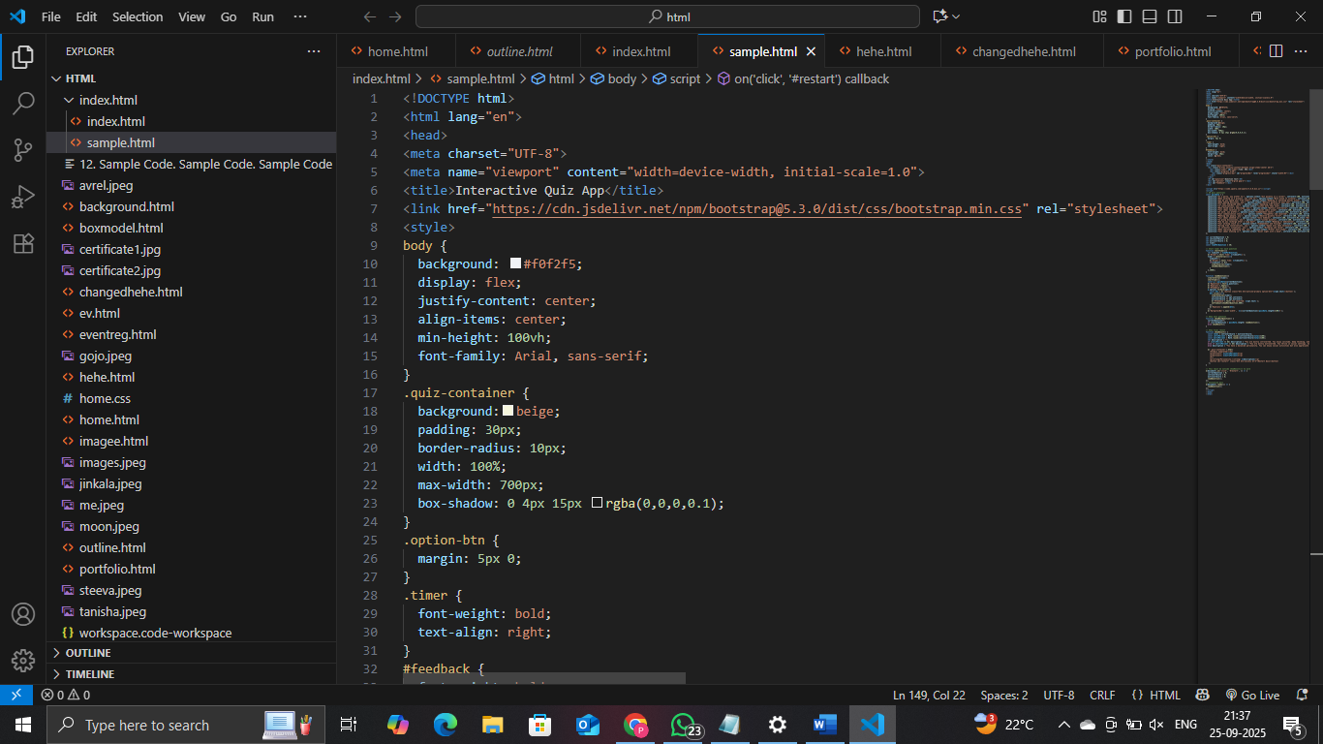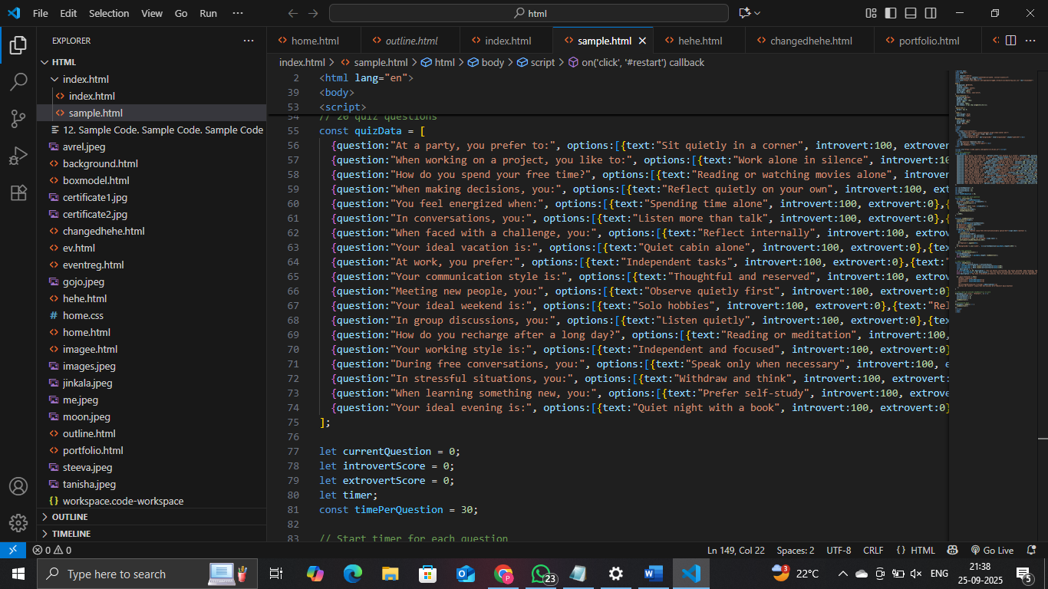

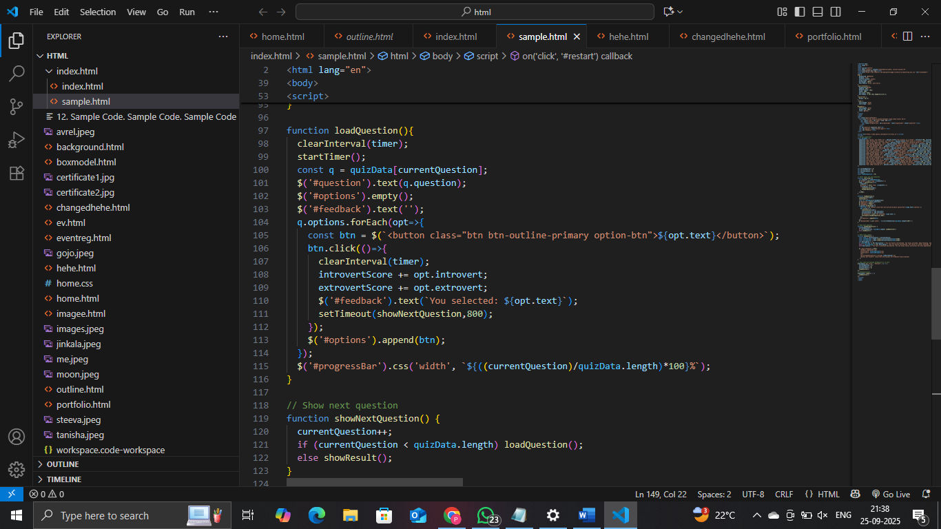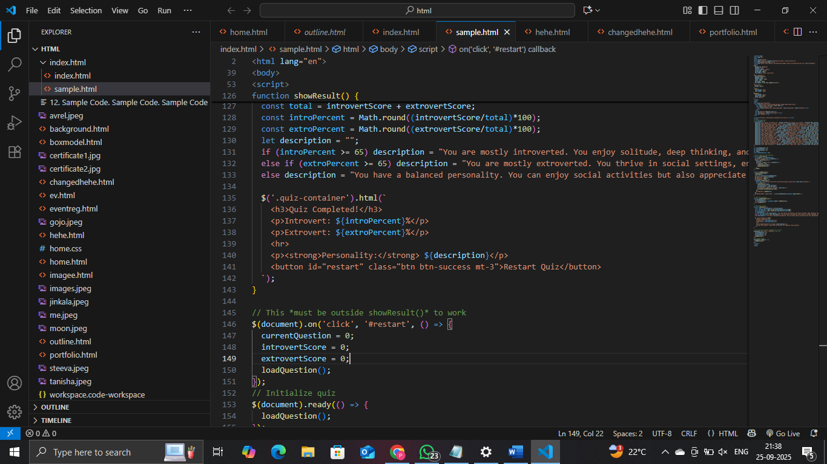

**13. Screenshots of Final Output**

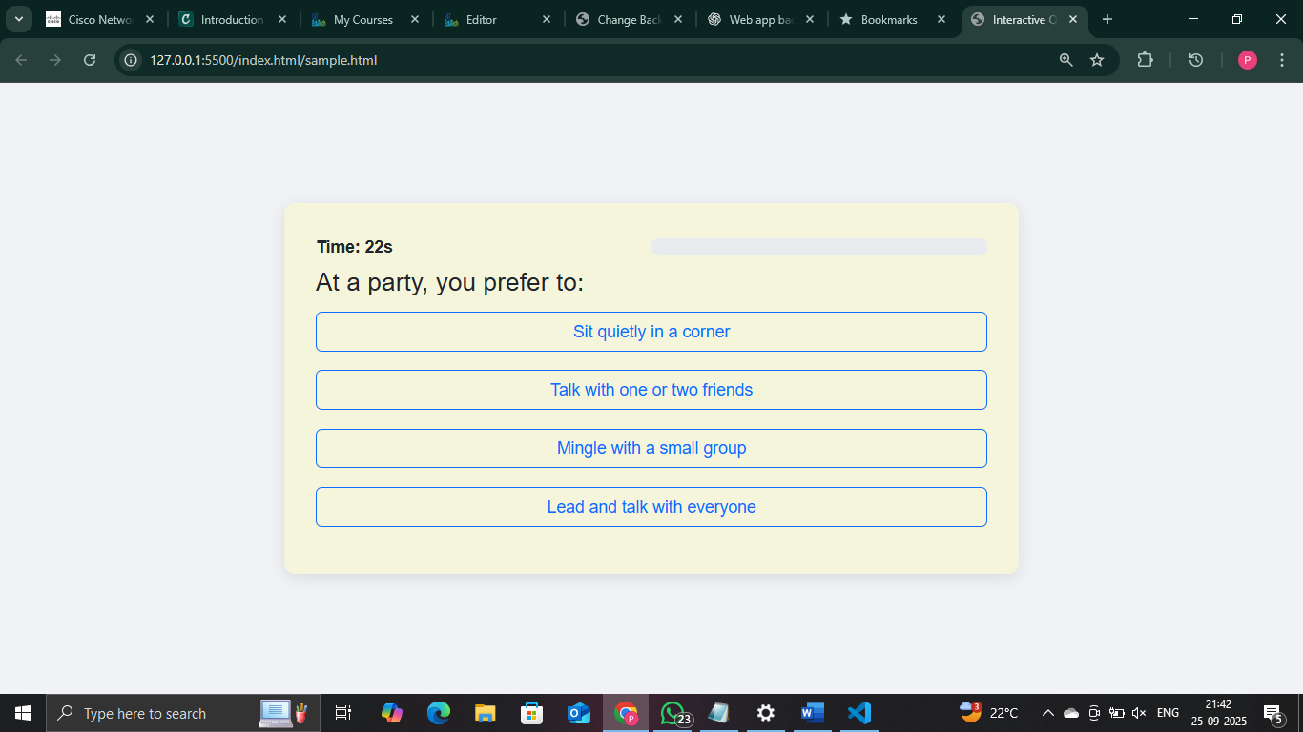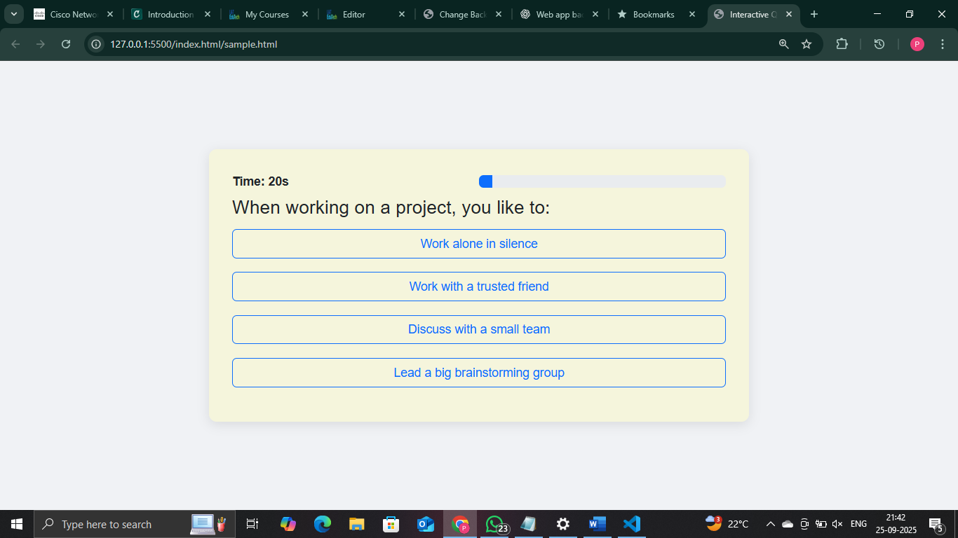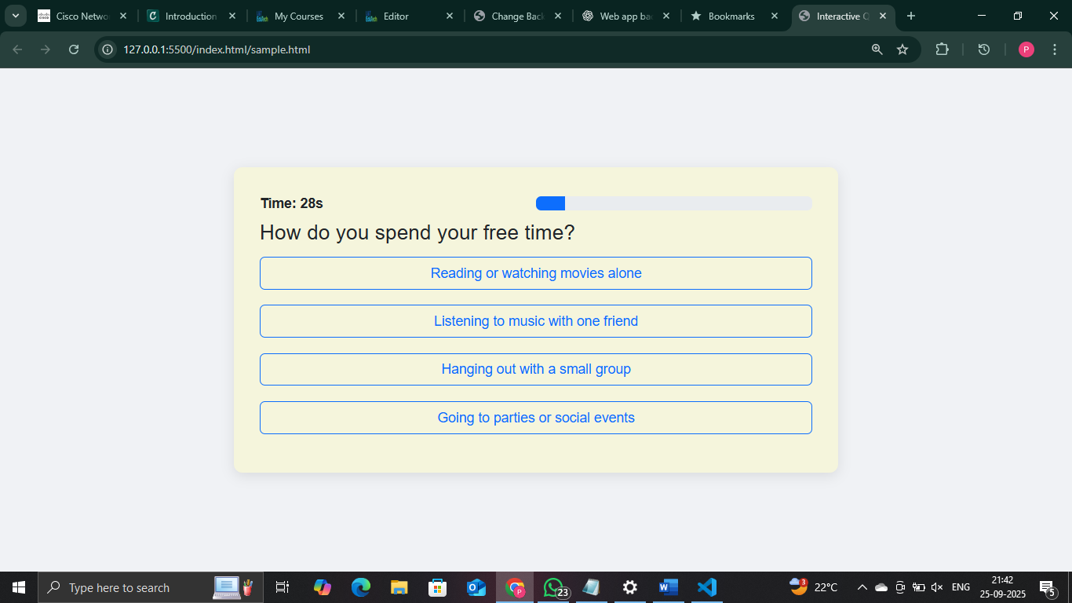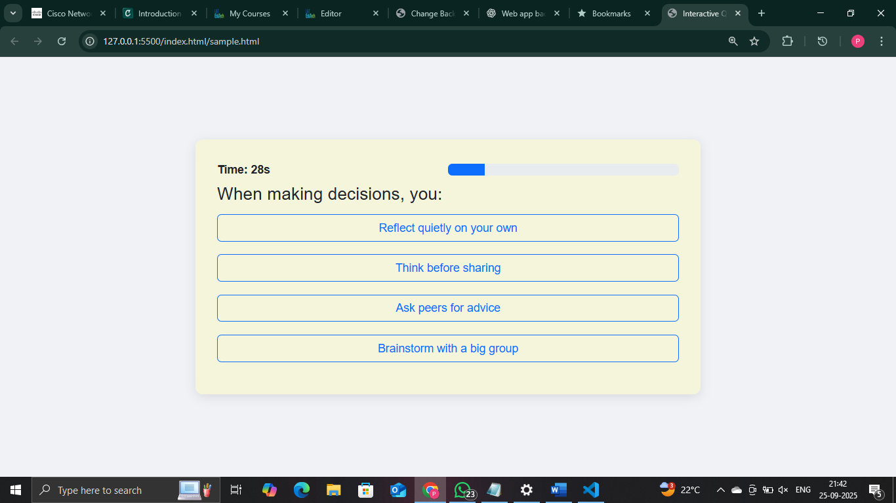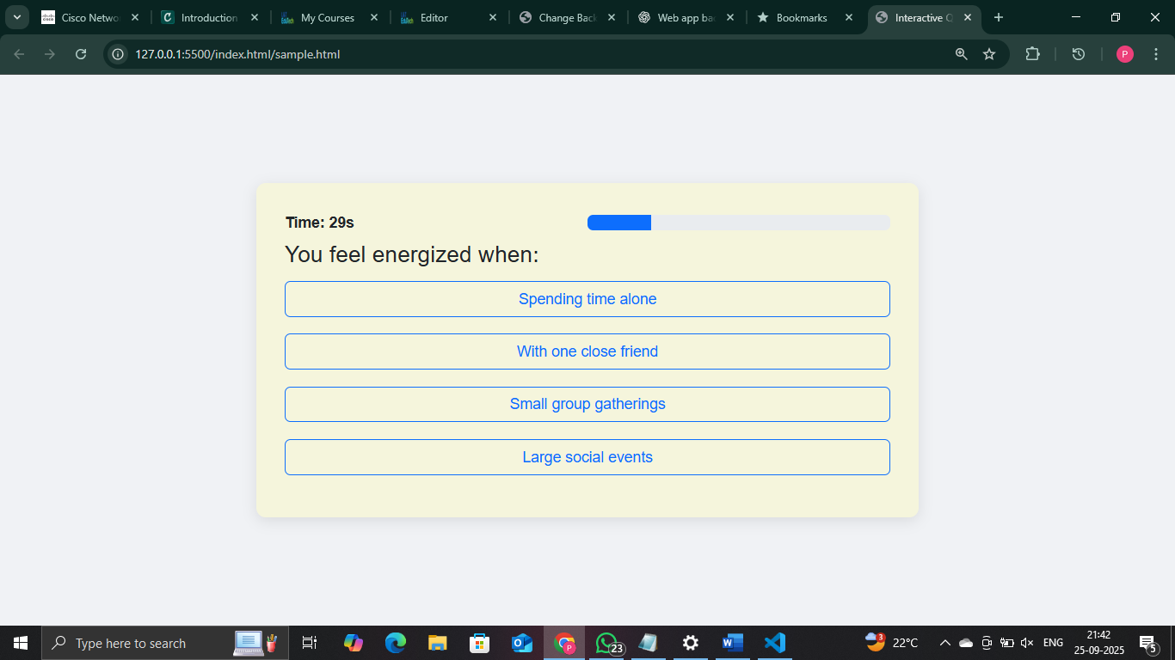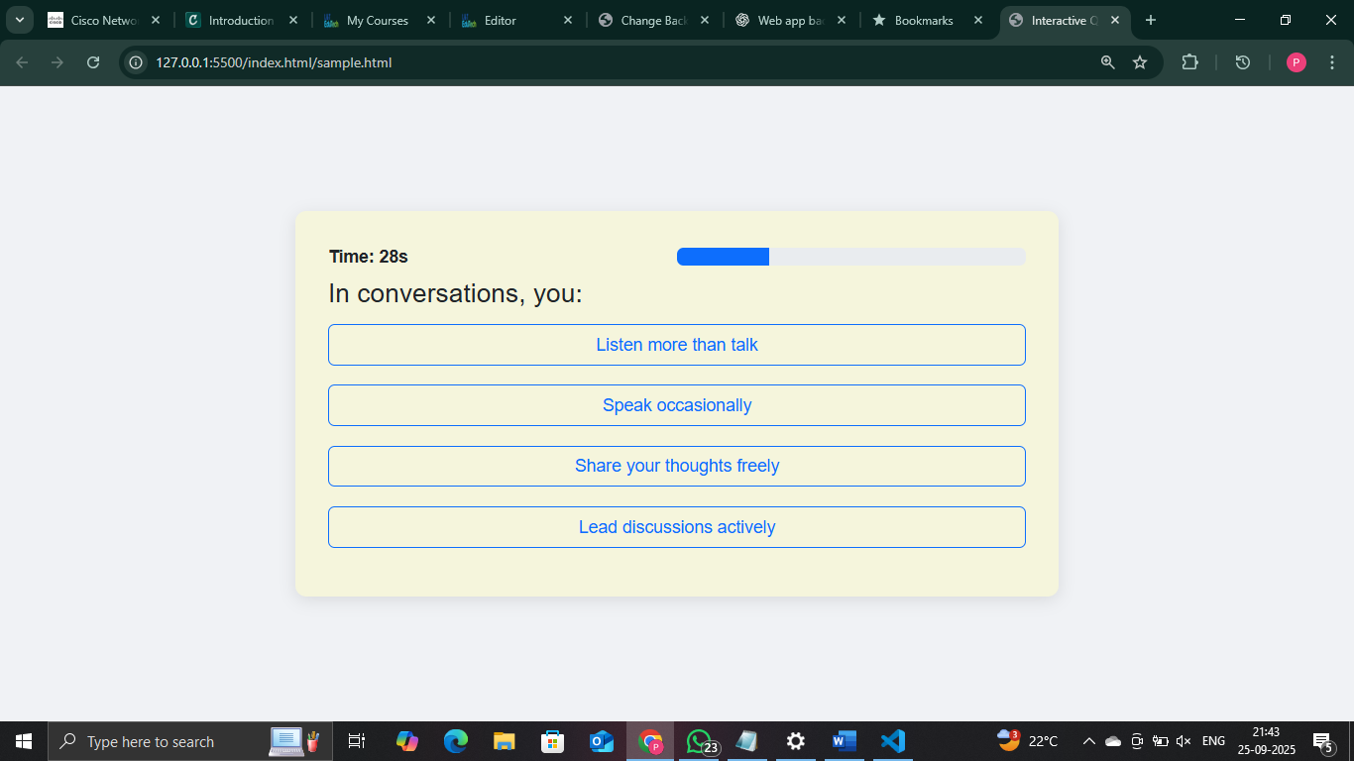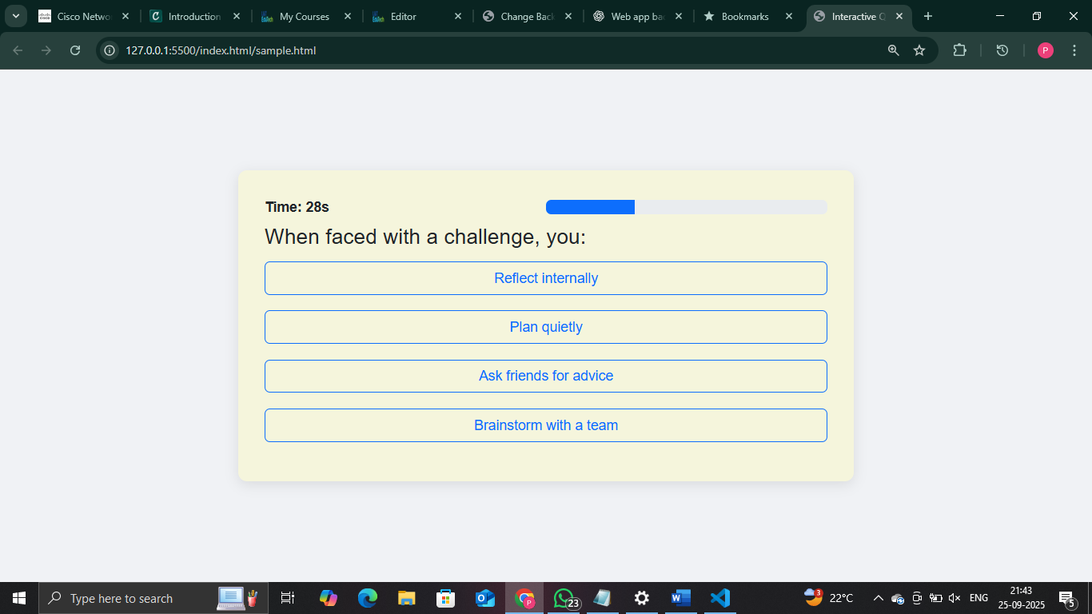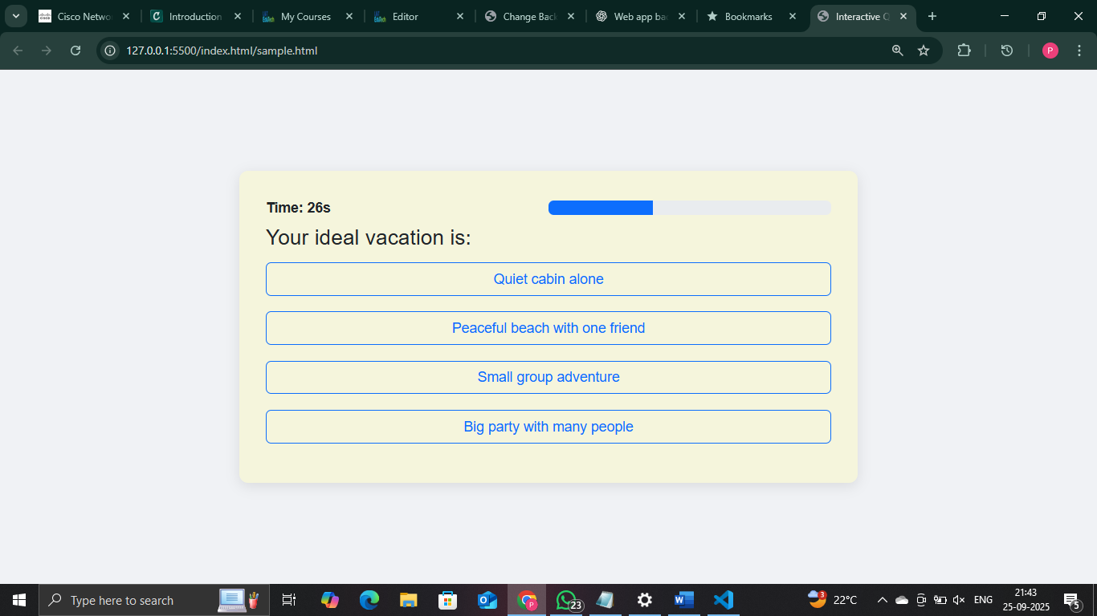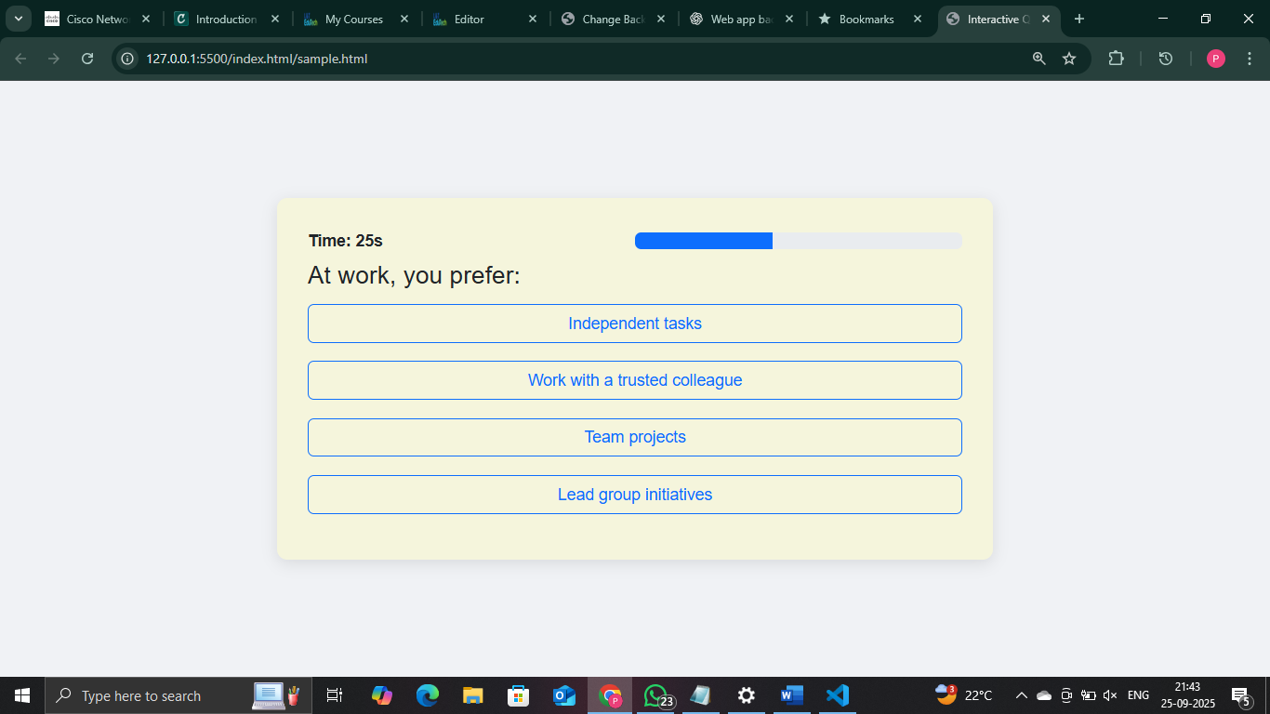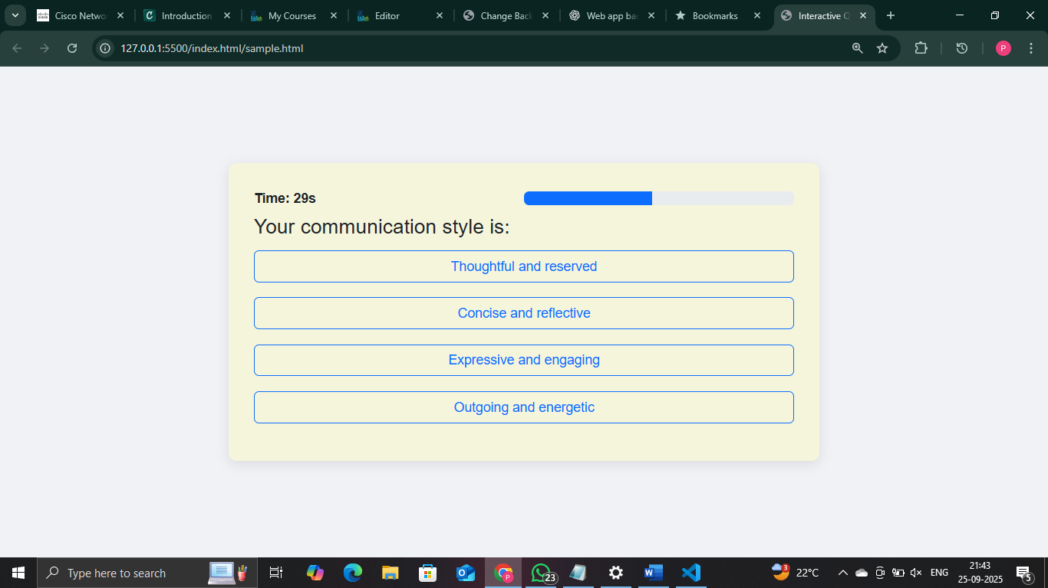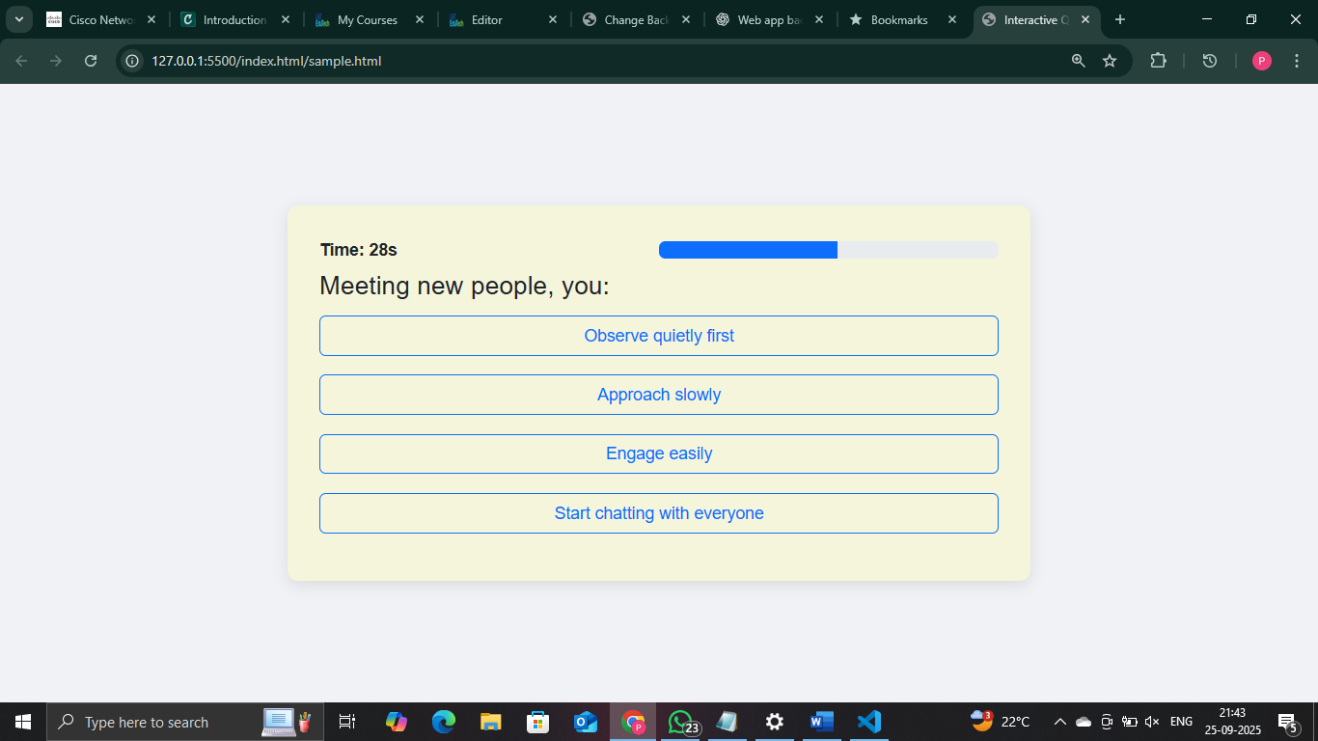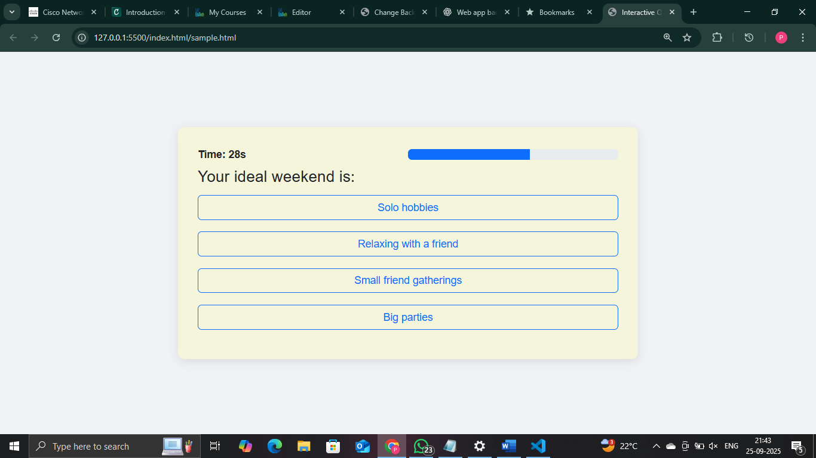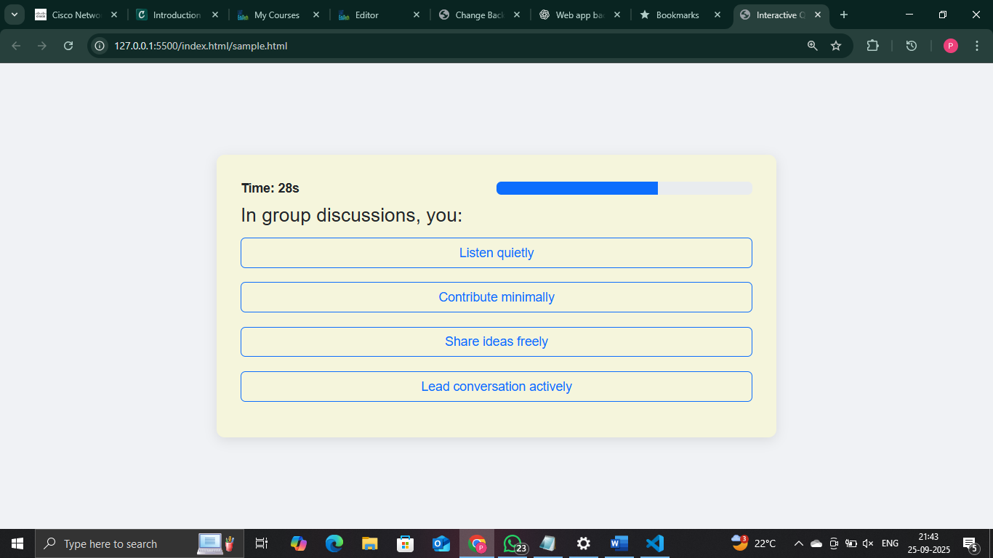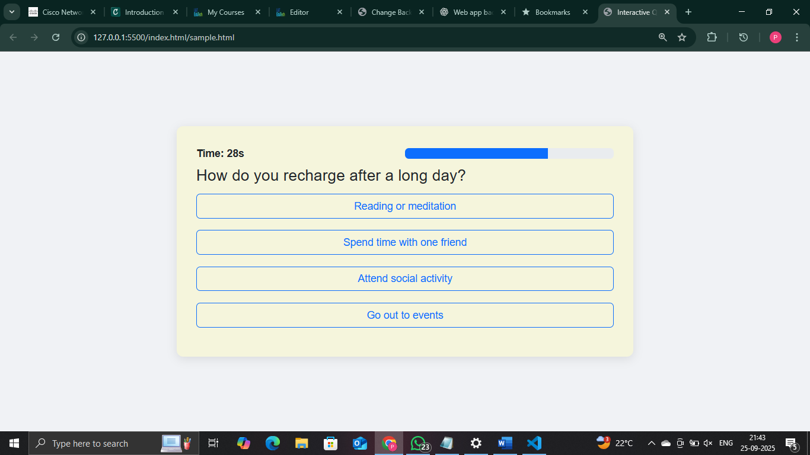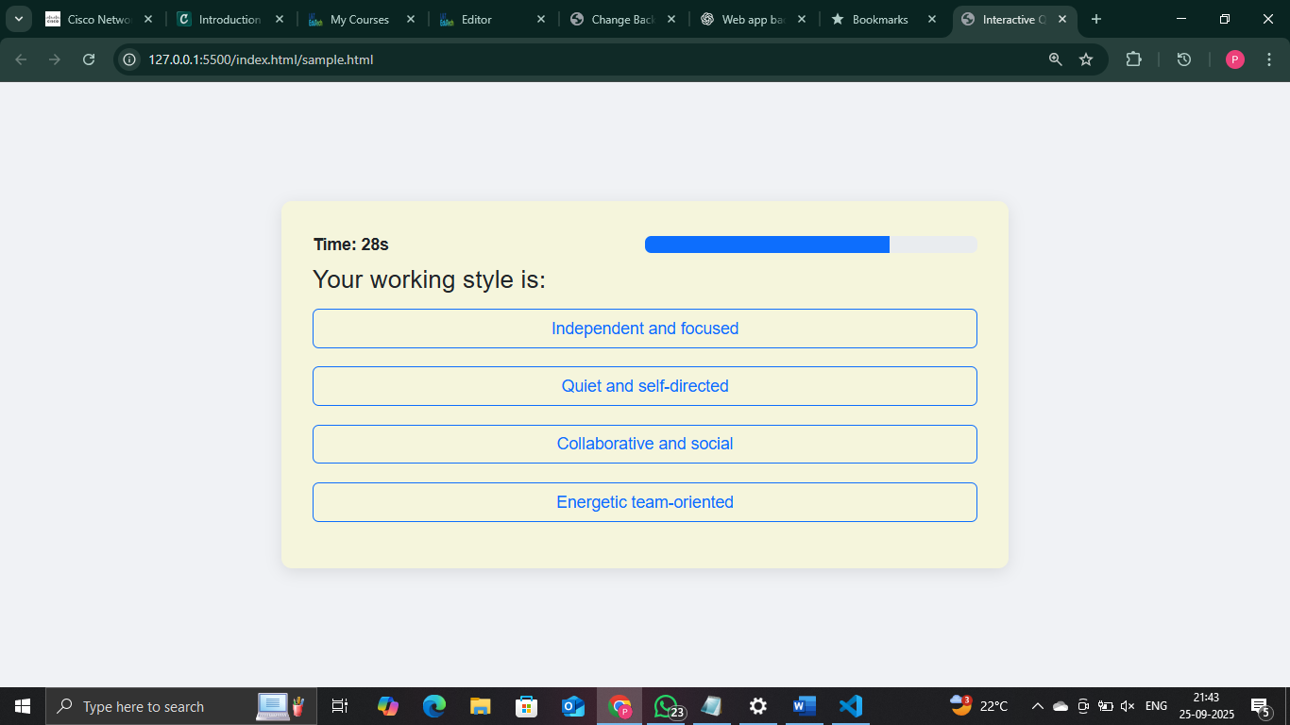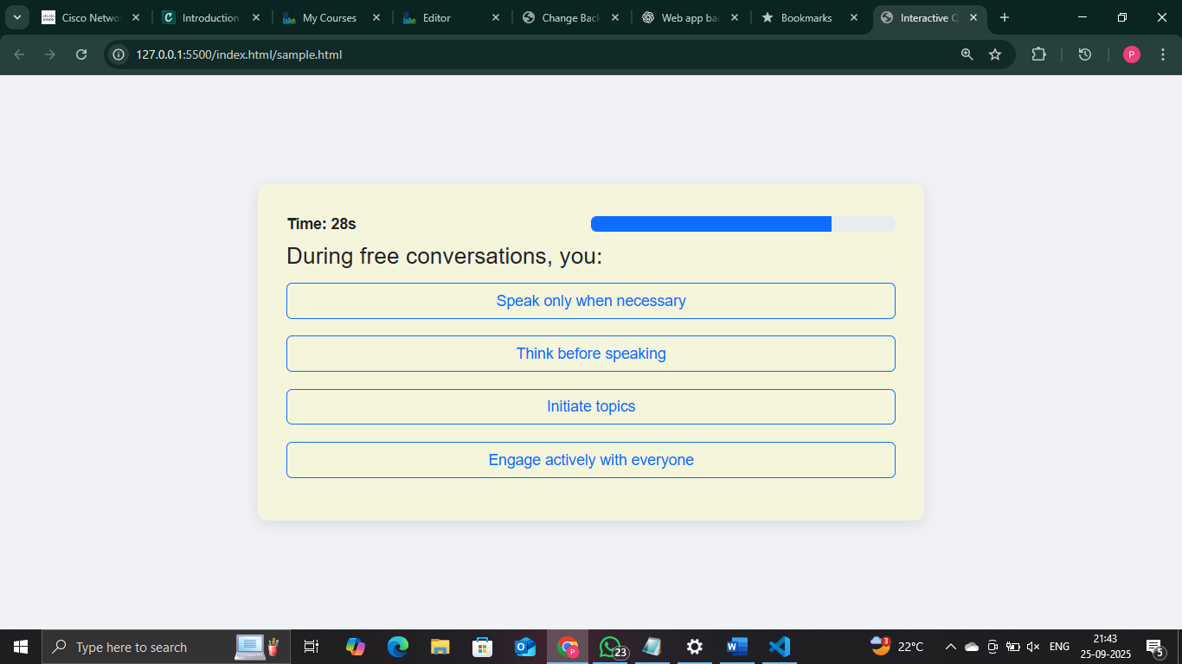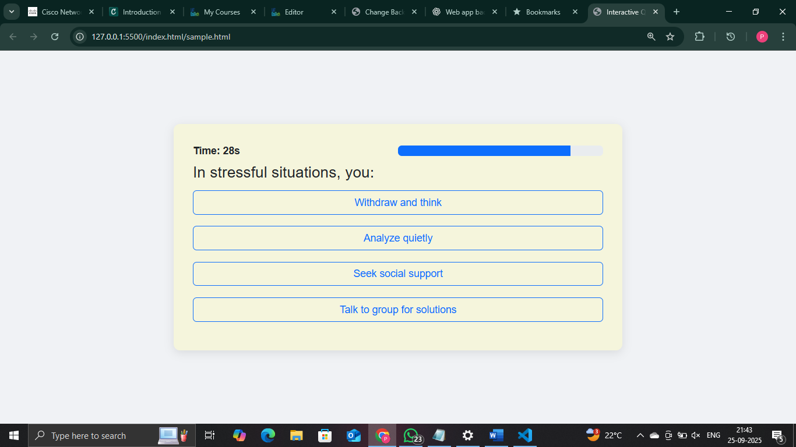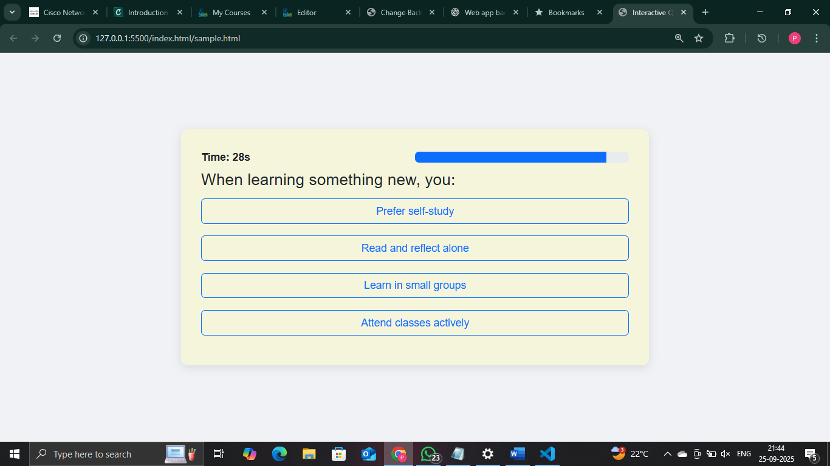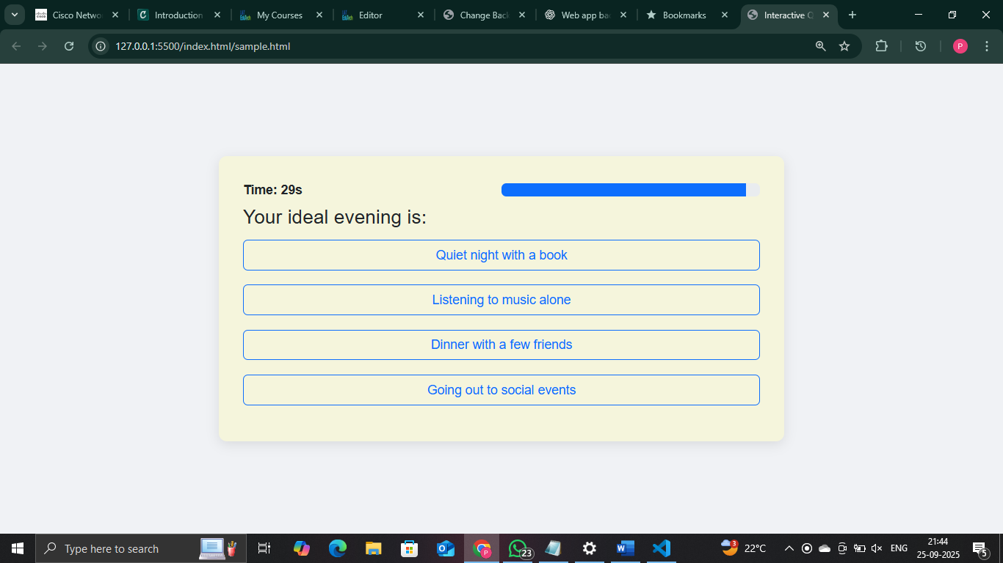

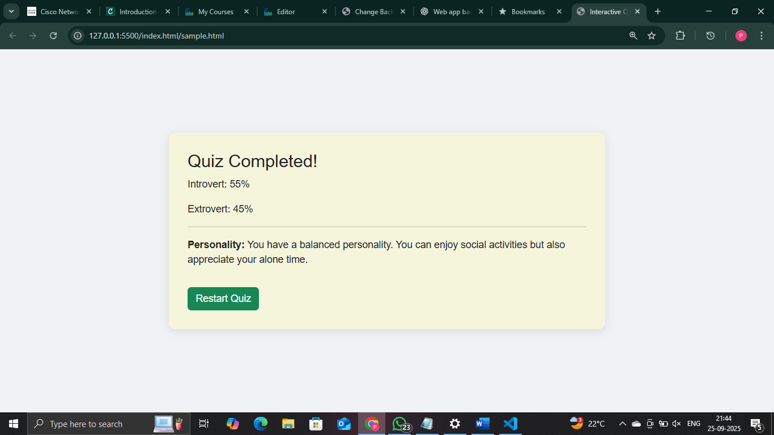

**14. Conclusion**

The Interactive Quiz Application project successfully demonstrated the development of a dynamic, responsive, and user-friendly web-based quiz. Through the implementation of HTML, CSS, Bootstrap, JavaScript, and jQuery, the project provided hands-on experience in creating interactive elements such as timers, progress bars, instant feedback, and dynamic result calculation. The application not only delivers an engaging user experience but also reinforces key frontend development skills, including DOM manipulation, event handling, and responsive design techniques. By completing this project, valuable insights were gained into UI/UX design principles, structured coding practices, and the integration of multiple web technologies to create a cohesive and functional application. Overall, the project highlights the importance of interactivity and responsiveness in modern web applications and serves as a strong foundation for future enhancements, such as backend integration, multiple quiz categories, and user personalization.

**15. References**

1. jQuery Documentation – https://api.jquery.com/

2. Bootstrap Documentation – https://getbootstrap.com/docs/5.0/getting-started/introduction/

3. W3Schools HTML, CSS, and JavaScript Tutorials – https://www.w3schools.com/

4. MDN Web Docs (Mozilla Developer Network) – https://developer.mozilla.org/en-US/

5. Learn.LntEdutech Portal – Course materials and project guidelines