Pastel Rainbow To-Do List
Submitted By: Jinkala Shahanaz , Priyavarseine Anthiyur Somasundaram
Roll Number: 2462086,2462127
College Email ID: j
inkala.shahanaz@btech.christuniversity.in , priyavarseine.anthiyur@btech.christuniversity.in
Course: UI/UX Design Fundamentals
Instructor Name: [Faculty Name]
Institution: Christ University
Date of Submission: [DD/MM/YYYY]

Abstract
This project is a colorful and interactive To-Do List application designed with a clean UI/UX approach. The primary goal is to create a task management tool where users can add, edit, delete, filter, and mark tasks as completed. It uses HTML5, CSS3, Bootstrap 5, and jQuery for implementation. The final outcome is a pastel-themed to-do list that stores tasks persistently using Local Storage, ensuring that user data remains intact across sessions. The project demonstrates practical skills in front-end development, usability, and state management, offering a simple yet effective productivity tool.

Objectives
• Design a user-friendly, visually appealing interface using pastel themes.
• Implement task creation, editing, deletion, and completion features.
• Add filtering options for active, completed, and all tasks.
• Ensure data persistence using Local Storage.
• Provide clear UI feedback through hover effects, badges, and responsive design.

Scope of the Project
The project focuses entirely on front-end development of a task management application. It does not include backend services or cloud storage, but instead uses browser Local Storage for data persistence. The scope includes task management operations, filtering, editing, and status updates with a user-friendly interface.

Tools & Technologies Used
Tool/Technology | Purpose
HTML5 | Markup and structure of the to-do app
CSS3 | Styling, layout, pastel color theme
Bootstrap 5 | Responsive design and UI components
jQuery | Event handling, DOM manipulation
JavaScript (Local Storage API) | Persistent task storage
VS Code | Code editor
Chrome DevTools | Debugging and testing

HTML Structure Overview
- Used <div> with Bootstrap grid for layout.
- Input field and button for adding tasks.
- <ul> element to render tasks dynamically.
- Filter controls with <select> and buttons.
- Each task displayed inside <li> with action buttons.

CSS Styling Strategy
- Applied pastel rainbow sticky-note colors cycling by index.
- Added hover effects and subtle shadows for interactive feel.
- Styled buttons with soft custom themes (Add, Edit, Delete).
- Used badges for task status: Active / Completed.
- Rounded corners and modern typography for friendly UI.

Key Features
Feature | Description
Add & Delete Tasks | Users can add new tasks or remove them.
Edit Tasks | Tasks can be updated with inline editing.
Mark Completed | Checkbox toggles task completion with strikethrough styling.
Filter Tasks | Users can filter by Active, Completed, or All tasks.
Clear Options | Remove only completed tasks or all tasks.
Persistent Storage | Tasks are saved in Local Storage and remain after reload.

Challenges Faced & Solutions
Challenge | Solution
Keeping tasks saved after page reload | Used Local Storage API to persist data.
Updating UI after changes | Re-rendered tasks after every state update.
Inline editing without breaking layout | Used hidden input fields toggled dynamically.
Maintaining clean UI with multiple features | Applied Bootstrap utility classes and CSS hover transitions.

Outcome
The project successfully delivers a functional and aesthetic to-do list application. It includes essential task management features and ensures smooth usability. The pastel theme improves visual appeal, while Local Storage ensures persistent data. Users can manage daily tasks easily with an intuitive interface.

Future Enhancements
• Add drag-and-drop task reordering.
• Implement categories or tags for tasks.
• Add due dates and reminders.
• Sync tasks with cloud storage or a backend.
• Add dark mode toggle for accessibility.

Sample Code

<!DOCTYPE html>
<html lang="en">
<head>
<meta charset="utf-8" />
<meta name="viewport" content="width=device-width,initial-scale=1" />
<title>Pastel Rainbow To-Do List</title>

<!-- Bootstrap 5 -->
<link href="https://cdn.jsdelivr.net/npm/bootstrap@5.3.2/dist/css/bootstrap.min.css" rel="stylesheet">
<!-- jQuery -->
<script src="https://code.jquery.com/jquery-3.7.1.min.js"></script>

<style>
body {
background: #fffdf7;
min-height: 100vh;
font-family: "Poppins", sans-serif;
}
.card {
border: none;
border-radius: 18px;
background: #ffffff;
box-shadow: 0 6px 20px rgba(0,0,0,0.06);
}
.completed {
text-decoration: line-through;
color: #555;
}
.list-group-item {
border: none;
margin-bottom: 12px;
border-radius: 14px !important;
padding: 14px;
font-weight: 500;
font-size: 1rem;
transition: all 0.2s ease;
}
.list-group-item:hover {
transform: scale(1.02);
box-shadow: 0 4px 12px rgba(0,0,0,0.08);
}

/* Pastel sticky note colors (rotate by index) */
.pastel-0 { background: #b5ead7; }
.pastel-1 { background: #ffdac1; }
.pastel-2 { background: #c7ceea; }
.pastel-3 { background: #fff5ba; }
.pastel-4 { background: #aee1f9; }

.btn-primary {
background: #77dd77;
border: none;
}
.btn-primary:hover { background: #5cc95c; }

.editBtn {
background: #779ecb;
border: none;
color: #fff;
}
.editBtn:hover { background: #5c86b5; }

.deleteBtn {
background: #ff6961;
border: none;
color: #fff;
}
.deleteBtn:hover { background: #e65a53; }

.form-select, .form-control {
border-radius: 12px;
border: 1px solid #ddd;
}

/* Badges */
.badge-status {
font-size: 0.75rem;
padding: 4px 8px;
border-radius: 8px;
margin-left: 10px;
font-weight: 500;
}
.badge-active { background: #fdbb74; color: #4e2a00; }
.badge-completed { background: #88d498; color: #fff; }
</style>
</head>
<body>
<div class="container py-5">
<div class="card shadow-sm p-4">
<h2 class="text-center mb-4 fw-bold" style="color:#ff8c94;"> To-Do List</h2>

<div class="row g-2 mb-3">
<div class="col">
<input id="taskInput" class="form-control" placeholder="Enter new task and press Enter or Add">
</div>
<div class="col-auto">
<button id="addTaskBtn" class="btn btn-primary">Add</button>
</div>
</div>

<div class="mb-3 d-flex flex-wrap gap-2">
<select id="filterTasks" class="form-select w-auto">
<option value="all">All Tasks</option>
<option value="active">Active Tasks</option>
<option value="completed">Completed Tasks</option>
</select>
<button id="clearCompleted" class="btn btn-outline-secondary btn-sm">Clear Completed</button>
<button id="clearAll" class="btn btn-outline-danger btn-sm">Clear All</button>
</div>

<ul id="taskList" class="list-group"></ul>
</div>
</div>

<script>
$(function () {
const STORAGE_KEY = 'todo.tasks.v1';
let tasks = [];
let currentFilter = 'all';

const pastelClasses = ['pastel-0','pastel-1','pastel-2','pastel-3','pastel-4'];

function loadTasks(){ const raw = localStorage.getItem(STORAGE_KEY); tasks = raw ? JSON.parse(raw) : []; }
function saveTasks(){ localStorage.setItem(STORAGE_KEY, JSON.stringify(tasks)); }
function renderTasks(){
const $list = $('#taskList');
$list.empty();
tasks.forEach((task, index) => {
if (currentFilter === 'active' && task.completed) return;
if (currentFilter === 'completed' && !task.completed) return;

const badge = task.completed
? '<span class="badge-status badge-completed">Done</span>'
: '<span class="badge-status badge-active">Active</span>';

const colorClass = pastelClasses[index % pastelClasses.length];

const li = $(`
<li class="list-group-item d-flex justify-content-between align-items-center ${colorClass}" data-id="${task.id}">
<div class="d-flex align-items-center w-100">
<input type="checkbox" class="form-check-input me-2 toggleComplete" ${task.completed ? 'checked' : ''} />
<span class="task-text flex-grow-1 ${task.completed ? 'completed' : ''}">${task.text}</span>
${badge}
<input type="text" class="form-control form-control-sm edit-input d-none" />
</div>
<div class="btn-group ms-2" role="group">
<button class="btn btn-sm editBtn">Edit</button>
<button class="btn btn-sm deleteBtn">Delete</button>
</div>
</li>
`);

$list.append(li);
});
}
function addTask(text){
if (!text || !text.trim()) return;
tasks.push({ id: Date.now(), text: text.trim(), completed: false });
saveTasks();
renderTasks();
}

loadTasks();
renderTasks();

$('#addTaskBtn').on('click', function(){ addTask($('#taskInput').val()); $('#taskInput').val('').focus(); });
$('#taskInput').on('keydown', function(e){ if (e.key === 'Enter') { addTask($(this).val()); $(this).val(''); } });
$('#filterTasks').on('change', function(){ currentFilter = $(this).val(); renderTasks(); });
$('#clearCompleted').on('click', function(){ tasks = tasks.filter(t => !t.completed); saveTasks(); renderTasks(); });
$('#clearAll').on('click', function(){ if (!confirm('Clear ALL tasks?')) return; tasks = []; saveTasks(); renderTasks(); });

$('#taskList')
.on('change', '.toggleComplete', function(){
const id = $(this).closest('li').data('id');
const t = tasks.find(x => x.id == id);
if (t) { t.completed = this.checked; saveTasks(); renderTasks(); }
})
.on('click', '.deleteBtn', function(){
const id = $(this).closest('li').data('id');
tasks = tasks.filter(x => x.id != id);
saveTasks();
renderTasks();
})
.on('click', '.editBtn', function(){
const $li = $(this).closest('li');
const id = $li.data('id');
const $span = $li.find('.task-text'), $input = $li.find('.edit-input');

if (!$li.data('editing')) {
$li.data('editing', true);
$input.val($span.text()).removeClass('d-none').focus();
$span.hide();
$(this).text('Save').removeClass('editBtn').addClass('btn-success saveBtn');
} else {
const newText = $input.val().trim();
if (!newText) { alert('Task cannot be empty.'); return; }
const t = tasks.find(x => x.id == id);
if (t) { t.text = newText; saveTasks(); }
$li.data('editing', false);
$span.text(newText).show();
$input.addClass('d-none');
$(this).text('Edit').removeClass('btn-success saveBtn').addClass('editBtn');
renderTasks();
}
});
});
</script>
</body>
</html>
<!DOCTYPE html>
<html lang="en">
<head>
<meta charset="utf-8" />
<meta name="viewport" content="width=device-width,initial-scale=1" />
<title>Pastel Rainbow To-Do List</title>

<!-- Bootstrap 5 -->
<link href="https://cdn.jsdelivr.net/npm/bootstrap@5.3.2/dist/css/bootstrap.min.css" rel="stylesheet">
<!-- jQuery -->
<script src="https://code.jquery.com/jquery-3.7.1.min.js"></script>

<style>
body {
background: #fffdf7;
min-height: 100vh;
font-family: "Poppins", sans-serif;
}
.card {
border: none;
border-radius: 18px;
background: #ffffff;
box-shadow: 0 6px 20px rgba(0,0,0,0.06);
}
.completed {
text-decoration: line-through;
color: #555;
}
.list-group-item {
border: none;
margin-bottom: 12px;
border-radius: 14px !important;
padding: 14px;
font-weight: 500;
font-size: 1rem;
transition: all 0.2s ease;
}
.list-group-item:hover {
transform: scale(1.02);
box-shadow: 0 4px 12px rgba(0,0,0,0.08);
}

/* Pastel sticky note colors (rotate by index) */
.pastel-0 { background: #b5ead7; }
.pastel-1 { background: #ffdac1; }
.pastel-2 { background: #c7ceea; }
.pastel-3 { background: #fff5ba; }
.pastel-4 { background: #aee1f9; }

.btn-primary {
background: #77dd77;
border: none;
}
.btn-primary:hover { background: #5cc95c; }

.editBtn {
background: #779ecb;
border: none;
color: #fff;
}
.editBtn:hover { background: #5c86b5; }

.deleteBtn {
background: #ff6961;
border: none;
color: #fff;
}
.deleteBtn:hover { background: #e65a53; }

.form-select, .form-control {
border-radius: 12px;
border: 1px solid #ddd;
}

/* Badges */
.badge-status {
font-size: 0.75rem;
padding: 4px 8px;
border-radius: 8px;
margin-left: 10px;
font-weight: 500;
}
.badge-active { background: #fdbb74; color: #4e2a00; }
.badge-completed { background: #88d498; color: #fff; }
</style>
</head>
<body>
<div class="container py-5">
<div class="card shadow-sm p-4">
<h2 class="text-center mb-4 fw-bold" style="color:#ff8c94;"> To-Do List</h2>

<div class="row g-2 mb-3">
<div class="col">
<input id="taskInput" class="form-control" placeholder="Enter new task and press Enter or Add">
</div>
<div class="col-auto">
<button id="addTaskBtn" class="btn btn-primary">Add</button>
</div>
</div>

<div class="mb-3 d-flex flex-wrap gap-2">
<select id="filterTasks" class="form-select w-auto">
<option value="all">All Tasks</option>
<option value="active">Active Tasks</option>
<option value="completed">Completed Tasks</option>
</select>
<button id="clearCompleted" class="btn btn-outline-secondary btn-sm">Clear Completed</button>
<button id="clearAll" class="btn btn-outline-danger btn-sm">Clear All</button>
</div>

<ul id="taskList" class="list-group"></ul>
</div>
</div>

<script>
$(function () {
const STORAGE_KEY = 'todo.tasks.v1';
let tasks = [];
let currentFilter = 'all';

const pastelClasses = ['pastel-0','pastel-1','pastel-2','pastel-3','pastel-4'];

function loadTasks(){ const raw = localStorage.getItem(STORAGE_KEY); tasks = raw ? JSON.parse(raw) : []; }
function saveTasks(){ localStorage.setItem(STORAGE_KEY, JSON.stringify(tasks)); }
function renderTasks(){
const $list = $('#taskList');
$list.empty();
tasks.forEach((task, index) => {
if (currentFilter === 'active' && task.completed) return;
if (currentFilter === 'completed' && !task.completed) return;

const badge = task.completed
? '<span class="badge-status badge-completed">Done</span>'
: '<span class="badge-status badge-active">Active</span>';

const colorClass = pastelClasses[index % pastelClasses.length];

const li = $(`
<li class="list-group-item d-flex justify-content-between align-items-center ${colorClass}" data-id="${task.id}">
<div class="d-flex align-items-center w-100">
<input type="checkbox" class="form-check-input me-2 toggleComplete" ${task.completed ? 'checked' : ''} />
<span class="task-text flex-grow-1 ${task.completed ? 'completed' : ''}">${task.text}</span>
${badge}
<input type="text" class="form-control form-control-sm edit-input d-none" />
</div>
<div class="btn-group ms-2" role="group">
<button class="btn btn-sm editBtn">Edit</button>
<button class="btn btn-sm deleteBtn">Delete</button>
</div>
</li>
`);

$list.append(li);
});
}
function addTask(text){
if (!text || !text.trim()) return;
tasks.push({ id: Date.now(), text: text.trim(), completed: false });
saveTasks();
renderTasks();
}

loadTasks();
renderTasks();

$('#addTaskBtn').on('click', function(){ addTask($('#taskInput').val()); $('#taskInput').val('').focus(); });
$('#taskInput').on('keydown', function(e){ if (e.key === 'Enter') { addTask($(this).val()); $(this).val(''); } });
$('#filterTasks').on('change', function(){ currentFilter = $(this).val(); renderTasks(); });
$('#clearCompleted').on('click', function(){ tasks = tasks.filter(t => !t.completed); saveTasks(); renderTasks(); });
$('#clearAll').on('click', function(){ if (!confirm('Clear ALL tasks?')) return; tasks = []; saveTasks(); renderTasks(); });

$('#taskList')
.on('change', '.toggleComplete', function(){
const id = $(this).closest('li').data('id');
const t = tasks.find(x => x.id == id);
if (t) { t.completed = this.checked; saveTasks(); renderTasks(); }
})
.on('click', '.deleteBtn', function(){
const id = $(this).closest('li').data('id');
tasks = tasks.filter(x => x.id != id);
saveTasks();
renderTasks();
})
.on('click', '.editBtn', function(){
const $li = $(this).closest('li');
const id = $li.data('id');
const $span = $li.find('.task-text'), $input = $li.find('.edit-input');

if (!$li.data('editing')) {
$li.data('editing', true);
$input.val($span.text()).removeClass('d-none').focus();
$span.hide();
$(this).text('Save').removeClass('editBtn').addClass('btn-success saveBtn');
} else {
const newText = $input.val().trim();
if (!newText) { alert('Task cannot be empty.'); return; }
const t = tasks.find(x => x.id == id);
if (t) { t.text = newText; saveTasks(); }
$li.data('editing', false);
$span.text(newText).show();
$input.addClass('d-none');
$(this).text('Edit').removeClass('btn-success saveBtn').addClass('editBtn');
renderTasks();
}
});
});
</script>
</body>
</html>

Sample output
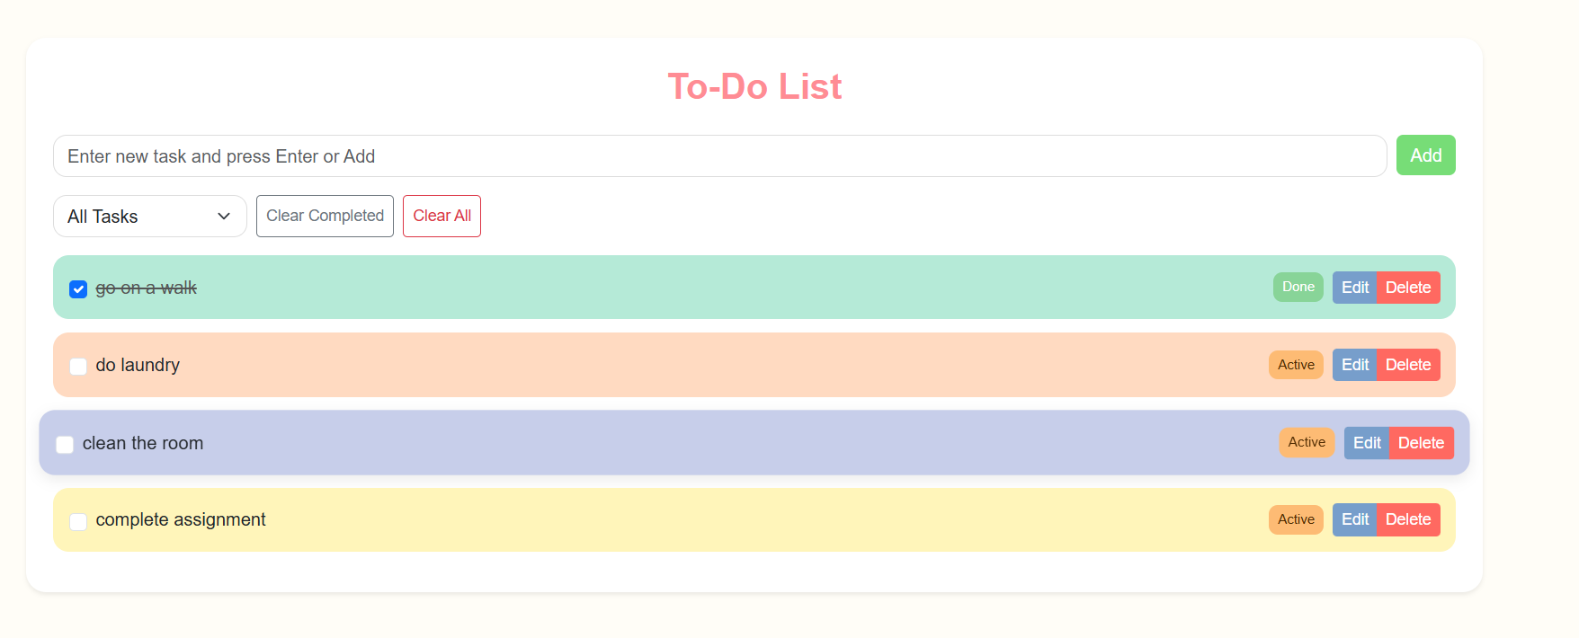
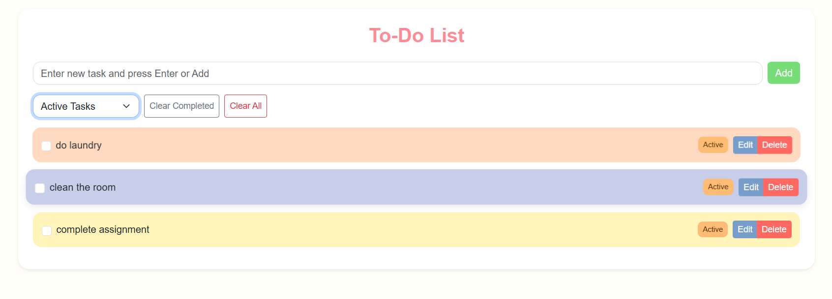

Conclusion
This project demonstrates the development of a functional, user-friendly to-do list using front-end technologies. It strengthened practical knowledge of HTML, CSS, Bootstrap, jQuery, and Local Storage. The project improved understanding of UI/UX principles like responsiveness, visual hierarchy, and user interaction design.

