POCKETSMART AI
Personalized Planning and Recommendation Assistant
Detailed Project Documentation

  - FastAPI + Jinja2 Web Application

Prepared for academic project submission
This document contains detailed explanations of the project, users, modules, technology, selected main code, architecture diagrams, project-management records, testing, deployment and maintenance. No personal photographs are used.

Contents and Document Guide
This 30-page version is designed as a detailed college project document. It focuses on what PocketSmart AI does, who uses it, how the application is organized, how the major modules work, and how the supplied implementation handles requests. The document uses selected main code only rather than reproducing the complete source tree.
Page | Section
3 | Project Overview
4 | What the Project Does
5 | Users and Use Cases
6 | Project Scope and Modules
7 | Technology Stack
8 | Project Architecture
9 | Architecture Diagram Explanation
10 | Functional Module Diagram
11 | Project Directory Structure
12 | FastAPI Application Setup
13 | Page Routing and Templates
14 | Home Planner
15 | Party Planner
16 | Jewelry Planner
17 | Recommendations and Budget Handling
18 | History and Persistence
19 | Frontend JavaScript
20 | Planner Input Design
21 | Illustrative Project UI
22 | Dashboard and Account Pages
23 | Testing Structure
24 | Selected Testing Code
25 | Project Management – Initiation
26 | Planning and Risk Management
27 | Execution and Progress Tracking
28 | Monitoring and Control
29 | Conclusion, Maintenance and Demo
30 | References and Submission Notes

3. Project Overview
PocketSmart AI is a multi-page web application for budget-oriented planning across home interiors, parties, and jewelry. The supplied implementation uses FastAPI as the application server and Jinja2 templates for page rendering. Planner forms collect structured values from the user and submit those values to dedicated backend endpoints. The backend returns structured JSON containing the selected inputs and a calculated budget-oriented breakdown. This gives the user a simple browser-based experience instead of requiring manual preparation of a plan.
The application is organized as a conventional web project. The main Python application is separated from templates, static CSS and JavaScript, data storage, models, routes, services, and testing files. The interface includes a landing page, feature information, planner selection, individual planners, recommendations, history, dashboard, profile, settings, login and registration pages. The project therefore demonstrates both user-facing application design and backend web development.
For academic presentation, PocketSmart AI can be explained as a practical example of how a web application accepts human preferences, processes structured inputs, and returns an organized planning response. The current starter implementation should be described accurately: the planner endpoints are lightweight deterministic/demo implementations, while the project structure provides places where more advanced recommendation or AI services can later be connected.

4. What the Project Does
The central function of PocketSmart AI is to convert a user's planning requirements into an organized digital plan. A user begins by selecting a planning category and then enters values such as budget, style, occasion, mood, quality preference, room or event information, and the type of result required. The browser sends these values to the corresponding FastAPI endpoint. The endpoint validates the request fields and returns a structured response that can be displayed by the frontend.
For a home requirement, the user can specify a budget, room, style, style preference, occasion, mood, what they want to plan, focus area, and quality level. For a party requirement, the application can collect event-related values such as budget, guest information, event type, occasion, priority, style, mood and quality. For jewelry planning, the fields cover budget, occasion, style, mood, look or feel, piece, metal and quality.
The application also contains supporting pages that make the experience feel like a complete product rather than a single form. Recommendations provide a dedicated place for planning information, History provides access to previous plans, and Dashboard provides a summary-oriented view. Account-oriented pages such as Profile, Settings, Login and Register provide a broader user-interface structure for future account functionality.

5. Users and Use Cases
The primary users are ordinary users who want help organizing personal planning requirements. A person preparing a new home can use the Home Planner to describe the room, budget, preferred style and mood. A person organizing an event can use the Party Planner to describe the event and guest-related requirements. A person planning a jewelry purchase can use the Jewelry Planner to specify the occasion, style, piece, metal and quality preferences. The system is designed to make the first stage of planning more structured and understandable.
The project also has academic users. Students can study the project to understand FastAPI routing, form handling, Jinja2 template rendering, static-file serving, browser-side JavaScript, JSON persistence and automated testing. Teachers and project evaluators can use the application during a demonstration to observe how the browser interface communicates with the backend. Developers can use the modular folder structure as a starting point for extending the project with stronger schemas, database persistence, authentication or a real AI recommendation service.
User | Typical Activity | Relevant Module
Personal planner | Enter budget and preferences | Home / Party / Jewelry Planner
Student | Study implementation | Main code, templates, tests
Project guide | Review functionality | Dashboard, planners, documentation
Evaluator | Observe demonstration | Home, planners, history
Developer | Extend application | Routes, services, models, data

6. Project Scope and Main Modules
The scope of the supplied application covers a multi-page planning interface with three primary planner categories and several supporting pages. The three planners are the main functional areas because they collect category-specific information. Supporting pages provide navigation, presentation and account-oriented screens. The current package is therefore broader than a single API endpoint, but the planner endpoints remain the most important executable backend functions.
- Home Planner – budget, room, style, mood, focus, quality and related preferences.
- Party Planner – budget, guest/event details, occasion, priority, style, mood and quality.
- Jewelry Planner – budget, occasion, style, mood, look/feel, piece, metal and quality.
- Recommendations – dedicated page for generated planning information.
- History – access to previously saved planning records.
- Dashboard – summary-oriented account and plan information.
- Profile, Settings, Login and Register – account-oriented interface pages.
The supplied project documentation also identifies future extension areas such as moving planner logic into the routes package, using stronger Pydantic models, replacing JSON persistence with a database, adding structured logging and connecting a real AI provider through a service layer. These should be presented as extension opportunities rather than as features already implemented by the current lightweight endpoints.

7. Technology Stack
Technology | Role in the Project
Python | Main programming language for server-side application logic.
FastAPI | Backend framework used for HTTP routes and request processing.
Uvicorn | ASGI server used to run the FastAPI application.
Jinja2 | Template engine used to render HTML pages.
HTML/CSS | Structure and visual presentation of the browser interface.
JavaScript | Client-side interactions, requests, navigation and persistence.
JSON | Simple local history storage format.
python-multipart | Supports form-data processing in FastAPI.
python-dotenv | Supports environment-style configuration.
The technology choices make the project appropriate for an academic full-stack demonstration. Python and FastAPI provide a compact backend, while HTML, CSS and JavaScript provide direct control over the user interface. Jinja2 allows server-side templates to be used with FastAPI. JSON provides a simple storage format for a local demonstration without introducing database configuration. The supplied requirements file contains the main dependencies needed to run the application.
The architecture also keeps static resources separate from templates. This separation improves maintainability because visual assets and client-side behavior do not have to be mixed into the Python application file. As the project grows, the existing models, routes and services folders provide natural locations for stronger application boundaries.

8. System Architecture
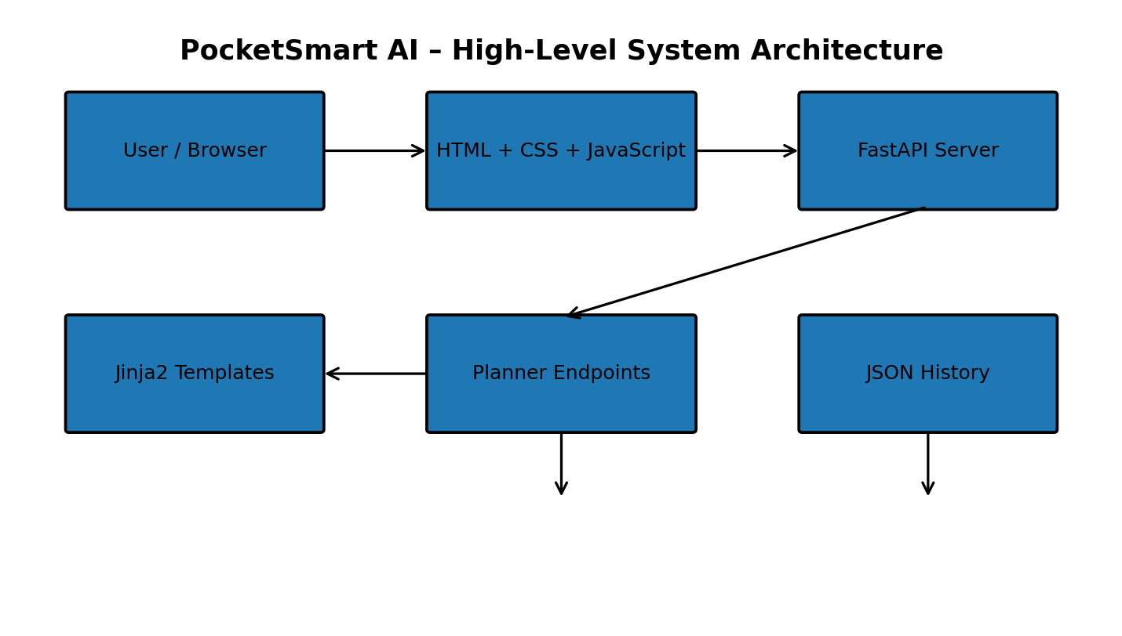
The architecture separates the browser layer from the application server. The user interacts with HTML pages, CSS styling and JavaScript in the browser. Jinja2 templates provide the page structure, while JavaScript can submit requests and update the client-side experience. FastAPI receives requests and executes the corresponding endpoint function. Planner endpoints process the structured inputs and return JSON.
History introduces a persistence layer. The supplied application uses browser localStorage for client-side records and a JSON history file through the backend API. This arrangement is suitable for a local academic demonstration because it avoids the setup required by a full database. For a multi-user production system, the same conceptual storage layer would normally be replaced or extended with authenticated database storage.

9. Architecture Diagram Explanation
The system architecture can be understood as a sequence of responsibilities rather than as one large program. The browser is responsible for collecting information and presenting results. The FastAPI server is responsible for receiving requests, validating form fields and returning structured responses. Jinja2 connects the server-side application to the HTML templates. Static files provide CSS and JavaScript resources.
A useful design property is that the frontend does not need to know the internal Python implementation. It only needs to submit the expected fields and interpret the response. Similarly, the backend does not need to know how the page is visually styled. This separation makes it possible to improve the interface without rewriting the core endpoint logic.
The project therefore demonstrates a basic layered web-application pattern: presentation, request handling, application logic and persistence. Although the current implementation is compact, the same separation can support future improvements such as Pydantic schemas, database repositories, authentication services and an external recommendation provider.

10. Functional Module Architecture
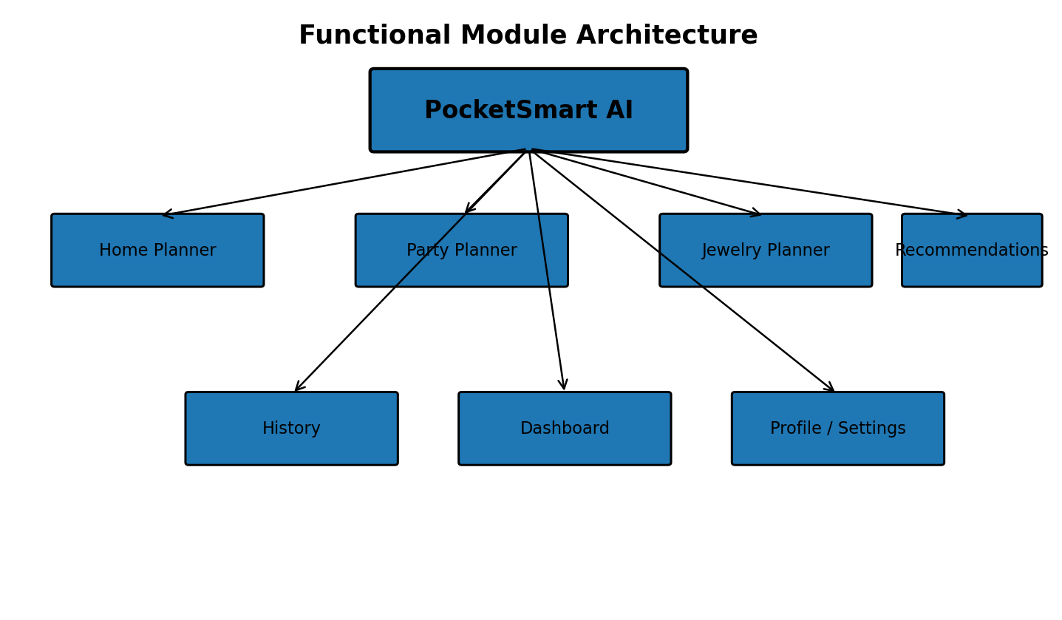
The functional module diagram groups the application into the three core planners and supporting services/pages. Home Planner, Party Planner and Jewelry Planner represent different categories of user requirements. Recommendations provides a presentation area for generated planning information. History and Dashboard support review and summary activities, while Profile and Settings provide account-oriented screens.
The module arrangement is useful during a demonstration because each area has a clear purpose. A presenter can start from the landing page, open the planner hub, select one of the three planners, enter a small set of example values, generate a plan, and then show the related history or dashboard page. This demonstrates navigation, form processing and result presentation without needing to expose every source file.

11. Project Directory Structure
Pocketsmart-ai & Recommention assistant/
├── main.py
├── requirements.txt
├── run_pocketsmart.bat
├── README.md
├── test_app.py
├── data/
│ └── planner_history.json
├── models/
│ └── schemas.py
├── routes/
│ └── planners.py
├── services/
│ └── recommendation_service.py
├── static/
│ ├── css/app.css
│ └── js/app.js
└── templates/
├── index.html
├── planners.html
├── home-planner.html
├── party-planner.html
├── jewelry-planner.html
├── recommendations.html
├── history.html
└── dashboard.html
The directory structure shows the project was organized with future expansion in mind. main.py contains the application entry point and several routes in the supplied implementation. The routes folder provides a natural location for separating planner routes as the application becomes larger. The services folder is suitable for recommendation logic, while models can contain schemas and structured data definitions. The templates and static folders separate browser resources from Python code.
The presence of run_pocketsmart.bat is useful on Windows because it can provide a repeatable way to launch the application. requirements.txt documents dependencies, README.md provides project-level instructions, and test_app.py provides automated test coverage for important pages and API behavior.

12. FastAPI Application Setup
The supplied main.py initializes the FastAPI application, creates the data directory when necessary, mounts the static directory and configures Jinja2 templates. The application title and version are defined during initialization. This is the foundation from which the browser pages and API endpoints are exposed.
from pathlib import Path
from fastapi import FastAPI
from fastapi.staticfiles import StaticFiles
from fastapi.templating import Jinja2Templates
app = FastAPI(title="PocketSmart AI Pro", version="2.0.0")
BASE = Path(__file__).resolve().parent
HISTORY_FILE = BASE / "data" / "planner_history.json"
HISTORY_FILE.parent.mkdir(parents=True, exist_ok=True)
app.mount("/static", StaticFiles(directory=BASE / "static"), name="static")
templates = Jinja2Templates(directory=BASE / "templates")
The important design idea in this code is the use of BASE. Rather than depending on the terminal's current directory, the application resolves paths relative to the location of main.py. This is helpful for static files, templates and local data because the application can locate its resources consistently when launched from the project directory.

13. Page Routing and Template Integration
PocketSmart AI contains a page map that connects URL paths with HTML template files. The application defines routes for the landing page, features, how-it-works information, planners, each planner category, recommendations, history, dashboard, testimonials, about, login, register, profile and settings. This makes the browser experience feel like a complete multi-page product.
PAGES = {
"/": "index.html",
"/features": "features.html",
"/planners": "planners.html",
"/home-planner": "home-planner.html",
"/party-planner": "party-planner.html",
"/jewelry-planner": "jewelry-planner.html",
"/recommendations": "recommendations.html",
"/history": "history.html",
"/dashboard": "dashboard.html",
"/login": "login.html",
"/register": "register.html",
"/profile": "profile.html",
"/settings": "settings.html",
}
The advantage of a page map is consistency. A route can render the correct template without duplicating large amounts of page-selection code. Jinja2 then supplies the template rendering mechanism. The templates remain in their own directory, making it easier for a frontend developer to modify the user interface without searching through Python logic.

14. Home Planner
The Home Planner is designed for users who want to organize a home-related requirement using a budget and several preferences. The supplied endpoint accepts fields such as budget, room, style, style preference, occasion, mood, what the user wants, focus and quality. The budget field is validated with a minimum and maximum range, which helps prevent obviously invalid values from reaching the planning logic.
@app.post("/generate-home")
async def generate_home(
budget: int = Form(..., ge=100, le=10_000_000),
room: str = Form("Living Room"),
style: str = Form("Modern"),
style_preference: str = Form("Contemporary"),
occasion: str = Form("New Home"),
mood: str = Form("Calm"),
what_you_want: str = Form("Complete room"),
focus: str = Form("Furniture"),
quality: str = Form("Value"),
):
return {
"type": "home",
"budget": budget,
"room": room,
"style": style,
"style_preference": style_preference,
"occasion": occasion,
"mood": mood,
"what_you_want": what_you_want,
"focus": focus,
"quality": quality
}
The endpoint illustrates a key project concept: user preferences are captured as named fields rather than as one unstructured text value. This makes the request easier to validate, display and extend. The current endpoint should be described as a lightweight planning/demo implementation rather than as a full external AI service.

15. Party Planner
The Party Planner applies the same general design to event planning. Instead of room and furniture preferences, it focuses on event-related requirements. The user can provide a budget together with event type, guest information and other preference fields. The response is structured so that the frontend can display the submitted planning context and a budget-oriented result.
The benefit of having a dedicated Party Planner is that the interface can present fields that make sense for events rather than forcing every user into a generic form. This improves usability because the user sees terminology related to the actual task. From a software-design perspective, it also demonstrates how the same backend framework can support multiple domain-specific endpoints.
- Collect a party or event budget.
- Collect event and occasion information.
- Capture style, mood, priority and quality preferences.
- Validate numeric budget input on the server.
- Return structured data for browser-side display.
- Allow generated planning information to participate in the application's history experience.
The planner is therefore both a functional module and an example of reuse: the application framework, template approach and request-processing pattern remain consistent while the data fields change to suit the category.

16. Jewelry Planner
The Jewelry Planner provides a category-specific interface for jewelry-related planning. The supplied documentation identifies fields such as budget, occasion, style, mood, look or feel, piece, metal and quality. This gives the user a structured way to describe what they are looking for instead of relying only on a free-text description.
The broader project concept mentions image-aware jewelry ideas and external commerce/service integrations, but the current runnable starter implementation should be presented carefully. The supplied planner endpoints are lightweight local implementations. A future version could connect the structured inputs to a recommendation service, product catalogue or image-analysis model, but those integrations should not be described as already active unless they are actually connected in the deployed project.
Input Category | Example Purpose
Budget | Defines spending range.
Occasion | Connects the request to a use case.
Style | Describes preferred appearance.
Mood / Look | Adds aesthetic context.
Piece | Specifies the jewelry type.
Metal | Narrows material preference.
Quality | Captures value/quality preference.

17. Recommendations and Budget Handling
Recommendations are a supporting concept across the planner modules. The backend receives structured inputs and returns data that can be presented as an organized plan. The project documentation describes budget breakdown behavior, meaning the response can be interpreted as categories or planning components within the available budget. This gives the user a more useful result than simply echoing the form submission.
The important distinction is between the interface concept and the current implementation depth. The project is structured to support recommendation services, and a recommendation_service.py file is present in the project organization. However, the current planner endpoints are lightweight. For an academic report, it is accurate to explain the recommendation layer as the project's planning/recommendation interface and extension point rather than claiming an external generative-AI model is running inside every request.
- Budget is treated as a central planning input.
- Category-specific preferences are retained in the response.
- Results can be displayed in a structured format.
- History can preserve generated planning records.
- The service layer can be expanded later for more advanced recommendation logic.

18. History and Persistence
PocketSmart AI uses two related persistence approaches in the supplied project: browser-side localStorage and a JSON history file accessed through the backend. Browser storage is convenient for keeping information available to the same browser session/profile, while the JSON file demonstrates server-side persistence without requiring a database server.
The history feature is important because planning is often iterative. A user may generate one plan, adjust preferences, generate another, and then compare the records. The History page provides a dedicated location for reviewing those saved items. In a production multi-user system, the history records would need to be associated with authenticated user identities and protected from access by other users.
The current local JSON approach is therefore best understood as a simple academic persistence mechanism. A future database version could use tables for users, plans, preferences and generated recommendations, with proper authentication and authorization. The existing data directory provides a clear place for the current local implementation.

19. Frontend JavaScript
The static JavaScript layer is responsible for client-side interactions. It can manage navigation behavior, form submission, local storage and requests to backend endpoints. This allows the application to respond to user actions without placing every interaction inside server-rendered HTML.
// Simplified representation of the client-side request pattern
const response = await fetch("/generate-home", {
method: "POST",
body: new FormData(form)
});
const data = await response.json();
renderPlan(data);
The exact implementation in the supplied application contains more interface behavior, but the important concept is the browser-to-server request cycle. Form values are packaged, sent to a FastAPI endpoint, converted to JSON on the response, and then rendered in the browser. This is a common pattern for interactive web applications.
The JavaScript layer also supports history-related behavior. The project documentation identifies localStorage and API-backed history as part of the persistence experience. This gives the frontend a way to retain and display planning information while the backend provides a server-side JSON record mechanism.

20. Planner Input Design
Planner forms are designed around structured inputs because structured information is easier to validate and process than a single large text box. A budget can be treated as a number, while room, style, occasion, mood and quality can be treated as selectable or textual values. This allows the backend to apply appropriate validation rules to different fields.
Field Type | Example | Why It Matters
Numeric | Budget | Supports range validation.
Category | Room / Piece | Identifies planning context.
Preference | Style / Mood | Personalizes the plan.
Occasion | New Home / Event | Adds contextual meaning.
Quality | Value / Premium | Represents user expectation.
Focus | Furniture / Main item | Identifies priority area.
A good planner form also reduces cognitive load by presenting only the fields relevant to the selected category. The Home Planner should feel like a home-planning form, while the Party Planner should feel like an event form. This category-specific design is one of the main usability characteristics of PocketSmart AI.

21. Illustrative Project UI
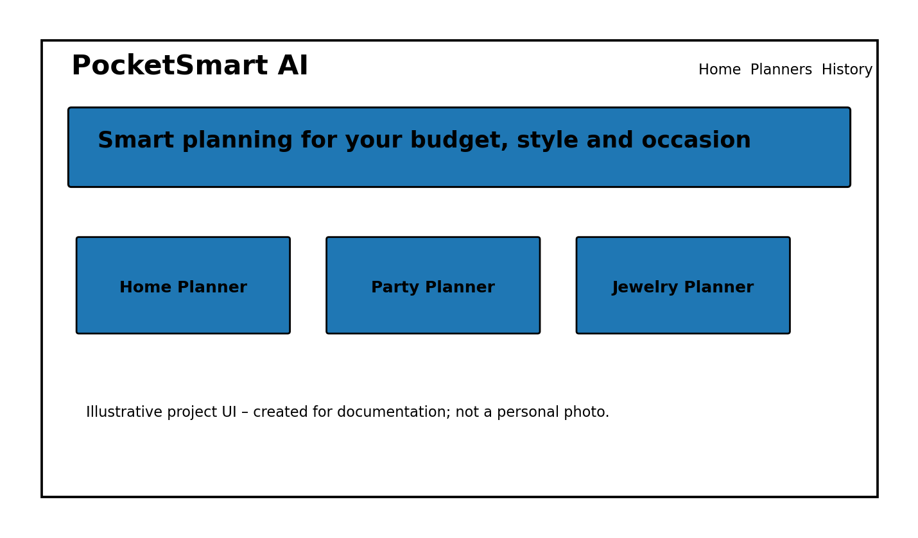
The image above is an illustrative project-style interface created specifically for this documentation. It is not a photograph of the user and does not contain a personal image. It shows the type of navigation and planner-card presentation used to explain the project's multi-module design.
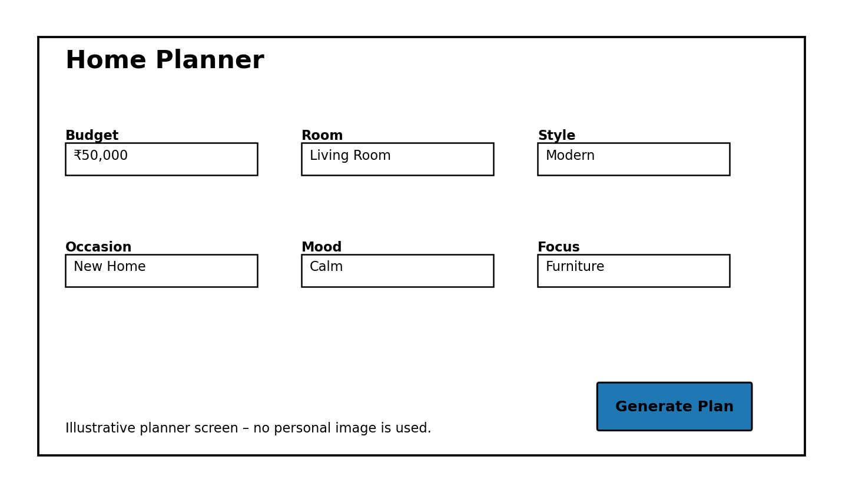
The second image illustrates a Home Planner form with representative fields. It is included to make the documentation easier to understand visually. Actual labels and styling may vary with the supplied HTML/CSS files; the project itself remains the source of truth for the exact running interface.

22. Dashboard and Account Pages
The Dashboard provides a summary-oriented view of the application. It can show account-related information and plan counts, giving the user a central place to understand their activity. The Profile and Settings pages provide the interface structure required for account-oriented functionality, while Login and Register pages provide the navigation surface for authentication concepts.
The supplied documentation notes that the current local demo account behavior is client-side and should not be presented as a secure production identity system. A real multi-user deployment would require server-side authentication, password hashing, session or token management, access control and user-specific history queries.
- Dashboard – summary of user/planning activity.
- Profile – user-facing account information.
- Settings – preferences and application configuration UI.
- Login – entry point for account access.
- Register – entry point for creating an account.
- History – review of previous planning records.
These pages demonstrate how a project can provide a complete product-style interface even while some account functionality remains suitable for demonstration rather than production use.

23. Testing Structure
The project includes test_app.py for automated checks. Testing is important because a multi-page web application can fail in several different places: the server may not start, a page route may be incorrect, a form field may not validate, a template may be missing, or an API may return an unexpected structure. Automated tests provide a repeatable way to check the most important behavior.
Test Area | Example Check
Application startup | FastAPI app can be imported.
Page routes | Important GET pages return expected status.
Home planner | POST request accepts valid budget and fields.
Validation | Invalid budget values are rejected.
History | History endpoint behaves as expected.
Navigation | Important application pages remain reachable.
Testing should be performed after dependency installation and whenever route or template files are changed. During a college demonstration, it is useful to explain that automated tests complement manual browser testing: the tests verify backend behavior, while the browser demonstration verifies the visible user experience.

24. Selected Testing Code
from fastapi.testclient import TestClient
from main import app
client = TestClient(app)
def test_home_page():
response = client.get("/")
assert response.status_code == 200
def test_home_planner():
response = client.post(
"/generate-home",
data={"budget": 50000, "room": "Living Room"}
)
assert response.status_code == 200
The example above demonstrates the basic testing pattern used with FastAPI's test client: create a client from the application, send a request, and assert the expected result. More tests can be added for the other planner endpoints, validation boundaries, history operations and page routes.
Testing also helps with the Windows launch process. The project previously showed that running the Python file directly does not automatically start Uvicorn because main.py defines the FastAPI application. The correct development approach is to run Uvicorn against the app from the project directory, for example: `py -m uvicorn main:app --reload`. Running the command from the wrong directory can produce an import error because Python cannot locate main.py.

25. Project Management – Initiation Phase
The Initiation Phase establishes the project identity, scope and stakeholders. The PocketSmart AI project is defined as a personalized planning and recommendation assistant that provides interactive planning features for home decoration, parties and jewelry selection. Users provide budget, preferences, style, occasion and other requirements, and the system organizes these inputs into planning information.
The project charter identifies the project team, project guide or supervisor, end users, project evaluators and system administrator as important stakeholders. The scope includes the web interface, backend APIs, recommendation-oriented functionality, budget-based planning and history management. The project proposal describes the value of providing one place where users can enter requirements and receive structured planning assistance.
Requirement Type | Requirement
Functional | Access through a browser.
Functional | Select a planning module.
Functional | Enter budget and preferences.
Functional | Submit details for processing.
Functional | Receive a planning response.
Functional | Access history/recommendation pages.
Non-functional | Simple and responsive interface.
Non-functional | Maintainable project structure.
Non-functional | Reliable backend processing.

26. Planning and Risk Management
The Planning Phase divides the project into manageable work packages. The supplied project-management documentation identifies project initiation, requirement analysis, UI development, backend development, testing, documentation and finalization as major work areas. This structure allows the team to track progress without treating the entire application as one task.
Risk | Possible Impact | Mitigation
Python configuration | Application may not start | Verify Python and environment.
Missing dependencies | Backend errors | Install requirements.
Wrong route configuration | Pages may not open | Test routes individually.
Invalid input | Incorrect output | Use server-side validation.
Template errors | Web page failure | Check Jinja2 templates.
Data storage error | History not saved | Validate file operations.
Time limitations | Incomplete features | Prioritize core modules.
Browser differences | UI variation | Test supported browsers.
The risk log is especially useful for this project because setup errors can look like application errors. For example, the project previously encountered a Python command typo, a missing app.py file, and an ASGI import error caused by launching Uvicorn from the parent directory. Recording these as environment/startup risks helps the team diagnose them systematically.

27. Execution and Progress Tracking
During execution, development decisions and progress should be recorded so that the team can explain how the project evolved. Important decisions for PocketSmart AI include using Python and FastAPI for backend development, using HTML/CSS/JavaScript for the interface, creating separate planner modules, using budget and preferences as major inputs, maintaining local history through JSON, and keeping the project organized into templates, static resources, routes, services, models and data.
Activity | Typical Status | Evidence
Project setup | Completed | Folder structure and requirements.
UI development | Completed / iterative | Templates and static assets.
FastAPI setup | Completed | main.py and Uvicorn launch.
Home Planner | Completed | Planner endpoint and page.
Other planners | Integrated | Party and Jewelry modules.
Testing | Iterative | test_app.py and manual checks.
Documentation | Iterative | Project report and diagrams.
Meeting minutes can record the project review purpose, discussion points, decisions and action items. Typical action items include completing planner pages, testing backend routes, checking navigation, preparing screenshots, completing documentation and preparing the demonstration video. This creates an audit trail that can be useful during academic evaluation.

28. Monitoring and Control
Monitoring and Control ensures that the project remains aligned with its planned scope. A status report can identify what is completed, what is in progress, current issues and the next activities. For PocketSmart AI, completed areas include the project structure, main web interface, FastAPI backend, the three planners, recommendation-oriented pages, history, dashboard and supporting account pages. Final testing, documentation and demonstration preparation are activities that can continue until submission.
Document ownership is also important. A project should have one responsible owner for each major record so that conflicting versions are avoided. For example, the project documentation can have one documentation owner, the risk log can have one project-management owner, and the source code should have a designated technical owner or team responsibility.
- Review route behavior after backend changes.
- Review templates after UI changes.
- Update the risk log when a new technical issue appears.
- Keep the project-management schedule consistent with actual progress.
- Maintain one current version of the final documentation.
- Before demonstration, verify startup command, browser URL and core planner forms.

29. Conclusion, Maintenance and Demonstration
PocketSmart AI is a compact full-stack planning application that combines a FastAPI backend, Jinja2 templates, HTML/CSS/JavaScript, structured planner forms and simple history persistence. Its most visible value is the ability to collect a user's planning context in a guided interface and return organized information for home, party and jewelry planning. The modular page structure also makes the project easy to demonstrate and explain.
For maintenance, the planner endpoints can eventually be moved from main.py into routes/planners.py, stronger Pydantic request and response models can be introduced, JSON persistence can be replaced with a database, and a real recommendation provider can be connected through the services layer. Production security would also require real authentication, authorization, HTTPS, protected secrets, input sanitization and user-specific history access.
For a demonstration, a clear sequence is: show the project tree in VS Code, open main.py briefly, start the application with Uvicorn, open the local web page in Chrome, show the planner selection, complete one Home Planner request, generate the plan, open History or Dashboard, and then return to the relevant backend code. This sequence connects the visible result to the implementation and fits a short academic demo.
The project should be described honestly as a working FastAPI/Jinja2 planning application with lightweight local planner endpoints. The broader AI/recommendation concept provides a foundation for future enhancement, but external AI or commerce integrations should only be claimed when they are actually connected and working in the submitted build.

30. References and Submission Notes
The documentation was prepared from the supplied PocketSmart AI project documentation and project-management records. The project materials identify FastAPI, Uvicorn, Jinja2, HTML/CSS, JavaScript and JSON as the principal technologies. The supplied implementation includes main.py, templates, static resources, data storage, tests, requirements and a Windows batch launcher.
Source / Artifact | Use in this Documentation
main.py | Backend initialization, routes and planner endpoint explanation.
templates/ | Page and user-interface structure.
static/ | CSS and JavaScript responsibilities.
data/ | History persistence concept.
test_app.py | Testing structure and selected test pattern.
requirements.txt | Technology and dependency list.
run_pocketsmart.bat | Windows launch support.
README.md | Project description and running guidance.
Project management document | Initiation, planning, execution and monitoring content.
Submission note: the diagrams and interface illustrations in this document are original documentation graphics created for explanation. They do not contain the user's personal photograph or identity. Where exact running UI evidence is required, screenshots from the actual submitted application can be inserted in place of the illustrative images.
End of detailed 30-page PocketSmart AI project documentation.

