

## **Embedded System Design Internship Program**

**Batch - VIT - ESDI Home Automation Jan'25**

**Report On**

**Home Automation**

**Bachelor of Technology**

**In**

**Electronics and Communication Engineering**

**(AI and cybernetic)**

**Submitted by: -**

**Priya Verma**

**(22BAC10024)**

**Table of Contents**

|  |  |  |
| --- | --- | --- |
| **S.No.** | **Content** | **Page No.** |
| **1** | **Student information** | **3** |
| **2** | **Introduction** | **4** |
| **3** | **Project Specifications** | **5** |
| **3.1** | **Function Requirements** | **5-8** |
| **3.2** | **Non-Function Requirements** | **9-10** |
| **4** | **Hardware Architecture** | **11** |
| **4.1** | **List of Hardware components used** | **11-12** |
| **5** | **Software Architecture** | **13** |
| **6** | **Code** | **14-16** |
| **7** | **Testing and Results** | **17-20** |
| **8** | **Future Work** | **21** |

**Student Information**

|  |  |
| --- | --- |
| **Student Name** | **Priya Verma** |
| **University Name** | VIT Bhopal University |
| **University Serial Number (USN):** | 22BAC10024 |
| **University Location** | Kothrikalan, Sehore, Madhya Pradesh - 466114 |
| **Course Name** | Embedded System Design Internship Program |
| **Project Title** | Home Automation System |
| **Submission Date** | 22 March 2025 |

**Introduction**

Home automation using embedded systems is a crucial innovation in modern smart living, combining IoT, sensors, microcontrollers, and actuators to automate and optimize household appliances. This technology enhances convenience, security, energy efficiency, and overall home management by allowing users to remotely control and monitor their devices through mobile apps, voice assistants like Alexa and Google Assistant, or even AI-based automation. One of the most important applications is **smart energy management**, where automation reduces power wastage by switching off unused appliances and optimizing electricity consumption, leading to cost savings and sustainability. Additionally, **home security** is significantly improved by integrating motion sensors, smart locks, and surveillance cameras that provide real-time monitoring and instant alerts in case of unauthorized access. This ensures enhanced protection and peace of mind for homeowners. Furthermore, home automation systems offer **adaptive control of lighting, temperature, and ventilation**, making the living environment more comfortable and efficient. Advanced AI and machine learning algorithms further enhance the system by analyzing user behavior and predicting usage patterns, enabling seamless automation without manual intervention. Another key benefit is its **scalability and flexibility**, as new devices and features can be easily integrated to expand the automation ecosystem. This project is highly relevant today, as it aligns with the global shift towards **smart cities, sustainable living, and energy-efficient solutions**, making homes more intelligent, cost-effective, and secure.

**Furthermore,** home **automation** automation plays a **key** role in **supporting** **older** **people** and **different** **people** by **controlling** **essential** **devices** **and** enabling **them** **to** **improve** accessibility and independence. It also supports **automation** **of** **climate** **control** **and** **ensures** optimal **internal** conditions by **adjusting** heating, **cooling** and ventilation **in** **real** **time** based on environmental data. With the **increasing** **integration** of **renewable** **energy,** **Smart** **Home** **Systems** can **efficiently** manage power **distribution,** **which** **allows** solar energy and battery storage **to** **be** **used** for sustainable living.

**Project Specifications**

**3.1 Function Requirements**

Functional specifications of a home automation system establish the essential functionalities and features that the system must deliver. These specifications enable the system to effectively satisfy its intended objective of automation and control of home appliances by promoting unhampered integration, real-time response, and user-friendliness. Remote access via a mobile application or web page is a feature that the system ought to support, allowing users to command appliances remotely. It should have sensor-based automation, which executes automated responses like switching on the lights, varying the speed of fans, or switching on security alarms, upon detecting temperature, motion, or light sensors. It should also support multi-user and role-based access control so that varying levels of authority can be provided to administrators, family members, and visitors.

AI-powered automation and learning should make the system learn from the users, modifying its energy usage patterns by switching off appliances that are not used. Voice and motion control integration with Google Assistant, Amazon Alexa, or Siri should offer hands-free functionality. Multi-protocol communication should be supported by the system to ensure compatibility with Wi-Fi, Bluetooth, Zigbee, Z-Wave, and MQTT to enable hassle-free device connection. For added reliability, the system must have failsafe features, including manual override capabilities and power failure recovery, to ensure operation during network outages. Real-time monitoring and alerts must notify users of security intrusions, device failure, or suspicious activity. The functional requirements as a whole seek to develop an intelligent, adaptive, and user-friendly home automation system that is efficient, secure, and convenient.

* **Remote Access and Control:**

The system needs to be controlled using mobile apps, web ports, or voice assistants such as Google Assistant, Alexa, and Siri by the users. It must have the capability of real-time remote monitoring so the users can see and control appliances from anywhere. Integration of the smart schedule provides self-control of devices based on pre-programmed timers or environmental factors, maximizing energy efficiency.

Also, the system should be designed to offer multi-user access with role-based permissions, letting administrators have full control while limiting guest access. AI-based automation can offer a better user experience by learning daily patterns and adapting devices to suit them, i.e., turning off the lights in the evening or changing the thermostat according to the occupancy. The presence of fail-safe options such as manual override and power failure recovery maintains the reliability and continuous operation of the system.

* **Device Automation and Scheduling:**

Users must be able to schedule appliance operation using time, motion detection, or environmental factors, like turning lights on at sunset or varying fan speed according to room temperature. The system must incorporate multiple sensors, like temperature, motion, humidity, and light sensors, to control devices automatically according to pre-programmed rules. For instance, motion sensors can turn on lights in a room upon detection of movement, and humidity sensors can turn on exhaust fans when there is excessive moisture. This smart automation adds convenience, maximizes energy efficiency, and minimizes manual intervention, making the home smarter and more responsive to user requirements.

* **Real-Time Monitoring and Alerts:**

The system should display real-time status information on environmental conditions, energy usage, and security notifications of the connected devices. Users should be able to view temperature, humidity, and motion detection information through a mobile application or web portal. The system should also offer detailed energy usage insights to enable users to optimize power usage and save electricity bills. Also, real-time security alerts, like attempts at unauthorized access or suspicious behavior, must be triggered through push notifications, SMS, or email. This makes the users aware and able to take prompt action when needed, providing convenience as well as safety in a smart home setting.

* **Energy Management and Optimization:**

The system needs to monitor and record the power consumption of all devices connected to it, so users can observe real-time power usage and locate high-power-consumption devices. It should keep historical data to analyze the trend of power consumption over a period of time, so users can make well-informed decisions regarding energy efficiency. In addition, the system must have smart suggestions to avoid wastage of energy, e.g., making recommendations for the best use schedules, identifying idle devices, and setting up automation based on usage habits. With these features, the system improves energy management, saves on electricity bills, and encourages green living.

* **Security and Safety Features:**

The system must include integrated intelligent locking, surveillance cameras, motion detectors, and alarm systems for improving home security. Smart locks must offer remote access control, with users able to lock and unlock doors remotely through a mobile app. Surveillance cameras with real-time streaming and motion detection must provide instant alerts upon detection of suspicious activity. Alarm systems must also issue automatic notifications and emergency responses during security incursions.

To enhance safety further, biometric authentication like fingerprint scanning or facial recognition should be used for key access points. This guarantees that only authorized personnel can access certain areas, providing an added layer of security. By integrating these advanced security features, the home automation system provides a safer and more secure living space.

* **Multi-User and Role-Based Access:**

The system should accommodate several users with varying levels of access to provide both security and ease of use. It should be able to support role-based access control, where every user is assigned permissions according to their requirements and roles.

The **Administrator Role** will control everything, including all smart devices, users, security settings, and automation rules. Administrators are able to add or delete users, define permissions, and adjust system-wide settings for seamless performance.For added security, **limited access for children** must be applied, so they cannot use essential devices like gas appliances, security systems, and sophisticated settings that may be hazardous. Guest users must be granted limited access so they can control simple functions like lighting or entertainment systems without jeopardizing home security.This multi-user management feature provides assurance that the home automation system is secure, yet delivers a smooth and personalized experience for all users.

* **AI-Based Automation and Learning:**

Artificial intelligence (AI) and machine learning (ML) play a key role in improving home automation by adapting to user behavior and optimizing system performance. Predictive Automation Enables analysis of usage patterns and auto-tune devices for maximum efficiency. Additionally, Energy Efficiency Optimization allows KI to monitor current consumption in real time, compare it with historical data, and propose energy-saving strategies to minimize waste. Intelligent decisions--By integrating the making algorithm, the system can actively adjust settings, simultaneously reducing electricity costs and improving general convenience to create a more comfortable, efficient and sustainable living environment.

* **Voice and Gesture Control:**

To create a truly intelligent and seamless user experience, home automation systems need to integrate both voice and gesture-based control functions. Advanced Voice Control enables hand-free input and allows users to control the device with simple voice commands by integrating with Amazon Alexa, Google Assistant and Apple Siri. Furthermore, gesture recognition improves accessibility by using cameras or motion sensors to interpret device-controlled hand movements. For example, the user can wave to turn the lights on or off. This combination of natural language processing (NLP) and computer vision not only improve user friendliness, but also makes it more intuitive, efficient and accessible, especially for people with disabilities and mobility restrictions.

**3.2 Non-Functional Requirements**

Home Automation System Functional Requirements Focused on ensuring a high performance, reliability, security, scalability and an intuitive user experience. The system must operate with minimum latency. This allows actual control of the device to handle multiple devices simultaneously. Reliability is extremely important and requires 99.9% of the time with fault prevention mechanisms such as offline mode, local device control, and safety power supply to avoid failures. Security comes with top priority with end-to-end encryption (AES256, TLS/SSL), multifactor authentication, and biometric checks, ensuring user data protection and preventing unauthorized access. The system must be scalable and flexible, supporting a variety of communication protocols

* **Reliability and Uptime**:

The system should provide a 99.9% uptime, with multiple concurrent requests handled without performance degradation. Devices must respond to commands with minimal delay, providing a response time of under one second for smooth operation. Scalability The design must be created in such a manner that it accommodates more devices without performance degrading, providing seamless scalability. It must be able to scale effectively room-wise, floor-wise, or even across different premises. A modular and flexible design will enable the simple incorporation of new smart devices and technologies without changing the structural layout extensively, thus providing long-term flexibility. Security and Privacy

* **Low Latency and High Performance:**

Commands must have a response time of milliseconds to provide an effortless user experience. Effective utilization of edge computing to locally process data and decrease dependence on cloud servers.

* **Power Efficiency**

Power consumption optimization is necessary to provide assurance that devices connected are not unnecessarily draining large amounts of power, driving overall sustainability. The system must include smart power management features that allow devices to go into low-power states when idle. Energy-efficient hardware and software optimizations must be used to extend battery life, lower electricity bills, and drive environmentally friendly smart home solutions.

* **Regulatory and Compliance Standards**

The system shall be in accordance with internationally accepted standards, such as IEEE, ISO, and IoT security standards, to provide secure and trustworthy operation. Electrical parts shall be regulatory safe when complying with standards like UL, CE, and RoHS certifications. Conforming to these industrial standards will improve product validity, guaranteeing it achieves legal and operational standards for smart home solutions.

* **Disaster Recovery and Backup**

An effective disaster recovery system should be implemented for the storage of important system settings in the cloud so that it can recover automatically upon hardware or software failure. The system also needs to be capable of offline modes so that it maintains primary functionality even without an internet connection. Such redundancy will make the system more resilient, allowing it to keep running under different conditions without affecting the user experience.

**Hardware Architecture**

The hardware architecture of the home automation system consists of an embedded controller, communication modules, sensors, actuators, and power management systems. The NodeMCU (ESP8266/ESP32) is selected as the central microcontroller due to its Wi-Fi capabilities, low power consumption, and ease of integration with IoT platforms.

**4.1 List of hardware components used**

|  |  |  |  |  |
| --- | --- | --- | --- | --- |
| **Component Name** | **Description** | **Specification** | **Functionaliy in Project** | **Hardware Overview** |
| ESP32 Development Board | Microcontroller with built-in Wi-Fi & Bluetooth | 240MHz Dual-Core, 520KB SRAM, Wi-Fi, BLE | Controls all sensors, actuators, and automation logic |  |
| DHT11 Temperature & Humidity Sensor | Measures temperature and humidity | Temperature range: 0-50°C, Humidity range: 20-90% RH | Used to automate fan and air circulation based on environmental conditions |  |
| Ultrasonic Sensor (HC-SR04) | Measures distance for object detection | Range: 2cm - 400cm, Accuracy: ±3mm | Used for motion-based automation like smart door unlocking |  |
| LDR (Light Dependent Resistor) | Detects ambient light intensity | Resistance: 1MΩ (dark), 10kΩ (bright) | Enables automatic light control based on surrounding brightness |  |
| LED (Light Emitting Diode) | indicator lights for system status | Voltage: 2V - 3.3V, Current: 20mA | Used to indicate power, automation status, and security alerts |  |
| Fan (DC or AC Controlled via Relay) | Cooling system or ventilation automation | DC: 5V/12V, AC: 220V | Automatically controlled based on temperature and user commands |  |
| Resistors (1kΩ, 10kΩ, etc.) | Used for circuit protection and signal conditioning | Various values (1kΩ, 10kΩ, 4.7kΩ) | Pull-up/pull-down resistors for stable sensor readings |  |
| Jumper Wires (Male-Male, Male-Female, Female-Female) | Connects components on breadboard/PCB | Various lengths (10cm - 20cm) | Ensures flexible connections between ESP32, sensors, and actuators |  |
| Breadboard/PCB | Prototyping platform for circuit assembly | Standard size 830 holes | Temporary circuit setup for testing and debugging before PCB implementation |  |

**Software Architecture**

The software architecture of the home automation system follows a modular architecture, which ensures scalability, efficiency, and simplicity in maintenance. The project is coded using Arduino IDE with C/C++ programming for ESP32, splitting the system into functional blocks including sensor data acquisition, decision-making, device control, user interaction, cloud communication, and security measures.

The module for system initialization is in charge of initializing the ESP32 microcontroller, setting GPIO pins, establishing a connection to Wi-Fi, and initializing actuators and sensors. The module for data acquisition from sensors acquires real-time values from several sensors, such as temperature and humidity from the DHT11, light intensity from the LDR, and motion detection from the ultrasonic sensor. These readings are then processed in the data processing and decision-making module, which employs automation logic. As an example, if the temperature increases to 30°C, the fan will turn on, and when the light intensity falls below a certain value, lights turn on. The device control module facilitates hassle-free functioning of appliances in the home using relay modules to turn devices like fans, lights, and security locks on and off.

User control is provided by means of mobile apps, web portals, or voice controllers such as Google Assistant and Alexa, permitting remote operation of devices. IoT cloud communication using Firebase or MQTT is also supported in the system to facilitate real-time monitoring and remote access. Furthermore, safety measures like manual override, secure transmission of data, and authentication validation are adopted for improving reliability and safety. The software design is optimized to provide real-time responsiveness, security, and low power consumption. The system is based on Wi-Fi communication between the ESP32, sensors, and cloud servers. Fail-safe features like network connectivity checks and power failure recoveries make sure that the system continues to run even in network failure situations. The modular programming design facilitates effortless debugging, upgradation, and future expansion. Through the use of IoT connectivity, cloud integration, and automation logic, the software architecture effectively develops a smart, responsive, and intelligent home automation system. AI-based predictive automation.

**Code**

ESP32 home automation is a sophisticated IoT-based solution for remotely controlling and automating household devices like lights, fans, ACs, and security systems. ESP32 microcontroller acts as the primary control module and incorporates sensors, actuators, and cloud-based services to manage automation. Inbuilt Wi-Fi and Bluetooth of ESP32 enable real-time connectivity between devices and users through mobile apps, web interfaces, or voice assistants like Google Assistant and Alexa.

It works by gathering real-time information from sensors like DHT11 for room temperature and humidity control, LDR for room illumination, and PIR motion detectors for security. According to the information gathered, ESP32 processes automation rules and invokes activities, like lights turning on when motion is sensed or fan speed control based on room temperature. In addition, relay modules drive electrical devices, facilitating remote control and scheduled automation. The system features MQTT communication protocol to provide lightweight and efficient data transfer between cloud servers and IoT devices. One of the major benefits of this system is its capability to provide enhanced security with intelligent locking systems, surveillance cameras, and biometric access for controlled access. Real-time notifications are provided to users in the event of security intrusions, unauthorized access attempts, or unusual energy usage. AI-based learning further enhances automation by monitoring user habits and optimizing energy consumption. The incorporation of fail-safe features like power failure recovery and manual overrides guarantees reliability and continuous operation.

In general, the ESP32-based home automation system provides a smart, efficient, and secure solution for homes today. It not only provides convenience through remote control but also energy efficiency and safety through automation and real-time monitoring. Potential future improvements would be AI-based predictive automation, additional protocol support for Zigbee and LoRa, and further integration with smart home ecosystems to offer an even more intelligent and adaptive living space.

**Code Implementation Snapshot:**

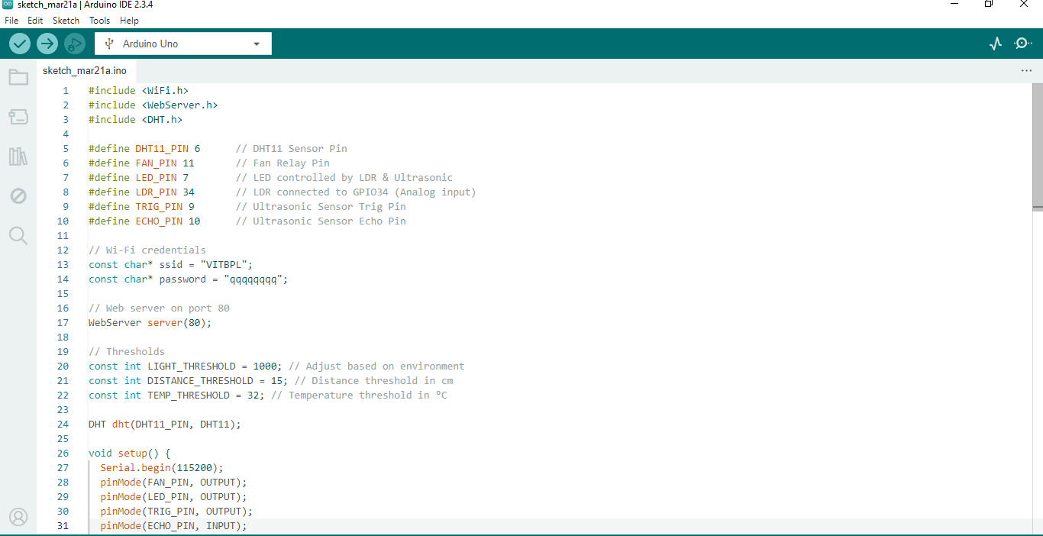

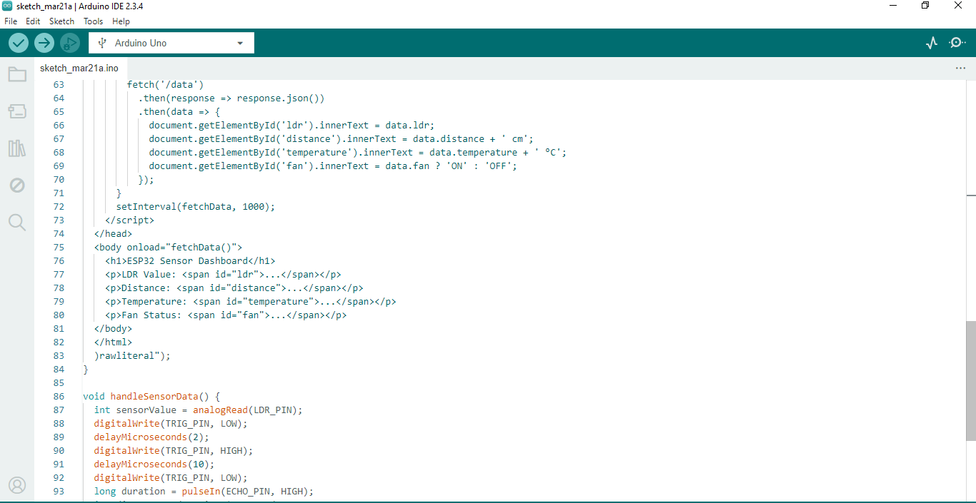

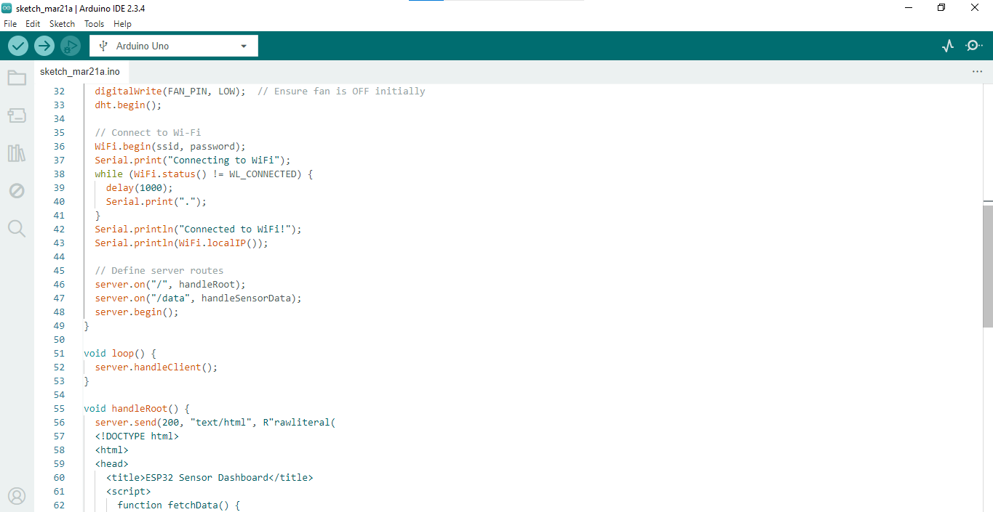

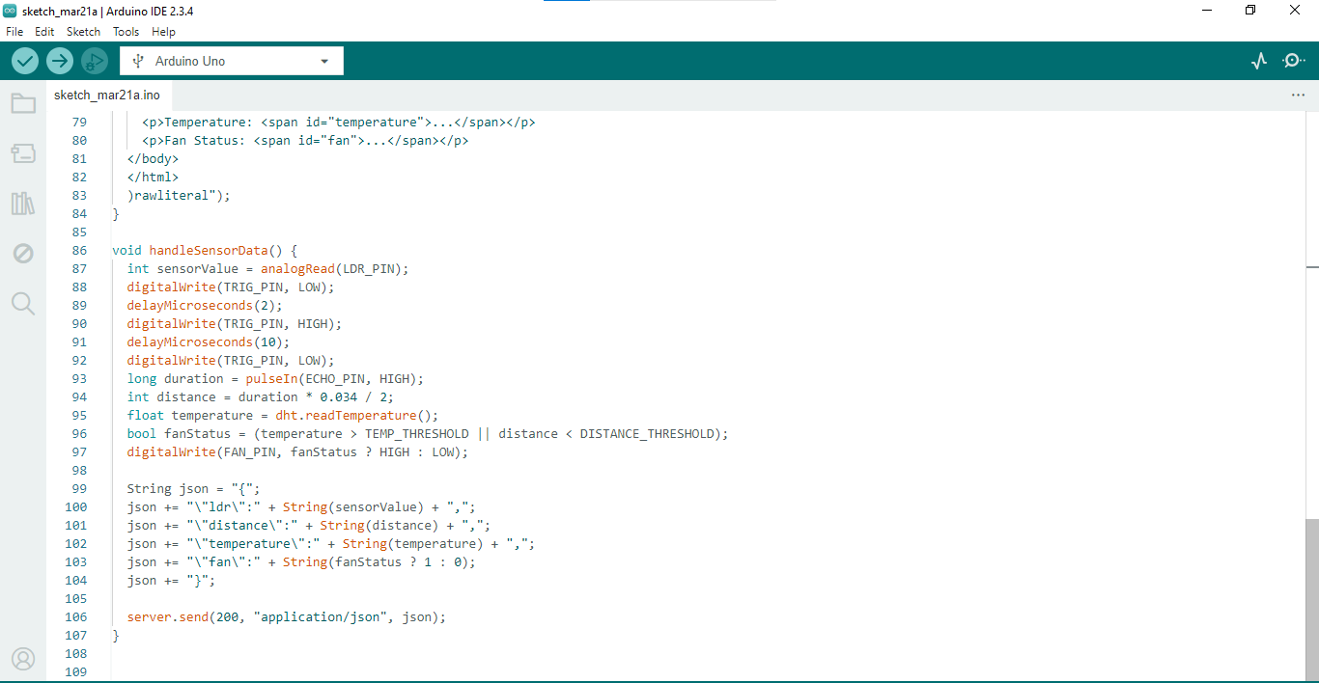

**Testing and results**

Once the code was successfully downloaded to the ESP32 microcontroller, rigorous testing was performed to assess the performance and efficiency of the home automation system. Testing included verification of sensor response, device control precision, communication reliability, and security measures to facilitate smooth operation. Every component was tested in a methodical fashion in various conditions to confirm its reliability and efficacy.

The **sensor validation** procedure involved real-time temperature, humidity, motion, and ambient light level monitoring to guarantee correct readings. The DHT11 sensor was validated against a calibrated thermometer for temperature correctness, and the LDR sensor was tested with different light intensities to verify correct operation. The motion detection feature of the ultrasonic sensor was evaluated through response time and distance accuracy measurements.

For **accuracy of device control**, devices like lights, fans, and security locks were controlled by multiple input sources, including mobile apps, web interfaces, and voice commands using Google Assistant and Alexa. The switching mechanism of the relay module was tested for responsiveness to ensure that devices turned on and off as desired without any perceptible delay.

The **stability of communication** was tested by checking the system's Wi-Fi connectivity, MQTT messaging, and cloud integration. The system's responsiveness in keeping real-time data synchronization going and in performing remote commands was checked under various network states. The testing was done by emulating weak internet signals and network cuts to check if the system could recover and run smoothly with low latency.

Security functionality was tested through mimicry of **unauthorized attempts** of access and system responses. The biometric login module, when introduced, was validated for authenticity of fingerprint or face scanning. The motion detectors were validated for enabling security alarm triggering and real-time notifications. The **fail-safe mechanisms** were tested through device manual overrides and power failure restore to determine if appliances came back to the previously saved state when reset.

The findings verified that the **home automation system worked effectively**, with **improved response times, precise sensor values, and stable communication**. The automation driven by AI efficiently adjusted to user habits, enhancing energy efficiency and user convenience. The security mechanisms successfully protected the system from illegal access.

Looking ahead, future enhancements would be **scaling up AI-based automation, adding more smart home standards such as Zigbee or LoRa, and reducing energy consumption with predictive analytics**. This will continue to make the system more intelligent, secure, and user-friendly.

**Final Project Demonstration:**

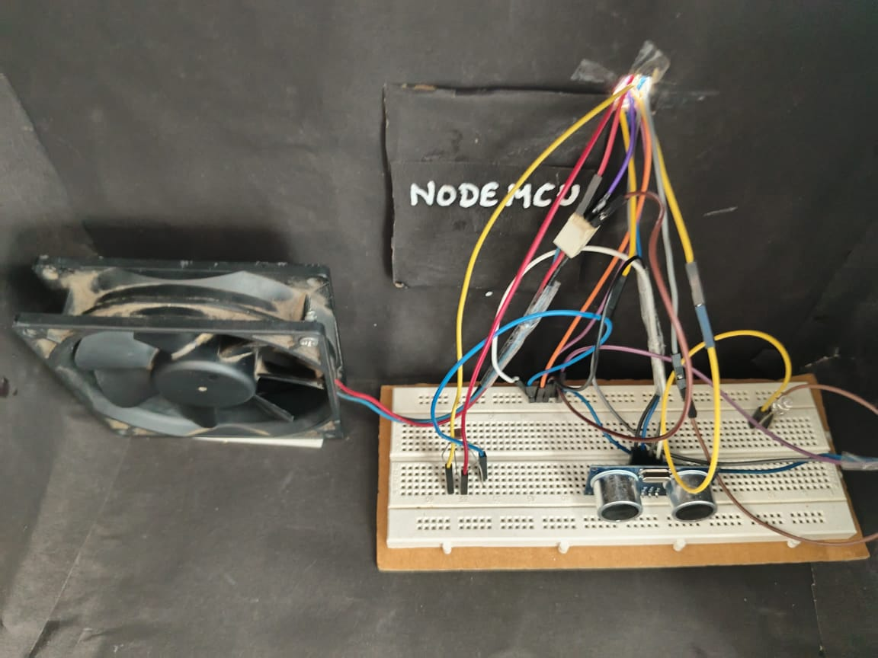

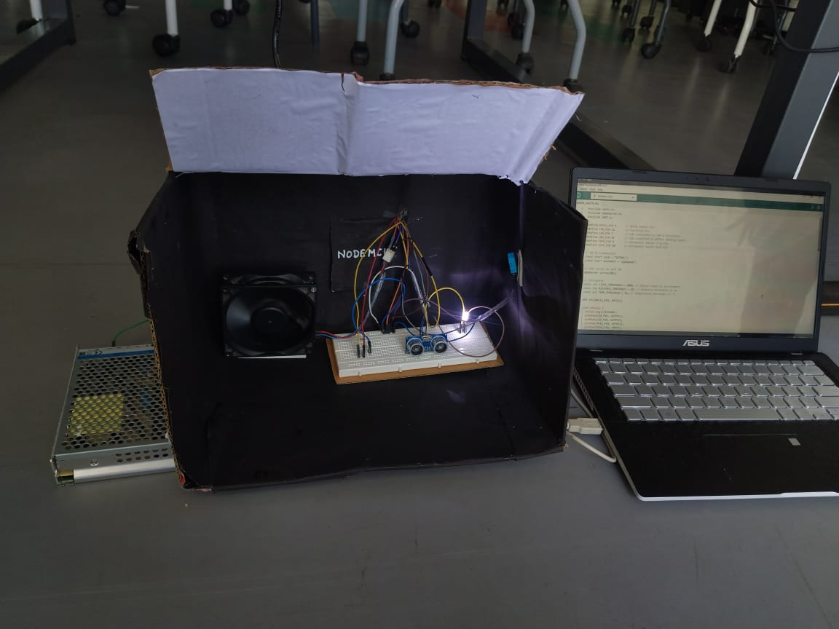

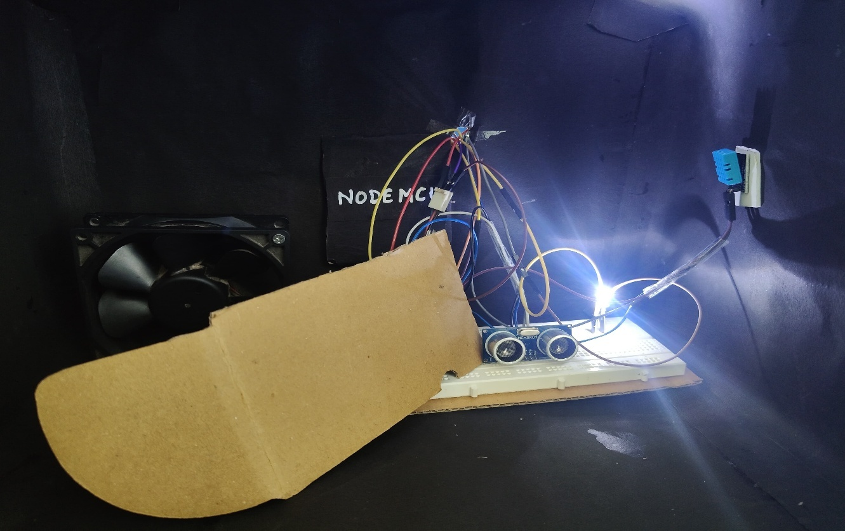

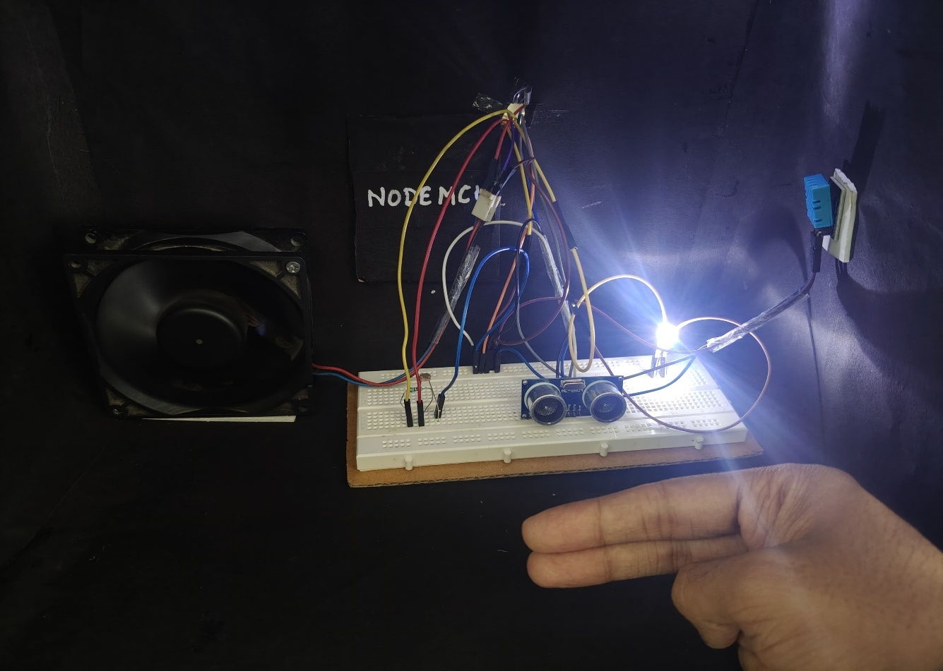

**Final video link:**

**https://drive.google.com/file/d/1wMYv0MZ8Ba7xeQQaIK0IzDRbK-xwjA8m/view?usp=sharing**

**Future work**

The home automation system can be upgraded further by incorporating **advanced AI-based automation, increased security features, energy optimization, and enhanced IoT compatibility**. **Artificial Intelligence (AI) and Machine Learning (ML)** can be used to monitor user behaviour, allowing **predictive automation**, like adjusting light, temperature, and appliances based on historical choice. **Voice and gesture recognition** can be enhanced by using **natural language processing (NLP) and computer vision**, providing a smooth and intuitive user experience.

Security is also an important feature, and future upgrades should be in the direction of **blockchain-based authentication, encrypted data transmission, and intrusion detection systems** to avoid cyber-attacks. The system can further be coupled with **emergency response systems**, like **fire and gas leak sensors, fall detection for elderly care, and automated alerts to emergency services**.

On the efficiency front, AI-driven **smart energy management systems** can be designed to regulate power consumption from past trends, current usage, and renewable power sources like **solar power**. **Smart grid integration** will facilitate the system's ability to automatically switch between sources of power for enhanced cost-efficiency and sustainability.

Furthermore, **multi-platform compatibility** can be improved by supporting **more IoT communication protocols** like **Zigbee, Z-Wave, LoRaWAN, and Matter**, ensuring interoperability with a wider range of devices. **Edge computing** can be utilized to process data locally, reducing reliance on cloud servers, improving response time, and enhancing data privacy.

Through these improvements, the home automation system will transform into a **highly intelligent, secure, and energy-efficient smart home ecosystem**.