EXPLORATORY DATA ANALYSIS (EDA) PROJECT
Submitted By
Name: Priyadharshini E
Department: B.Tech Information Technology
Year: III Year
College: PANIMALAR ENGINEERING COLLEGE

Project Title
Sales Data Analysis Using Exploratory Data Analysis (EDA)

Abstract
Exploratory Data Analysis (EDA) is a process of analyzing datasets to summarize their main characteristics using statistical methods and visualizations. This project focuses on analyzing a sales dataset to identify trends, correlations, and business insights. Python libraries such as Pandas, Matplotlib, and Seaborn are used for data analysis and visualization. The project helps understand customer purchasing patterns and overall business performance.

Objectives
- To analyze sales data using statistical methods.
- To identify patterns and trends in the dataset.
- To visualize sales performance using charts.
- To find correlations between sales and profit.
- To generate meaningful business insights.

Tools and Technologies Used
- Python
- Pandas
- NumPy
- Matplotlib
- Seaborn
- Visual Studio Code (VS Code)

Dataset Description
The dataset contains information about products, categories, regions, sales, and profit.
Attribute | Description
Product | Product Name
Category | Product Category
Region | Sales Region
Sales | Sales Amount
Profit | Profit Amount

Methodology
Step 1: Data Collection
A sample sales dataset was created and stored in CSV format.
Step 2: Data Loading
The dataset was loaded into Python using the Pandas library.
Step 3: Statistical Analysis
Descriptive statistics such as mean, count, minimum, maximum, and standard deviation were calculated.
Step 4: Data Visualization
Bar charts and heatmaps were generated to analyze trends and relationships.
Step 5: Correlation Analysis
The relationship between Sales and Profit was analyzed using a correlation matrix and heatmap.

Implementation
Libraries Used
- Pandas
- Matplotlib
- Seaborn
Visualizations Generated
- Sales by Category (Bar Chart)
- Correlation Heatmap

Output
Figure 1: Sales by Category
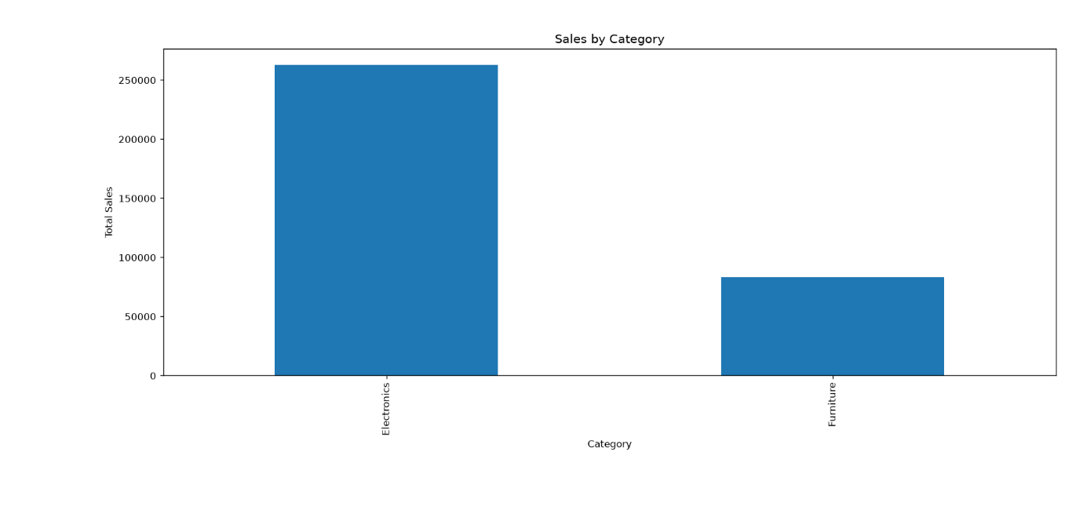
Observation
The Electronics category generated the highest sales compared to the Furniture category.

Figure 2: Correlation Heatmap
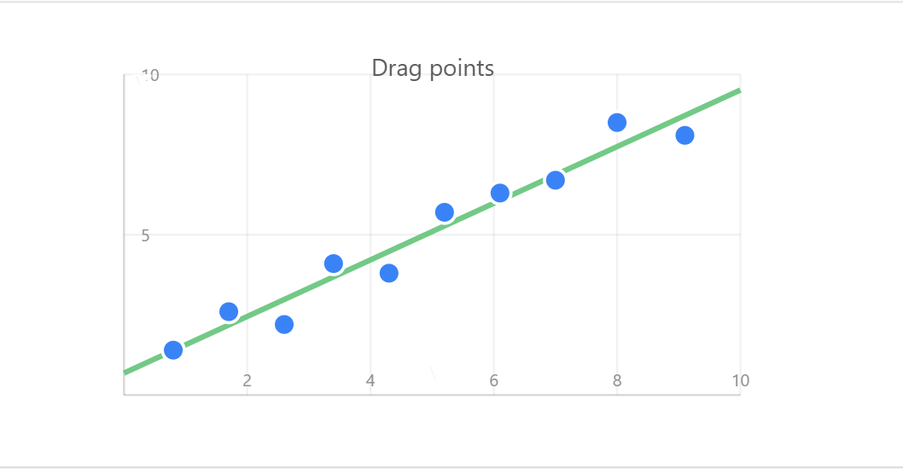
Observation
The heatmap shows a strong positive correlation between Sales and Profit, indicating that higher sales generally lead to higher profit.

Figure 3: Terminal Output
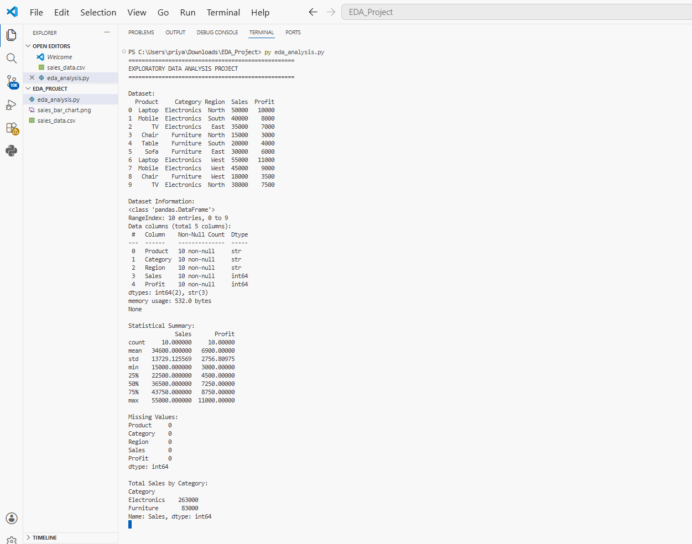
Sample Output
EDA PROJECT
Statistical Summary Generated
Missing Values:
0
Total Sales by Category:
Electronics = 263000
Furniture = 83000
EDA Completed Successfully

Results and Insights
- Electronics products contribute the highest revenue.
- Furniture products contribute lower revenue.
- Sales and Profit are strongly correlated.
- No missing values were found in the dataset.
- The dataset provides useful insights into business performance.

Advantages
- Easy understanding of data patterns.
- Helps identify business trends.
- Supports data-driven decision making.
- Improves analytical skills.

Future Enhancement
- Use large real-world datasets.
- Create interactive dashboards using Power BI or Tableau.
- Apply machine learning models for prediction.
- Perform advanced customer segmentation analysis.

Conclusion
The Exploratory Data Analysis project successfully analyzed sales data using statistical techniques and visualizations. The project identified important trends and correlations that can help businesses make informed decisions. EDA is a crucial step in understanding data before applying machine learning techniques.

References
- Python Documentation
- Pandas Documentation
- Matplotlib Documentation
- Seaborn Documentation
- Data Science Learning Resources

