HOUSE PRICE PREDICTION USING MACHINE LEARNING
PROJECT REPORT
Submitted By
Name: Priyadharshini E
Department: B.Tech Information Technology
Year: III Year
College: PANIMALAR ENGINEERING COLLEGE

ABSTRACT
House Price Prediction is a Machine Learning project that predicts the selling price of a house based on various factors such as area, number of bedrooms, and age of the house. This project uses the Linear Regression algorithm to analyze historical housing data and estimate future house prices. The project demonstrates data preprocessing, visualization, model training, prediction, and performance evaluation using Python and Scikit-Learn.

OBJECTIVES
- To build a predictive model for house prices.
- To apply Linear Regression in Machine Learning.
- To train and test the model using housing data.
- To evaluate model performance using statistical metrics.
- To visualize the relationship between house area and price.

TOOLS AND TECHNOLOGIES USED
- Python
- Pandas
- NumPy
- Matplotlib
- Seaborn
- Scikit-Learn
- Visual Studio Code

DATASET DESCRIPTION
The dataset contains information about houses including:
Attribute | Description
Area | Area of house (sq.ft)
Bedrooms | Number of bedrooms
Age | Age of house
Price | Selling price of house
Sample Dataset:
Area, Bedrooms, Age, Price
1000, 2, 5, 3000000
1200, 3, 10, 3500000
1500, 3, 7, 4500000
1800, 4, 8, 5500000
2000, 4, 5, 6500000

METHODOLOGY
Step 1: Data Collection
The housing dataset is collected and stored in CSV format.
Step 2: Data Preprocessing
- Load dataset using Pandas.
- Check missing values.
- Prepare input and output variables.
Step 3: Data Visualization
A scatter plot is generated to analyze the relationship between area and house price.
Step 4: Model Training
Linear Regression is used to train the machine learning model.
Step 5: Prediction
The trained model predicts the price of a new house based on user input.
Step 6: Evaluation
The model is evaluated using:
- R² Score
- Mean Absolute Error (MAE)

IMPLEMENTATION
Algorithm Used
Linear Regression
Linear Regression is a supervised learning algorithm used to predict continuous numerical values. It finds the best-fit line between independent variables and dependent variables.
Formula:
Price = m × Area + c
Where:
- m = Slope
- c = Intercept

OUTPUT
Figure 1: Area vs House Price Scatter Plot
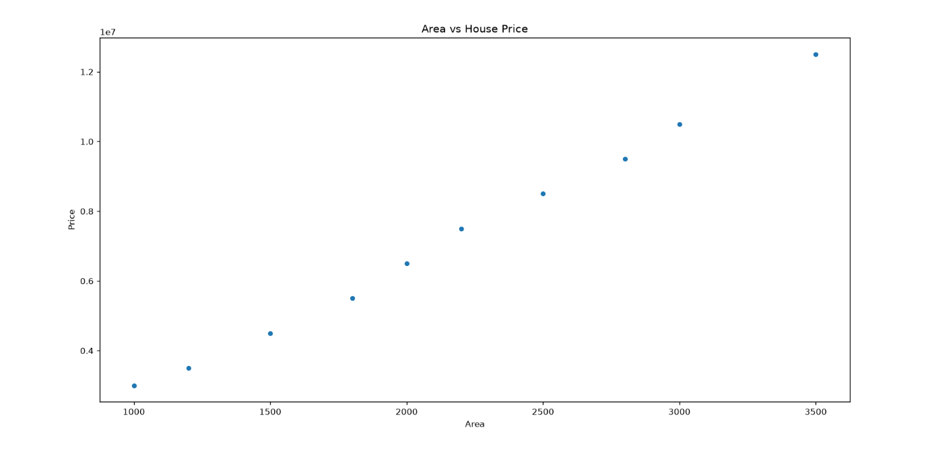
Figure 2: Terminal Output
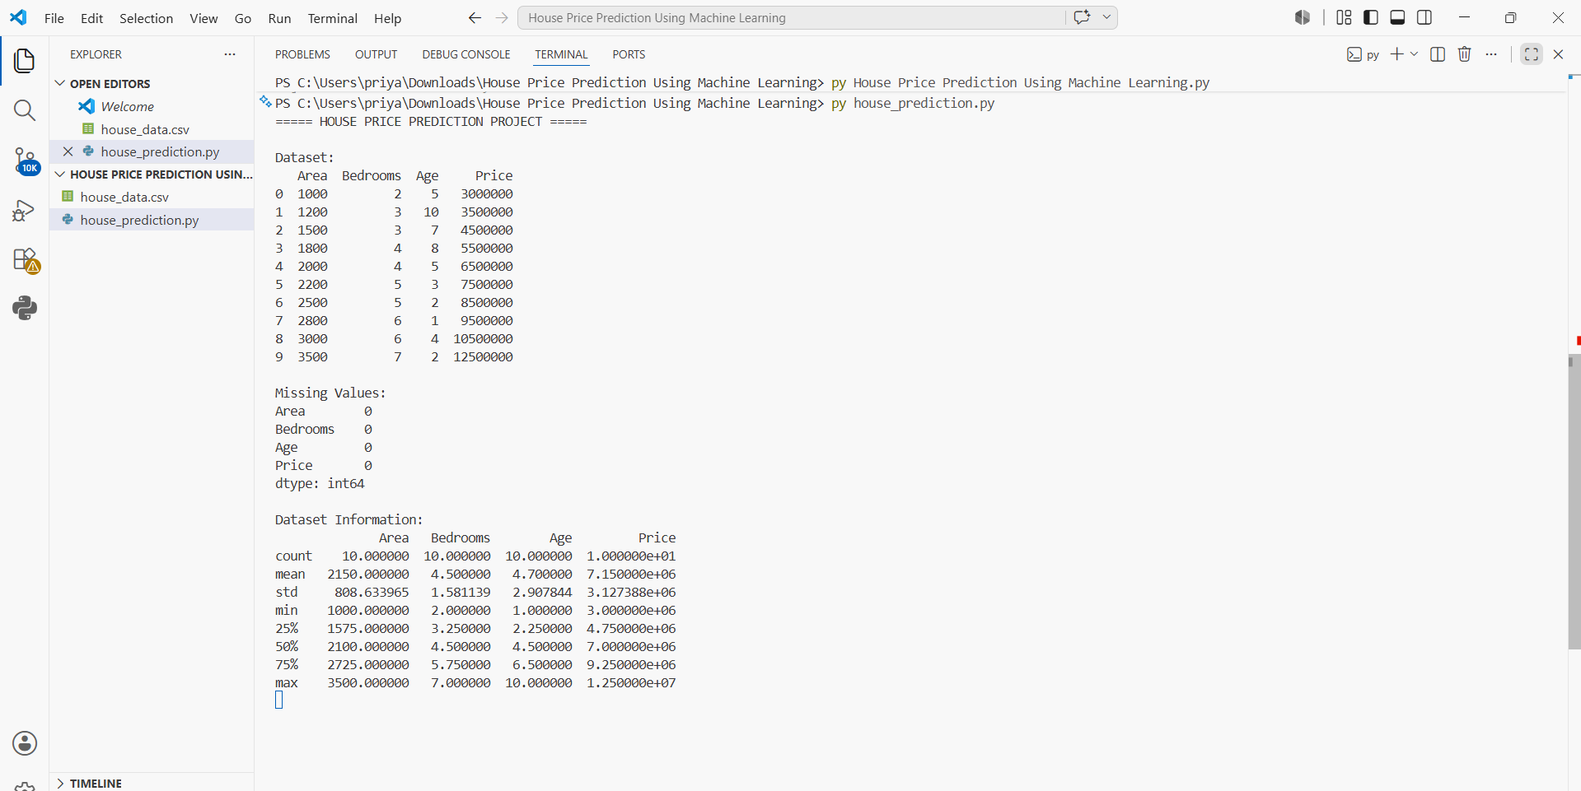
Sample Output:
Model Trained Successfully
R2 Score: 0.98
Mean Absolute Error: 150000
Predicted House Price: ₹ 7900000
Project Completed Successfully

RESULTS
- The model successfully predicts house prices.
- Area has a strong positive relationship with house price.
- The Linear Regression model achieved high prediction accuracy.
- Visualization clearly shows increasing price with increasing area.

ADVANTAGES
- Accurate price prediction.
- Helps buyers and sellers make informed decisions.
- Easy to implement and understand.
- Useful for real estate analysis.

FUTURE ENHANCEMENTS
- Use larger real-world datasets.
- Implement Random Forest Regression.
- Build a web application using Flask.
- Deploy the model online.

CONCLUSION
The House Price Prediction project successfully demonstrates the use of Machine Learning for predicting house prices. Linear Regression was used to train and evaluate the model. The project provides practical knowledge of supervised learning, data visualization, and predictive analytics. It is suitable for academic, internship, and portfolio purposes.

REFERENCES
- Python Documentation
- Scikit-Learn Documentation
- Pandas Documentation
- Matplotlib Documentation
- Machine Learning Learning Resources

