***EQUIFAX***

CMS Fusion

**Operations tab**

**DOCUMENTATION**

Table of Contents

Operations tab 2

1. Schedule job 3

# Operations Tab

Operations tab provide parameterized job automation facility. It will take job stack process as input and automate job stack

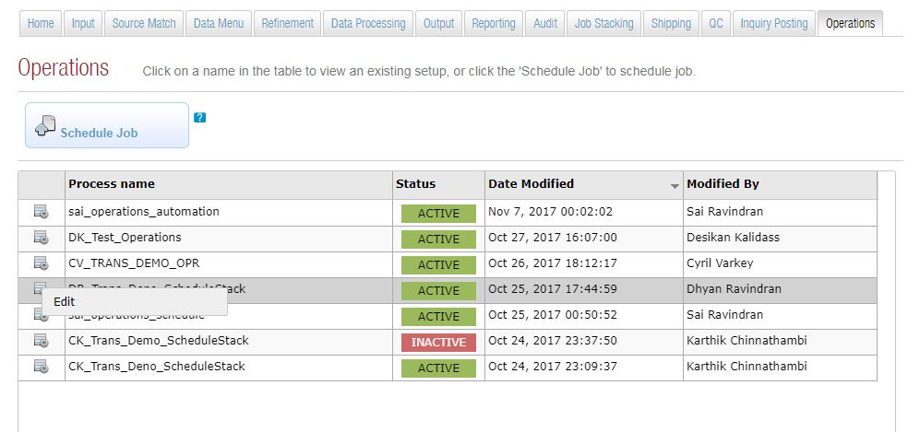

## View project QC Status

While clicking on the Operations tab, it will list all the automated job stack with status .

* Process name
* Status
* Date Modified
* Modified By

User can edit process

## Schedule job

This tab will allow to automate job stack execution.

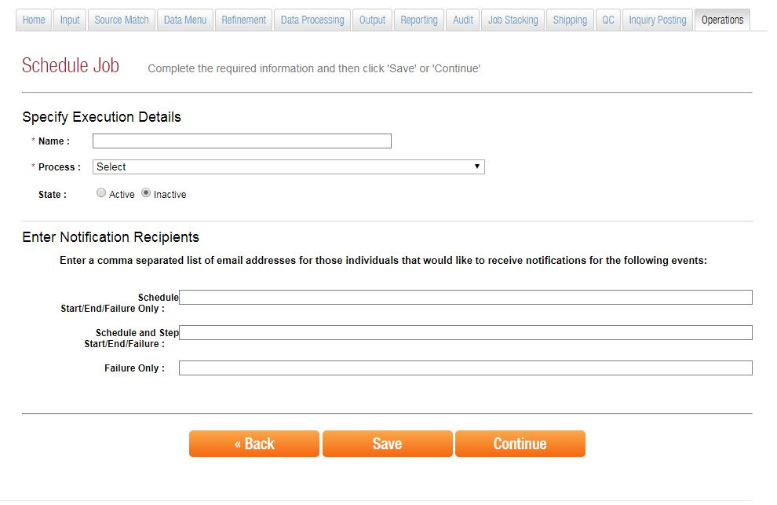

## Specify Execution Details

Name: - specify name of the process.

Process: - select appropriate job stack process from the pre populated list.

State: - choose either Active or Inactive based on the requirement.

## Enter Notification Recipients

Enter a comma separated list of email addresses for those individuals that would like to receive notifications for the following events

**Schedule Start/End/Failure Only**

**Schedule and Step Start/End/22Failure:**

**Failure Only:**

## Schedule job configuration

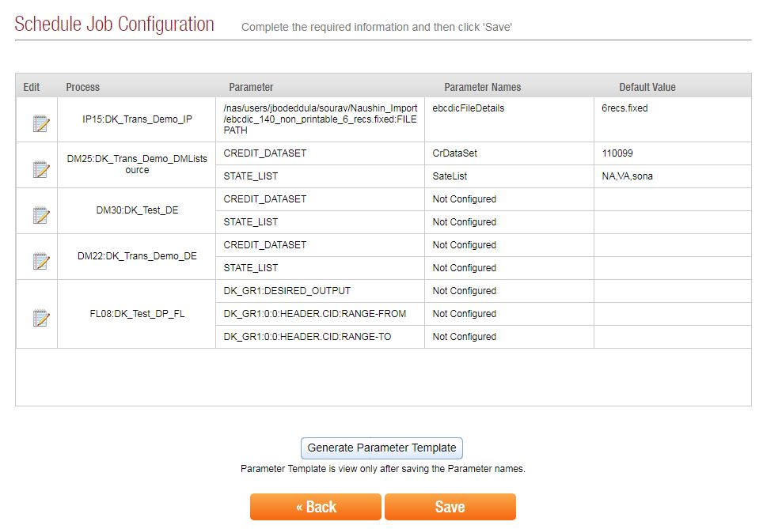

Process in the stack will listed on configuration page. Job automation supports certain parameters overwritten in runtime.

Edit for specify the process parameter value. User can give parameter name and default value.

**Edit (Process Parameter details )**

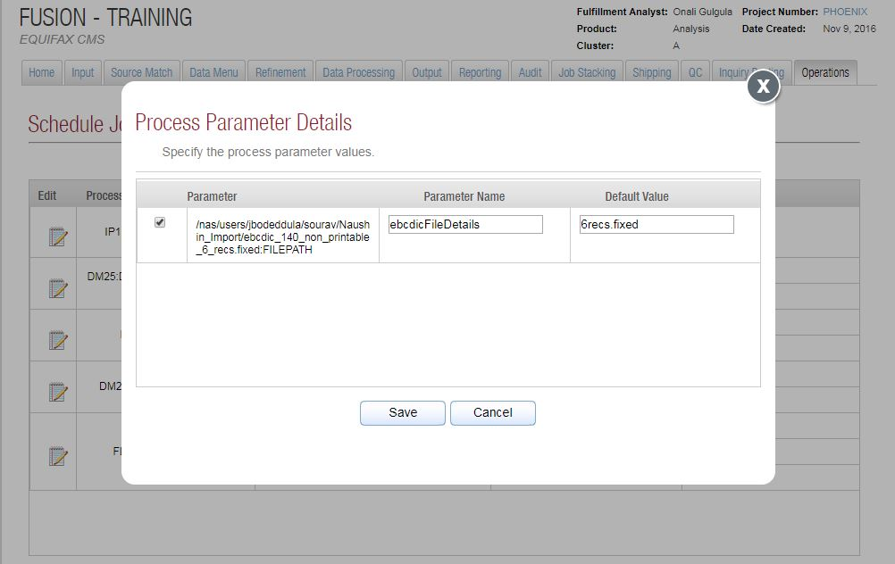

Three levels value can provide to process

1. Run time value for parameter
2. If runtime value missing then pickup default value.
3. If not have default value then pickup value from process

**Parameter template**

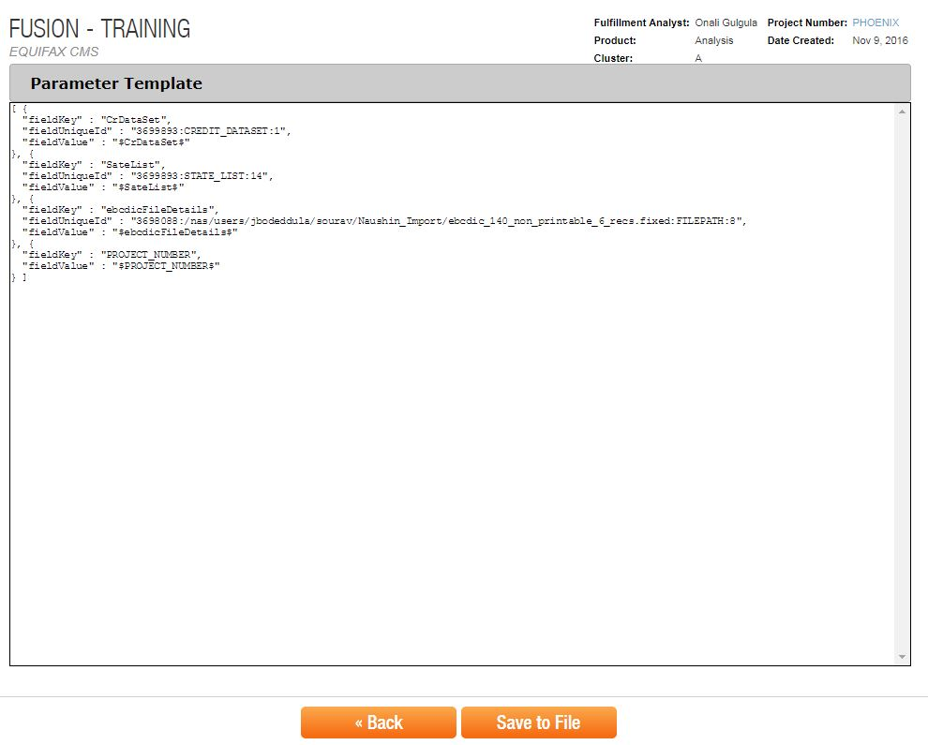

Project template files allow changing values on runtime. It will use to periodic job schedules. Parameter template helps to automation override values irrespective of project. For example it will allow to changing project number too. Parameter template can save as a text file.