***EQUIFAX***

CMS Fusion

**Audit**

**DOCUMENTATION**

Table of Contents

Audit Tab 3

1. Sample Files – Table Ditto 6

2. Sample File – Credit Files 9

3. Data Compare 17

**Revision History**

| **Revision** | **Author** | **Date** | **Status and Description** |
| --- | --- | --- | --- |
| 1.0 | UST Global | 12/01/2017 | Initial Draft |
|  |  |  |  |
|  |  |  |  |

# Audit Tab

As the name indicates, the Audit tab is used to perform Auditing activities or provide input for the Audit Tool that performs the audit activities.

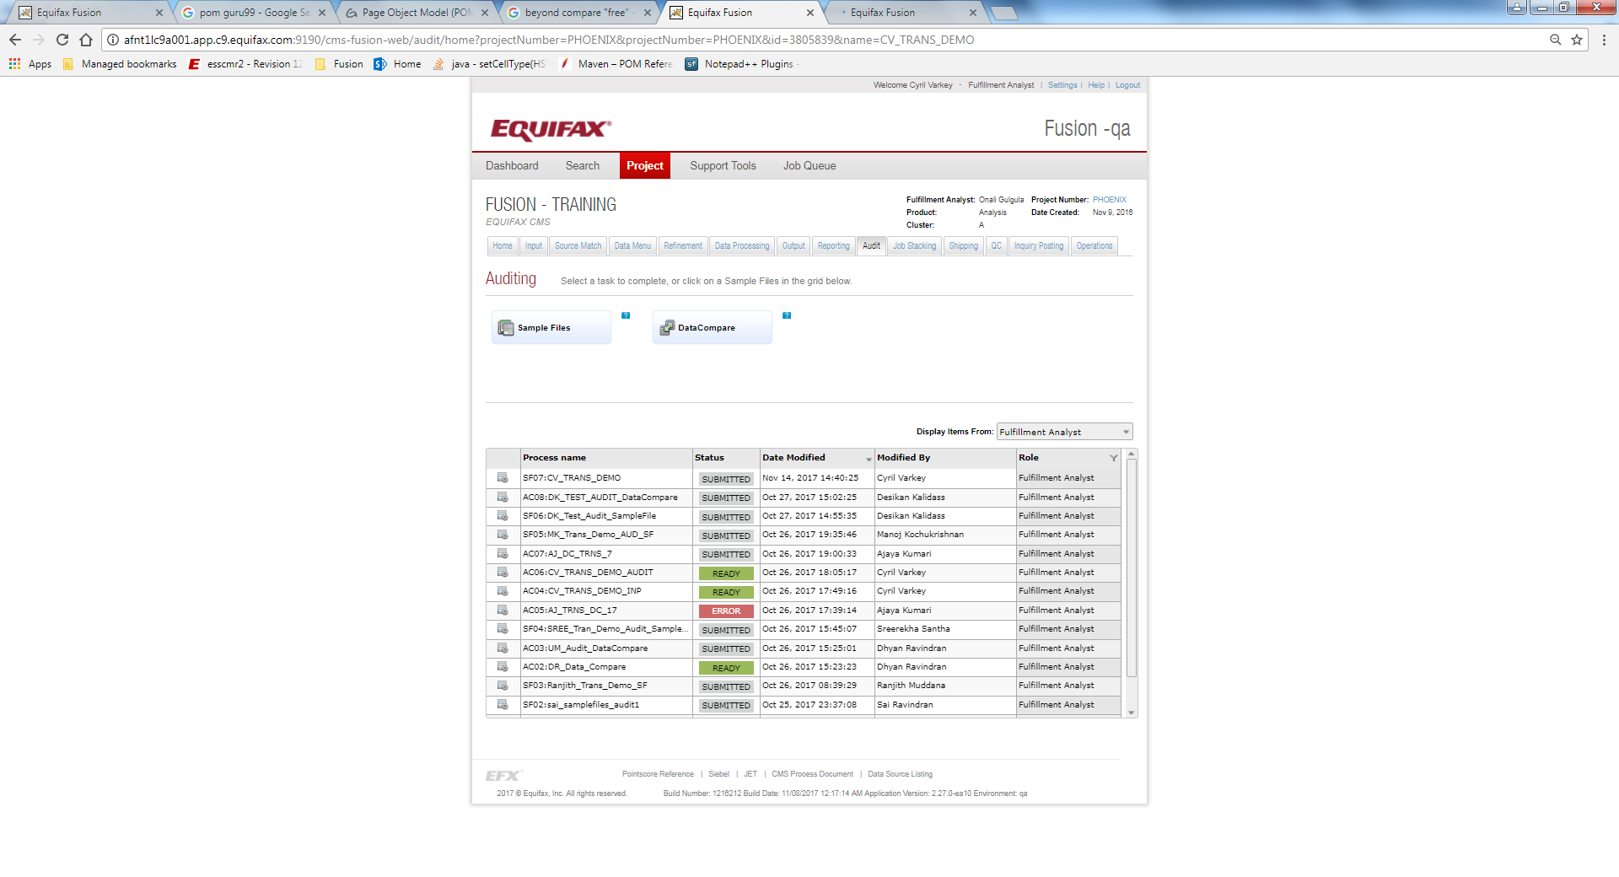

**What is Audit?**

An audit is a systematic and independent examination of books, accounts, statutory records, documents and vouchers of an organization to ascertain how far the financial statements as well as non-financial disclosures present a true and fair view of the concern.

Any subject matter may be audited. Auditing is a safeguard measure since ancient times. Audits provide third party assurance to various [stakeholders](https://en.wikipedia.org/wiki/Stakeholder_%28corporate%29) that the subject matter is free from [material](https://en.wikipedia.org/wiki/Materiality_%28auditing%29) misstatement.

As a result of an audit, stakeholders may effectively evaluate and improve the effectiveness of risk management, control, and the governance process over the subject matter.

**Sample Files**

A sample file is a printed report of the credit files, which is human readable. It is a way to create printed version of the ACRO data (which is stored in mdb format).

**Data Compare**

Production programmers utilize the compare the tables.

**Duplicate Process**

This is used to create a duplicate of the existing process as per the below image.

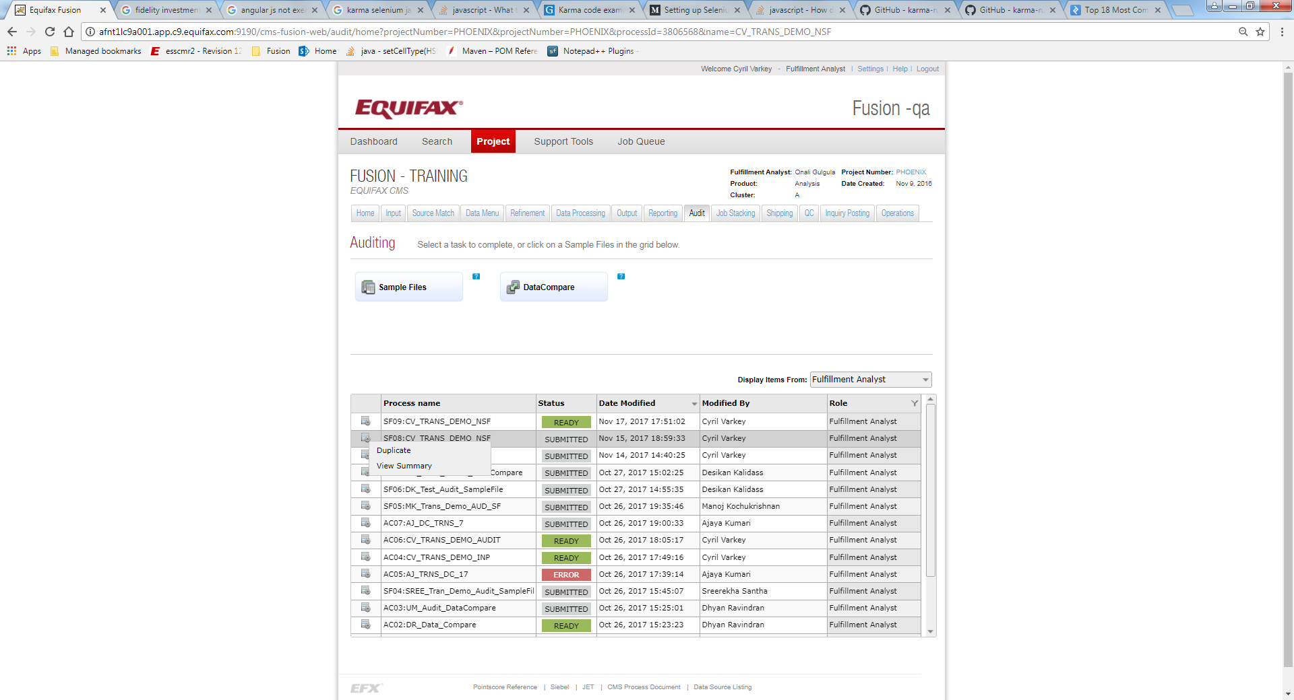

**View Summary**

This is used to view the summary of the process. A sample Summary page is displayed below:

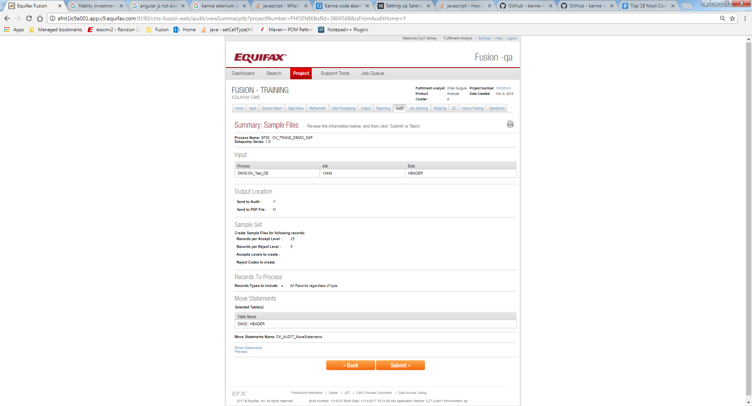

## Sample Files – Table Ditto

Table Ditto is the process of sampling the selected table during the select input option, which is mainly for QC purpose. This is used mainly to get sampling of the output. The sample file gives a dump of 50 records, where we can identify how the raw data in the table looks like.

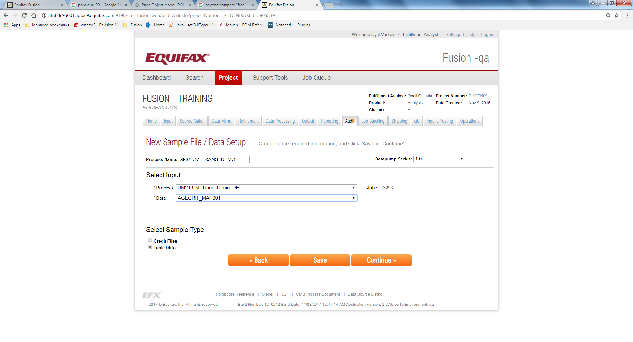

**Process Name -** This field is used to give a name for the Audit process. It is prefixed with an auto generated keyword called as **Process Identifier**, which is used to given the unique names for the source match processes, so the user does not need to worry about the uniqueness of the names.

**Select input -** This section is used to select the particular input process for matching. User can select the Input process from the process drop down. When the input process is selected its Job ID will be displayed under the Job heading.

**Process Name -** This field is used to select a Particular Process.

***Data -*** *This field is used to select the particular table for the input selection process.*

**Select Sample Type-** This field is used to select between the options “Credit File” and “Table Ditto”. When we select the “Table Ditto” as the option, the sample files will not be loaded into the Audit application and will create a csv file with 50 samples.

The Summary view of the Sample Files – Table Ditto is as below

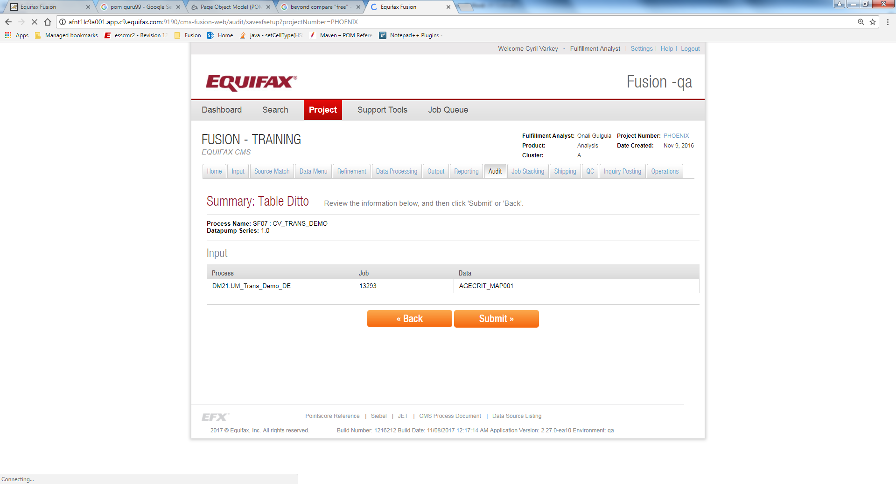

The response visible when clicking on the View link of the Sample File Process is as below.

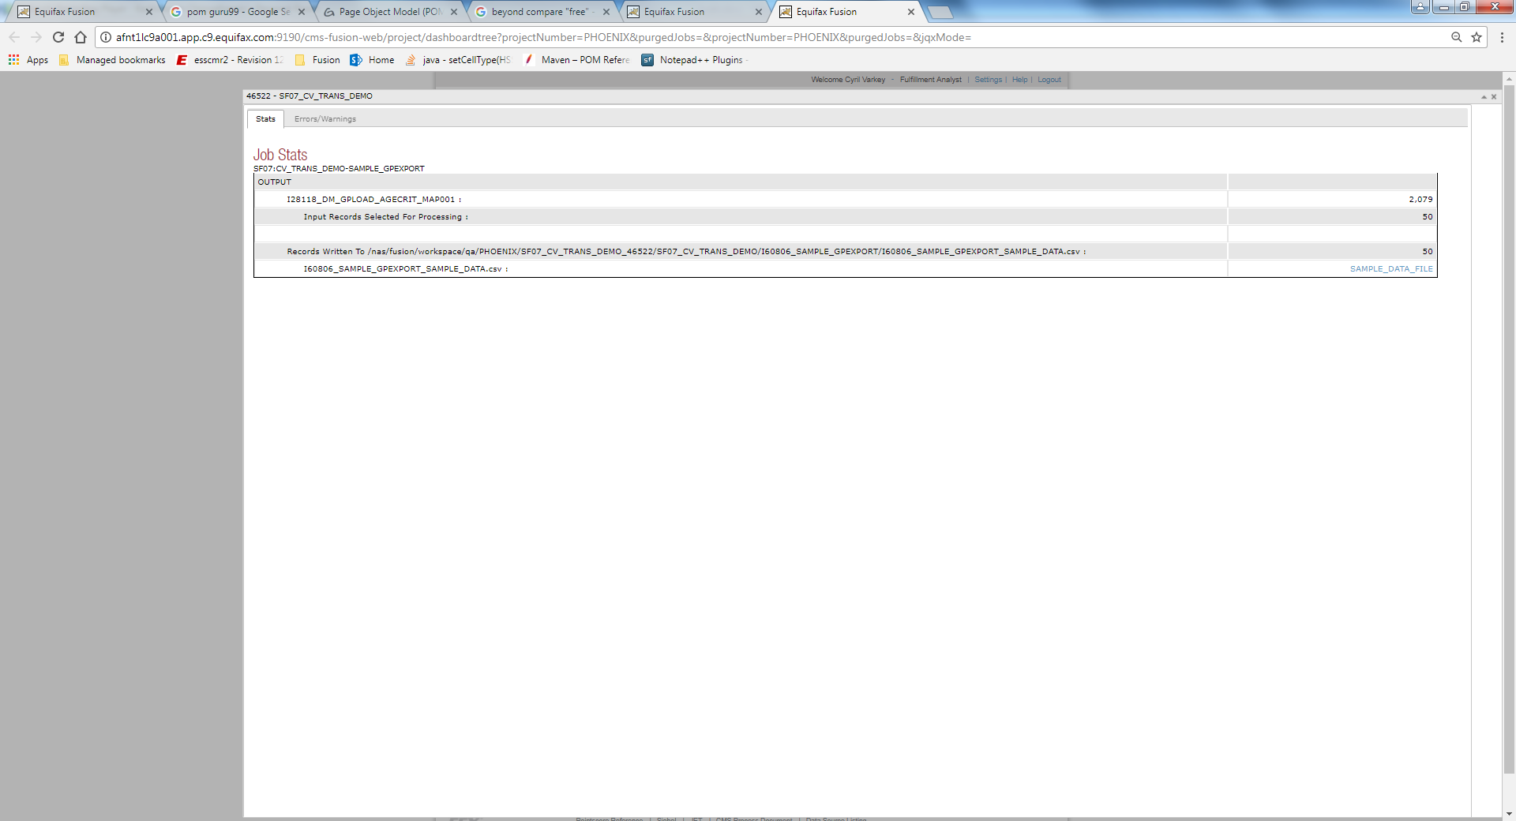

The sample available as part of the Sample File – Table Ditto process is having a count of 50 records. The contents of the sample ditto file are displayed as below:

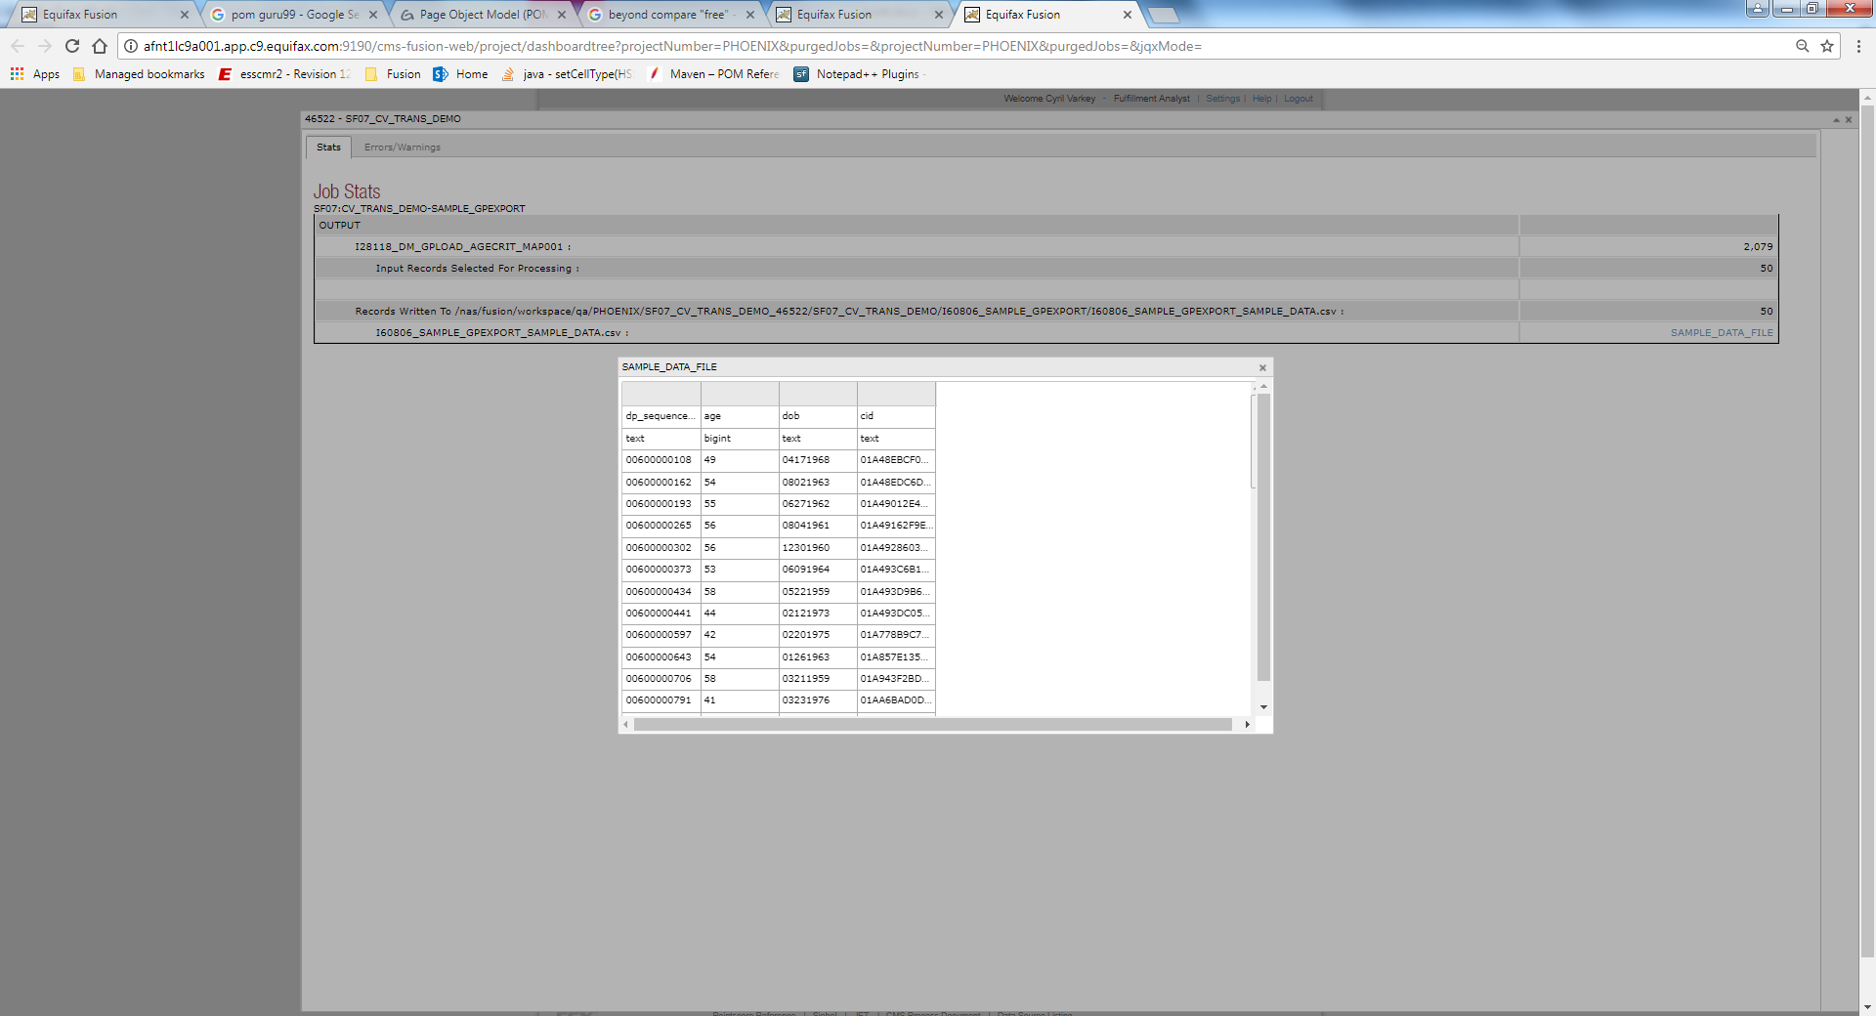

## Sample File – Credit Files

The Credit files selection creates human readable version of the credit file, which can be printed.

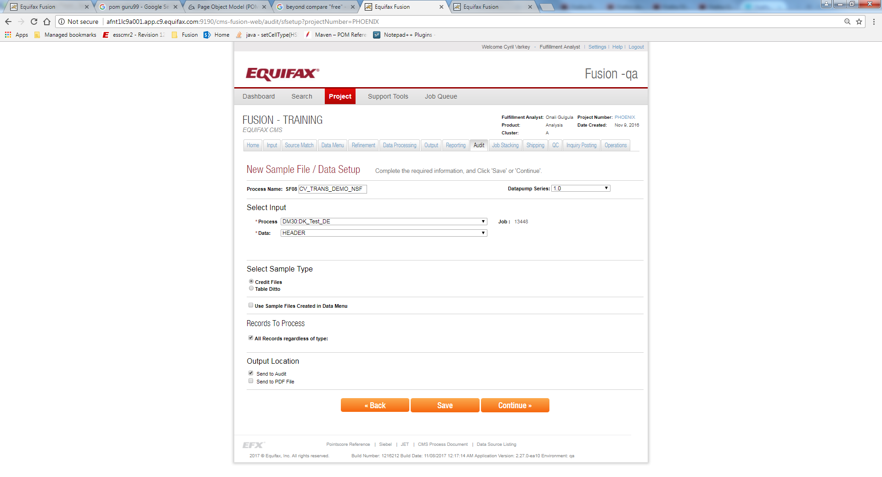

**Process Name -** This field is used to give a name for the Sample File process. It is prefixed with an auto generated keyword called as **Process Identifier**, which is used to given the unique names for the source match processes, so the user does not need to worry about the uniqueness of the names.

**Select Input -** This section is used to select the particular process for matching. User can select the Input process from the process drop down. When the input process is selected its Job ID will be displayed under the Job heading.

**Select Sample Type -** This section allows the fulfillment analyst to choose the type of sample available for selection. When Credit file is chosen as the option, the sample files will be created and loaded onto the Audit application.

***Use Sample Files Created in Data Menu –*** *The Sample files created in Data Menu process can be re-used by checking this checkbox. This is visible only when the Data Menu has created the sample files for the particular process (in the Autopilot & Score Model screen of the Data Menu). When the option for the same is checked, there is no need to perform another data pump job to retrieve/match the credit record.*

**Record to Process -** *This section defines the type of records to process from the selected process, such that the filtering of unwanted records is done. The filtering options available are the Accepts, Rejects and All Records as per the options mentioned in the below image. The Accept level tags are usually A,B,C,D,etc. When we select the specific accept or reject codes, only those records will be processed.*

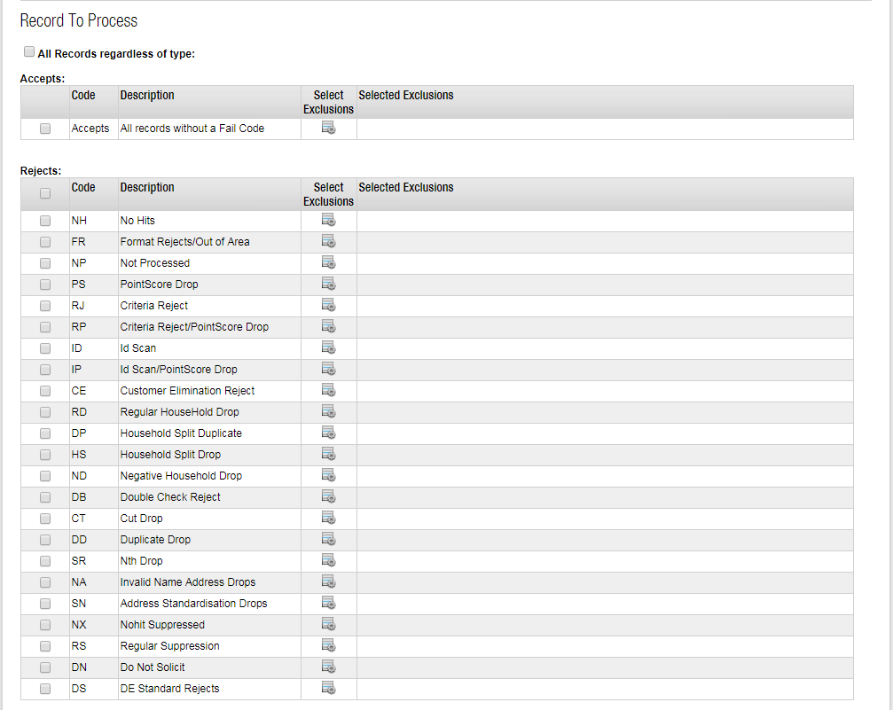

***Output Location-*** *Output Location allows users to specify the where the data needs to be sent. We can send to the Audit Tool and/or we can send it to a PDF file. The sample files created will be sent to Audit tool, when the same is selected.*

After selecting the necessary options in the New Sample File/Data page, we navigate to the Sample Set Setup page as seen below:  
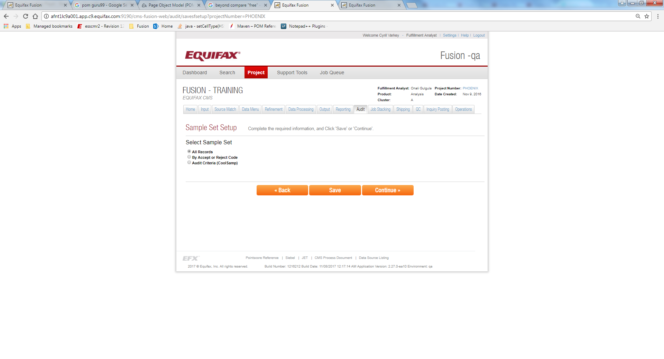

***All Records -*** *This is the default option is used to select all the records, irrespective of their status. This will create samples with all the records.*

***By Accept or Reject Code -*** *This option is used to select the specified number records, based on their status. We can define the number of records per accept and reject code. Also we can define the Accept Levels (such as A, B, C, etc.) and Reject codes (such as 7, 8, etc.). The default values populated which selects the records per accept level as 25 and for the reject codes are 5 are as per the image below.*

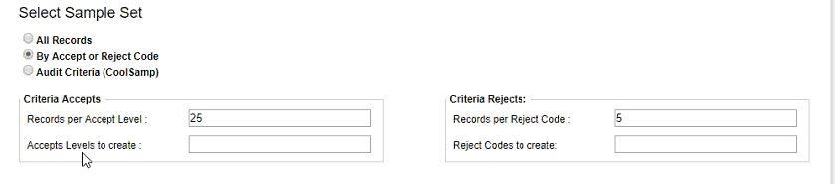

***Audit Criteria (CoolSamp) -*** *This option is used to define the auditing criteria. The artefacts created during Process Input, are displayed along with the fields. Here we perform an operation similar to that of filtering, where the sample set of data is defined based on certain condition. Additionally a tagging process is also done in multiple fields, which is displayed on the Audit Tool.*

*We can also select the count of the records as per the audit criteria mentioned in the below image.*

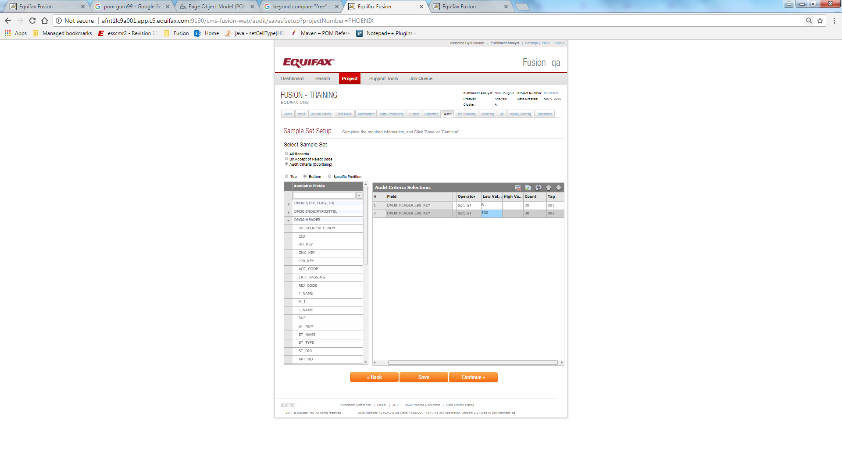

If we want to append the processed data to the report, we need to select the table from the list of “Available Tables” we can use the exiting move statements template or by creating the new move statements template.

Move Statements is an optional step/field, to give more data to the sample file (generated as part of Data Menu Process) on top of the existing file to the Audit Tool. 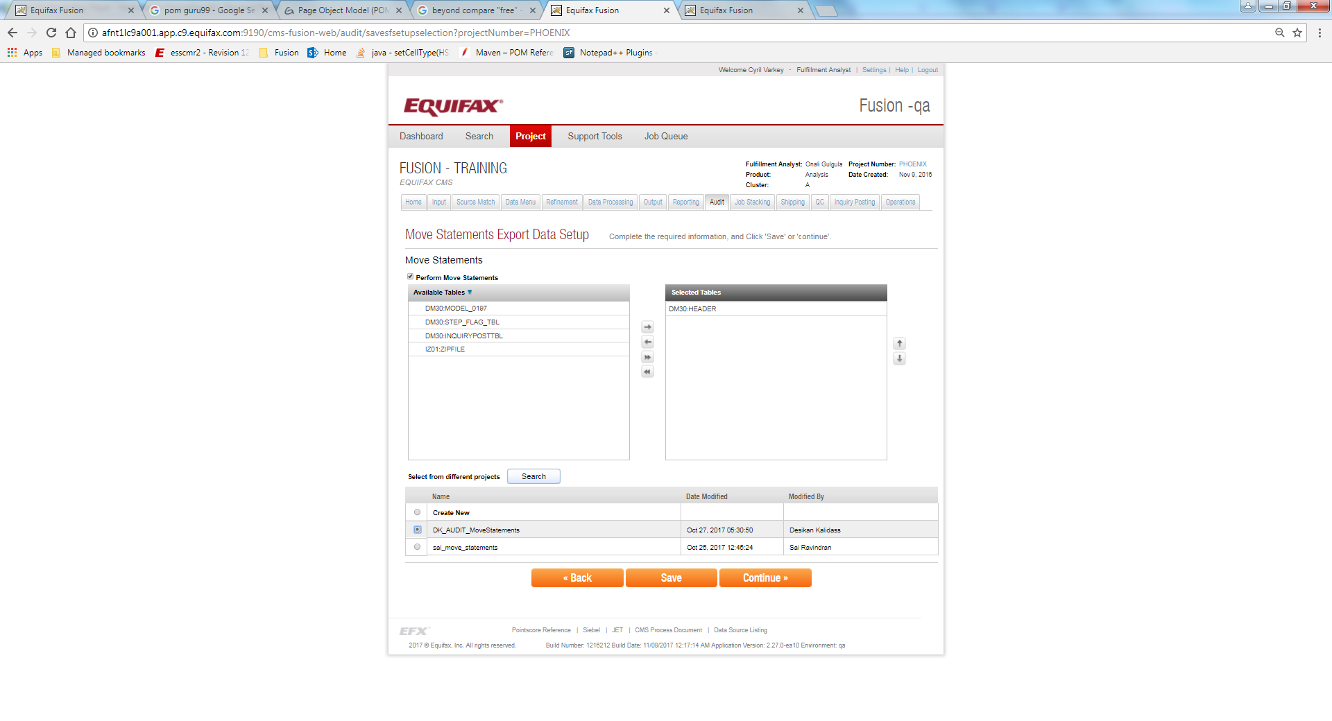

In the Edit Move Statements page, we select the fields that need to be appended to the report. We can define the headers for the fields by providing the value in the Literal field. We also define the ordering of the fields, and the location where the exported data will be available in the xml.

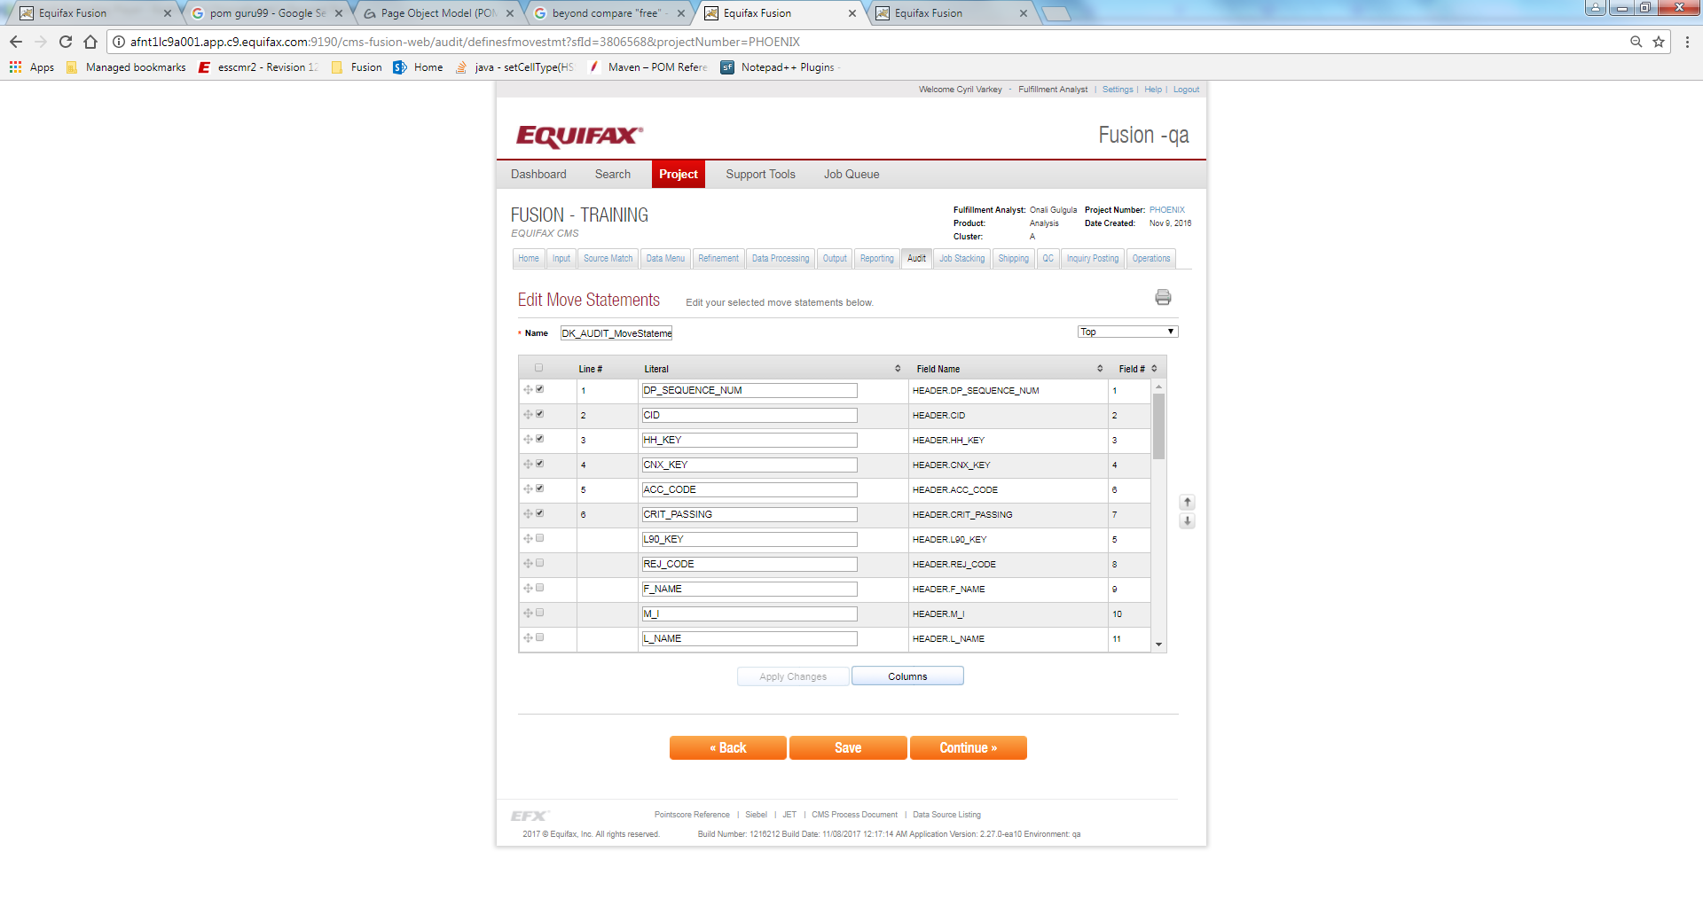

Then we have to define the columns, also the starting position of the literal and the value for the attribute in the particular position, for providing enough spacing between the literals.

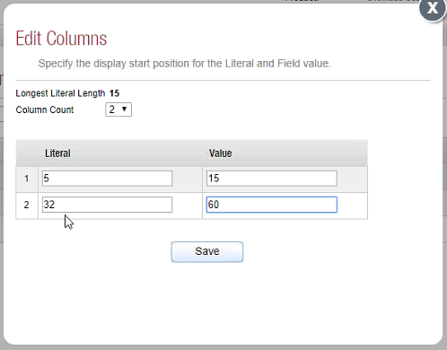

The Preview link in the below helps you understand, how your data is organized.

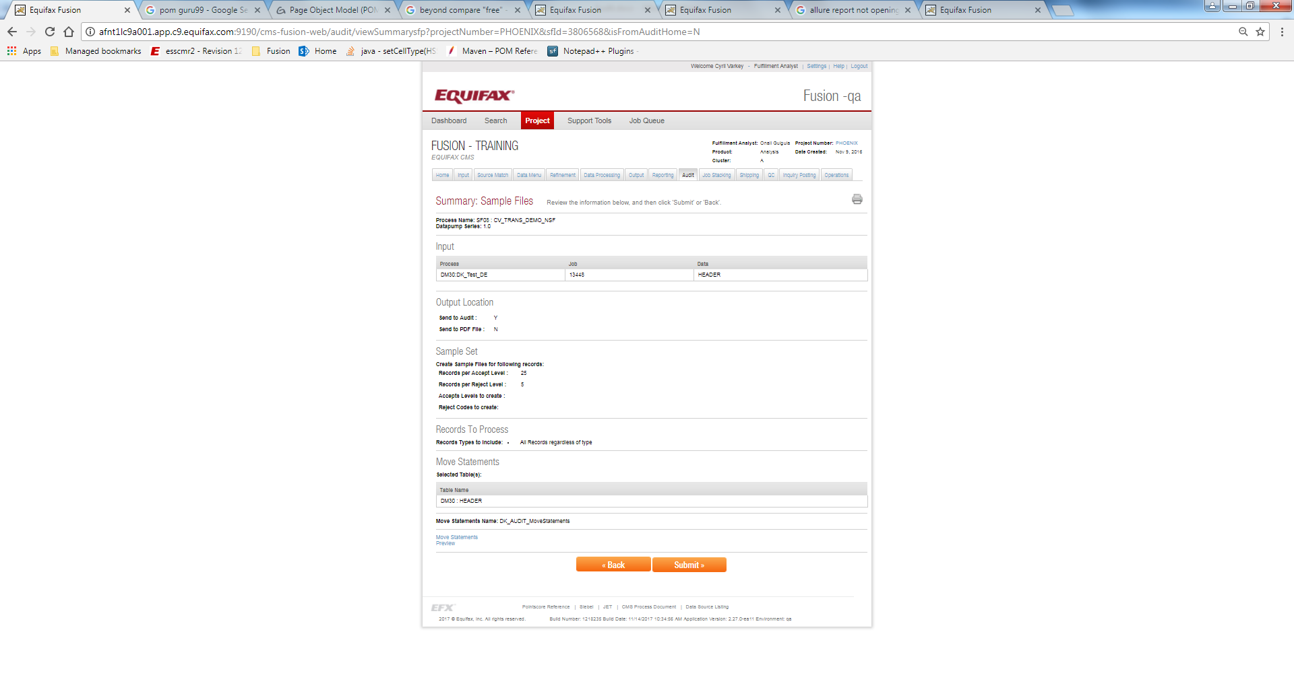

## Data Compare

The Credit files selection creates human readable version of the credit file, which can be printed. This can be files from the same project or from a different project.

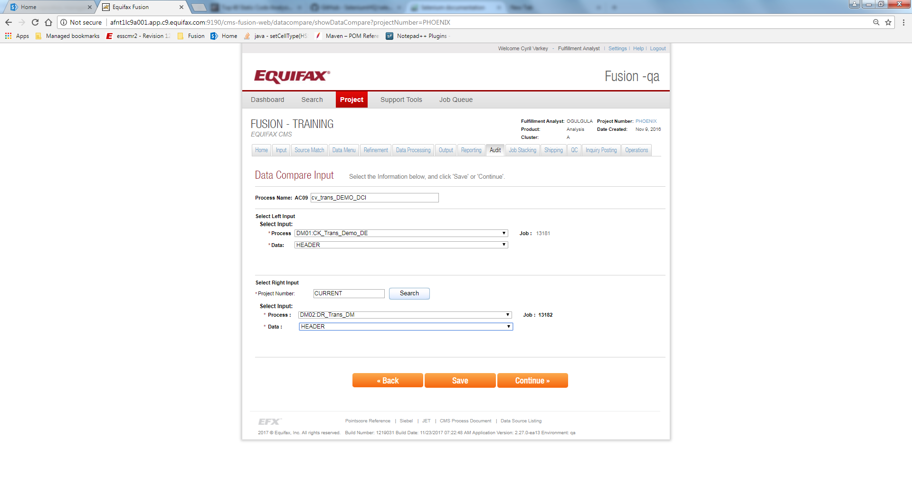

**Process Name -** This field is used to give a name for the Data Compare Input process. It is prefixed with an auto generated keyword called as **Process Identifier**, which is used to given the unique names for the source match processes, so the user does not need to worry about the uniqueness of the names.

***Select Left Input -*** *This section is used to select the particular input process for Comparison.*

***Select Right Input -*** *This section is used to select the particular input process to be matched. This can be from the same project or a different project. This is done by searching against a project Number. If the Project Number refers to the Project number as CURRENT, then the data within the same project is compared.*

***Select input -*** *This section is used to select the particular input process for matching. This should be any process that contains PII information to match against the credit file. User can select the Input process from the process drop down. When the input process is selected its Job ID will be displayed under the Job heading.*

Clicking on the Continue button navigates us to the data compare page. We need to select the similar left table and right table fields, for matching and comparing the data There is a maximum of three fields selected from the left and right side.

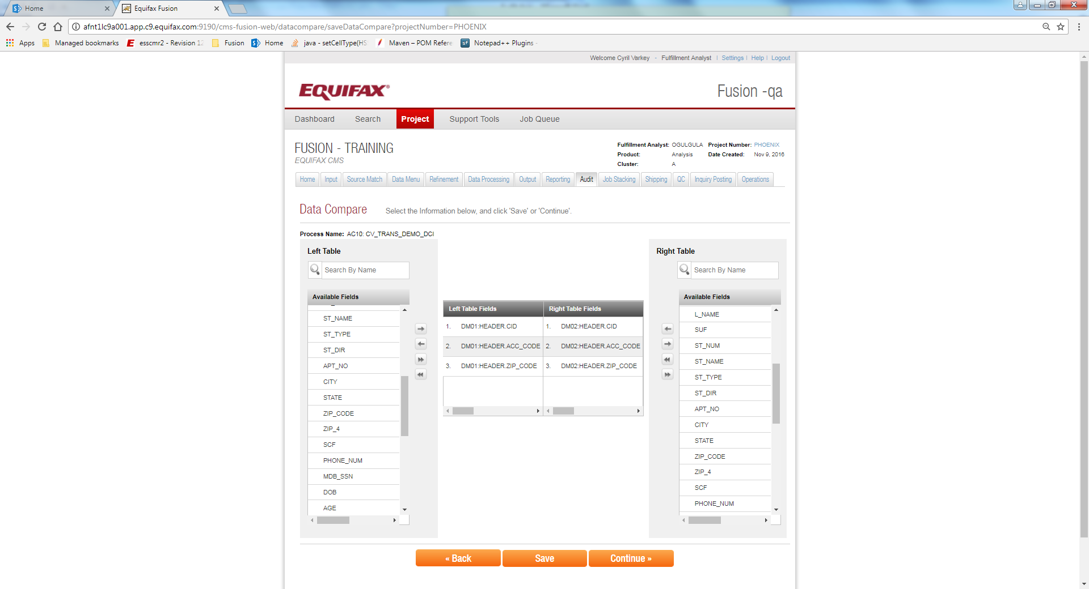

The Summary screen in the below image helps us to understand the data alignment for the data compare process.

