***EQUIFAX***

CMS Fusion

**Shipping Technical Flow**

**DOCUMENTATION**

**Revision History**

| **Revision** | **Author** | **Date** | **Status and Description** |
| --- | --- | --- | --- |
| 1.0 | UST Global | 12/18/2017 | Initial Draft |
|  |  |  |  |
|  |  |  |  |

Table of Contents

Shipping 2

1. WEB UI 2

2. REST FLOW 3

3. CORE Application 5

# Shipping

Shipping is the process which will deliver files to customer. The files may be reports or the output files. This document describes a very high level understanding of shipment of output files of an already completed job via FTP

### WEB UI

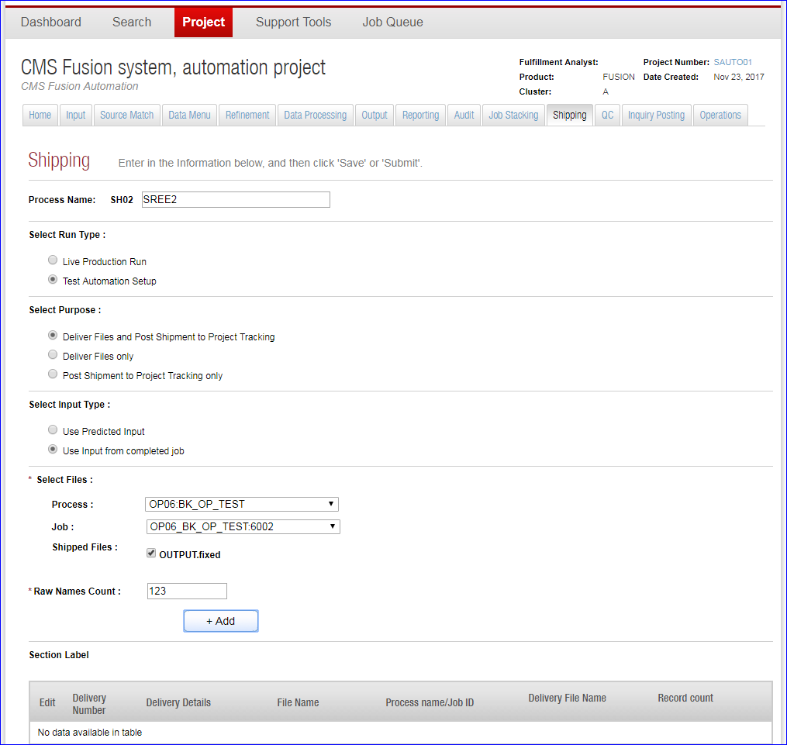

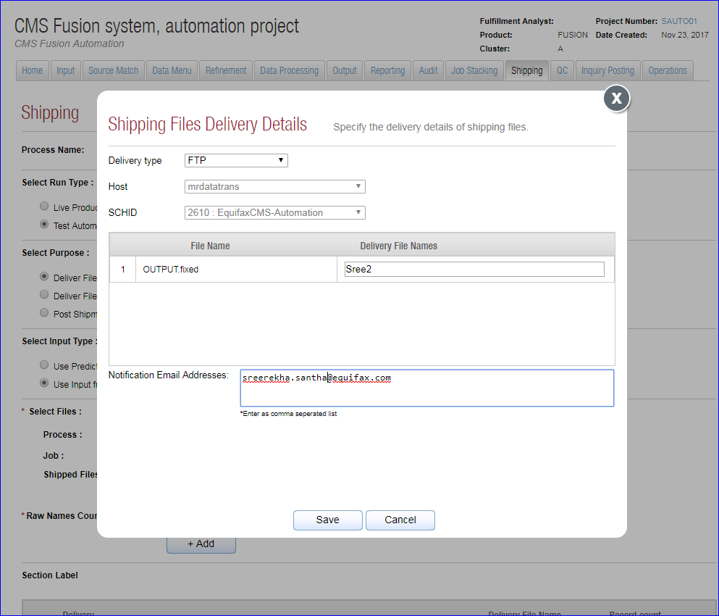

**Request URI** : /shipping/compareJobRunInstances , /shipping/getData

|  |
| --- |
| **Tables created/updated** |
| process_master |
| SHIPPING_PROCESS |
| PROCESS_ARTIFACT |
| SHIPPING_DELIVERY_DETAIL |
| process_table |
| SHIPPING_DELIVERY_FILE |
| process_relationship |
| SHIPPING_INPUT_XREF |
| project_master |
| QC_ITEM |
| QC_ITEM_SHIPPING_INPUT_XREF |

The shipping and its corresponding jobs has to be approved before doing a shipping.

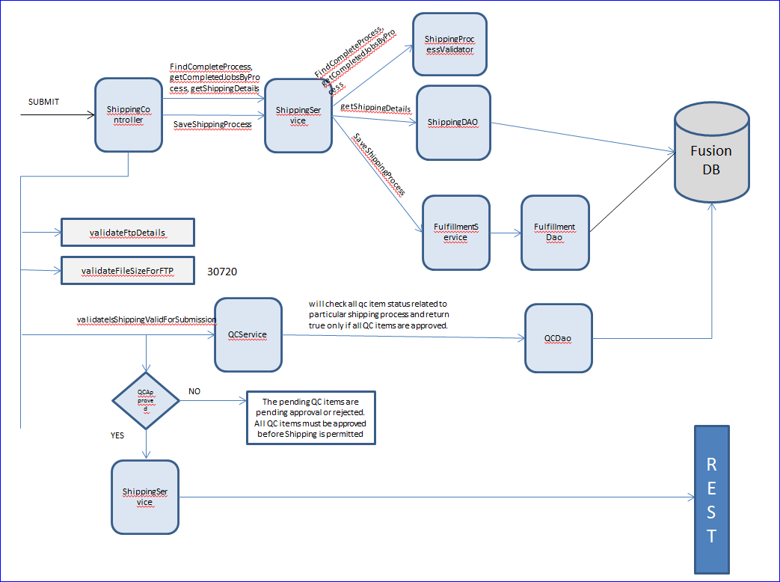

### REST FLOW

The JSON request from UI contains the workflow definition, process step configuration, item configurations etc. A sample json request is given below.

{

{

"userId": "sxs894",

"jobName": "SH01_SREETEST",

"jobType": null,

"jobDescription": null,

"projectNumber": "SAUTO01",

"runtimeProjectNumber": null,

"allNotificationEmailIds": null,

"jobNotificationEmailIds": null,

"failureNotificationEmailIds": null,

"workflowDefinition": {

"id": null,

"steps": [{

"type": "script-step",

"id": "1",

"name": "_fusion_1",

"description": "submitToFileDelivery",

"startsWithPrevious": false,

"script": "out:println \"Executing item 1-SHP_FTP\";",

"scriptLanguage": null

},

{

"type": "script-step",

"id": "2",

"name": "_fusion_2",

"description": "submitToAccounting",

"startsWithPrevious": false,

"script": "out:println \"Executing item 2-SHP_ACCOUNTING\";",

"scriptLanguage": null

}],

"key": null,

"name": null,

"description": null,

"category": null,

"startFormDefinition": null

},

"processStepConfigurations": [{

"processId": 20314,

"stepNumber": 1,

"stepName": "SH01:SREETEST",

"processType": "SHIPPING",

"runConfigId": null

}],

"itemConfigurations": [{

"predictorItemNumber": null,

"processStepNumber": 1,

"itemName": "SHP_FTP",

"itemIndex": 1,

"description": "submitToFileDelivery",

"mainType": "SHP",

"subType": "FTP",

"inputMappingList": [{

"parameterName": "shipping_file_group",

"parameterValue": "2",

"mappingStrategy": null,

"mappingConfig": null

},

{

"parameterName": "input_job_number",

"parameterValue": "7150:7460",

"mappingStrategy": null,

"mappingConfig": null

}]

},

{

"predictorItemNumber": null,

"processStepNumber": 1,

"itemName": "SHP_ACCOUNTING",

"itemIndex": 2,

"description": "submitToAccounting",

"mainType": "SHP",

"subType": "ACCOUNTING",

"inputMappingList": [{

"parameterName": "shipping_file_artofact_ids",

"parameterValue": "7559",

"mappingStrategy": null,

"mappingConfig": null

},

{

"parameterName": "input_job_number",

"parameterValue": "7150:7460",

"mappingStrategy": null,

"mappingConfig": null

}]

}],

"jobSets": [],

"executionCluster": "A"

}

}

REST application mainly contains 3 components, **Workflow Manager**, **Activity Engine**, **Spring Executer [Workflow Advancer]**.

The tables which are getting updated in REST flow

|  |  |
| --- | --- |
| **Fusion Tables** | **Description** |
| FULFILLMENT_JOB_DOCUMENT | Saves JOB_CONFIGURATON_JSON |
| FULFILLMENT_JOB |  |
| JOB_PROCESS_STEP |  |
| WORK_ITEM | Dynamically resolved process artifacts |
| WORK_ITEM_INPUT_MAPPING |  |

### CORE Application

CORE is mainly a Spring scheduler which mainly deals with two scheduled task

**Submit** : Submit is responsible for processing the work items and interact with outside fusion systems.

**retrieveStatus**: Retrieve Status mainly check for the done file created by the work item’s , and if such a done file exists in the nas location for the work_item, then the work_item is considered as completed and update the WORK_ITEM.status to COMPLETED.

The work items which are getting created for shipping [FTP + Purpose : Deliver files and post shipment for project tractking] is given below

* SHP_FTP
* SHP_ACCOUNTING

Other work items based on the selection of process, input type, delivery types, kind of shipped artifact. And other work items created based on the selection is given below

* SHP_OTHER
* SHP_SFTP
* SHP_DIRECTCONNECT
* SHP_EMAILDELIVERY

**1. SHP_FTP**

This work item will call the XJOB with the details of the files that needs to be shipped. Find below the sample XJOB request which will ship 3 files via FTP

/nas/code/unix/bin/schid_ftp -r mrdatatrans -s 2610 -n /nas/fusion/workspace/qa/PHOENIX/OP10_SREE_Trans_Demo_OP_13290/OP10_SREE_Trans_Demo_OP/I28097_OT_COMBINEFILE/SREE_OUTPUT_FILE_3.fixed -o FILE1 -n /nas/fusion/workspace/qa/PHOENIX/OP10_SREE_Trans_Demo_OP_13290/OP10_SREE_Trans_Demo_OP/I28097_OT_COMBINEFILE/SREE_OUTPUT_FILE_1.fixed -o FILE2 -n /nas/fusion/workspace/qa/PHOENIX/OP10_SREE_Trans_Demo_OP_13290/OP10_SREE_Trans_Demo_OP/I28097_OT_COMBINEFILE/SREE_OUTPUT_FILE_2.fixed -o FILE3 –z

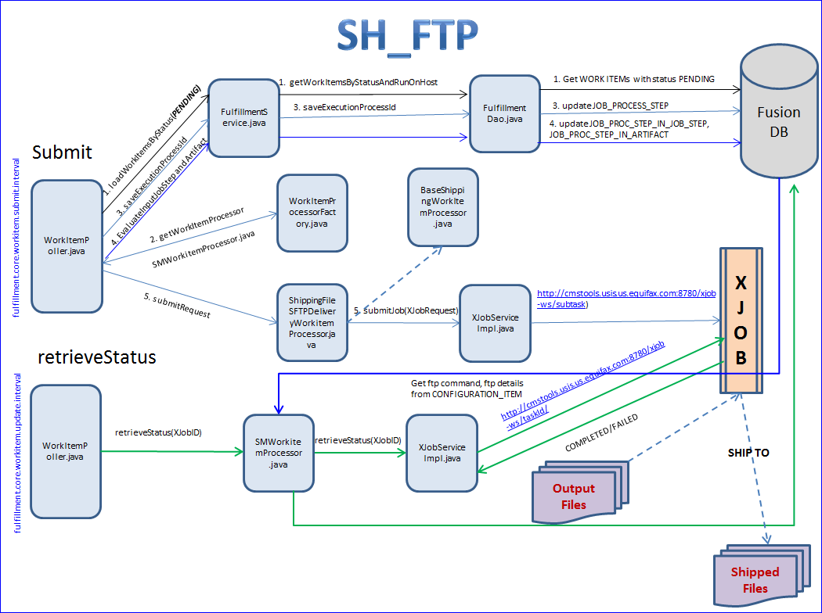

**2. SHP_ACCOUNTING**

This work item will send the details of the shipment file, the score models used, no of accepts, shipped etc to the project accounting team for accounting purpose.

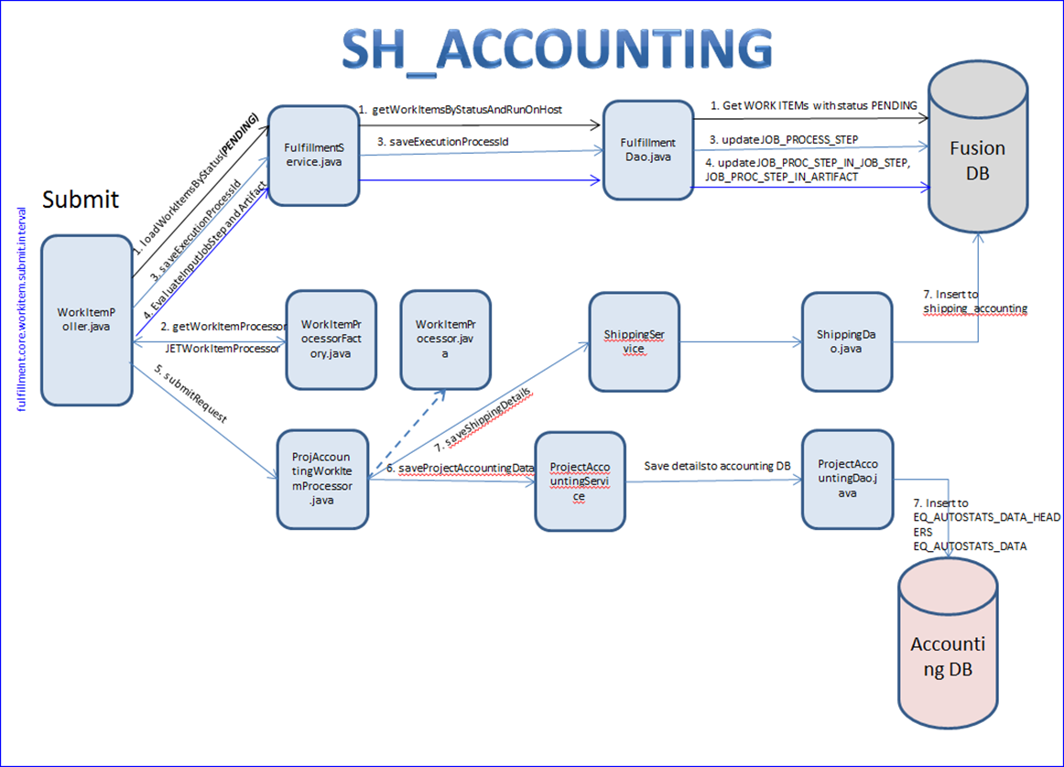

Below are the details which are sending to the accounting database

