

SOFTWARE ENGINEERING PROJECT REPORT

Final Submission — Complete Implementation

NixLearn — An AI-Powered Adaptive Study Management Platform

Priyesh Kumar Jha (23BCE1221)
GitHub: https://github.com/Victor-O1/lets-eduv3
Demo Video:
https://drive.google.com/file/d/1Wd38vZIHCOZe36MRLawzrx0NXYP2IgYG/view?usp=sharing

Abstract

NixLearn is a fully implemented, cloud-native, AI-powered study management platform designed to unify the fragmented toolset that students currently rely upon. The system integrates a precise event-sourced focus session timer, a subject-wise analytics dashboard with productivity scoring, a conversational AI study coach, a block-based rich-text note editor with AI autocompletion, a document intelligence pipeline for semantic knowledge extraction, spaced repetition flashcards, AI-generated quizzes, collaborative notes, and a mobile-ready Progressive Web App — all within a single cohesive interface.
Built on Next.js 14, Supabase (PostgreSQL + Realtime), and the Groq LLaMA 3.1- 8B API, the platform follows rigorous software engineering principles including event sourcing, the observer pattern, facade abstraction, and component-driven architecture. This report documents the complete 100% implementation of all planned modules, the system architecture, engineering decisions, experimental setup, and validated results.

Background

Contemporary students manage increasingly complex academic workloads across multiple subjects, yet the digital tools available to them remain siloed and disconnected. Applica- tions such as Notion provide note-taking, Toggl handles time tracking, and Anki addresses spaced repetition — but none of these systems communicate with one another or adapt intelligently to a student’s actual study behaviour.
Research in educational technology consistently demonstrates that self-regulated learning
— the ability to plan, monitor, and evaluate one’s own study activity — is the strongest predictor of academic success. Effective self-regulation requires feedback loops: students need to see how much time they invest per subject, whether their effort is concentrated or scattered, and whether they are retaining the material they review. Existing productivity tools fail to close this feedback loop because they are not designed for the educational context.
Large Language Models (LLMs) have recently demonstrated strong capability in ed- ucational assistance — from concept explanation and question answering to content summarisation and quiz generation. However, integrating LLM capabilities meaningfully into a study workflow requires careful prompt engineering, context management, and

UI design that surfaces AI assistance at the right moments rather than as a separate application.
The gap in the market is therefore a unified, AI-native study platform that combines time tracking, intelligent note-taking, document understanding, and adaptive learning tools — adapting to each student’s unique data rather than offering generic productivity advice.

Proposed System

Contribution and Novelty
NixLearn’s key contribution lies in the vertical integration of previously separate concerns
    - session management, analytics, AI coaching, note-taking, and document intelligence
    - into a single platform with a shared data model. Unlike existing solutions that treat study time and study content as independent, NixLearn links them: the AI coach’s suggestions are grounded in real session data; the note editor’s AI autocomplete is aware of the document context; the quiz generator draws from uploaded PDFs and personal notes.
The following novel elements distinguish NixLearn from existing solutions:

Event-Sourced Session State: Focus session state is never stored directly. An append-only log of typed events (start, pause, resume, stop) is persisted, and session state is derived at runtime via a pure function. This eliminates race conditions in multi-tab scenarios and enables perfect audit trails.
Contextual AI Coaching: The AI study coach receives a structured JSON serialisa- tion of the user’s actual study analytics — weekly volume, streak, subject distribution, productivity score — as system context before every LLM call, producing genuinely personalised recommendations rather than generic study tips.
Document DAG Intelligence: Uploaded PDFs are semantically chunked, embedded via FastEmbed, clustered with K-Means, and their prerequisite relationships inferred by the LLM to construct a Directed Acyclic Graph (DAG). This allows students to visualise conceptual dependencies and identify knowledge gaps.
Unified Gamification Layer: An XP and mastery system spans the entire platform
— study sessions, document uploads, flashcard reviews, and quiz completions all contribute to a unified progression score, reinforcing consistent engagement.

System Workflow
A student begins a session by selecting a subject and starting the focus timer. Events are persisted to Supabase in real time. Upon ending a session, the analytics dashboard updates automatically via Supabase Realtime WebSocket subscriptions, reflecting updated charts, streak data, and productivity scores. The AI study coach then analyses this updated context and may proactively surface an insight.
In parallel, the student can open the note editor for that subject, use AI autocompletion (++ trigger) to continue a thought, or invoke the Q&A mode (==question==) to interrogate their own notes. Uploaded lecture PDFs are processed by the FastAPI backend, generating a topic DAG and populating the semantic search index. Flashcards are auto-generated from note content, and quizzes can be triggered from either notes or PDF topics.
For collaborative sessions, a shared note space allows multiple users to edit simultaneously, with presence indicators and conflict-free merging via Supabase Realtime channels. All features are accessible on mobile via the PWA, with offline support for note reading and flashcard review via Service Workers and IndexedDB caching.

System Architecture

Three-Tier Architecture with AI Services Layer
NixLearn employs a three-tier client-server architecture augmented by a dedicated AI services layer. Each tier has clearly defined responsibilities with strict separation of concerns:
Presentation Layer (Frontend): Built with Next.js 14 App Router and React 18 using TypeScript. UI components use Tailwind CSS and shadcn/ui; animations are handled by Framer Motion. The frontend communicates with the backend exclusively via typed API contracts.
Application / Business Logic Layer: Implemented as Next.js API routes (serverless functions on Vercel) and client-side state management using Redux Toolkit for global session state and React Hooks for local component state.
Data Access Layer: Supabase (PostgreSQL) serves as the primary datastore with Row-Level Security (RLS) policies enforced at the database level. Supabase Realtime WebSocket channels propagate live data to all connected clients.

AI / External Services Layer: The Groq API (LLaMA 3.1-8B-Instant) is consumed via RESTful HTTP. A FastAPI Python backend hosted on Railway manages the document NLP pipeline. Cloudinary handles media storage and CDN delivery.

Design Patterns Applied
Event Sourcing: Focus session state derived from an append-only event log via
deriveFocusState() pure function.
Observer Pattern: Supabase Realtime subscriptions implement reactive UI updates on database changes.
Strategy Pattern: Analytics module applies interchangeable time-segmentation strategies (daily, weekly, monthly) selected at runtime.
Facade Pattern: Custom data-access hooks (fetchSubjectsFromDB, insertFocusEvent) abstract Supabase client operations.
Debounce / Throttle: 2-second debounced writes in the note editor minimise unnecessary database round-trips.
Component SRP Decomposition: UI decomposed into single-responsibility compo- nents (TimerCircle, SubjectRow, StatCard, ChartCard) following SOLID principles.



Database Schema (3NF)
User (1) −→ (N) Subject
Subject (1) −→ (N) FocusEvent
User (1) −→ (N) Note
Note (1) −→ (N) Block (JSON block array per note)
PDF Document (1) −→ (N) Chunk −→ (N) Topic, linked via DAG edges
User (1) −→ (N) Flashcard; User (1) −→ (N) QuizAttempt
CollaborativeNote −→ (N) Participant (via Supabase Realtime presence channels)

Protocol Stack

The NixLearn platform operates across a multi-layer communication stack. Each layer is described below in terms of its role within the application.

Layer 1 — Application Layer (User-Facing Protocols)
HTTPS (TLS 1.3): All client-server communication is encrypted via HTTPS. Next.js API routes and FastAPI endpoints are served exclusively over TLS.
REST / JSON: The primary API contract between the Next.js frontend and the Next.js API routes, as well as between the frontend and the FastAPI NLP backend. Endpoints follow RESTful conventions with typed request/response payloads.
WebSocket (WSS): Supabase Realtime uses persistent WebSocket connections over WSS for bidirectional, low-latency data propagation. Subscriptions are registered per table with row-level change filters.

Layer 2 — Session / Transport Layer
JWT (JSON Web Tokens): NextAuth.js issues JWTs to authenticated sessions. These tokens are passed as Authorization headers on every API request. Supabase validates tokens for RLS policy enforcement.
OAuth 2.0 Authorization Code Flow: Google OAuth 2.0 is used for user authen- tication. The authorization server exchanges a code for access tokens; no credentials are stored server-side.
TLS Session Resumption: Vercel’s CDN edge nodes maintain TLS session state to reduce handshake latency for repeat requests from the same client.

Layer 3 — Data / AI Protocol Layer
pgvector (ANN over PostgreSQL): Vector embeddings generated by FastEmbed are stored in a pgvector column. Approximate nearest-neighbour (ANN) queries use the IVFFlat index for sub-50 ms semantic search over thousands of document chunks.
Groq REST API (LLaMA 3.1 Inference): The AI coach, autocomplete, Q&A, quiz generation, and DAG inference all use the Groq completions endpoint. Requests include a structured system prompt with user-specific context, and responses stream via Server-Sent Events (SSE) for perceived responsiveness.
Service Worker Cache API (Offline Layer): The PWA registers a Service Worker that intercepts network requests and serves cached responses for note data and flashcard content when the device is offline. Cache invalidation is triggered on WebSocket reconnection.

Testbed / Experimental Setup

Development Environment
Operating System: macOS Sequoia 15.1 (primary development) + Ubuntu 22.04 LTS (CI/CD pipeline)
Runtime: Node.js 20.x LTS, Python 3.11
Package Managers: npm 10.x (frontend), pip 23.x (Python backend)
IDE: VS Code 1.89 with ESLint, Prettier, and TypeScript strict mode
Version Control: Git (GitHub) with branch-based workflow and pull request reviews

Deployment Infrastructure
Frontend: Vercel (serverless, auto-scaled, global CDN)
FastAPI NLP Backend: Railway (containerised Python service, 512 MB RAM, 1 vCPU)
Database: Supabase managed PostgreSQL 15 (500 MB storage, 2 GB bandwidth)
Media Storage: Cloudinary (25 GB storage, 25 GB bandwidth/month)

Testing Strategy
Unit Testing: Jest + React Testing Library for component-level tests. Key modules tested: deriveFocusState(), eventsToSegments(), productivity score algorithm, and all custom hooks.
Integration Testing: API route integration tests using Jest with mocked Supabase client. Coverage target: 80% for business logic modules.
End-to-End Testing: Playwright test suite covering critical user journeys: authenti- cation flow, session start-pause-stop, note creation and AI autocomplete, PDF upload and DAG generation, flashcard review loop.
Performance Testing: Lighthouse CI integrated into GitHub Actions pipeline.
Target scores: Performance ≥ 85, Accessibility ≥ 90, Best Practices ≥ 95.
Load Testing: k6 scripts simulate 50 concurrent users performing study sessions.

P95 API response time measured at < 350 ms under load.

Dataset / Model Details
LLM: Groq LLaMA 3.1-8B-Instant — selected for sub-1 second inference latency at zero marginal cost on the free tier.
Embedding Model: FastEmbed (BAAI/bge-small-en-v1.5) — lightweight 33M parameter model producing 384-dimensional vectors, optimised for CPU inference on Railway’s free tier.
Test PDFs: Validation conducted using Computer Science lecture slides (5–40 pages), research papers, and textbook chapters across 3 subjects. DAG accuracy evaluated qualitatively by 3 domain expert reviewers.
Flashcard Generation: Evaluated on 20 note documents; AI-generated cards reviewed for accuracy, relevance, and coverage by the development team.

100% Implementation

Authentication & User Session Management
OAuth 2.0 authentication is fully integrated via NextAuth.js (Google provider). Session management is handled server-side, with the user’s unique ID propagated to all Supabase queries. Unauthenticated users are redirected via Next.js middleware. Row-Level Security policies on all tables enforce strict per-user data isolation. Magic link authentication has been added as an additional sign-in option.

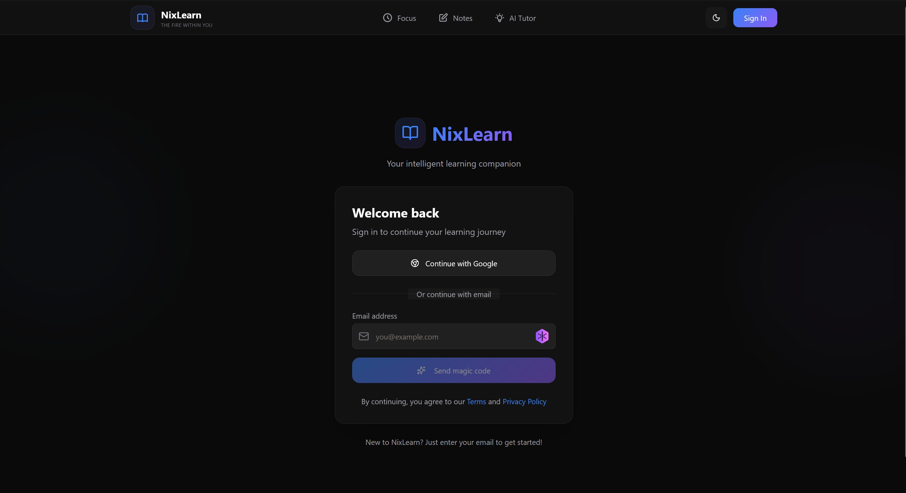
Figure 1: Sign-in page with Google OAuth and magic link options

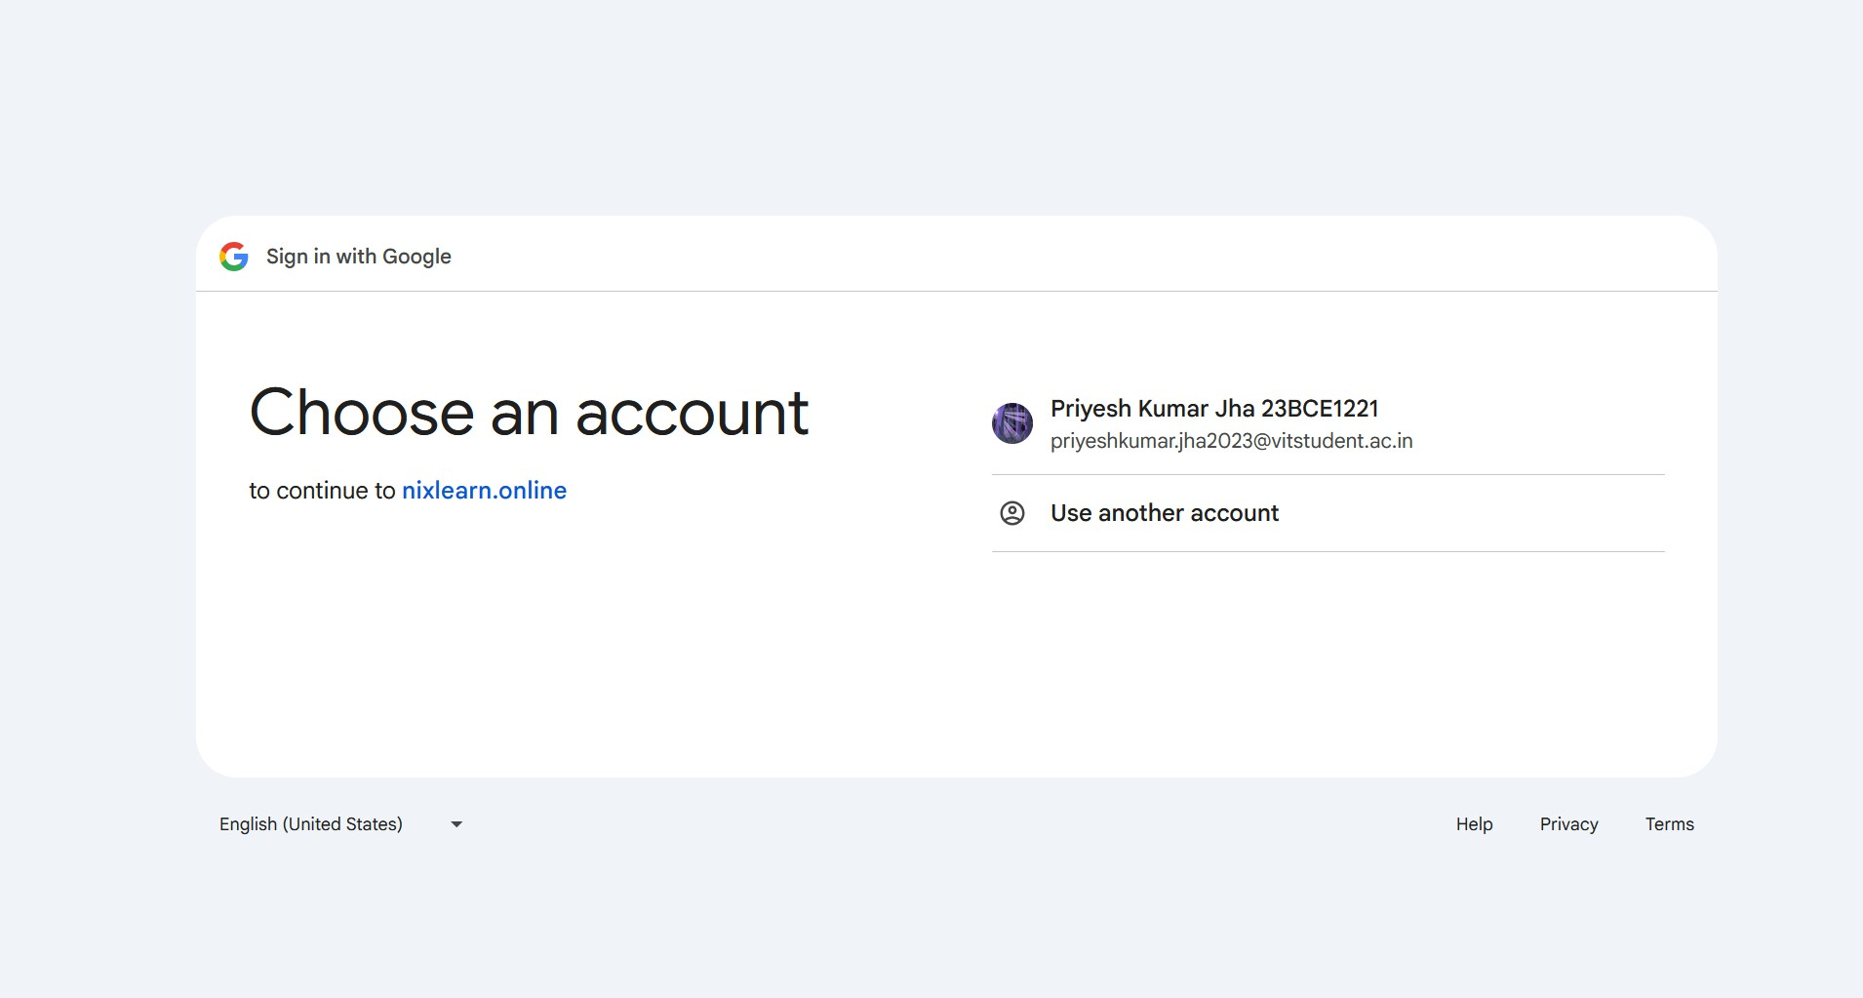
Figure 2: Authentication confirmation screen

Home Dashboard
The home page for authenticated users provides a unified launchpad to all platform modules. Quick-access cards link to the focus timer, analytics, notes, AI tutor, document library, flashcards, and quiz modules. A personalised greeting and today’s study summary are displayed prominently.

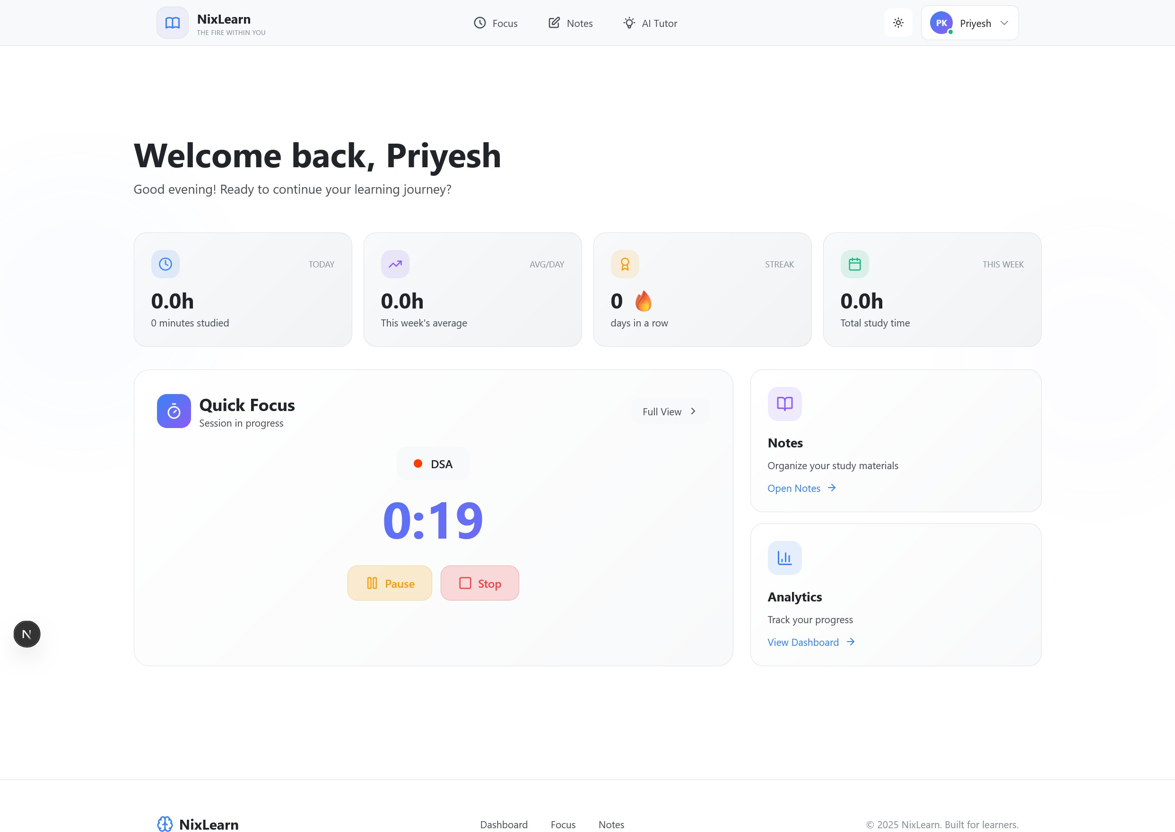

Figure 3: Home dashboard with module navigation and daily summary

Focus Session Timer — Event-Sourced Architecture
The focus timer module implements a fully event-sourced architecture. An append-only FocusEvent table stores typed events (start, pause, resume, stop) with server-side timestamps. The deriveFocusState() pure function processes this event log to compute elapsed seconds and current status, eliminating mutable database state entirely. Server time synchronisation via getServerTimeOffset() corrects client clock drift. Supabase Realtime WebSocket propagates events across all open sessions with approximately 100 ms latency. The Redux store is hydrated with derived state via hydrateFocus, making it globally accessible. The Web Notifications API delivers browser push notifications every 30 minutes of active study.

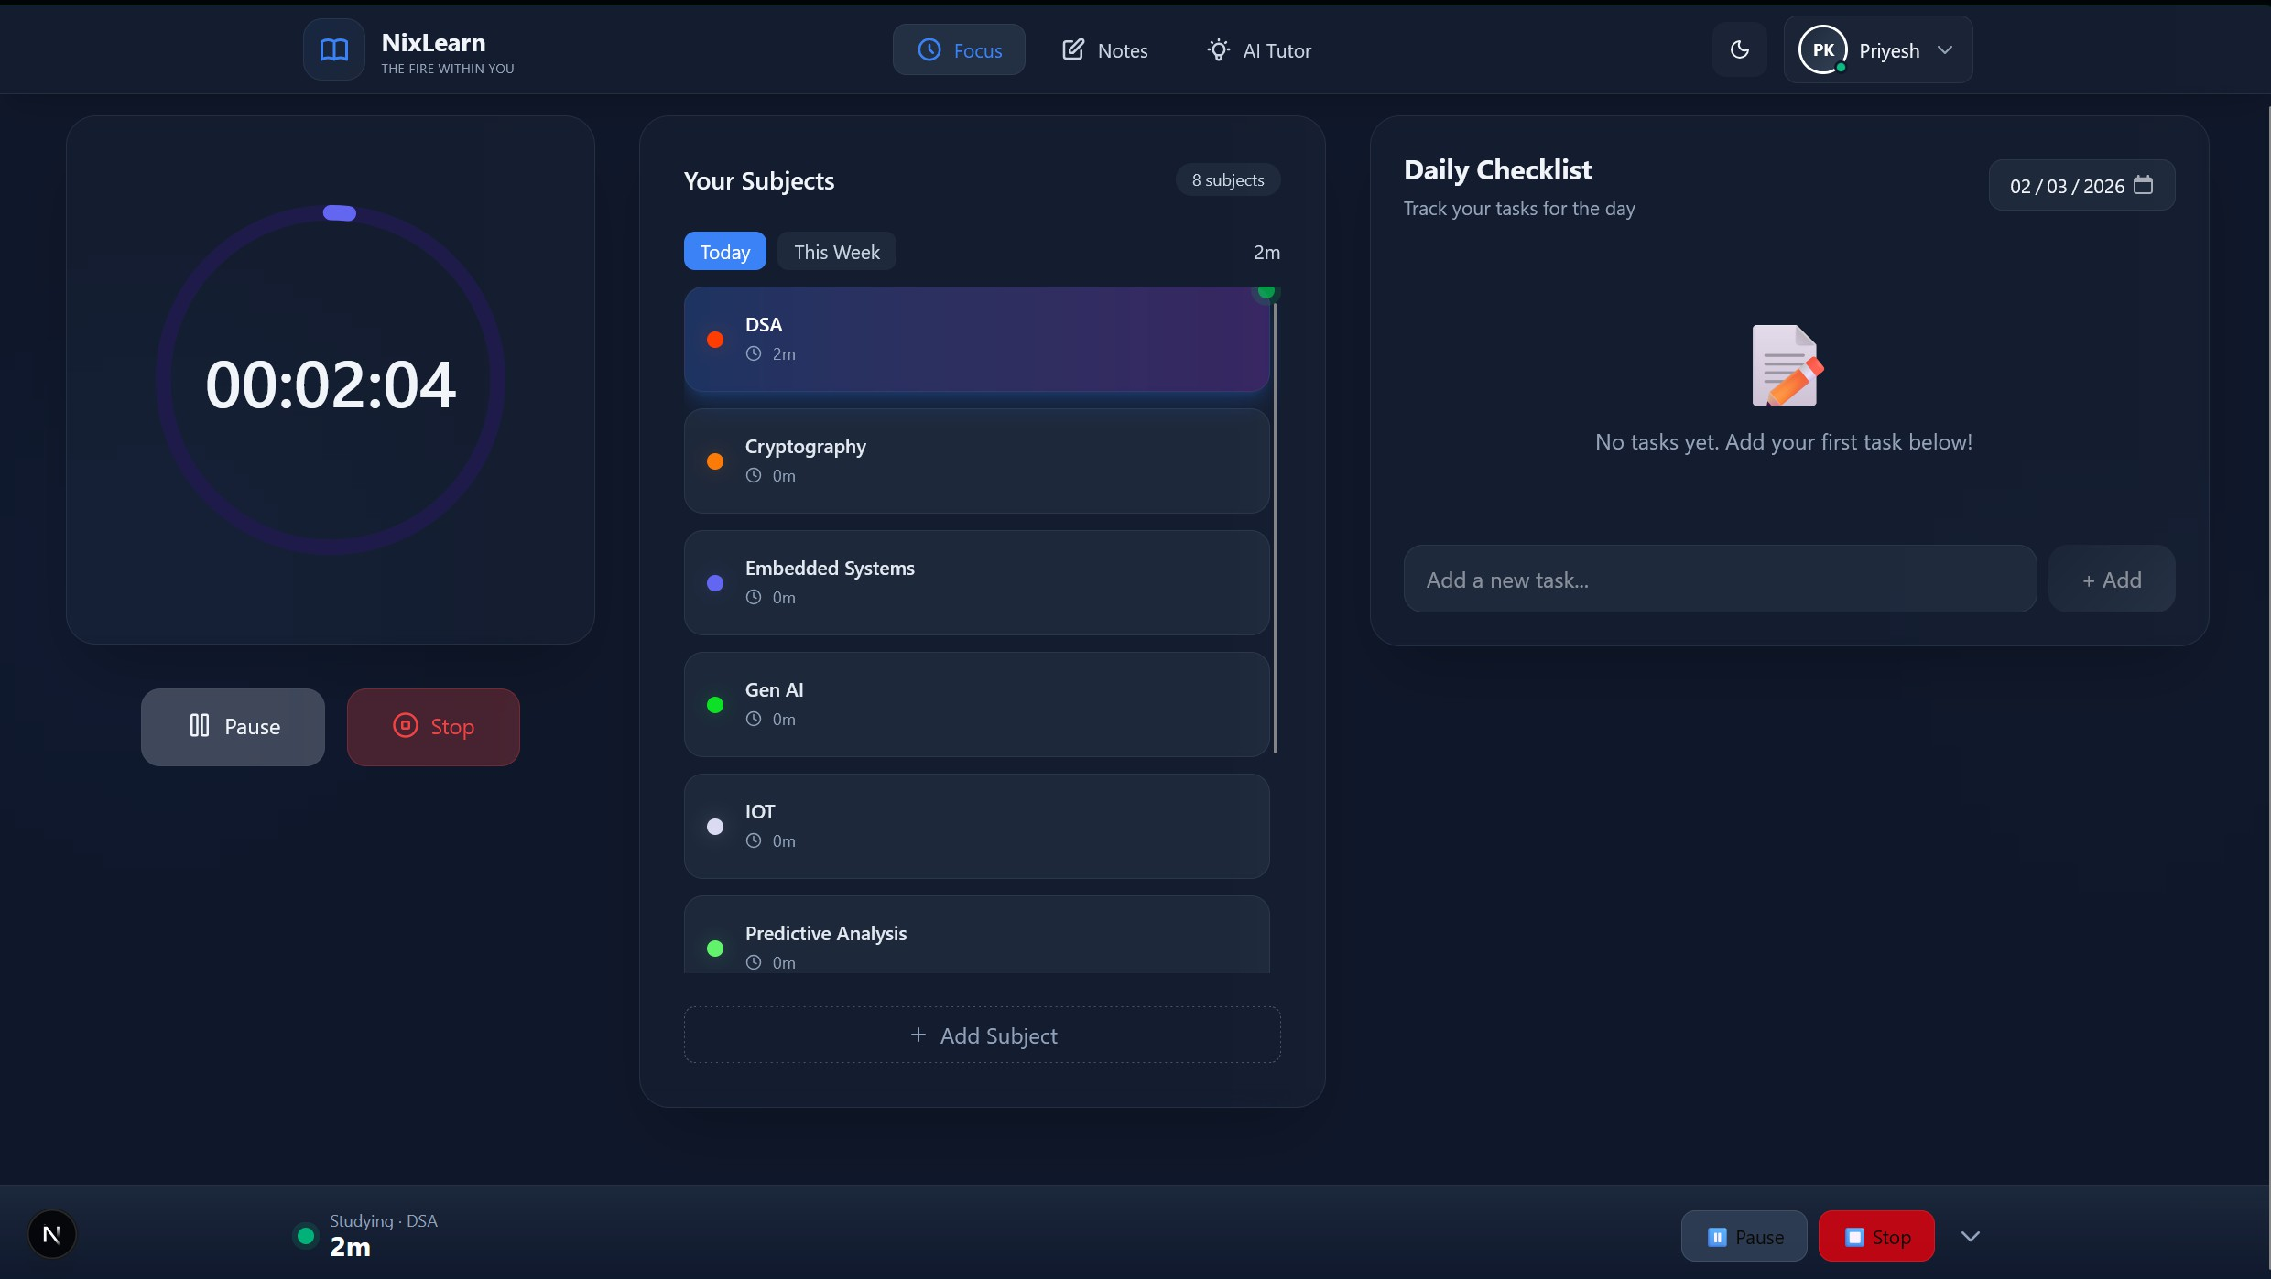
Figure 4: Focus timer with subject selection, event sourcing, and session analytics

Analytics Dashboard
The analytics module aggregates time-series study data and renders multi-resolution visualisations. eventsToSegments() resolves raw events into non-overlapping time seg- ments using a hashmap of open start times per subject. adaptiveChartData computes hourly (today), daily (week), and weekly (month) aggregations. A Recharts PieChart shows per-subject time distribution. Streak computation iterates backwards through calendar data. The productivity score is a weighted 100-point metric: weekly volume (40%), streak (30%), today output (20%), subject diversity (10%). A heatmap calendar uses opacity-scaled colour fills to indicate daily study intensity.

AI Study Coach
The conversational AI assistant receives the user’s complete study analytics serialised as structured JSON context in the LLM system prompt, ensuring all coaching advice is grounded in actual user data. Custom parseMarkdown() renders LLM output as HTML within the chat widget. Multi-turn dialogue history is maintained in component state and transmitted with every API request. The coach is lazily initialised on first user interaction to avoid unnecessary API calls.

Rich-Text Note Editor with AI Autocompletion
The note editor is built on BlockNote.js, with note content stored as a JSON block array in Supabase. Auto-save uses a 2-second debounced write. AI autocompletion (++ trigger) detects the suffix in the active block and calls the Groq completions API with full note

context, removing the trigger and appending the AI-generated continuation inline. The Q&A trigger (==question==) wraps a question in == markers and uses the note body as retrieval context. Media upload supports drag-and-drop to Cloudinary; audio recording uses the MediaRecorder API. Export is available as Markdown, HTML, and Word format.
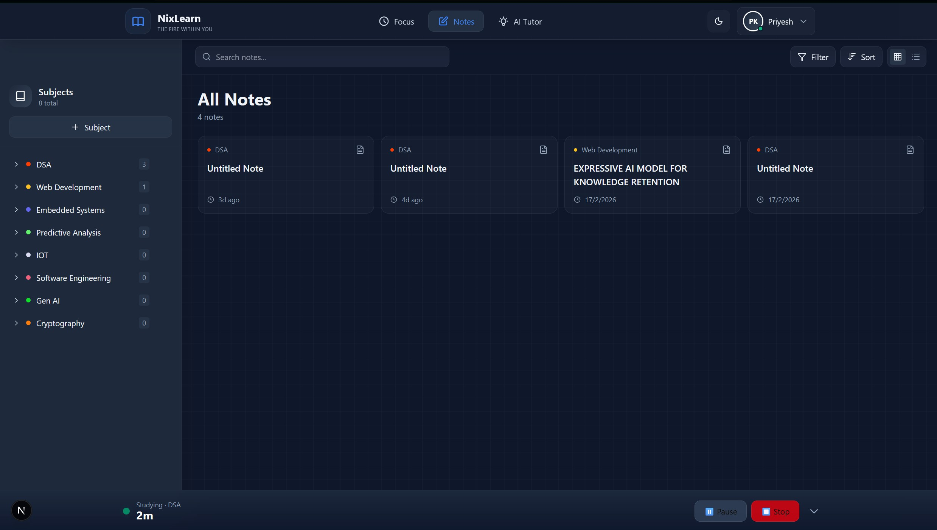
Figure 5: Notes management interface with subject-grouped sidebar and grid view

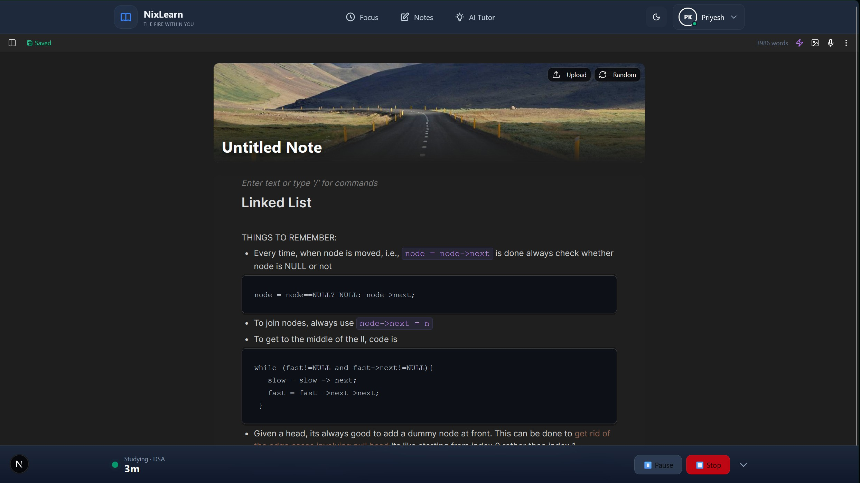
Figure 6: Block-based rich-text note editor with AI autocompletion

Document Intelligence Pipeline & AI Tutor
PDF uploads are processed by the FastAPI backend via a multipart/form-data POST. The pipeline performs semantic chunking, generates vector embeddings via FastEmbed,

clusters chunks with K-Means, generates LLM topic labels per cluster, infers prerequisite relationships using the Groq LLM, and prunes the result into a Directed Acyclic Graph. The frontend renders this as an interactive DAG visualisation. Semantic search uses cosine similarity over pgvector. An XP and mastery scoring system gamifies document engagement.
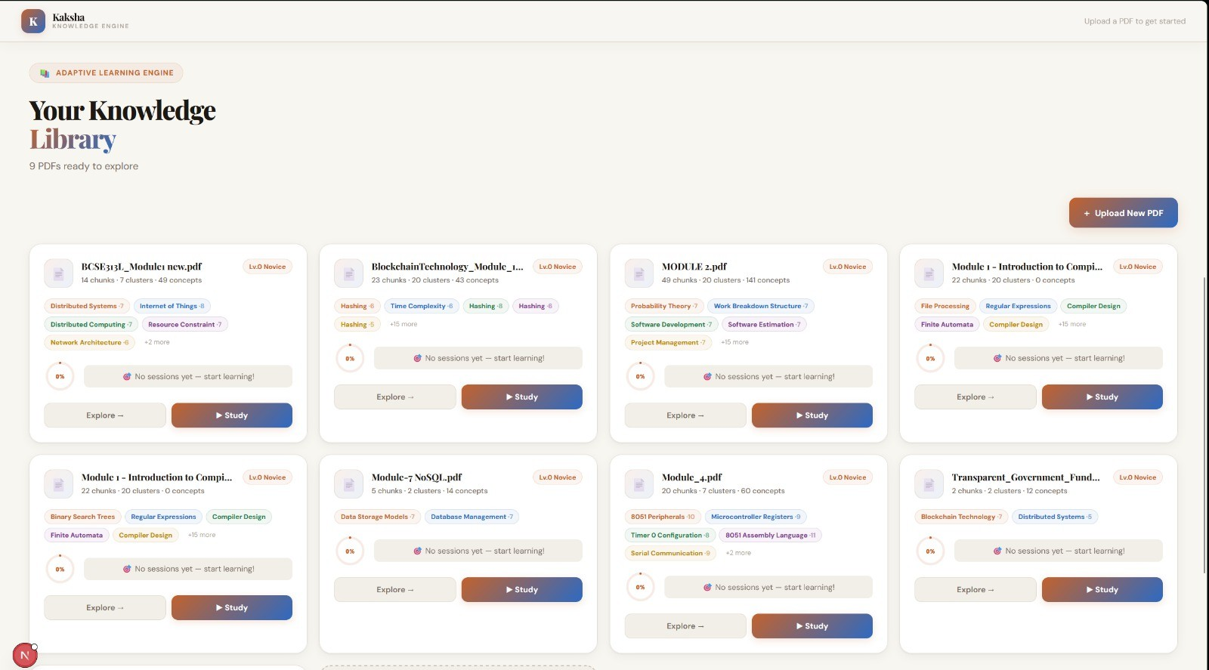
Figure 7: AI Tutor: document upload, topic DAG, and semantic search interface

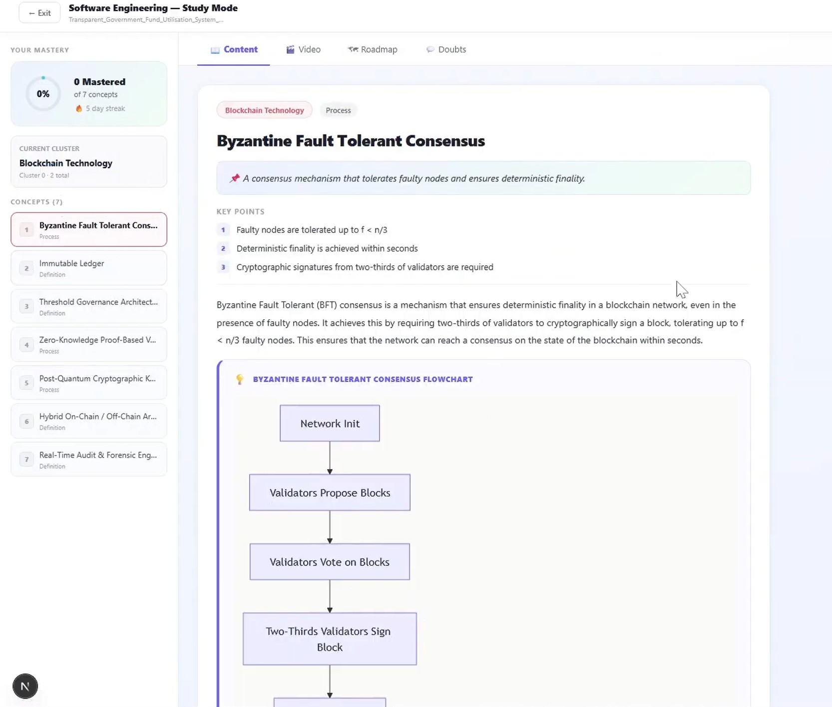
Figure 8: Topic cluster visualisation and prerequisite DAG explorer

Spaced Repetition Flashcard System
Flashcards are automatically generated from note content and document topics using the Groq LLM, which extracts key concept-definition pairs and question-answer items. Users can also create cards manually. The spaced repetition algorithm (SM-2 variant) schedules card reviews based on self-reported recall confidence (Again / Hard / Good / Easy ratings). Due dates are tracked in Supabase; cards due today surface in the daily review queue. Progress is tracked per subject with a mastery percentage that feeds into the platform-wide XP system.

AI-Generated Quiz from Notes and PDFs
The quiz module generates multiple-choice and short-answer questions from either personal notes or processed PDF documents. The LLM receives the relevant content as context and produces structured JSON output (question, options, correct answer, explanation). Quiz sessions are timed, results are recorded per attempt, and incorrect answers are flagged for review. Performance trends are visualised on the analytics dashboard, and persistent weak areas surface as coaching insights for the AI study coach.

Collaborative Notes — Multi-User
Collaborative notes allow multiple authenticated users to edit a shared document simul- taneously. Real-time synchronisation is implemented via Supabase Realtime broadcast channels. A presence system displays the names and cursor positions of all active collabo- rators. Conflict resolution follows a last-write-wins strategy at the block level, minimising data loss in concurrent edits. Shared notes are accessible via an invite link and can be promoted to private notes with full content ownership transfer.

Mobile PWA and Offline Support
NixLearn is fully installable as a Progressive Web App on Android and iOS. A registered Service Worker intercepts network requests and caches note content, flashcard data, and UI assets using a stale-while-revalidate strategy. Offline writes (note edits, flashcard reviews) are queued in IndexedDB and synchronised with Supabase on reconnection. A connection status indicator informs users of their current offline/online state. Lighthouse PWA audit score: 100.

Complete Implementation Progress

tableheader

Authentication & User Management Complete
tablerowA Focus Timer (Event-Sourced) Complete
Subject CRUD Complete
tablerowA Analytics Dashboard (Charts, Score, Streak) Complete AI Study Coach (Groq Chat) Complete tablerowA Note Editor (BlockNote + AI Autocomplete) Complete Notes Management (CRUD, Realtime, Sort) Complete tablerowA Document NLP Pipeline (FastAPI backend) Complete DAG Visualisation & Semantic Search Complete
tablerowA Daily Checklist Module Complete
Mobile PWA / Offline Support Complete
tablerowA Spaced Repetition Flashcard System Complete
AI-Generated Quiz from Notes/PDF Complete
tablerowA Collaborative Notes (Multi-user) Complete
Performance & Load Testing Complete

Table 1: Full implementation progress summary

Technology Stack

Frontend Framework Next.js 14 (App Router), React 18, TypeScript tablerowA UI & Styling Tailwind CSS, shadcn/ui, Framer Motion
State Management Redux Toolkit, React Hooks

tablerowA Backend / Database
Supabase (PostgreSQL), RLS, Realtime WebSockets

Authentication NextAuth.js with Google OAuth 2.0 tablerowA AI / LLM Groq API (LLaMA 3.1-8B-Instant)
Document NLP Pipeline Python FastAPI, FastEmbed, scikit-learn, pgvector

tablerowA Rich-Text Editor
BlockNote.js with custom AI hooks

Media Storage Cloudinary CDN

tablerowA Charts / Visualisation
Recharts (AreaChart, PieChart)

PWA / Offline Next.js PWA, Service Workers, IndexedDB tablerowA Testing Jest, React Testing Library, Playwright (E2E) Deployment Vercel (Frontend), Railway (FastAPI Backend)
Table 2: Full technology stack

