SYSTEM ANALYSIS

Overall System Design Using Designing Tools:

  - Main Modules of System:
The Shamballa temple website is thoughtfully structured into distinct modules, each serving a vital purpose in facilitating seamless navigation and user experience. Recognizing the importance of logical separation for efficient development and testing, our website modules are designed to uphold simplicity without compromising effectiveness. The systematic organization of our website ensures clarity and accessibility for visitors seeking spiritual guidance and connection. The different modules include:
    - Temple Information Module: Delve into the rich history, significance, and offerings of the Shamballa temple. Explore details on Darshan Time, Aarti Time, and captivating Photos and Videos capturing the essence of our sacred space.

    - Donation Module: Support our noble endeavors by contributing through our Donation module. Your generous donations help sustain our temple, support community initiatives, and uphold our spiritual mission. Every contribution makes a difference in nurturing our sacred space.

    - Shop Module: Explore divine treasures and spiritual essentials in our Shop module. Browse through a curated selection of merchandise inspired by Hindu culture, including sacred artifacts, religious literature, and handcrafted offerings. Each item reflects the spiritual essence of Shamballa.

    - Events Module: Stay connected with the vibrant tapestry of events and celebrations at Shamballa through our Events module.it shows upcoming events and recent events photos, videos and events information.

Feasibility Study

Before proceeding with the development of the Shamballa Temple website, we conducted a thorough feasibility study to assess its viability. This study focused on three key aspects:

- Technical Feasibility:
Developing a website requires specific software and hardware resources. Fortunately, Shamballa Temple possesses the necessary infrastructure or can easily acquire them. This technical readiness ensures that the project is technically feasible, laying a strong foundation for its development.
- Economical Feasibility:
The proposed website for Shamballa Temple is economically feasible. There are no significant investments or purchases required. The website primarily relies on basic resources such as hosting services and web development tools. This cost-effective approach minimizes financial burden while achieving our website's objectives.
- Operational Feasibility:
Currently, Shamballa Temple operates with manual processes. This includes managing temple activities, events, and donations. The proposed website aims to streamline these operations by automating complex tasks such as shop, donation, event scheduling, and information dissemination. By implementing this system, we enhance operational efficiency and provide a user-friendly experience for both temple administrators and visitors.

DATA DICTIONARY

Table Name :- Admin
Database Name :- Shamballa |  |  |  | : Primary Key :
Foreign Key :- |  |  |  | Reference :-
Sr.  No. | Field  Name |  | Data Types | Field Size  (bytes) |  | Format | Null | Description
1 | Name |  | varchar | 50
2 | Password |  | Int | 10 |  | User Input
Total No Of Fields  5 |  | One Row Size  (in bytes)  60 |  |  | No of Records expected |  |  |  | Overall Size Of Table
: Table Remark:
This table describes the admin

Table Name :- donation
Database Name :-Shamballa |  |  |  | Primary Key :  D_ID
Foreign Key :-Email |  |  |  | Reference :-
Sr.  No. | Field  Name |  | Data Types | Field Size  (bytes) |  | Format | Null | Description
1 | D_id |  | Int | 11 |  |  | No | Unique identifier for each  donation record.
2 | D_name |  | Varchar | 40 |  | User Input | Not null
3 | Email |  | Varchar | 40
4 | D_amount |  | Decimal | 10,2
5 | D_date |  | Date |  |  |  | Not null
6 | Pay_method |  | Varchar | 30
7 | Tran_id |  | varchar | 30 |  |  | Null
Total No Of Fields  7 |  | One Row Size  (in bytes)  161 |  |  | No of Records expected |  |  |  | Overall Size Of Table
: Table Remark:
This table describes the donation

Table Name :- Events
Database Name :- Shamballa |  |  |  | : Primary Key :  E_ID
Foreign Key :- |  |  |  | Reference :-
Sr.  No. | Field  Name |  | Data Types | Field Size  (bytes) |  | Format | Null | Description
1 | E_ID |  | Int | 10 |  |  | No | Auto increment
2 | E_  name |  | Varchar | 30 |  | User Input |  | User input name
3 | E_date |  | Date |  |  |  | Not null
4 | E_time |  | Time | 8 |  |  | Not null
5 | E_location |  | Varchar | 50 |  |  | Not null
Total No Of Fields  5 |  | One Row Size  (in bytes)  98 |  |  | No of Records expected |  |  |  | Overall Size Of Table
: Table Remark:
This table describes the events

Table Name :- Product
Database Name :- Shamballa |  |  |  | : Primary Key :  P_ID
Foreign Key :- |  |  |  | Reference :-
Sr.  No. | Field  Name |  | Data Types | Field Size  (bytes) |  | Format | Null | Description
1 | P_ID |  | Int | 10 |  |  | No | Auto increment
2 | P_name |  | Varchar | 30 |  | User Input | Not null
3 | P_des |  | Text
4 | p_price |  | Decimal |  |  |  | Not null
5 | Stock_qun |  | Int | 50 |  |  | Not null
Total No Of Fields  5 |  | One Row Size  (in bytes)  90 |  |  | No of Records expected |  |  |  | Overall Size Of Table
: Table Remark:
This table describes the product

Table Name :- registraction
Database Name :- Shamballa |  |  |  | : Primary Key :  user_ID
Foreign Key :- |  |  |  | Reference :-u_name,email
Sr.  No. | Field  Name |  | Data Types | Field Size  (bytes) |  | Format | Null | Description
1 | User_ID |  | Int | 10 |  |  | No | Auto increment
2 | U_  name |  | Varchar | 50 |  | User Input
3 | Password |  | Varchar | 40 |  |  | Not null
4 | email |  | Varchar | 50 |  |  | Not null
5 | Phone no |  | Varchar | 10 |  |  | Not null
6 | Address |  | Varchar | 100 |  |  | Not null
7 | Regi_date |  | datetime
Total No Of Fields  7 |  | One Row Size  (in bytes)  260 |  |  | No of Records expected |  |  |  | Overall Size Of Table
Table Remark:
This table describes the registration

Table Name :- order
Database Name :- Shamballa |  |  |  | : Primary Key :  order_ID
Foreign Key :-user_id |  |  |  | Reference :-
Sr.  No. | Field  Name |  | Data Types | Field Size  (bytes) |  | Format | Null | Description
1 | order_ID |  | Int | 30 |  |  | No
2 | User_id |  | Int | 30 |  | User Input
3 | I_name |  | Varchar | 30 |  |  | Not null
4 | quantity |  | Int | 30 |  |  | Not null
5 | O_price |  | Decimal | 10,2 |  |  | Not null
6 | Tot_amt |  | Decimal | 10,2
7 | 0_date |  | Datetime
8 | Status |  | Varchar | 50
Total No Of Fields  8 |  | One Row Size  (in bytes)  190 |  |  | No of Records expected |  |  |  | Overall Size Of Table
: Table Remark:
This table describes the order

Table Name :- payment
Database Name :- Shamballa |  |  |  | : Primary Key :  Pay_ID
Foreign Key :- |  |  |  | Reference :-
Sr.  No. | Field  Name |  | Data Types | Field Size  (bytes) |  | Format | Null | Description
1 | pay_ID |  | Int | 30 |  |  | No
2 | User_id |  | Int | 30 |  | User Input
3 | Pay_amt |  | Decimal
4 | Pay_date |  | Datetime | 19 |  |  | Not null
5 | Pay_method |  | Varchar | 30 |  |  | Not null
6 | Pay_status |  | Enum | 8
7 | Tran_id |  | Varchar | 30
Total No Of Fields  8 |  | One Row Size  (in bytes)  147 |  |  | No of Records expected |  |  |  | Overall Size Of Table
: Table Remark:
This table describes the payment

ER-DIAGRAM

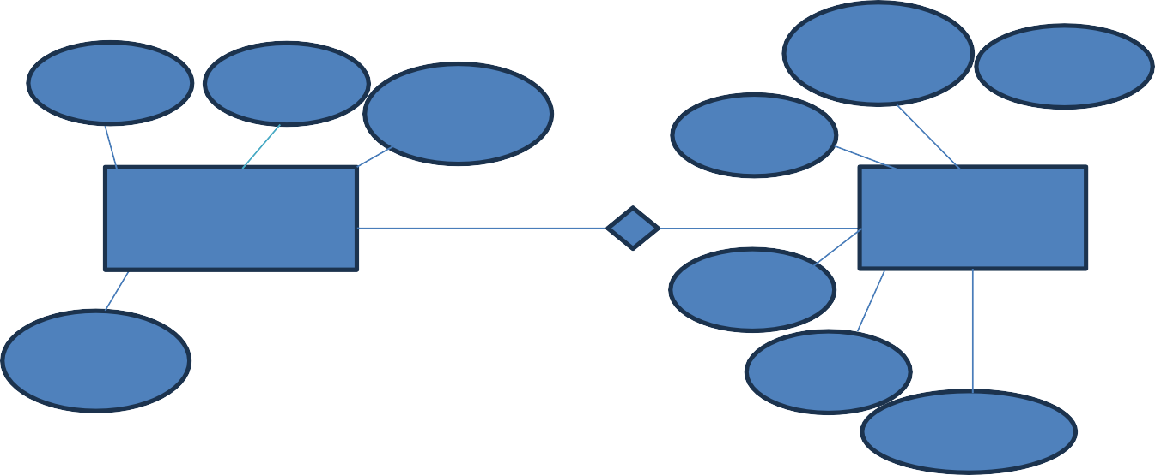
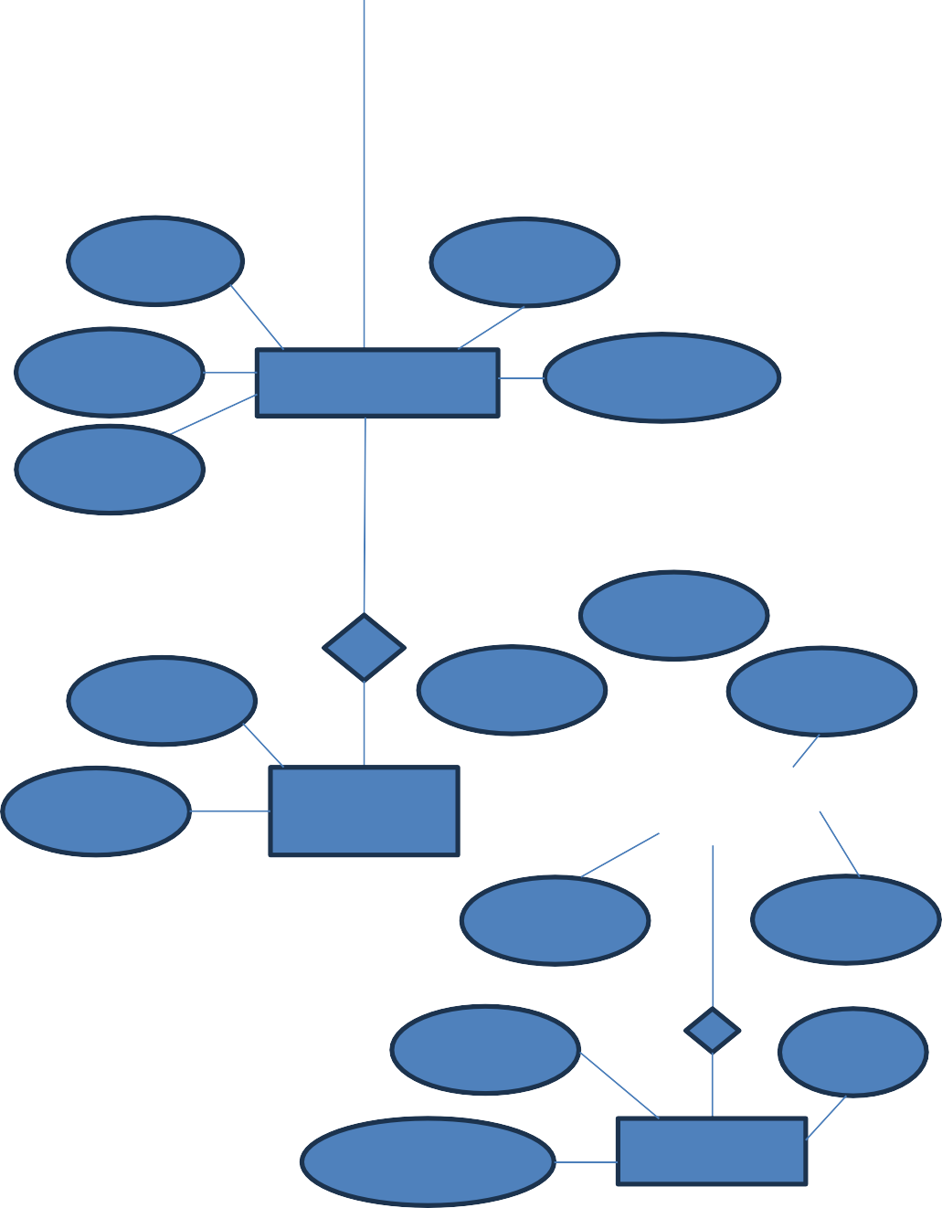

U_name
User_id

Password

D_id
D_Name T_ID

Admin 1 M Donation

D_Date

Email Email

D_Amount

E_id E_Time

E_Name Events E_Location E_Date

P_Id

U_Id O_Id P_Name

O_Date Order
Product

Price Desc

Pay_Id Type

Pay_Amount Payment

