System Development Life Cycle
- The system development life cycle (SDLC) is a formal way of ensuring that adequate security controls and requirements are implemented in a new system or application. Integrating technologies and practices into the development of new system and application deployments provides an opportunity to design security into the solution on the front end of the process, rather than retrofitting it after the solution is deployed.











Preliminary investigation
System Requirement
Implementation
System
Development Life Cycle
Design of System
Testing
Development

Various Phases of Life Cycle:

- Preliminary analysis:
  - To identify the real problem of the system with all necessary user requirements is called preliminary investing of the system. The preliminary investigation of the project or system is helpin:

    - Conduct the preliminary analysis: Discover the system or project objectives and the nature and scope of the problem under study. Even if a problem refers only to a small segment of the system itself, find out what the objectives of the system itself are. Then see how the problem being studiedfits in with them.

    - Propose alternative solutions: After analyses into the system objectives and specific problems, several solutions may have been discovered.
    - Cost benefit analysis: Analyze and describe the costs and benefits of implementing the proposedchanges. In the end, the ultimate decision on whether to leave the system as is, improve it, or develop a new system will be guided by this and the rest of the preliminary analysis data.

Systems analysis, requirements definition:

  - Define project goals into defined functions and operations of the intended application. This involves the process of gathering and interpreting facts, diagnosing problems, and recommending improvements to the system. Project goals will be further aided by analysis of end-user information needs and the removal of any inconsistencies and incompleteness inthese requirements.

A series of steps followed by the developer include:

    - Collection of facts: Obtain end user requirements through documentation, study about system, observation, and questionnaires.
    - Analysis of the proposed system: Find solutions to the shortcomings described in step two and prepare the specifications using any specific user proposals.

Systems design:
  - At this step desired features and operations are described in detail, including screen layouts, business rules, process diagrams and other documentation.

  - Develop detailed design specifications that translate functional specifications into a logical and physical design. Detailed design specifications are developed during the design phase of the SDLC and describe how the system or application is designed to satisfy the requirements documented in thefunctional specifications.
Detailed design specifications should include the following:

    - Database requirements — relationship between data elements.
    - System flow diagram — sequential flow of programs that are executed, their relationships to inputsand outputs, and security provisions between programs.
    - Program requirements — programs used and their purpose, description of formulas and calculations, and interrelationships between programs.
    - Screen designs — fields in each screen, purpose of each field, description of how each screen is triggered, logical flow of screens specifying screens that pull other screens, input checks performed, and description of error messages.
    - Report designs — data contained in each field of each report and a definition of how each data result is derived.
    - Security design — description of access control mechanisms, audit log provisions, user authentication and encryption provisions.

Development:
  - The development phase is where the system or application’s security features are developed, configured and enabled. Use the program specifications to describe the program logic and processing requirements. Program specifications are developed as part of the development phase prior to the commencement of programming. These specifications provide the thought process required to determinethe steps to code the programs.

System Testing:
  - The system testing is used experimentally to ensure that the project works is perfectly or completely. Data are input in the system and the result of the system performance is checked for data processing. Testing is performed by analyst, user and persons who are not at all connected with the system that help to the developer to developed well system for real environment.

Implementation:
  - The implementation view of software requirement presents the real world manifestation of processing functions and information structures. This computerized system is specified in a manner that dictates accommodation of certain implementation details.

Data Flow Diagram (DFD)

Introduction
  - A data flow diagram shows how data is processed within a system based on inputs and outputs. Visual symbols are used to represent the flow of information, data sources and destinations, and where data is stored. Data flow diagrams are often used as a first step toward redesigning a system. They provide a graphical representation of a system at any level of detail, creating an easy-to- understand picture of what the system does. A general overview of a system is represented with a context diagram, also known as a level 0 DFD, which shows a system as a single process. A level 1 diagram provides greater detail, focusing on a system’s main functions. Diagrams that are level 2 or higher illustrate a system’s functioning with increasing detail. It’s rare for a DFD to go beyond level 2 because of the increasing complexity, which makes it less effective as a communication tool.
- RULES FOR DFD:
- Fix the scope of the system by means of context diagrams.
- Organize the DFD so that the main sequence of the actions
- Reads left to right and top to bottom.

- Identify all inputs and outputs.
- Identify and label each process internal to the system with Rounded circles.
- A process is required for all the data transformation and Transfers. Therefore, never connect a data store to a data Source or the destinations or another data store with just a Data flow arrow.
- Do not indicate hardware and ignore control information.
- Make sure the names of the processes accurately convey everything the process is done.
- There must not be unnamed process.
- Indicate external sources and destinations of the data, with Squares.
- Number each occurrence of repeated external entities.
- Identify all data flows for each process step, except simple Record retrievals.
- Label data flow on each arrow.
- Use details flow on each arrow.
- Use the details flow arrow to indicate data movements.

Data Flow Diagram Notaions

- DFDs are designed in a way so that it will become easier to understand DFD as well as its base system.

- Even drawing DFD is also an easy task to perform because all drawn DFDs use unified notations to represent the system.

- These notations are divided into 2 categories.

  - Yourdon
  - Gane – Sarson.

- Four basic notations are used to draw DFD…

External Entity:

Yourdon and Coad Gane and Sarson
  - Also known as actors, sources or sinks, and terminators, external entities produce and consume data that flows between the entity and the system being diagrammed. These data flows are the inputs and outputs of the DFD. Since they are external to the system being analyzed, these entities are typically placed at the boundaries of the diagram. They can represent another system or indicate a subsystem.

Process:

Yourdon and Coad Gane and Sarson
  - An activity that changes or transforms data flows. Since they transform incoming data to outgoing data, all processes must have inputs and outputs on a DFD. This symbol is given a simple name based on its function, such as “Ship Order,” rather than being labeled “process” on a diagram. In Gane- Sarson notation, a rectangular box is used and may be labeled with a reference number, location of where in the system the process occurs and a short title that describes its function. Processes are typically oriented from top to bottom and left to right on a data flow diagram.

Data Store:

Yourdon and Coad Gane and Sarson
  - A datastore does not generate any operations but simply holds data for later access. Datastores could consist of files held long-term or a batch of documents stored briefly while they wait to be processed. Input flows to a data store include information or operations that change the stored data. Output flows would be data retrieved from the store.

Data Flow:
Yourdon and Coad Gane and Sarson
  - The movement of data between external entities, processes, and data stores is represented with an arrow symbol, which indicates the direction of flow. This data could be electronic, written, or verbal. Input and output data flows are labeled based on the type of data or its associated processordata store, and this name is written alongside the arrow.

- Context Level DFD / 0 Level DFD:

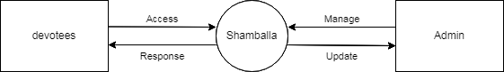

- 1st Level User DFD

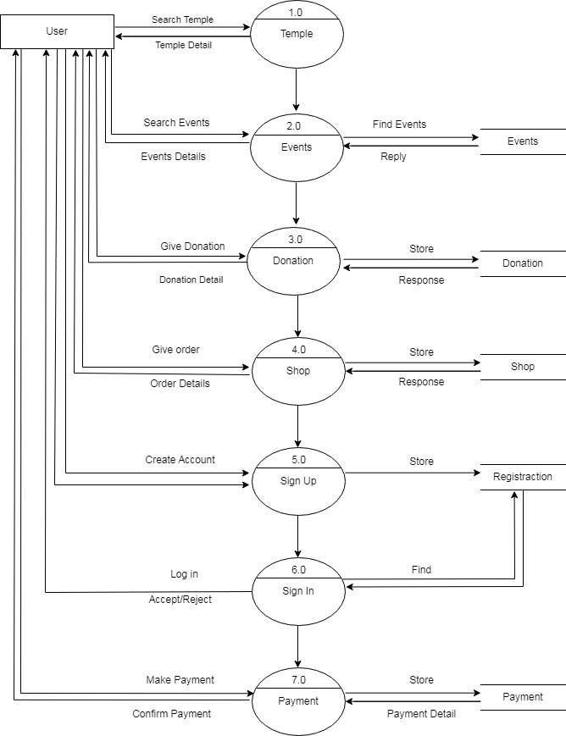

- 1st Level Admin DFD
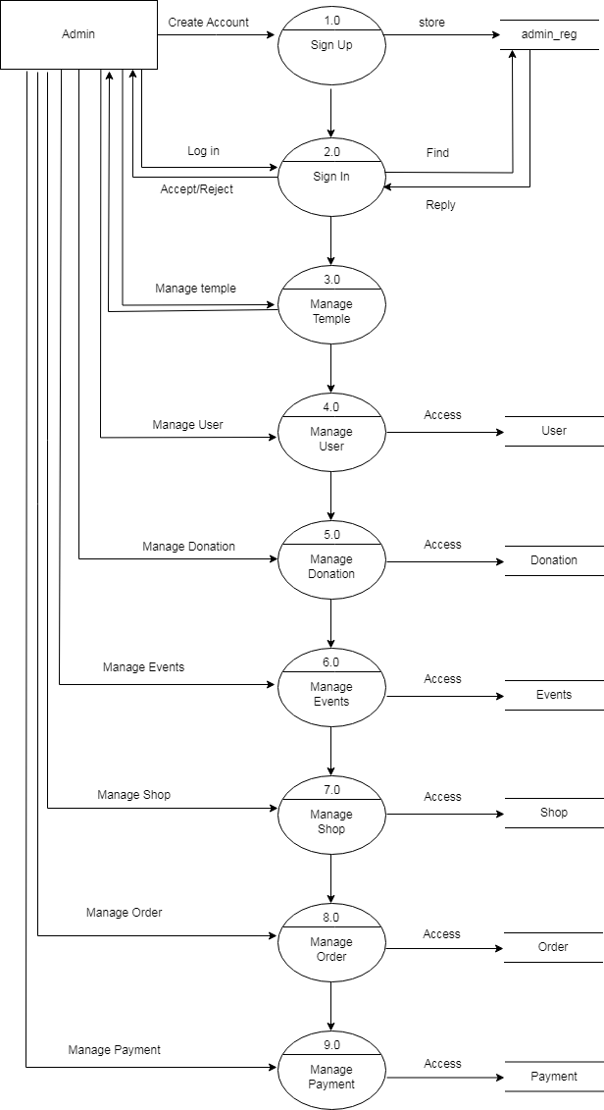

- 2nd Level User DFD
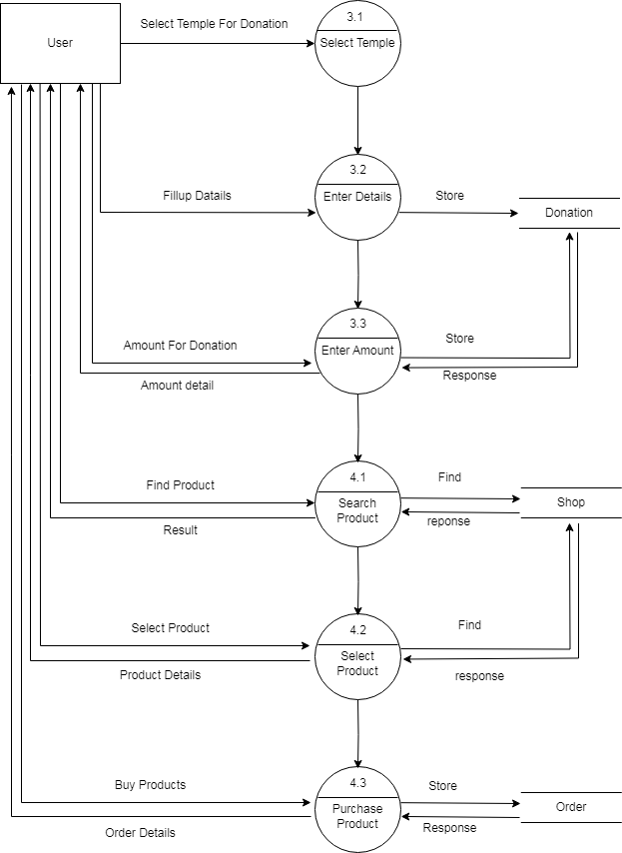

- 2nd Level Admin DFD
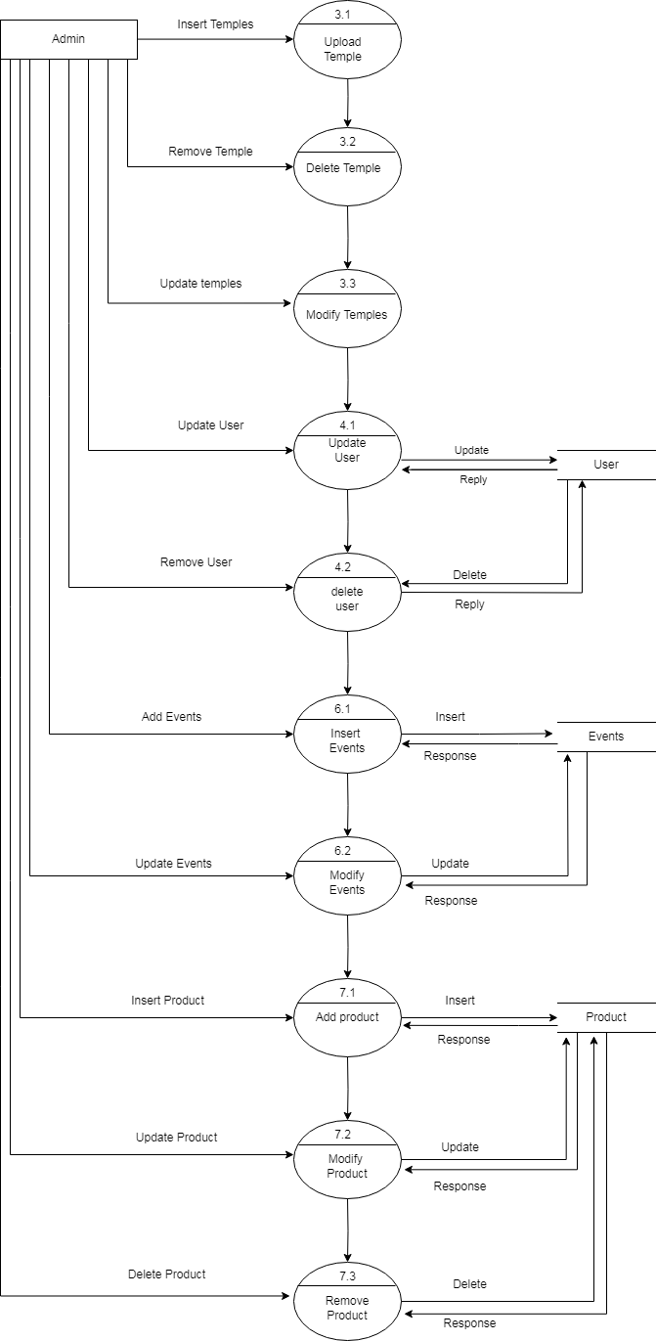

Organizational Process Chart
