- What is Testing?

  - Software testing can be stated as the process of verifying and validating that software or application is bug-free, meets the technical requirements as guided by its design and development, and meets the user requirements effectively and efficiently with handling all the exceptional and boundary cases.

  - The process of software testing aims not only at finding faults in the existing software but also at finding measures to improve the software in terms of efficiency, accuracy, and usability. It mainly aims at measuring the specification, functionality, and performance of a software program or application.

- Testing Objective

- Testing is the process of executing a program with the intend of finding an error. A good test case is one that has high profitability of finding an as yet discovered error. A successful test is one that uncovers a yet undiscovered error.

- Type of Testing:

- Code Testing
- Unit testing
- Integration testing
- Validation testing
- System testing
- Output testing
- User acceptance testing

- Code Testing:
- This was done side by side with coding thus examines the logic of the program. Every path of the program was tested.
- Unit Testing:

- To locate errors focus is given on the modules, independent of the other modules. This is known as unit testing. This enables us to detect errors and correct it without affecting any other modules. Thus, all the modules are individually tested from bottom up starting with the smallest level modules and proceeding one at a time.

- Integration Testing:
- Once the unit testing are through then the unit is integrated with the package and tested for its correctness and behaviors. A comprehensive integrated testing includes integrated test plans in the design phase of system.

- Validation Testing:

- At the conclusion of the integrated testing, software is completely assembled as a package. Interfacing errors have been uncovered and correlated. Then as find series of software test validation tests are carried out.
- System Testing:

- System testing is a series of different tests that verify all system elements have been properly integrated and performed allocated functions. Recovering testing was conducted by forcing the system to fail in all possible ways and verify that recovering is properly performed. Security test was conducted to verify that protection mechanism built into the system protects it from improper penetration.

- Output Testing:

- After performing the validation testing the next step is output testing of the proposed system since no system could be useful if it does not produce the output is the required format. Comparing the output with the format required by the user is output testing.

- User Acceptance Testing:

- User acceptance of a system is the key factor for the success of any system. The system under consideration was tested for user acceptance by constantly keeping the touch with the users of the organization necessary changes were made.

Different techniques of Software Testing:

- Black Box Testing:
  - The technique of testing in which the tester doesn’t have access to the source code of the software and is conducted at the software interface without concern with the internal logical structure of the software is known as black-box testing.

White-Box Testing:
  - The technique of testing in which the tester is aware of the internal workings of the product has access to its source code and is conducted by making sure that all internal operations are performed according to the specifications is known as white box testing.

- Test Cases

- What is a Test case?

  - A test case is a document, which has a set of test data, preconditions, expected results, and post conditions, developed for a particular test scenario in order to verify compliance against a specific requirement.

  - Test Case acts as the starting point for the test execution, and after applying a set of input values; the application has a definitive outcome and leaves the system at some endpoint or also known as execution post condition.

Typical Test Case Parameters:

  - Test Case ID
  - Test Scenario
  - Test Case Description
  - Test Steps
  - Prerequisite
  - Test Data
  - Expected Result
  - Test Parameters
  - Actual Result
  - Environment Information
  - Comments

Test Case Number | 1
Name | Valid Backend Admin Login
Description | This test case will check and allow administrator to log-in to system administrator / the backend of Second opinion system.
Input Data | - Enter valid username  - Enter valid password
Expected Output | - System need to check if username and password is valid into admin My SQL database.  - Case 1: If username and password are match and found from database then allow to access system (by forwarding to Dashboard screen).  - Case 2: If username and password does not match in database then give message “Invalid Login Attempt”
Actual Result | System allowed login.

Test Case Number | 2
Name | Valid Signup User
Description | This test case will allow user to “request” to access Shamballa to administrator by fill-up Sign up.
Input Data | - Enter valid username  - Enter valid password  - Enter confirm password
Expected Output | - All fields are compulsory / require  - Username should be valid  - Enter valid password  - Enter confirm/renter password
Actual Result | System allow to store user and access system

Test Case Number | 3
Name | Valid Login User
Description | In this case only existing User can logged in.
Input Data | - Enter your username  - Enter your password
Expected Output | - Username and password should be compulsory / require.  - Without username and password can Entered a website.
Actual Result | System allow login.

Test Case Number | 4
Name | User Temple Donation.
Description | In this case only existing User can logged in.
Input Data | - Enter you donor name  - Enter Mobile number  - Select Temple
Expected Output | - All are compulsory / require.  - Choose donation method.  - Case 1:-Donation successfully redirect to donation page.  - Case 2:-Donation Unsuccessfully then
Actual Result | As expected.

Test Case Number | 5
Name | Buy a Product
Description | In this case User can Buy a Temples Related Product.
Input Data | - Enter your full name  - Enter Mobile number  - Enter Email Address  - Enter Pincode
Expected Output | - All are compulsory / require.  - Enter your full name  - Enter your mobile number.  - Enter valid email address.  - Enter Your Pincode
Actual Output | As expected.

Test Case Number | 6
Name | Admin add product
Description | In this case Admin can Add a Temples Related Product with admin panel.
Input Data | - Enter product id.  - Enter Temple Product image.  - Enter product name.
Expected Output | - Admin can add product image ,id and product name.
Actual Output | As expected.

- Screenshot

- Home page:-

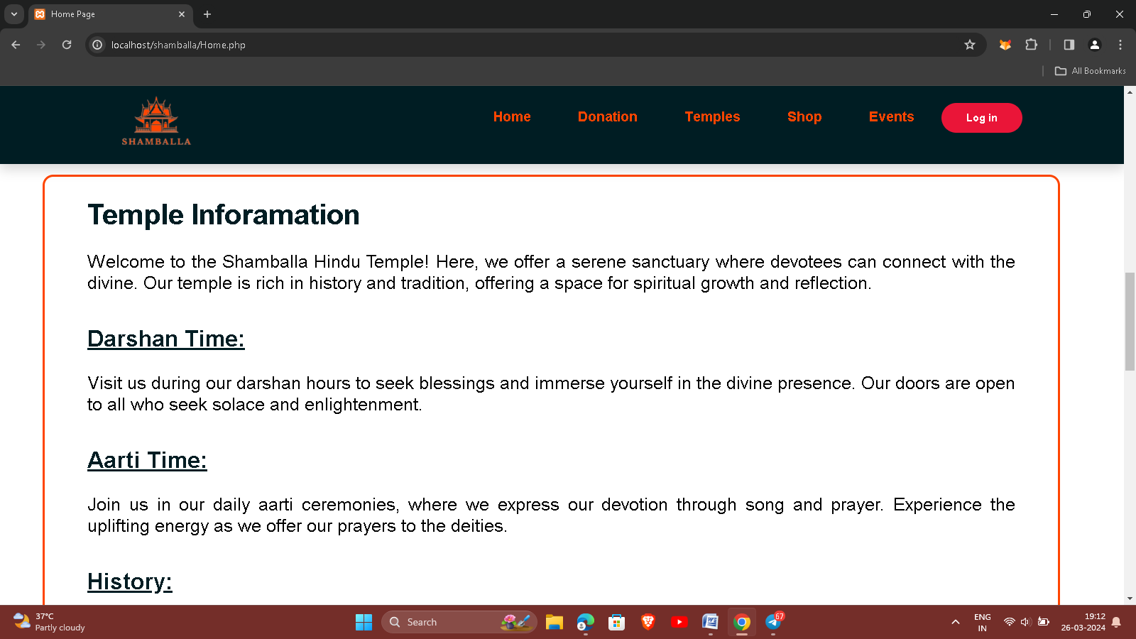

- This is home page to display the website pages information.

- Donation Page:-

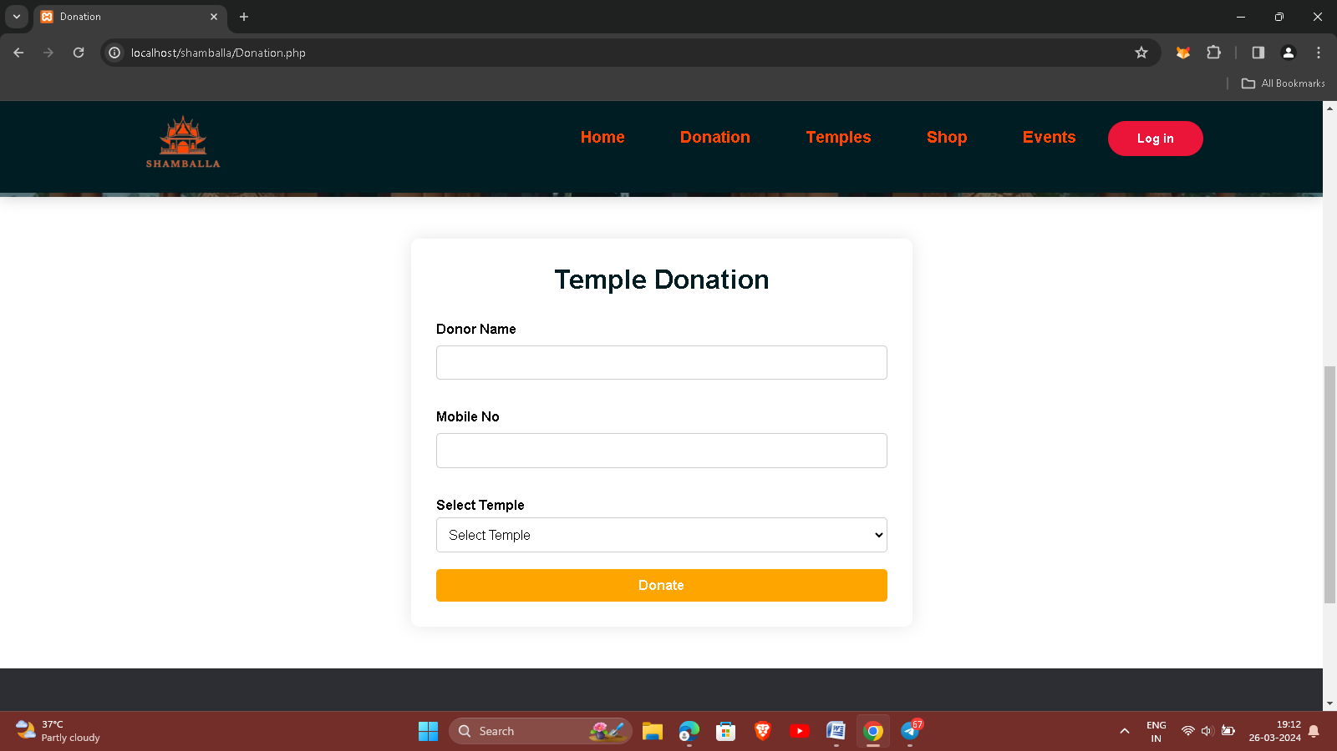

- This is donation page to devotees can donation in temple.
- Here, Enter a donor name ,mobile no and choose temple which can donate.

- Temples page:-

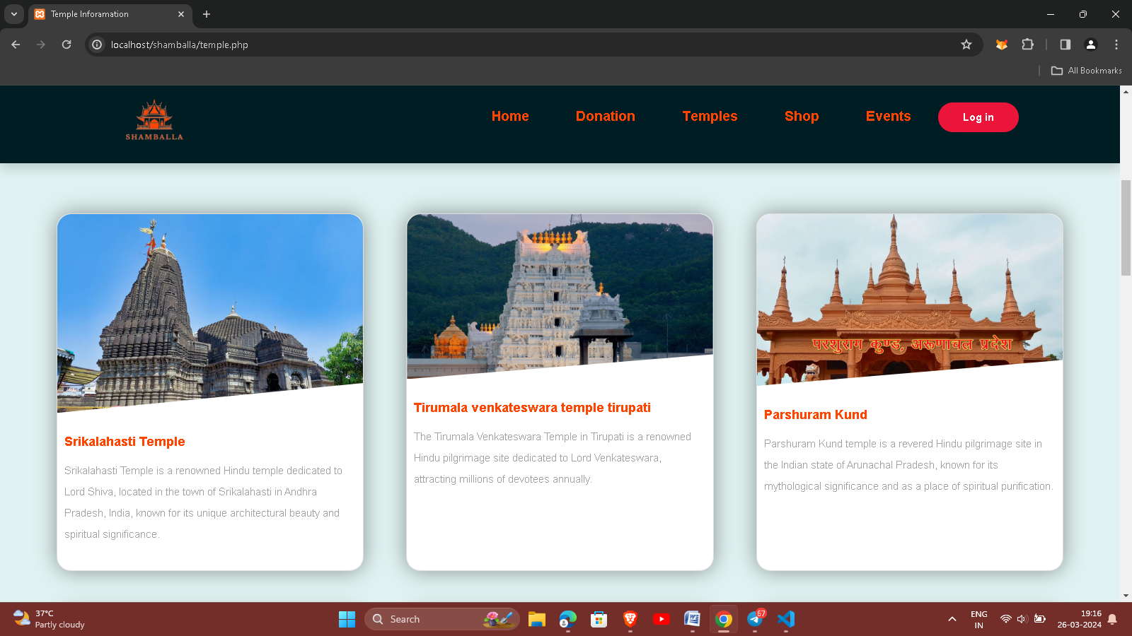

- Here, temples information cards.
- Click any cards to get information of temple.

- Temple Sub page:-

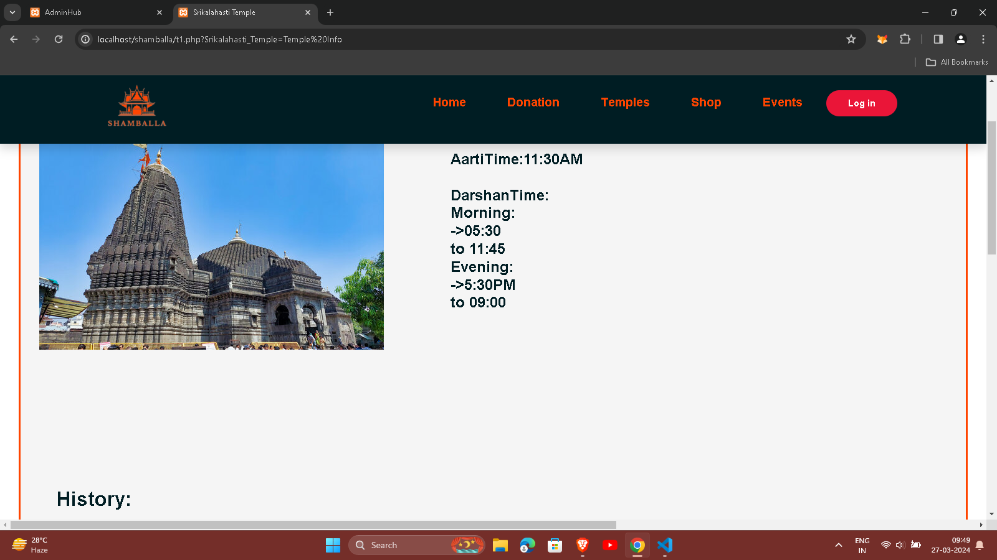

- This is temples sub page.
- It is display the specific information like temple darshan time,aarti time,history and gallery.

- Shop page:-

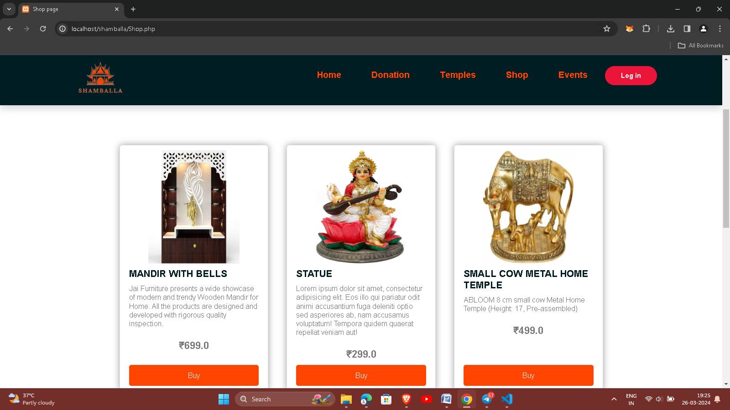

- This is a shop page of our website.
- It is show the temple related product like statue, books etc.
- User can purchase any product.

- Login page:-

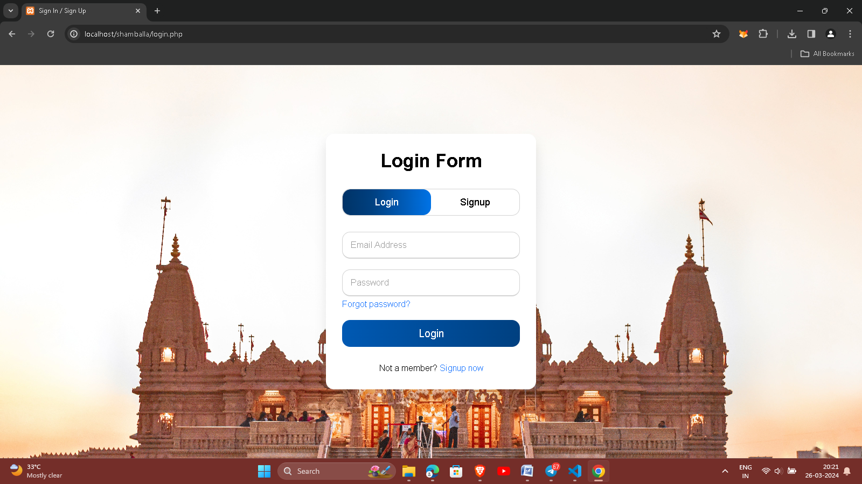

- It is login page.
- Enter your username and password.
- Then click to SignIn.

- SignUp:-

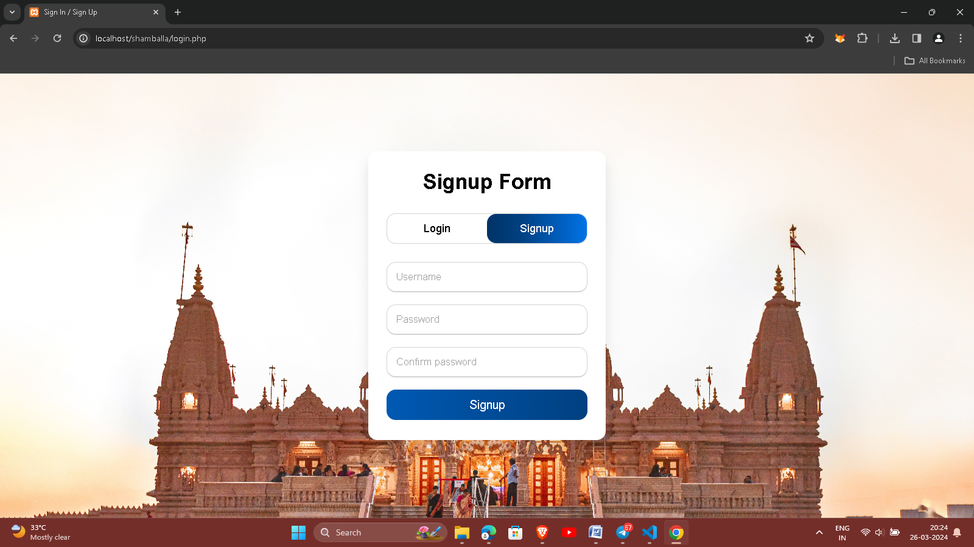

- It is signup page.
- Here user can create account.
- Simple enter a username, password and confirm password.
- Click to signup.

