1> Insert many student record with name, primary address, favorite teacher and age..

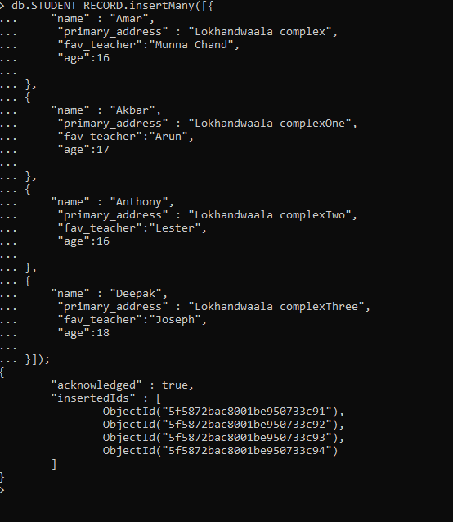

2> Check weather a student name ‘Arun’ is present in the collection.

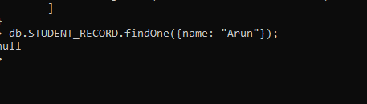

3> Change the primary address of the student ‘Vijay’ as no ‘123 abc nagar Chennai.’

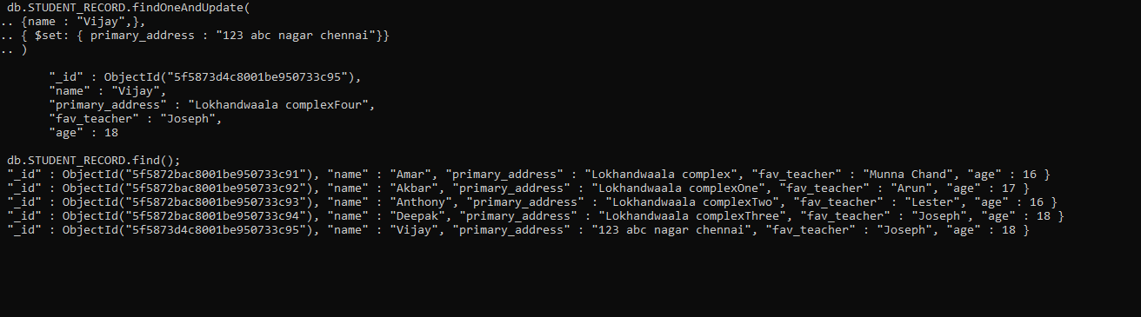

4> Find all the student whose age is greater than 12.

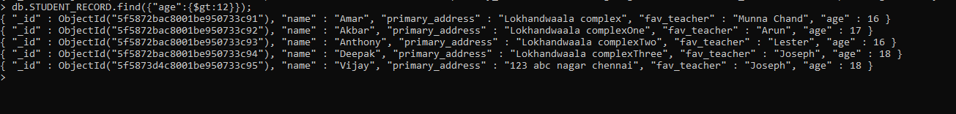

5> Find the favorite teacher of student ‘Ashwini’



6> Count the number of student present in student collection.

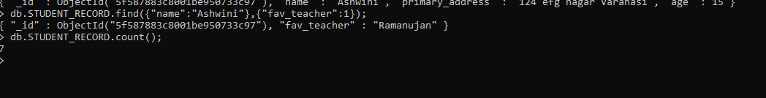

7> Count the students who live in Chennai

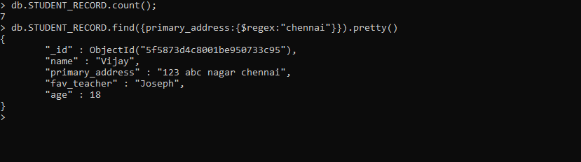

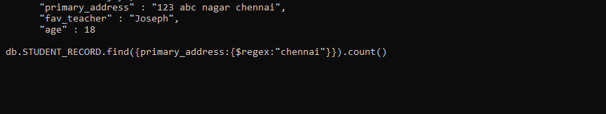

8> Count the student whose favorite teacher is ‘Anita’.

