ShopNest Store Power BI Capstone Report

Dashboard Overview
Complete dashboard view showing KPIs, sales, delivery performance, and revenue trends.
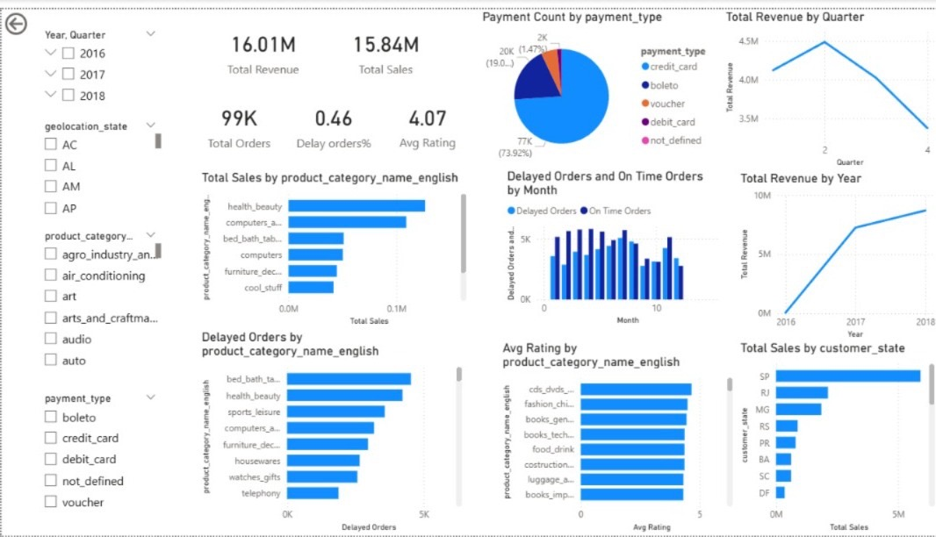

Key Performance Indicators
Total Revenue: 16.01M
Total Sales: 15.84M
Total Orders: 99K
Delay Orders %: 0.46
Average Rating: 4.07

Task 1: Top Categories by Total Sales
Health & Beauty and Computers are the top performing categories generating the highest sales.
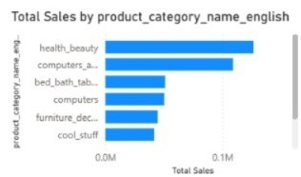

Task 2: Delayed Orders by Category
Bed Bath and Health & Beauty categories show the highest number of delayed orders indicating logistics inefficiencies.
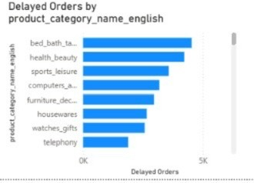

Task 3: Monthly Delayed vs On-Time Orders
The comparison shows fluctuation in delayed and on-time deliveries across months with some peak delay periods.
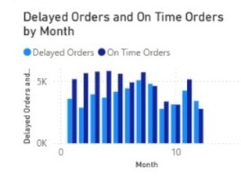

Task 4: Payment Method Analysis
Credit card is the most frequently used payment method followed by boleto and voucher.
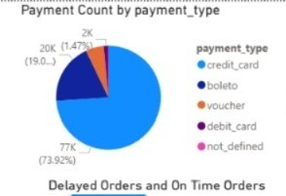

Task 5: Product Rating Analysis
Categories such as CDs/DVDs and Fashion show high average ratings indicating good customer satisfaction.
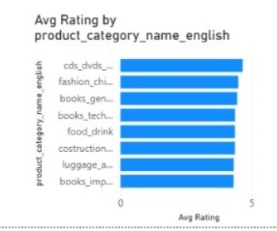

Task 6: State-wise Sales Analysis
SP, RJ, and MG states contribute the highest total sales showing strong regional demand.
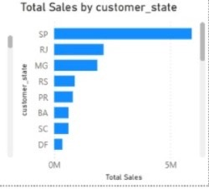

Task 7: Seasonal Sales Pattern (Quarterly)
Revenue peaks in Quarter 2 and declines towards Quarter 4 indicating seasonal buying behavior.
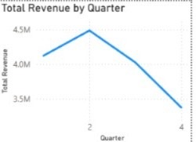

Task 8: Revenue Trend (Yearly)
Revenue shows steady growth from 2016 to 2018 indicating business expansion.
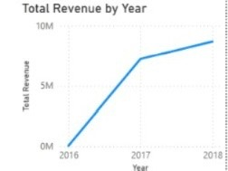

Conclusion
The dashboard provides valuable insights into sales performance, customer behavior, delivery efficiency, and revenue growth. The analysis helps identify high-performing categories, logistics challenges, and regional opportunities for business improvement.

