

INTERNSHIP REPORT
ON
FULL STACK
AT
IUNOWARE PRIVATE LIMITED
MADURAI
SUBMITTED BY
N. PRIYA (910423104036)

BACHELOR OF ENGINEERING
IN
COMPUTER SCIENCE AND ENGINEERING
FATIMA MICHAEL COLLEGE OF ENGINEERING
&
TECHNOLOGY, MADURAI
2025-2026(ODD SEM)
FULL STACK INTERNSHIP
S. No | TABLE OF CONTENTS
1 | Abstract
2 | Introduction
3 | Internship Objectives
4 | Tools and Technologies Used
5 | Overview of Full Stack Internship
6 | Day-wise Internship Activities (Day 1 to Day 30)
7 | Skills Gained
8 | Challenges Faced and Solutions
9 | Learning Outcomes
10 | Project Description
11 | Project Demo
12 | Conclusion
13 | Internship photos

1. Abstract
This report describes the one-month Full Stack Development internship completed at Iunoware Pvt Ltd.
The internship focused on frontend development using HTML, CSS, and JavaScript, backend development
using Python and Flask, and database management using SQLite/MySQL. The main goal was to understand
the complete web application development process by integrating user interface, server-side logic,
and database operations.
2. Introduction
This internship focuses on understanding Full Stack web development, which includes frontend, backend, and database technologies. Full Stack development involves designing user interfaces, handling server-side logic, and managing databases.
Through this internship, I gained practical exposure to building complete web applications where frontend pages interact with backend APIs and databases. This experience helped me understand the end-to-end workflow of real-time web applications.
3. Internship Objectives
The main objective of this internship was to gain practical knowledge in Full Stack Development.
The internship aimed to understand frontend design, backend development using Python and Flask, database operations, and integration of all components into a complete web application.
It also focused on improving problem-solving skills, understanding real-world project workflows, and gaining hands-on experience in developing full stack applications.

4. Tools and Technologies Used
Frontend:
HTML
CSS
JavaScript
Backend:
Python
Flask
Database:
SQLite / MySQL
Other Tools:
Postman
VS Code
Git
5. Overview of Full Stack Development
Full Stack Development refers to the complete development of a web application, including frontend, backend, and database components. The frontend handles user interaction and visual design, while the backend manages server-side logic and data processing. The database stores and manages application data.
In Full Stack development, frontend technologies like HTML, CSS, and JavaScript communicate with backend frameworks such as Flask through APIs. The backend processes user requests, interacts with databases, and sends responses back to the frontend.
Full Stack developers are responsible for ensuring smooth interaction between all components, security, performance, and user experience. This internship helped me understand the complete application lifecycle.
6. Day-wise Internship Activities
Day 1 Date:10.12.2025
On the first day of the internship, I was introduced to Iunoware Pvt Ltd and its working environment. The mentor explained the rules, internship structure, and expectations. An overview of backend development was given, explaining how server-side applications work. I learned about the role of backend developers in real-world projects. The importance of Python and Flask in backend development was discussed. The session helped me understand the internship goals clearly. I also set up my system for development. This day built a strong foundation for the internship.

Day 2 Date:11.12.2025
The second day focused on Python basics. I revised Python syntax, variables, and data types. The mentor explained how Python is used in backend applications. Simple programs were practiced to improve logic building. I learned about indentation and coding standards. The importance of clean code was highlighted. Practice exercises were given for better understanding. This day strengthened my Python fundamentals.
Day 3 Date:12.12.2025
On the third day, control statements such as if-else, loops, and conditional logic were taught. I practiced writing programs using these concepts. Real-time examples were used to explain decision-making logic. I also learned about basic problem-solving techniques. The mentor guided me in correcting errors. This session improved my logical thinking. It was useful for understanding backend workflows.
Day 4 Date:13.12.2025
This day covered Python functions and modules. I learned how to define and call functions. The importance of code reusability was explained. Built-in and user-defined functions were discussed. I also learned about importing modules. File handling concepts such as reading and writing files were introduced. Practice tasks were given. This helped me manage data efficiently.
Day 5 Date:14.12.2025
On the fifth day, I was introduced to the Flask framework. The mentor explained what Flask is and why it is used. Installation and environment setup were completed. I created my first Flask application. Basic application structure was explained. I learned how Flask handles requests. This day marked my entry into web backend development.
Day 6 Date:15.12.2025
This day focused on Flask routing. I learned how URLs are mapped to functions. Different route patterns were practiced. The use of decorators in Flask was explained. I created multiple routes in a sample application. I understood how requests reach the server. This session improved my understanding of request handling.
Day 7 Date:16.12.2025
On day seven, GET and POST methods were discussed. I learned the difference between them. Form data handling was explained. I practiced sending data from client to server. The importance of secure data handling was highlighted. Practical examples were demonstrated.
Day 8 Date:17.12.2025
Frontend design using HTML and integration with Flask backend. I learned how frontend templates connect with Flask. Passing data from backend to frontend was practiced. Template inheritance was introduced. I created simple HTML pages. This session helped me understand backend–frontend integration.
Day 9 Date:18.12.2025
On the ninth day, database concepts were introduced. I learned about relational databases and tables. SQL basics such as SELECT and INSERT were explained. The importance of data storage was discussed. Simple queries were practiced. This session built the foundation for database integration.
Day 10 Date:19.12.2025
This day focused on database table creation. I learned about primary keys and constraints. CRUD concepts were explained. I practiced writing SQL queries. Data insertion and retrieval were demonstrated. This helped me understand structured data handling.
Day 11 Date:20.12.2025
On day eleven, Flask and database connection was taught. I learned how to connect Flask apps to databases. Configuration settings were explained. I tested database connections successfully. This session helped me understand backend data flow.
Day 12 Date:21.12.2025
This day focused on performing CRUD operations using Flask. I implemented create and read operations. Update and delete concepts were explained. I practiced modifying database records. This improved my backend programming confidence.
Day 13 Date:22.12.2025
On this day, user registration functionality was developed. I learned how to store user data securely. Input validation was explained. I practiced building registration forms. This session helped me understand real-time applications.
Day 14 Date:23.12.2025
This day focused on user login functionality. Authentication logic was explained. I learned how credentials are verified. Session concepts were introduced. I implemented basic login features.
Day 15 Date:24.12.2025
On day fifteen, session handling and validation were covered. I learned how sessions maintain user state. Logout functionality was discussed. Security aspects were highlighted.
Day 16 Date:26.12.2025
This day introduced REST API concepts. I learned about REST architecture. API endpoints were discussed. The importance of APIs was explained.
Day 17 Date:27.12.2025
This day focused on creating REST APIs using the Flask framework. I developed simple APIs that returned responses in JSON format. Request handling and response structures were explained clearly. I practiced sending parameters through APIs. HTTP status codes and their importance were discussed. Error handling in APIs was also introduced. This session increased my confidence in backend API development. It was very useful for project implementation
Day 18 Date:28.12.2025
On day eighteen, API testing was done using Postman. I learned how to test GET and POST requests. JSON responses were analyzed carefully. I practiced debugging incorrect API outputs. The mentor explained how API testing helps before frontend integration. Error responses and status codes were verified. This session improved my testing skills. It also helped me understand real-time debugging.
Day 19 Date:29.12.2025
This day focused on exception handling and error management in Flask applications. I learned how runtime errors occur and how to handle them. Try-except blocks were implemented in code. Custom error messages were created for users. Logging basics were also discussed. Proper error handling improves application reliability. This session helped me write safer backend code.
Day 20 Date:30.12.2025
On the twentieth day, debugging and code optimization techniques were taught. I learned how to identify logical errors in programs. Flask debug mode was used to trace issues. Best coding practices were explained by the mentor. Code readability and performance were improved. This day enhanced my problem-solving skills. It prepared me for handling larger projects.
Day 21 Date:31.12.2025
From this day, project development was started. I began working on an E-Commerce website Full Stack project. Project requirements and features were explained clearly. The overall flow of the e-commerce application was discussed. I designed the basic Flask project structure. Database planning for users and products was done. This day marked the beginning of hands-on project work.
Day 22 Date:2.12.2025
On this day, database design for the e-commerce project was implemented. Tables for users, products, and orders were created. Relationships between tables were defined. CRUD operations for products were planned. Sample data was added to the database. This session improved my database design skills. It was very useful for real-time applications.

Day 23 Date:3.1.2026
This day focused on user authentication for the e-commerce website. User registration and login functionalities were implemented. Password validation and secure handling were discussed. Session management concepts were revised. Access control for users was ensured. Security importance in e-commerce applications was explained. This session strengthened my backend security knowledge.
Day 24 Date:4.1.2026
On the twenty-fourth day, product management features were developed. APIs to add, update, view, and delete products were created. Product details like name, price, and description were handled. Database interactions were tested successfully. This helped me understand real-world backend logic. It was a key project development day.
Day 25 Date:5.1.2026
This day focused on implementing cart functionality. I learned how shopping cart systems work. Adding and removing products from the cart was implemented. Total price calculation logic was written. User-specific cart handling was practiced. This feature simulated real-time shopping behavior. It added major value to the project.

Day 26 Date:6.1.2026
On day twenty-six, order management features were developed. Order placement functionality was implemented. Order details were stored in the database. Basic order status handling was practiced. Transaction flow in e-commerce systems was explained. This session helped me understand backend transaction logic.
Day 27 Date:7.1.2026
This day focused on improving project performance. Database queries were optimized. Code refactoring was done for better structure. Error handling was improved across modules. Mentor feedback was applied to the project. The application became more stable and efficient. This session enhanced code quality.
Day 28 Date:8.1.2026
On day twenty-eight, complete backend testing was done. All APIs were tested using Postman. Edge cases were checked carefully. Bugs were identified and fixed. The application flow was verified end-to-end. This ensured smooth functioning of the project.
Day 29 Date:9.1.2026
This day focused on documentation and final review. API documentation was prepared. Project workflow was explained clearly. Final changes were made based on feedback. The project was prepared for submission. This helped improve presentation skills.

Day 30 Date:10.1.2026
On the final day of the internship, the E-Commerce backend project was successfully submitted. A complete project demonstration was given to the mentor. Feedback was received and discussed. Overall learning outcomes were reviewed. The internship concluded successfully with real-world backend development experience.

7. Skills Gained
- Learned frontend development using HTML, CSS, and JavaScript
- Gained backend development experience using Python and Flask
- Learned database design and CRUD operations
- Developed and tested REST APIs using Postman
- Integrated frontend with backend applications
- Improved debugging, problem-solving, and logical thinking skills
- Gained hands-on experience in Full Stack E-Commerce project
8.Challenges Faced and Solutions
  - Understanding Flask framework initially
→ Solved by practicing simple examples and referring to mentor guidance.
  - Database connection errors
→ Fixed by checking configuration settings and understanding connection methods.
  - Handling API errors and incorrect responses
→ Solved using proper debugging and testing APIs with Postman.
  - Authentication and session management issues
→ Overcome by learning session handling concepts and secure login logic.
  - Implementing cart and order logic in e-commerce project
→ Solved by breaking the problem into smaller modules and testing step by step.
  - Debugging runtime and logical errors
→ Resolved using Flask debug mode and systematic code review.
9.Learning Outcomes

- Gained clear understanding of Full Stack Development concepts
- Learned to build complete web applications from frontend to backend
- Understood frontend–backend–database interaction
- Developed and tested REST APIs
- Gained real-world project experience through a Full Stack application
- Improved confidence to work on industry-level projects

10. Project Description
As part of the internship, The frontend of the application was developed using HTML, CSS, and JavaScript to provide an interactive user interface, which was integrated with the Flask backend.. The main objective of the project was to design and implement the server-side functionalities required for an online shopping application.
The backend system supports user registration and login, ensuring secure authentication and session management. It allows product management, where products can be added, viewed, updated, and deleted. A shopping cart module was implemented to enable users to add or remove products and calculate the total cost. The order management system handles order placement and stores order details in the database.
REST APIs were developed using Flask to handle communication between frontend and backend. The database was designed to store user, product, cart, and order information efficiently. The entire project was tested using Postman to ensure proper functionality. This project provided real-world experience in backend development and helped in understanding complete application workflow.

11.Project Demo
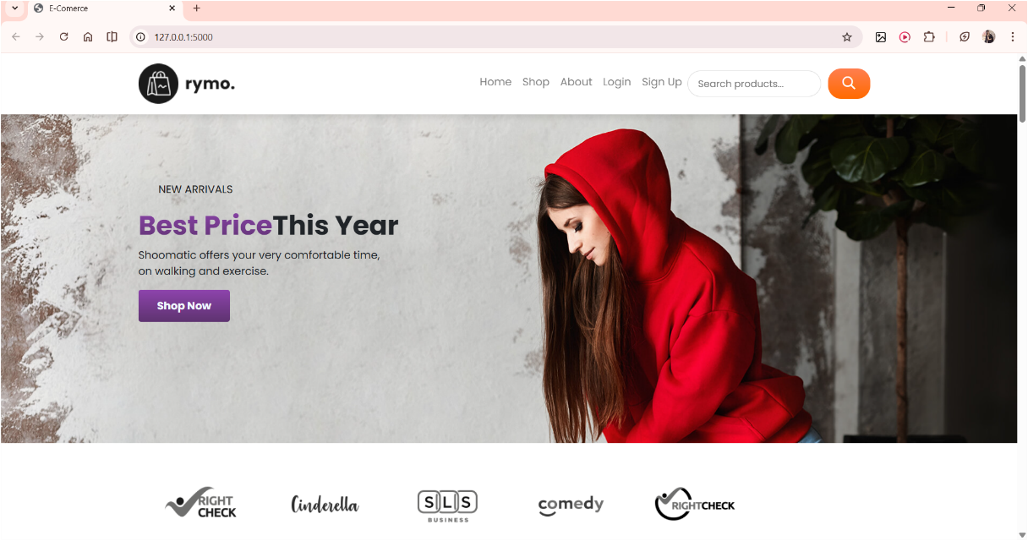

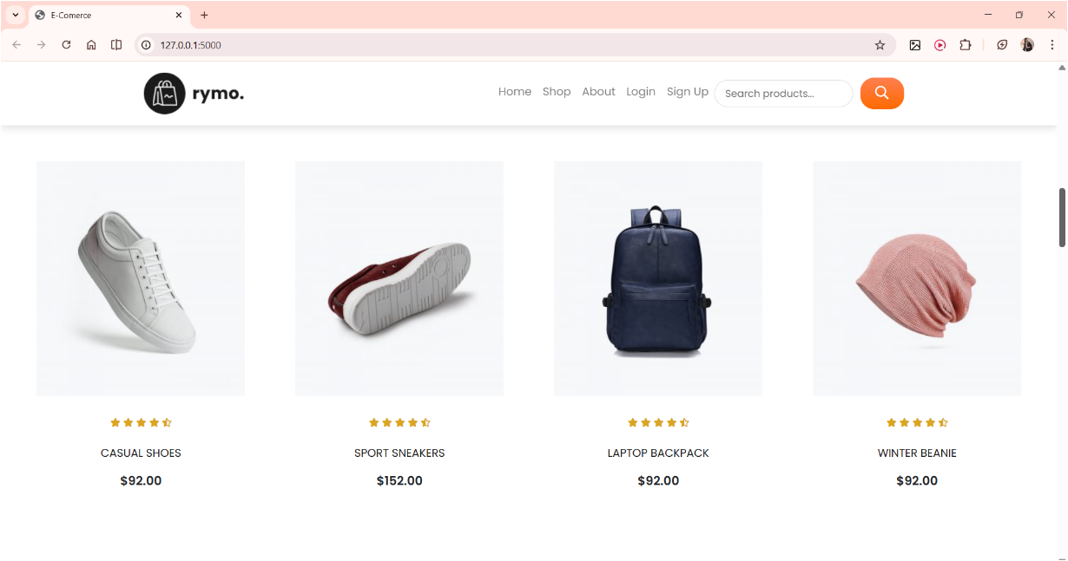

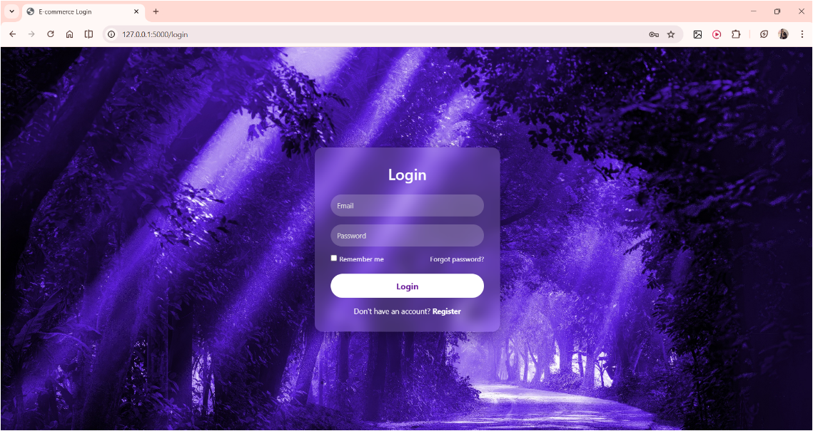

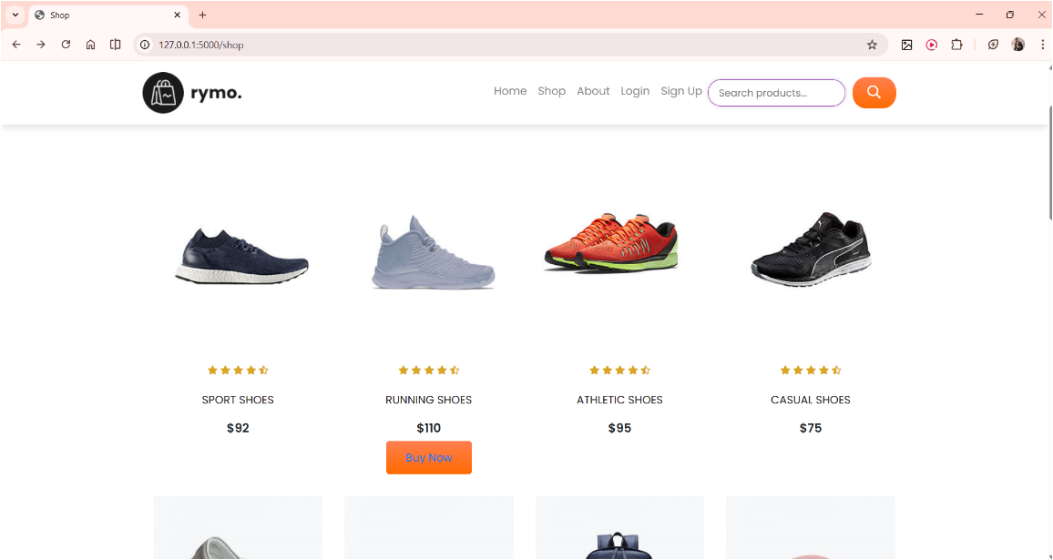

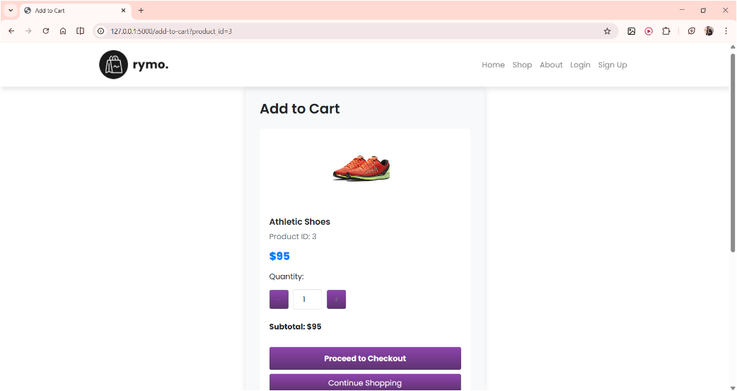

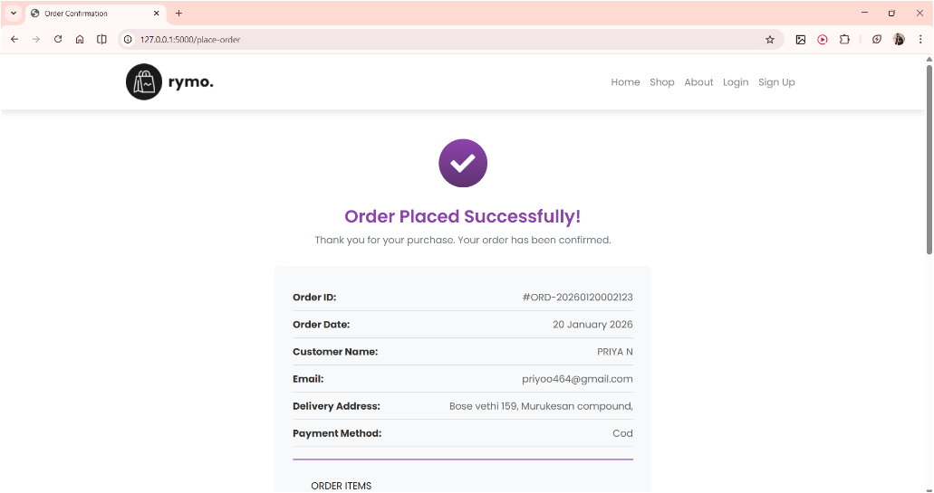

12. Conclusion
The one-month Full Stack Development internship at Iunoware Pvt Ltd was a valuable and enriching learning experience at Iunoware Pvt Ltd. During this internship, I gained practical knowledge of backend development using Python, Flask, and database technologies. The training helped me understand how real-world web applications are designed and developed.
Working on the E-Commerce website backend project gave me hands-on experience in implementing authentication, database management, API development, and testing. This internship improved my technical skills, problem-solving ability, and confidence to work on real-time projects. Overall, the internship provided a strong foundation for my future career in backend and software development.

13. Internship Photos

