NP-hard problem-In the static setting, the objective is to determine facility locations and transportation paths from each node to the destination via the network of facilities such that the total cost of commodity transportation is minimized.

We have design a decision variable space for our framework
We can use Max Entropy Principle

FOR A DYNAMIC SETTING,
We design an appropriate control Lyapunov function to determine the time evolution of facilities and paths such that the transportation cost at each time instant is minimized.

Comodity can be information,raw and processed goods
Nodes in these problems can transport only to nearby locations
This drawback is addressed by overlaying a much smaller network of facilities (special nodes) where each facility has resources to transport commodities to other facilities even if they are far

NODE---Network of facilities---Destination node
s-FLPO-static problems
d-FLPO- dynamic problems
problems In [28] and [29]
[28] was not scalable due to high time complexity of decision variable space
[29] was applicable to few ordered facilities only

We use stage-wise viewpoint that brings the size of decision variable space to O(M^3) without any enforcing path structure such as in [29]
s-FLPO problem also provides quantitative insights that are very helpful

LIPCHITZ FUNCTION: slope of any secant line of function f should be between -k and +k where k is positive real number.

S-FLPO problem

M facilities
N nodes
Node ni is located at xi, i is from 1 to N
Facilities fj at yj, j lies from 1 to M
Destination delta at z
Big gamma knot is set of all nodes
Big gamma k is the collection of all facilities and the destination
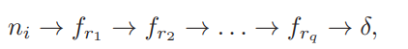
rj is from 1 to M
q distinct facilities
small gamma k belongs to big gamma k
G is the set of all transportation paths

Q) what are association weights basically? Are they the probability of a particular node being chosen?? How is it different from relative weight?

Q)k means algo is similar to greedy algorithm?

Now we associate each node with a weighing parameter/association weights p
Weighing parameter is the probability of the node being chosen in the optimum path
Relative weight is something else?
Sum of all weighing parameters is 1

If weighing parameter is equal to nu then (5)=(3)

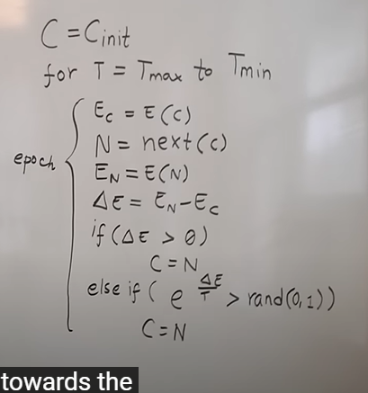

- Comes from metallurgy, to make really strong metallic objects, people follow a slow and controlled procedure called Annealing , same can be appied to CS algos
- I mainly used it to plan a path for a robot
- Can be used to solve travelling salesman problems, designing printed circuit boards
- Explain it using the toy game that we play with its called rings ,initially we do random moves press it continuously but after some time if some rings get into It we play more cautiously
- Similarly early on we accept all solutions but as we move towards a solution we become more cautious
- To apply this algorithm , the condition is that every problem we are solving we should be able to define the way to describe the fitness of the solution
- We call this energy
- Problem is that sometimes the solution gets stuck at the local maxima
- There should be a way to change the current configuration , which is called making a move

Simulated annealing algorithm
so we have an initial configuration or given random configuration

T is generally the standard deviation of some 200 starting states
Then we introduce a variable known as temperature
We go from high temp to low temp

For every value of temp
We calc energy for the current configuration
Then change configuration by making the “move”
We calc new energy
We have delta E
If delta E is a positive /good move we accept the move therefore we set the next configuration to the current configuration
If delta is negative we calculate the probability given by e^delta E/T if it is high we accept, we only accept the move in a certain situation in which temperature is high enough
Then fibally we expect the solution to converge towards the global minima

HILL CLIMBING ALGO/GREEDY ALGO/k- means algorithm/Lloyds algorithm: always except the good moves only (get stuck at global minima) GREEDY
RANDOM WALK: continuously explore the space such algos never converge

M is the number of facilities
How is it 25% better?
earlier time 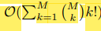
Now O(M^3)
For around 17000 nodes and M=50 facilities 25% better

