**Priyanga (Computer Science Engineering)**

**REAL-TIME EMOTION RECOGNITION**

**PROBLEM STATEMENT**

This project aims to recognize emotions from facial expressions in real-time using deep learning techniques.  
The system processes video footage, detects faces, and classifies emotions into predefined categories, such as:

* Angry, Disgust, Fear, Happy, Neutral, Sad, Surprise

**LIBRARIES USED**

1. **OpenCV (cv2):** 
   * For image and video processing, face detection, and visualization.
2. **TensorFlow (tensorflow) and Keras:** 
   * For loading and using a pre-trained deep learning model to predict emotions.
3. **NumPy (numpy):** 
   * For numerical operations and handling image arrays.
4. **time.sleep:** 
   * To control the frame rate and simulate real-time processing.

**ALGORITHM**

1. **Initialization:**
   * Define parameters for face detection and emotion prediction.
   * Load the pre-trained emotion recognition model.
   * Initialize video capture for real-time face tracking.
2. **Load Video Feed:**
   * Open the webcam stream using cv2.VideoCapture.
3. **Face Detection:**
   * Use a pre-trained Haar cascade classifier (haarcascade_frontalface_default.xml) for face detection in each frame.
4. **Face Preprocessing:**
   * Convert the face region of interest (ROI) to grayscale.
   * Resize the face image to 48x48 pixels.
   * Normalize and convert it to an array suitable for model input.
5. **Emotion Prediction:**
   * Use the pre-trained emotion detection model to predict the emotion from the ROI.
   * Display the predicted emotion on the screen.
6. **Real-Time Visualization:**
   * Draw bounding boxes around detected faces and display the recognized emotion.
   * Continuously update the emotion on the screen in real-time.
7. **Exit Condition:**
   * Stop processing when the user presses the 'q' key.

**CODE**

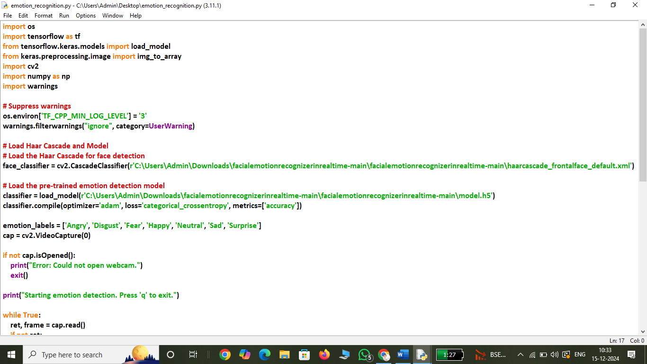

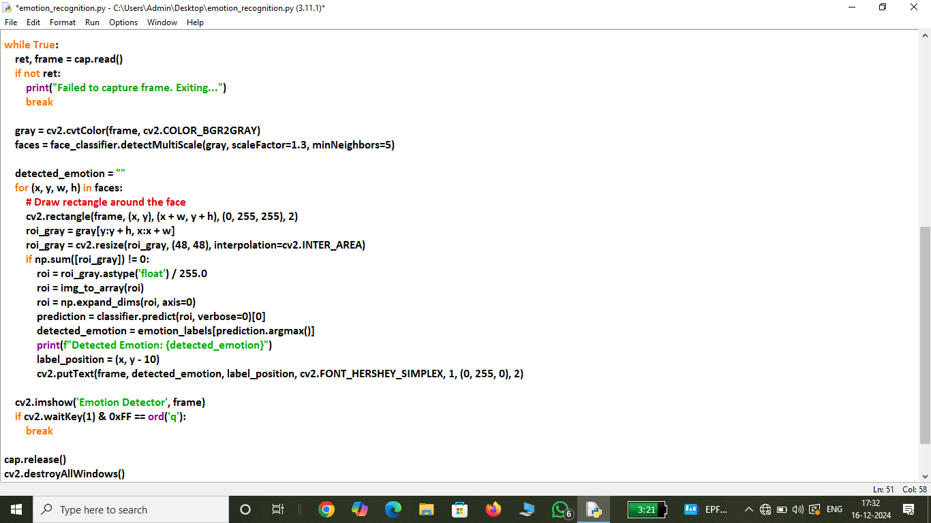

**INPUT**

* **Input File:** Live system camera feed

**OUTPUT**

1. **Real-Time Emotion Display:**
   * The system will display the predicted emotion label on the screen above the detected face.
   * For example: "Happy", "Sad", "Angry", etc.
2. **Bounding Boxes:**
   * Faces detected will be highlighted with bounding boxes.

**OUTPUT VISUALIZATION EXAMPLE**

* **Live Video Stream:** 
  + Faces will be highlighted with bounding boxes.
  + The detected emotion will be displayed as a label above each face.

**EXIT CONDITION**

* Press the 'q' key to stop the program and close the video window.

**SAMPLE OUTPUT (REAL TIME):**

